**TIME SERIES ANALYSIS**

**PRACTICAL – 6**

**Submitted By: Ridam Singhal(5040)**

**AIM:** To compute seasonal indices by link relatives’ method.

**EXPERIMENT:** 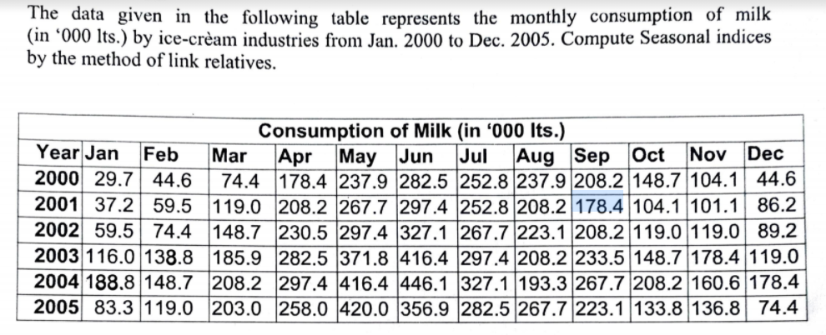

**THEORY:**

Link relative method, also known as Pearson’s method is based on averaging the link relatives. Link relative is the value of one season expressed as a percentage of the value of the preceding season (season refers to time period. For e.g. month for monthly data, quarter for quarterly data, etc.). Thus, for monthly data, we have:

Link relative for any month (L.R.) = (Current Month’s Value/Previous Month’s Value)*100

1. Calculate the link relatives (L.R.) from the original data using formula given above, and calculate the average link relatives for each month.
2. Calculate chain relatives (C.R.) by the formula:

(L.R. of that season) * (C.R. of preceding season)/100.

Take the C.R. of first season as 100.

1. Now calculate new C.R. for the first season(month) by the formula:

(L.R. of first month) * (C.R. of last month)/100

1. Correction Factor (d) = (New C.R. for first month – 100)/n

n=12 for monthly data, and n=4 for quarterly data.

1. Now calculate adjusted C.R. (we have to adjust chain relatives for the trend because New C.R. is not 100).

The adjusted chain relative of ith month = chain relative of ith month - (i-1) * c

1. Now finally, calculate the adjusted seasonal indices by:

Adjusted Seasonal indices for ith month =

(Adjusted C.R. for ith month/Average of adjusted C.R.)*100

**CALCULATIONS:**

|  |  |  |  |  |  |  |  |  |  |  |  |  |  |  |  |  |  |  |  |  |  |  |  |
| --- | --- | --- | --- | --- | --- | --- | --- | --- | --- | --- | --- | --- | --- | --- | --- | --- | --- | --- | --- | --- | --- | --- | --- |
|  | Table 6.1 |  | |  | |  | |  | |  | |  | |  | |  | |  | |  | |  | |
|  | CONSUMPTION OF MILK (in '000 ltrs) | | | | | | | | | | | | | | | | | | | | | | | | |  |
|  | YEAR | JAN | | | FEB | | MAR | | APR | | MAY | | JUN | | JUL | | AUG | | SEP | | OCT | | NOV | | DEC |  |
|  | 2000 | 29.7 | | | 44.6 | | 74.4 | | 178.4 | | 237.9 | | 282.5 | | 252.8 | | 237.9 | | 208.2 | | 148.7 | | 104.1 | | 44.6 |  |
|  | 2001 | 37.2 | | | 59.5 | | 119 | | 208.2 | | 267.7 | | 297.4 | | 252.8 | | 208.2 | | 178.4 | | 104.1 | | 101.1 | | 86.2 |  |
|  | 2002 | 59.5 | | | 74.4 | | 148.7 | | 230.5 | | 297.4 | | 327.1 | | 267.7 | | 223.1 | | 208.2 | | 119 | | 119 | | 89.2 |  |
|  | 2003 | 116 | | | 138.8 | | 185.9 | | 282.5 | | 371.8 | | 416.4 | | 297.4 | | 208.2 | | 233.5 | | 148.7 | | 178.4 | | 119 |  |
|  | 2004 | 188.8 | | | 148.7 | | 208.2 | | 297.4 | | 416.4 | | 446.1 | | 327.1 | | 193.3 | | 267.7 | | 208.2 | | 160.6 | | 178.4 |  |
|  | 2005 | 83.3 | | | 119 | | 203 | | 258 | | 420 | | 356.9 | | 282.5 | | 267.7 | | 223.1 | | 133.8 | | 136.8 | | 74.4 |  |
|  |  |  | | |  | |  | |  | |  | |  | |  | |  | |  | |  | |  | |  |  |
|  | Table 6.2 |  | | |  | |  | |  | |  | |  | |  | |  | |  | |  | |  | |  |  |
|  | LINK RELATIVES (L.R.) | | | | | | | | | | | | | | | | | | | | | | | | |  |
|  | YEAR | | JAN | | FEB | | MAR | | APR | | MAY | | JUN | | JUL | | AUG | | SEP | | OCT | | NOV | | DEC |  |
|  | 2000 | |  | | 150.17 | | 166.82 | | 239.78 | | 133.35 | | 118.75 | | 89.49 | | 94.11 | | 87.52 | | 71.42 | | 70.01 | | 42.84 |  |
|  | 2001 | | 83.41 | | 159.95 | | 200.00 | | 174.96 | | 128.58 | | 111.09 | | 85.00 | | 82.36 | | 85.69 | | 58.35 | | 97.12 | | 85.26 |  |
|  | 2002 | | 69.03 | | 125.04 | | 199.87 | | 155.01 | | 129.02 | | 109.99 | | 81.84 | | 83.34 | | 93.32 | | 57.16 | | 100.00 | | 74.96 |  |
|  | 2003 | | 130.04 | | 119.66 | | 133.93 | | 151.96 | | 131.61 | | 112.00 | | 71.42 | | 70.01 | | 112.15 | | 63.68 | | 119.97 | | 66.70 |  |
|  | 2004 | | 158.66 | | 78.76 | | 140.01 | | 142.84 | | 140.01 | | 107.13 | | 73.32 | | 59.10 | | 138.49 | | 77.77 | | 77.14 | | 111.08 |  |
|  | 2005 | | 46.69 | | 142.86 | | 170.59 | | 127.09 | | 162.79 | | 84.98 | | 79.15 | | 94.76 | | 83.34 | | 59.97 | | 102.24 | | 54.39 |  |
|  | Avg. L.R. | | 97.57 | | 129.40 | | 168.54 | | 165.28 | | 137.56 | | 107.32 | | 80.04 | | 80.61 | | 100.08 | | 64.73 | | 94.41 | | 72.54 |  |
|  | C.R. | | 100 | | 129.40 | | 218.09 | | 360.46 | | 495.85 | | 532.16 | | 425.93 | | 343.35 | | 343.63 | | 222.42 | | 210.00 | | 152.33 |  |
|  | Adj_C.R. | | 100 | | 125.35 | | 209.99 | | 348.30 | | 479.64 | | 511.90 | | 401.62 | | 314.98 | | 311.22 | | 185.96 | | 169.48 | | 107.76 |  |
|  | Adj_S.I. | | 36.74 | | 46.05 | | 77.15 | | 127.97 | | 176.22 | | 188.07 | | 147.55 | | 115.72 | | 114.34 | | 68.32 | | 62.27 | | 39.59 |  |

|  |  |
| --- | --- |
| C.R.-> Chain Relatives |  |
| New C.R. for January = | 148.6215 |
| d= | 4.051792 |
| Avg. of adjusted C.R.= | 272.1834 |
|  |  |

Graph 6.1

**RESULT:**

* Seasonal adjusted indices have been calculated in table 6.2, and plotted in graph 6.1
* Correction factor (d) is coming out to be 4.051792

**CONCLUSION:**

* It can be concluded from the given graph 6.1, that the highest consumption of milk is observed in the month of June, and least consumption is in the month of January.