**Semester Project Milestone – 2**

GAGANDEEP PARMAR

Semester Project Git hub Link -<https://github.com/Gagandeep-Parmar/DGL203-Semester-Project-Gagandeep-Parmar>

After reviewing the feedbacks from the peers on my Milestone1 Project proposal which is the target user and the website use is not clear. So, keeping that in mind tried to add few more features.

Due to the changes that I will bring in my website design which can easily help the user who the target audience is and what is the main purpose of the website, the layout and structure of the landing page will be different to adapt the new changes.

Website Goals-

**The main goal is to create a website for a restaurant which will help their customers and new users to explore the cuisine and can order the food or can reserve table for their Breakfast, Lunch and Dinner-**

* The User Interface should be basic yet effective in order to improve the User Experience.
* The website will primarily **target mobile users**, as more than 90% of clients will search for Food & Restaurant websites on mobile devices.
* Website should achieve good Usability score in such areas –

1. Page speed
2. Readability
3. Clear Navigation

User Persona-

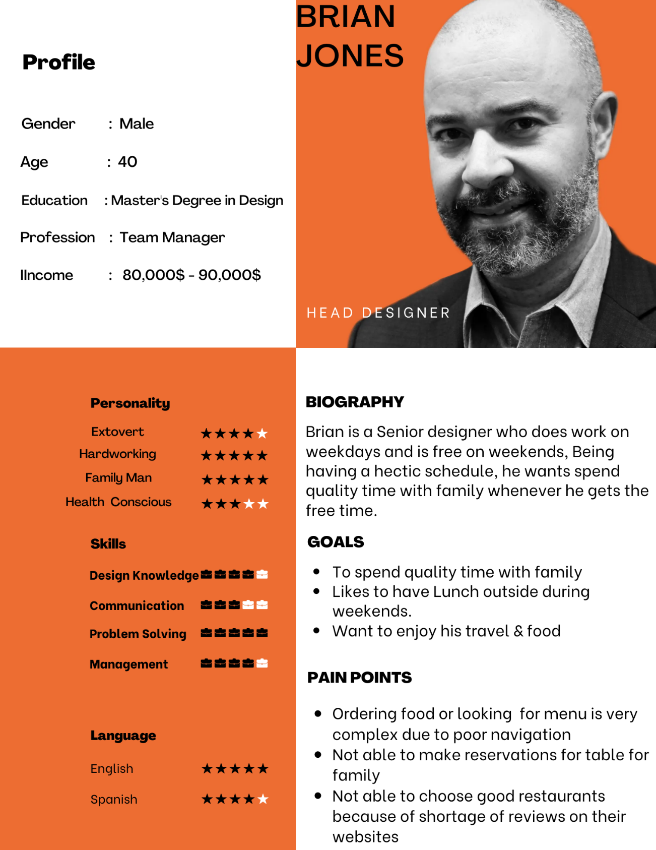

Competitors Websites-



* Locals Restaurant - <https://localscomoxvalley.com/>

Locally grown and produced foods are fresh, and fresh is synonymous with healthy. Health conscious peoplee are willing to make the little extra effort to source food grown and produced locally



* Browns Social House - <https://brownssocialhouse.com/>

Browns Socialhouse® is a franchise established in Vancouver that is part of the Browns Restaurant Group, which has over 80 locations across Canada. They provide flavorful food that is always fresh and entertaining!



* Manvirro’s Indian Grill - <https://manvirros-indiangrill.com/>

The food of Northern India is the speciality of Manvirro’s Indian Grill. Run by Tony Kandola and his brother Kal Kandola, Manvirro’s opened January 19 .

Advantages-

* Better Layout than previous proposal which will lead to clear navigation on website page.
* Better use of styles to make an professional looking website
* Used better font-family which can be easily read by visitors rather than cursive headings
* Provides space between each different section (NOT CONFINED)
* Better color contrast which increases the readability.

KPIs (Key Performance Indicators)-

* **Unique Website Visitors**-

when a visitor arrives at your client's website and interacts with one or more pages throughout a defined time period. **Google Analytics** can be use to track this data

It matters because it helps the company or owner to get data such as-

1. What are the difficulties that are impeding the website's performance?
2. What the size of the audience is;
3. How the website ranks in search results;

* **Average Time on Page-**

Average time on page is a KPI that shows the average time that visitors spend on a single page. Again, Google analytics is a good option to track this data by dividing the total time spent on a single page by the total number of pageviews, minus the number of exits.

* **Conversion Rate-**

It indicates whether or not a user completed the action you or your client desired on a website.

It matters because it helps the company or owner to get data such as-

1. One can know that is the page navigation is clear to site visitors.
2. It lets them accurately predict the new flow of sales and revenue;

Comments-

* The main user of the site is not clear. Is the restaurant owner is using it for advertising or the website is like normal website where one can order food?
* Is the site going to be single page or multipage?
* Are you making website on a real world restaurant?
* Add some layout clarity so one can easily identify the purpose of the website.