SALES ANALYSIS PROJECT
Azure Data Factory (ADF) ETL Workflow & Implementation
Source: Sales Analysis project documentation and implementation screenshots

1. Project Overview
The Sales Analysis project was designed to automate the collection, transformation, integration, and reporting of sales data originating from multiple sources and formats. Azure Data Factory (ADF) was used as the centralized ETL orchestration platform. Raw CSV, JSON, Excel, Azure SQL, and on-premises SQL Server data were brought into an analytical workflow, subjected to data-quality checks and business transformations, standardized for currency analysis, and delivered to Power BI.

2. Business Requirement
- Centralize fragmented sales data from multiple sources.
- Clean and standardize inconsistent source data.
- Remove duplicate and missing/invalid records.
- Integrate product, region, sales, and exchange-rate information.
- Convert international sales values into USD for consistent analysis.
- Automate the ETL process through a scheduled ADF pipeline.
- Deliver curated sales information to Power BI for KPI and trend analysis.

3. End-to-End ADF ETL Architecture
The end-to-end workflow follows the sequence below:
Azure Blob Storage → ADF Pipelines → ADLS Gen2 Raw Layer → Mapping Data Flows / Copy Activity → Azure SQL Database → Data Integration & Exchange-Rate Join → Currency Conversion to USD → Derived Calculations → Curated Sales Table → SQL Server/SSMS via Self-Hosted Integration Runtime → Power BI

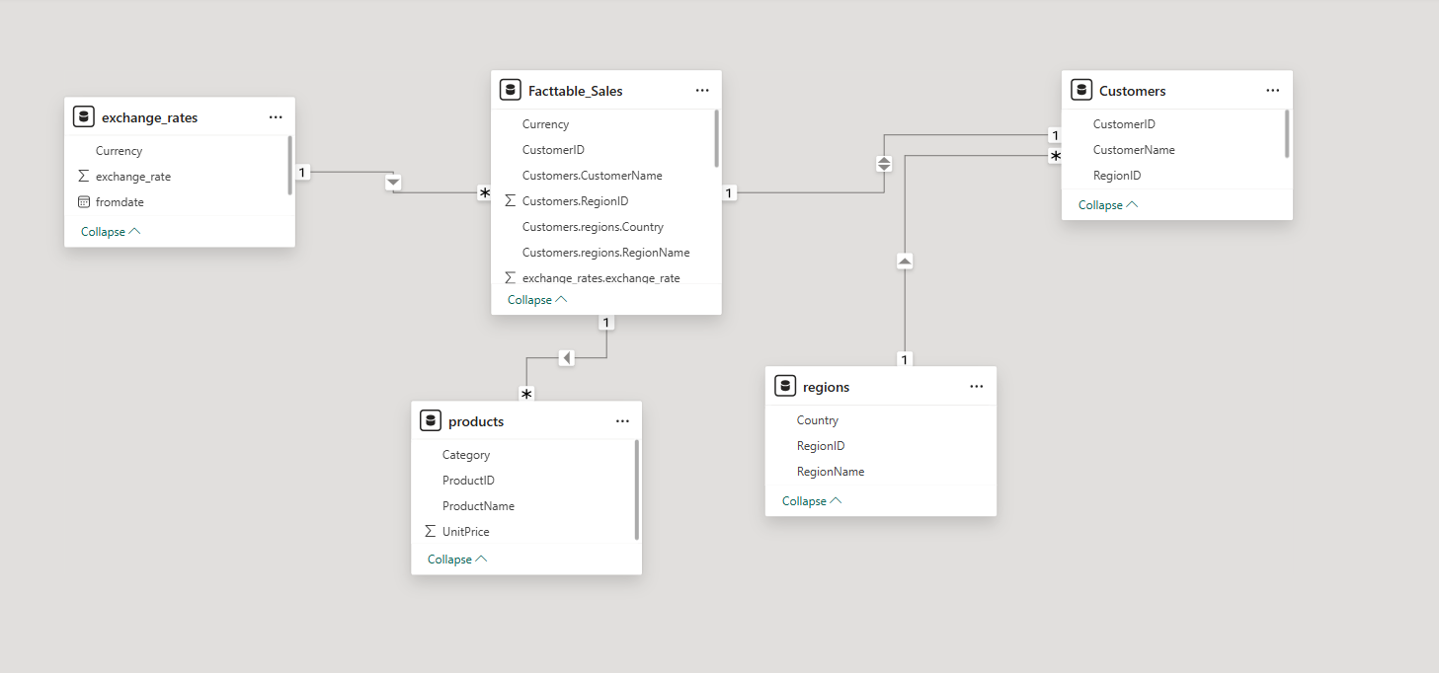
. Project data-model / architecture screenshot.

4. Source Data and Ingestion
Product.csv and Regions.csv were stored in Azure Blob Storage. ADF Copy Activity was used to move the raw files into Azure Data Lake Storage Gen2. Separate pipelines and Mapping Data Flows were used for the individual CSV datasets. JSON exchange-rate data was also extracted from Blob Storage, mapped into tabular form, and loaded into Azure SQL Database.

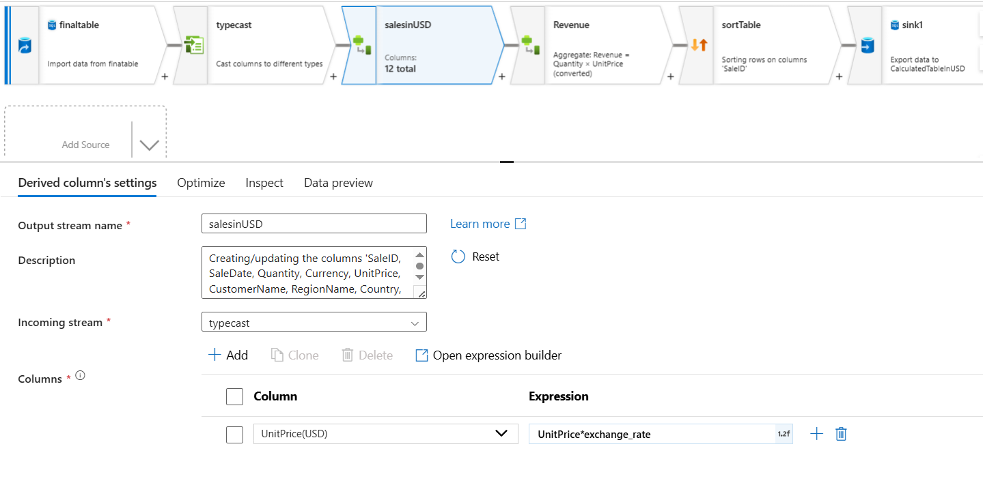
Figure 3. ADF pipeline/data ingestion implementation screenshot.
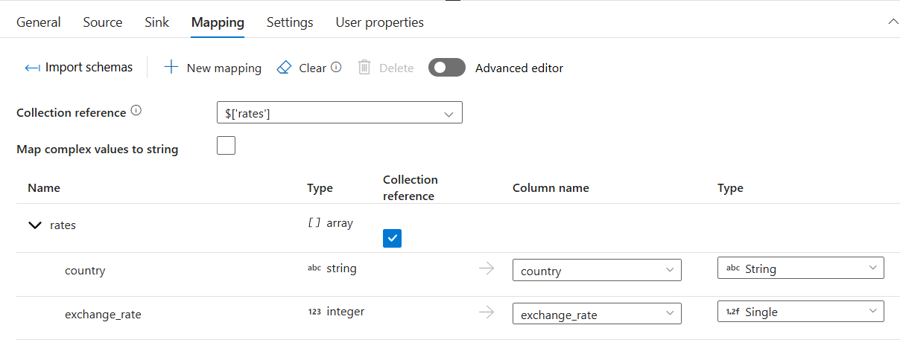
Dataset mapping / source configuration screenshot.

5. Product Data Transformation
The Product dataset was extracted from Blob Storage and processed through a Mapping Data Flow. The transformation logic addressed missing values, duplicate ProductID records, and data-type consistency before the cleaned data was written to Azure SQL Database and ADLS Gen2.
- Handle missing values using conditional transformation logic.
- Group records by ProductID and apply aggregation logic to remove duplicate records.
- Apply appropriate data types before loading to the target database.
- Write the cleansed Product data through the Sink transformation.
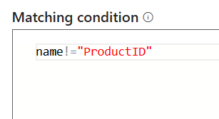
Figure 5. Product duplicate-removal matching condition: name == "ProductID".
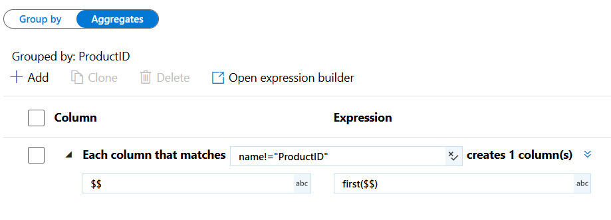
Product aggregation/group-by implementation.
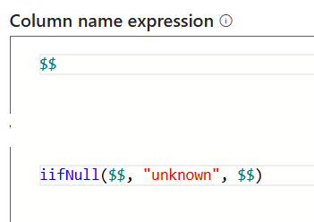
Missing-value handling expression using iifNull.

6. Region Data Transformation
The Regions dataset followed a similar ETL pattern. Duplicate RegionID records were identified and removed through aggregation, while missing or invalid records were handled using the Alter Row transformation. The cleansed dataset was then loaded through a Sink into Azure SQL Database and ADLS Gen2.
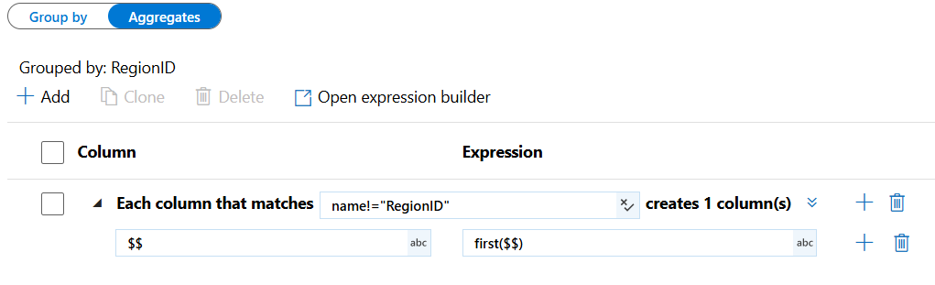
Figure 8. Region aggregation/group-by implementation.
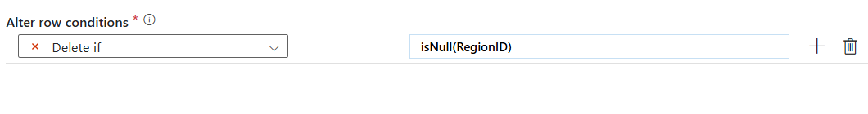
Region missing-record handling using Alter Row.

7. JSON Exchange-Rate Ingestion
The exchange-rate source was maintained as JSON. ADF Copy Activity was used to extract the file, apply column mapping, and convert the nested JSON information into a structured table. The resulting exchange-rate data was loaded into Azure SQL Database for integration with the Sales dataset.
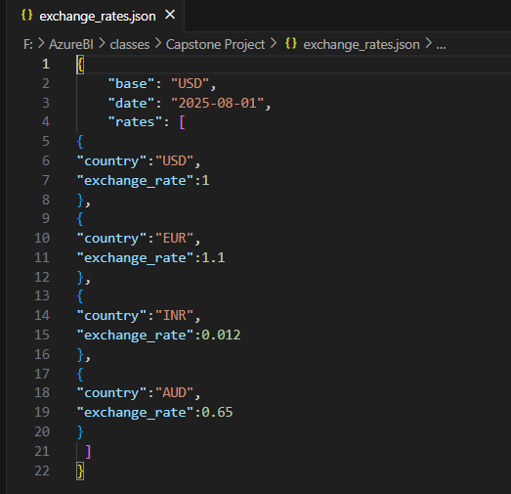
Figure 10. Exchange-rate JSON source. Base currency is USD; the documented rates are USD=1, EUR=1.1, INR=0.012, and AUD=0.65.
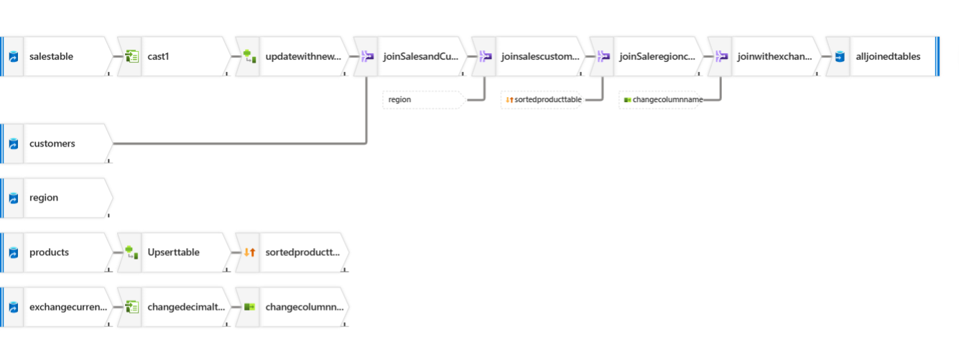
ADF pipeline implementation screenshot for data movement and transformation.

8. Currency Conversion to USD
Currency standardization is a key business requirement because the source sales data contains values in different currencies. The Exchange Rate table is joined to the Sales data using the currency/country key. The exchange-rate column is used to calculate a standardized USD value before the final curated dataset is produced.
Currency Conversion Formula
Sales in USD = Sales Amount × Applicable Exchange Rate
Documented example exchange-rate values: USD = 1; EUR = 1.1; INR = 0.012; AUD = 0.65.
The exact direction of the conversion should follow the rate convention implemented in the project. The source screenshot identifies USD as the base currency and provides the corresponding exchange-rate values.

9. Integrated Data and Derived Calculations
After the source tables are cleansed, the Sales, Product, Region, and Exchange Rate datasets are integrated using their respective keys. The transformed dataset is then used for derived calculations. The project documentation specifically shows a Revenue calculation based on the USD unit price and quantity.
Revenue Formula
Revenue = UnitPrice(USD) × Quantity
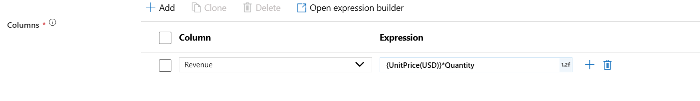
Derived-column expression for Revenue = UnitPrice(USD) × Quantity.

10. Additional SQL / Data Integration Evidence
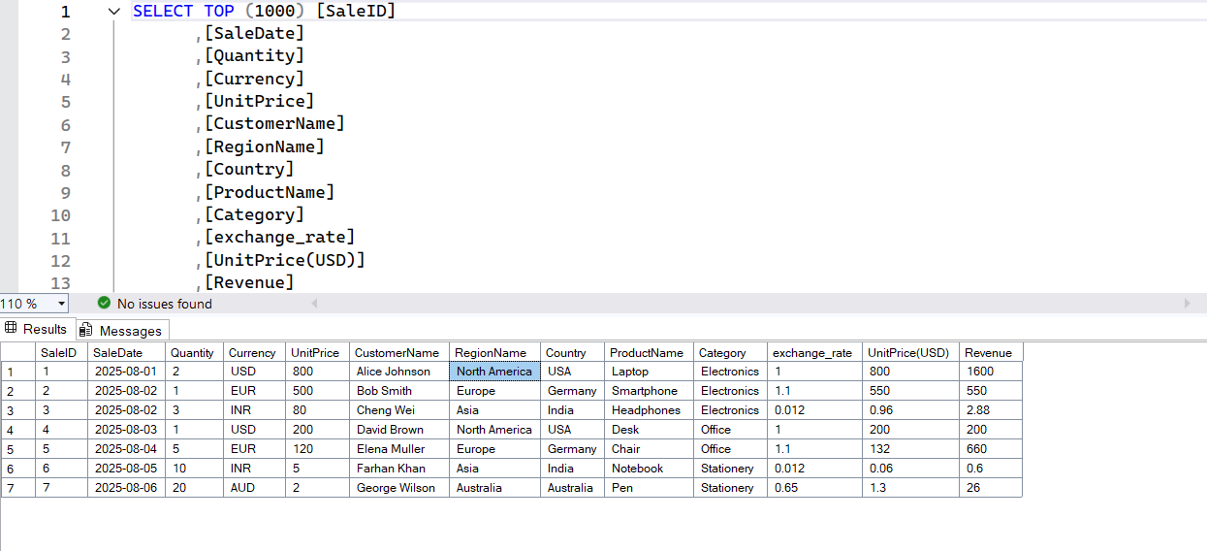
SQL/data integration screenshot showing the curated dataset.

11. Loading and On-Premises Integration
The final transformed data is loaded into the target SQL environment. For the on-premises SQL Server environment, the project uses a Self-Hosted Integration Runtime to support data movement between ADF and SQL Server/SSMS. This enables the curated dataset to be made available for downstream reporting.

12. Scheduling and Automation
The centralized ADF pipeline is configured with a scheduled trigger to run automatically every Monday at 9:00 AM. This removes the need for repetitive manual execution and establishes a consistent refresh cycle for the analytical data.

13. Power BI Reporting
The final curated sales table is connected to Power BI. The report provides analysis of total sales by product, country, customer, category, and region. The project also uses a snowflake schema to represent relationships between fact and dimension tables.
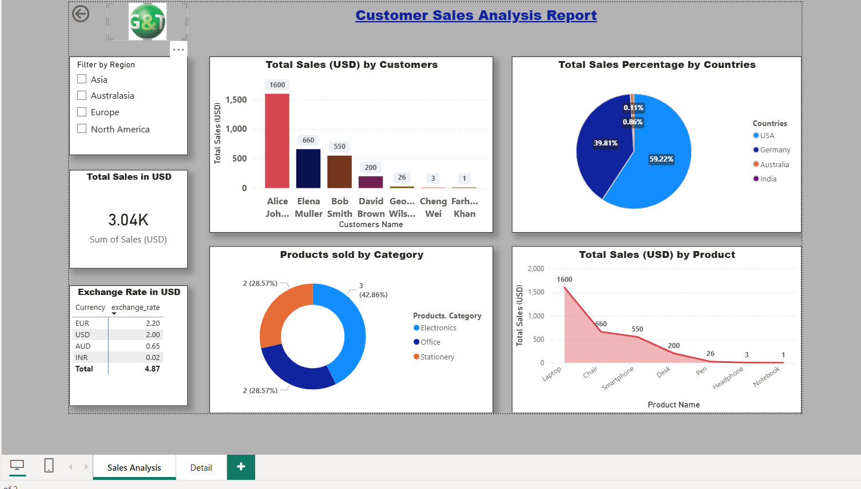
Figure 15. Power BI dashboard screenshot from the source presentation.

14. Power BI / DAX Calculation
The project documentation states that DAX formulas were used to create a calculated column for Sales in USD currency. The exact DAX expression is not displayed as text in the supplied documentation; therefore, it is not reproduced here as an invented formula. The implemented USD conversion logic is represented in the ADF transformation section above.

15. Key ADF Transformation Expressions Captured from the Screenshots
Transformation | Expression / Logic | Purpose
Duplicate matching | name == "ProductID" | Identifies Product records by ProductID for aggregation.
Missing-value handling | iifNull($$, "unknown", $$) | Replaces a null value with "unknown".
Revenue calculation | UnitPrice(USD) × Quantity | Calculates revenue using standardized USD unit price.
Currency standardization | Sales Amount × Applicable Exchange Rate | Converts sales values to a common USD basis.

16. Complete ETL Workflow Summary
- Extract raw CSV and JSON data from Azure Blob Storage.
- Copy raw files into ADLS Gen2.
- Create datasets and ADF pipelines for the source files.
- Use Mapping Data Flows to cleanse Product and Region datasets.
- Handle missing values and remove duplicates through aggregation/grouping and Alter Row logic.
- Apply data-type casting and load cleansed datasets into Azure SQL Database and ADLS Gen2.
- Extract and map exchange-rate JSON data into a structured SQL table.
- Join Sales with Product, Region, and Exchange Rate data using the documented keys.
- Standardize international sales values into USD using the applicable exchange rate.
- Create derived calculations such as Revenue = UnitPrice(USD) × Quantity.
- Load the final curated dataset to SQL Server/SSMS through Self-Hosted Integration Runtime.
- Refresh Power BI reporting from the curated dataset.
- Schedule the ADF workflow to run every Monday at 9:00 AM.

Prepared from the supplied Sales Analysis documentation and implementation screenshots.

