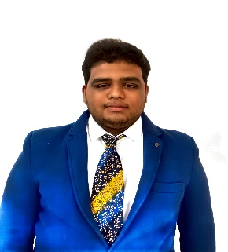

Professional Overview
I am an enthusiastic undergraduate student with a strong interest in robotics, automation, and full-stack development. My technical foundation includes Artificial Intelligence and Machine Learning (AIML), Robot Operating System 2 (ROS 2), Internet of Things (IoT), and Generative AI. I'm also well-versed in the MERN stack (MongoDB, Express.js, React, Node.js), enabling me to develop robust, scalable web applications that complement intelligent system design. With a multidisciplinary skill set bridging software development and intelligent automation, I thrive on building integrated solutions that address real-world challenges.

Work Experience

Robotics and AI Developer Intern / Trainee

MyEquation | Apr 2025 – Jun 2025
Learnt about Robotics and
- Internship trainee and Intern
- Learnt about Robotics, AIML, ROS - 2.

MERN Stack Developer Intern

Cantilever Labs | May 2025 – Jun 2025
Learnt about MERN Stack, where: -
- Learnt front end development using React.js
- Learnt backend development using Node.js and Express.js
- Learnt Database connectivity using MongoDB
- Learn live website deployment using Vercel and GitHub

Advanced Machine Learning Intern / Trainee

Teachnook | Oct 2023 – Dec 2023
Learnt about AIML and studied about
- Machine Learning and its implications
- Created projects based on ML and DL

AI Developer Intern / Trainee

Corizo Edutech | Jun 2023 – Aug 2023
Learnt about AIML and learnt
- AI Development using Python
- Project created using CSV Datasets and Python for AI

EDUCATION
Bachelor’s Degree: -
Geethanjali College of Engineering and Technology

12th Grade: -
Nano Junior College

Technical Skills

- C, Python, Java, ALP
- MERN Stack Development
- ROS – 2, IoT
- Industrial Design
- HTML, CSS, JS
- MySQL, MongoDB

+91 9989446922

ghk7125@gmail.com

Hyderabad, TG

MARELLA GAGAN HARI KIRAN

LINKS

- LinkedIn: https://www.linkedin.com/in/gagan-hari-kiran-462856287

- GitHub: https://www.github.com/Gaganharikiranmarella

