EXPERIMENT 9

NAME: Gagan S. Jain
SUIT
Roll no: 15

Source code:
#include <stdio.h>
#include <stdlib.h>
/* ADJACENCY MATRIX */
int source,V,E,time,visited[20],G[20][20];
void DFS(int i)
{
int j;
visited[i]=1;
printf(" %d->",i+1);
for(j=0;j<V;j++)
{
if(G[i][j]==1&&visited[j]==0)
DFS(j);
}
}
int main()
{
int i,j,v1,v2;
printf("\t\t\tGraphs\n");
printf("Enter the no of edges:");
scanf("%d",&E);
printf("Enter the no of vertices:");
scanf("%d",&V);
for(i=0;i<V;i++)
{
for(j=0;j<V;j++)
G[i][j]=0;
}
/* creating edges :P */
for(i=0;i<E;i++)
{
printf("Enter the edges (format: V1 V2) : ");
scanf("%d%d",&v1,&v2);
G[v1-1][v2-1]=1;

}

for(i=0;i<V;i++)
{
for(j=0;j<V;j++)
printf(" %d ",G[i][j]);
printf("\n");
}
printf("Enter the source: ");
scanf("%d",&source);
DFS(source-1);
return 0;
}
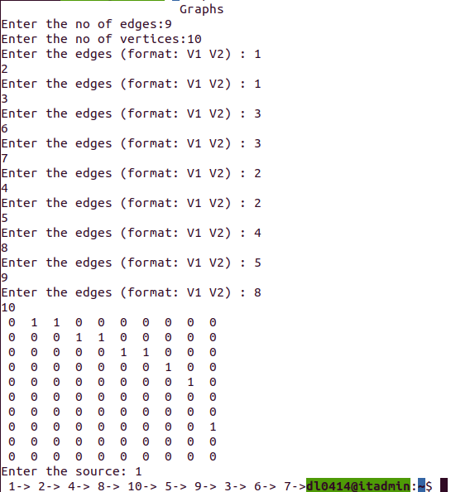

OUTPUT:

dl0414@itadmin:~$ ./a.out
Graphs
Enter the no of edges:9
Enter the no of vertices:10
Enter the edges (format: V1 V2) : 1
2
Enter the edges (format: V1 V2) : 1
3
Enter the edges (format: V1 V2) : 3
6
Enter the edges (format: V1 V2) : 3
7
Enter the edges (format: V1 V2) : 2
4
Enter the edges (format: V1 V2) : 2
5
Enter the edges (format: V1 V2) : 4
8
Enter the edges (format: V1 V2) : 5
9
Enter the edges (format: V1 V2) : 8
10
0 1 1 0 0 0 0 0 0 0
0 0 0 1 1 0 0 0 0 0
0 0 0 0 0 1 1 0 0 0
0 0 0 0 0 0 0 1 0 0
0 0 0 0 0 0 0 0 1 0
0 0 0 0 0 0 0 0 0 0
0 0 0 0 0 0 0 0 0 0
0 0 0 0 0 0 0 0 0 1
0 0 0 0 0 0 0 0 0 0
0 0 0 0 0 0 0 0 0 0
Enter the source: 1
1-> 2-> 4-> 8-> 10-> 5-> 9-> 3-> 6-> 7->dl0414@itadmin:~$

