Design of Traffic light using Arduino.

int rpin = 6;

int ypin = 5;

int gpin = 4;

int d1 = 3000;

int d2 = 2000;

int d3 = 1000;

void setup() {

// put your setup code here, to run once:

pinMode(rpin, OUTPUT);

pinMode(ypin, OUTPUT);

pinMode(gpin, OUTPUT);

}

void loop() {

// put your main code here, to run repeatedly:

digitalWrite(rpin, HIGH);

delay(2000);

digitalWrite(ypin, HIGH);

delay(1000);

digitalWrite(rpin, LOW);

digitalWrite(ypin, LOW);

digitalWrite(gpin, HIGH);

delay(3000);

digitalWrite(gpin, LOW);

delay(500);

digitalWrite(gpin, HIGH);

delay(500);

digitalWrite(gpin, LOW);

delay(500);

digitalWrite(gpin, HIGH);

delay(500);

digitalWrite(gpin, LOW);

delay(500);

digitalWrite(gpin, HIGH);

delay(500);

digitalWrite(gpin, LOW);

delay(5000);

}

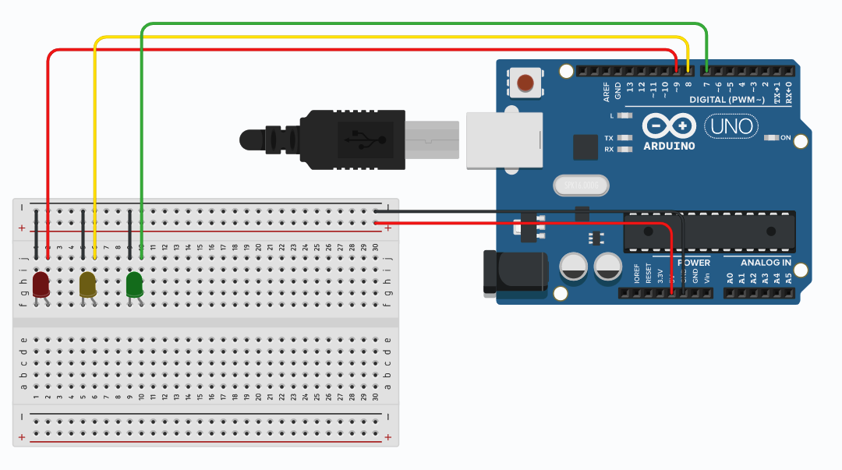

To Print Temperature and Humidity in serial monitor using appropriate sensor

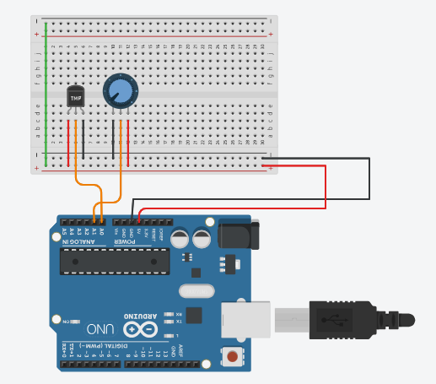.

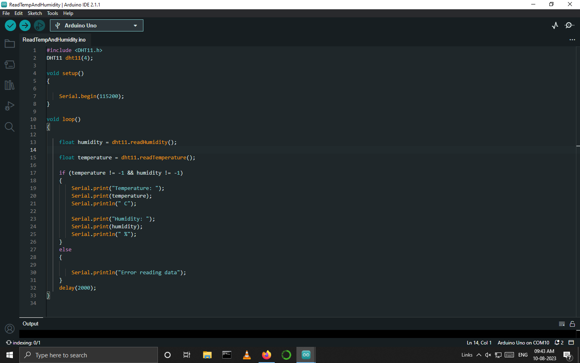

1. To Detect Smoke and turn on the buzzer by using an appropriate sensor.
2. To Detect Alcohol and turn on the buzzer by using an appropriate sensor.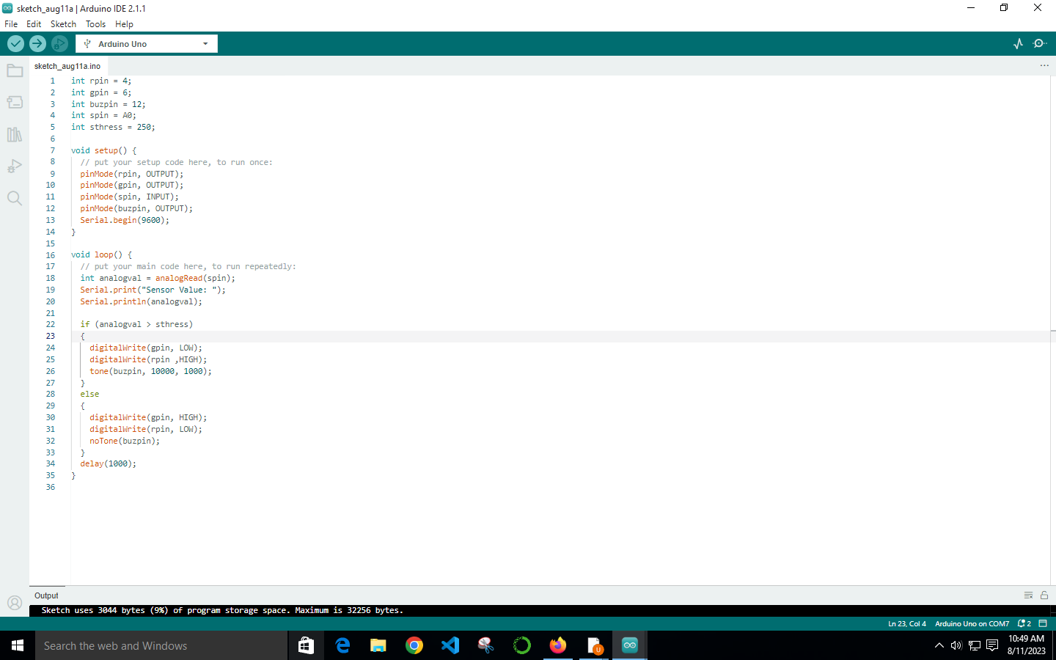

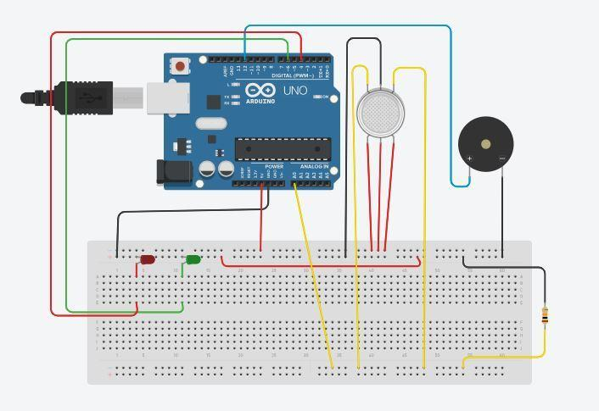

1. To glow two LEDs serially using NODE MCU.