**EXPERIMENT NO. 9**

**Aim** : Study of Raspberry Pi, Installation of Raspbian OS, Programming.

**Objective** :

1. To know about How to install and setup OS in Raspberry Pi
2. To know how to do programming in python for Raspberry Pi Programming
3. To interface a LED and operate it using Raspberry pi.

**Software/Hardware Required** :

1. **To Install and Setup OS on Raspberry Pi**:

Hardware :

* Raspberry Pi board
* MicroSD card (16GB or higher recommended)
* Card reader
* Computer with an SD card slot

Software:

* Raspberry Pi OS image (downloaded from the official Raspberry Pi website)
* Etcher (or a similar tool) for flashing the OS image to the microSD card

2. **To Program in Python for Raspberry Pi** :

Hardware:

* Raspberry Pi board
* Computer with SSH capabilities (optional for remote development)

Software:

* Raspberry Pi OS (pre installed with Python)
* Text editor (e.g., Thonny, Nano, Visual Studio Code) on the Raspberry Pi
* SSH client (e.g., PuTTY) for remote access (optional)

3. **To Interface a LED and Operate it using Raspberry Pi** :

Hardware:

* Raspberry Pi board
* LED (with appropriate resistor)
* Jumper wires

Software:

* RPi.GPIO Python library (pre installed on Raspberry Pi OS)

Ensure to use the correct resistors and connections to safely interface the LED with the Raspberry Pi's GPIO pins. Always exercise caution when working with electronic components and follow proper safety guidelines.

**Theory** :

Python is a popular programming language for Raspberry Pi due to its simplicity and versatility. Raspberry Pi OS comes with Python preinstalled.

Steps:

1. Open a Terminal:

* Open the terminal on the Raspberry Pi to start writing and executing Python code.

1. Write Python Code:

* Use a text editor or an integrated development environment (IDE) like Thonny to write Python code.

1. Run Python Code:

* Use the python command followed by the filename to run the Python script.

4. Interfacing a LED and Operating it using Raspberry Pi:

**Theory** :

Interfacing a LED with Raspberry Pi involves connecting the LED to the GPIO (General-Purpose Input/Output) pins of the Raspberry Pi and controlling it through Python programming.

Steps:

1. Connect the LED:
   * Connect the longer leg (anode) of the LED to a GPIO pin and the shorter leg (cathode) to a ground (GND) pin on the Raspberry Pi.
2. Write Python Code to Control the LED:
   * Use the RPi.GPIO Python library to control the GPIO pins and turn the LED on and off.
3. Execute the Python Code:
   * Run the Python script to control the LED and observe the LED turning on and off.

These steps provide a general outline for achieving the specified objectives. For detailed instructions and troubleshooting, refer to official Raspberry Pi documentation and tutorials.

**Circuit Diagram from TinkerCard** :

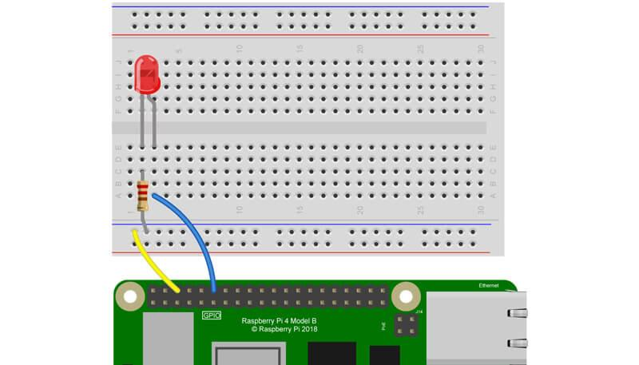

**Code Screenshot** :

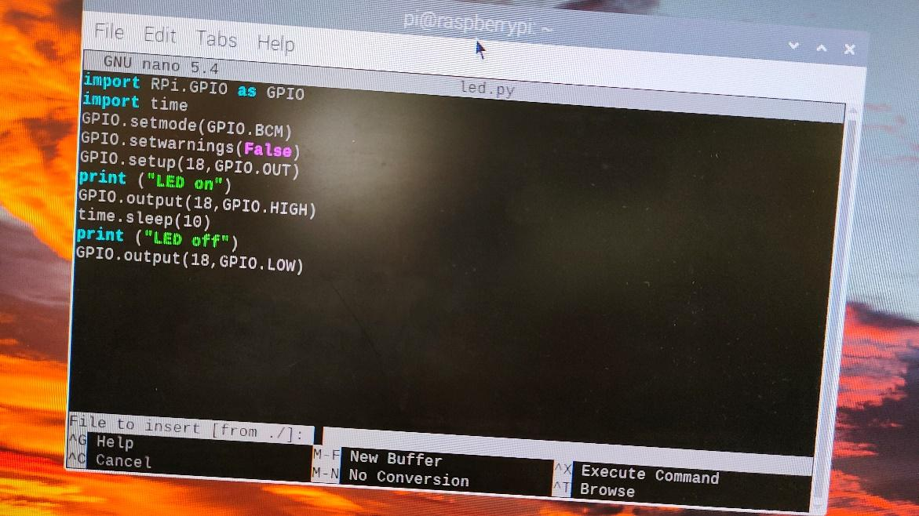

**Output Photo** :

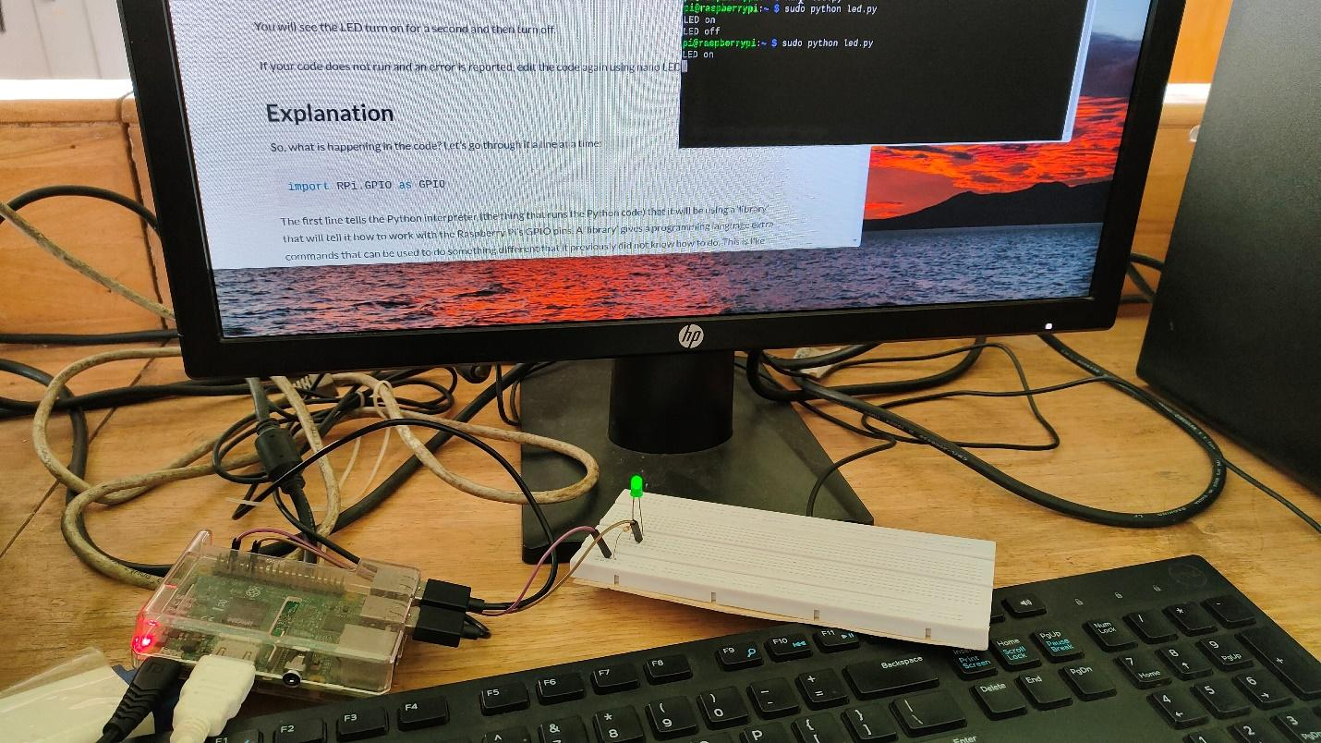

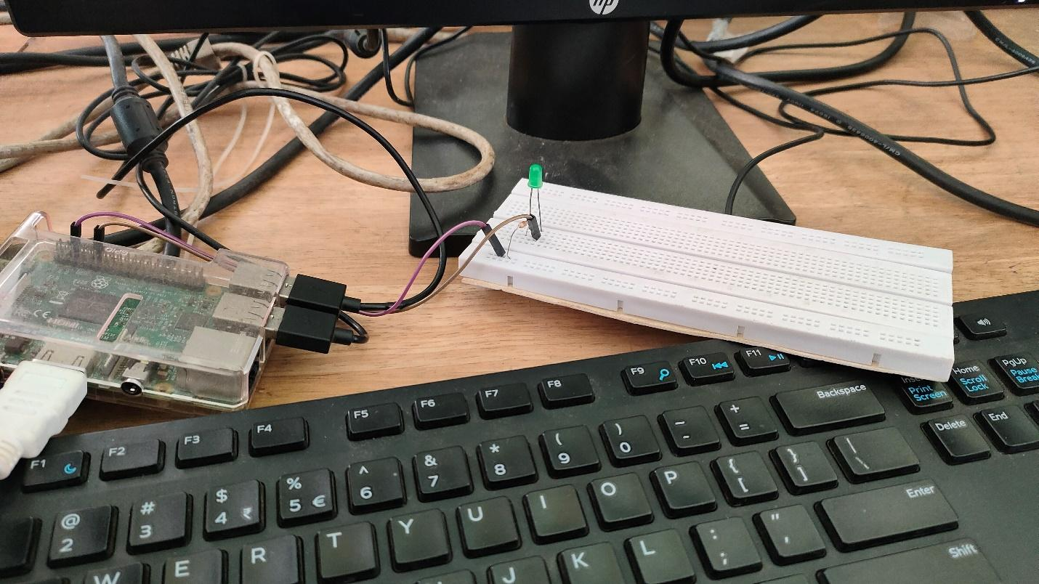

**Conclusion** :

In conclusion, achieving the outlined objectives of installing and setting up an operating system on a Raspberry Pi, programming in Python for Raspberry Pi, and interfacing and operating an LED involves a combination of specific hardware and software requirements.

For installing and setting up the OS:

- The necessary hardware includes a Raspberry Pi board, a microSD card, a card reader, and a computer with an SD card slot.

- The required software includes the Raspberry Pi OS image and a tool like Etcher for flashing the OS image to the microSD card.

For programming in Python for Raspberry Pi:

- The essential hardware includes a Raspberry Pi board and a computer with SSH capabilities (optional for remote development).

- The required software involves the Raspberry Pi OS (pre installed with Python) and a text editor (e.g., Thonny, Nano, Visual Studio Code) on the Raspberry Pi. Optionally, an SSH client (e.g., PuTTY) can be used for remote access.

For interfacing a LED and operating it using Raspberry Pi:

- The necessary hardware comprises a Raspberry Pi board, an LED with an appropriate resistor, and jumper wires.

- The essential software is the RPi.GPIO Python library, which is preinstalled on Raspberry Pi OS.

By carefully following the steps and guidelines for each objective, individuals can successfully install and set up the OS, program in Python, and interface and operate an LED with a Raspberry Pi. It's important to prioritize safety and adherence to proper electronic component handling practices throughout the process.