## Replication:

**Test 1:**

|  |  |
| --- | --- |
| **Test Name** | Balance Increment |
| **Use Case Tested:** | Increasing player's balance after winning |
| **Test Description:** | There is an increase in balance of the player when winning the bet |
| **Pre-conditions** | Player must be win the bet |
| **Post-conditions** | Increase in balance |
| **Notes:** | Player must be have played bet |
| **Result (Pass/Fail/Warning/Incomplete)** |  |
| |  |  |  |  |  | | --- | --- | --- | --- | --- | |  | **TEST STEP** | **EXPECTED TEST RESULTS** | P | F | | 1. | Set bet on 'Crown' | Set bet of Rs. 5 on 'Crown' | P |  | | 2. | Dice rolled | Any three dice values come (Out of three values, there is one 'Crown', then...) | P |  | | 3. | Result | Increase in player's balance of Rs. 10 | P |  | | |

|  |  |  |  |  |  |
| --- | --- | --- | --- | --- | --- |
| **Test Data Table** | | | | | |
|  | **1** | **2** | **3** | **4** | **5** |
| Player's name | Fred | Fred | Fred | Fred | Fred |
| Balance | 100 (Starting bet) | 95 (when Fred lost) | 90 (Again Fred lost) | 90 (Fred won) | 85 (Fred lost) |
| Limit | 0 | 0 | 0 | 0 | 0 |

**Test 2:**

|  |  |
| --- | --- |
| **Test Name** | End balance |
| **Use Case Tested:** | Game end when player has balance 5(instead of balance 0) |
| **Test Description:** | Game ends when player has zero balance |
| **Pre-conditions** | Player must play all turns and loose all money |
| **Post-conditions** | Game ends |
| **Notes:** | Player must be have played bet |
| **Result (Pass/Fail/Warning/Incomplete)** |  |
| |  |  |  |  | | --- | --- | --- | --- | | **TEST STEP** | **EXPECTED TEST RESULTS** | P | F | | Set bet on 'Crown' | Set bet of Rs. 5 on 'Crown' | P |  | | Dice rolled and player lose bet and balance got zero | Any three dice values came and player lose the bet | P |  | | Result | Balance did not get zero | **P** |  | | |

|  |  |  |  |  |  |
| --- | --- | --- | --- | --- | --- |
| **Test Data Table** | | | | | |
|  | **1** | **2** | **3** | **4** | **5** |
| Player's name | Fred | Fred | Fred | Fred | Fred |
| Balance | 100 (Starting bet) | 95 (when Fred lost) | 45(Again Fred lost) | 25 (Fred won) | 5 (End game) |
| Limit | 0 | 0 | 0 | 0 | 0 |

**Test 3:**

|  |  |
| --- | --- |
| **Test Name** | Odds of winnings |
| **Use Case Tested:** | Total win counts of the player |
| **Test Description:** | Odds of winnings should not be more than 0.42 |
| **Pre-conditions** | Player must play bets |
| **Post-conditions** | Total win counts of player |
| **Notes:** | Player must be have played bet |
| **Result (Pass/Fail/Warning/Incomplete)** |  |
| |  |  |  |  |  | | --- | --- | --- | --- | --- | |  | **TEST STEP** | **EXPECTED TEST RESULTS** | P | F | |  | Set bet on 'Crown' | Set bet of Rs. 5 on 'Crown' | P |  | |  | Dice rolled and player lose bet in turns and balance got zero | Any three dice values came | P |  | |  | Result | Total win counts 0.61 | P |  | | |

|  |  |  |  |  |  |
| --- | --- | --- | --- | --- | --- |
| **Test Data Table** | | | | | |
|  | **1** | **2** | **3** | **4** | **5** |
| Player's name | Fred | Fred | Fred | Fred | Fred |
| Balance | 100 (Starting bet) | 95 (when Fred lost) | 45(Again Fred lost) | 25 (Fred won) | 5 (End game) |
| Total wincounts |  |  | 2874(Win count) | 1900 (Loose count) | 0.61 |

## Simplification:

**Bug 1:** Game does not pay out at correct level.

When player wins on 1 match, balance does not increase.

**Bug 2:** Player cannot reach betting limit:

Limit set to 0, but game ends with player still with 5 (dollars) remaining.

**Bug 3:** Odds in the game do not appear to be correct.

Crown and Anchor games have an approximate 8% bias to the house. So the win : (win+lose) ratio should approximately equal 0.42. This does not appear to be the case.

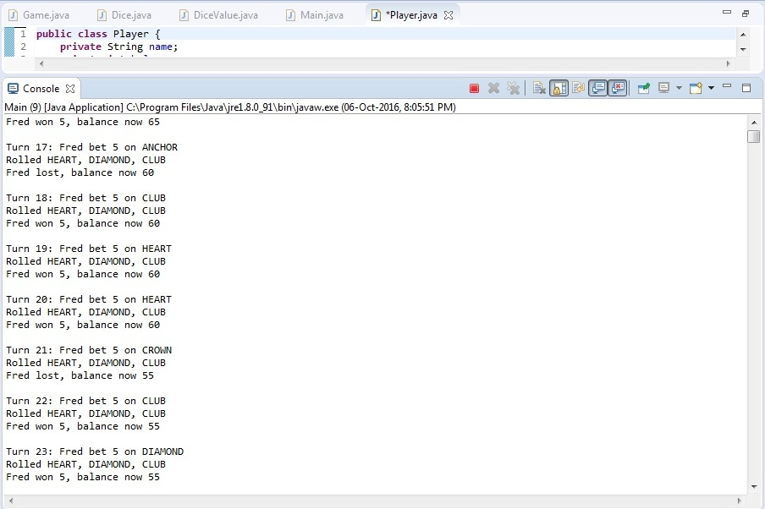

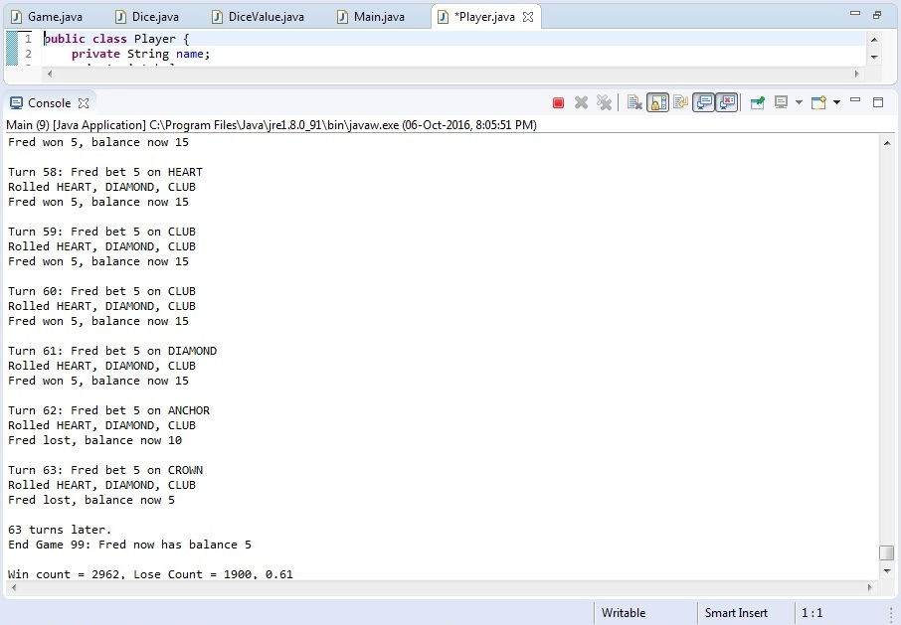

|  |  |  |  |
| --- | --- | --- | --- |
| **Method** | **Parameters** | **Mutates** | **Returns** |
| Constructor | String player | Sets player name, balance etc. | Object reference |
| Main | Int arguments | Initialize main program | Int |
| Winnings | Int winning | Calculate total winnings of player | Int |

|  |  |  |  |
| --- | --- | --- | --- |
| **Method** | **Parameters** | **Mutates** | **Returns** |
| Constructor | String name, Int balance | Check name and balance of the player(i.e should not be null) | Object reference |
| Set limit | Int limit | Initialize limit | Void |
| balanceExceedsLimit | Int amount | If balance greater than limit, show balance | Boolean |
| balanceExceedsLimitBy | ------ | Exception throw if balance greater than limit | Boolean |
| takeBet | Int bet | Checks conditions for bet | Int |
| recieveWinnings | Int winnings | If winnings greater than zero, increase balance, otherwise exception thrown | Int |
| toString |  |  | Name, Balance, Limit |

## Tracing:

**Bug 1 (Origin):**

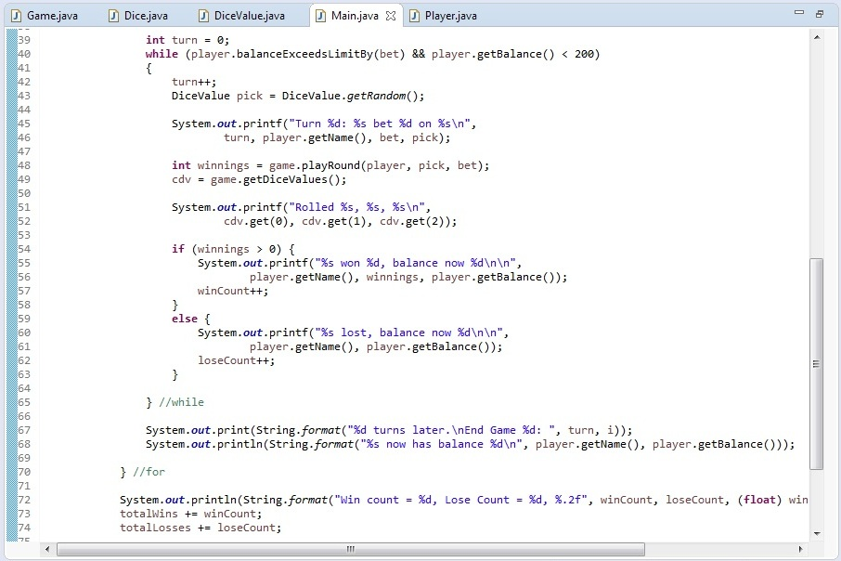

**Bug 2 (Origin):**

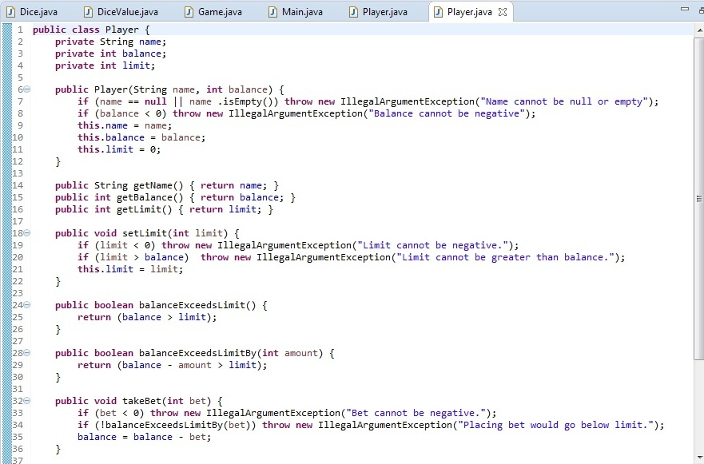



**Bug 3 (Origin):**

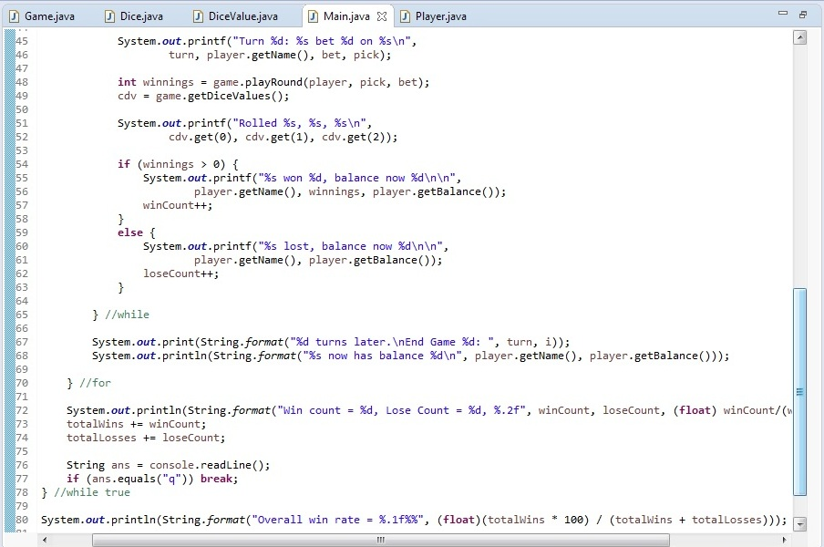



## Resolution:

**Bug 1:** Game does not pay out at correct level.

When player wins on 1 match, balance does not increase.

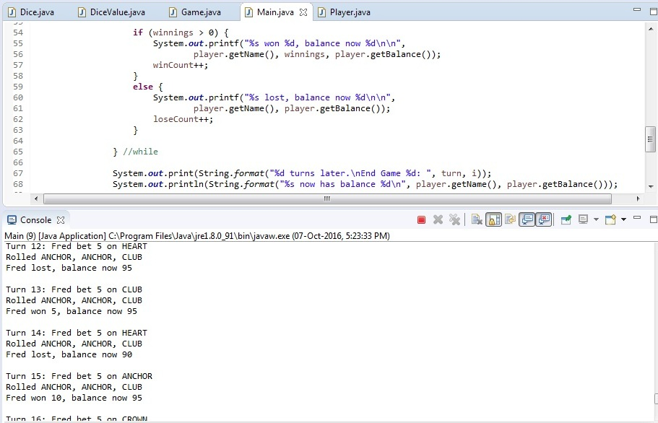

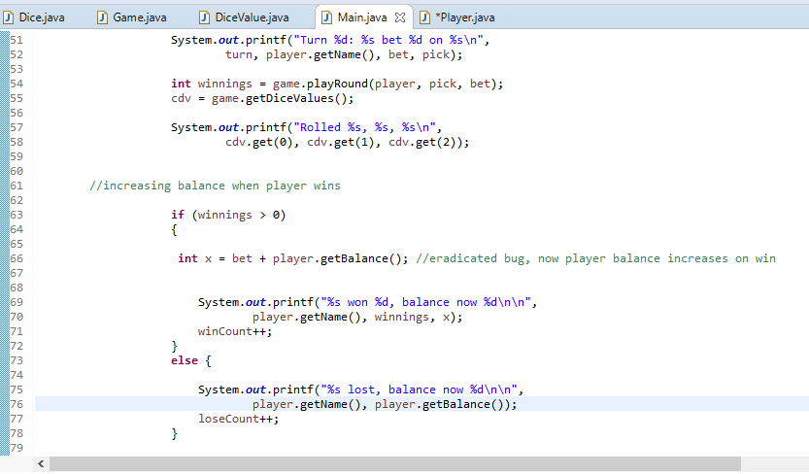

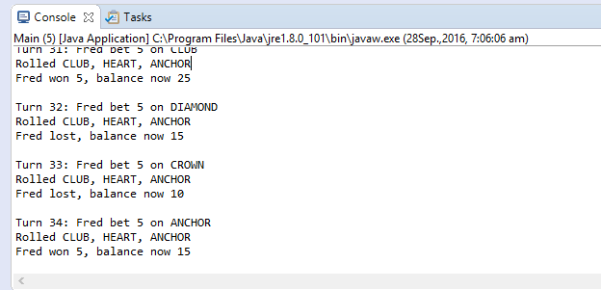

**Bug 2:** Player cannot reach betting limit:

Limit set to 0, but game ends with player still with 5 (dollars) remaining.

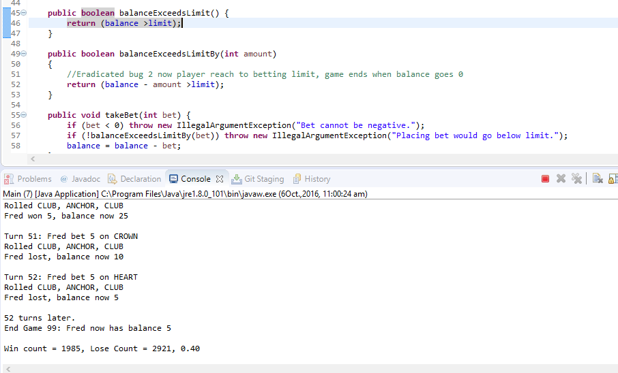

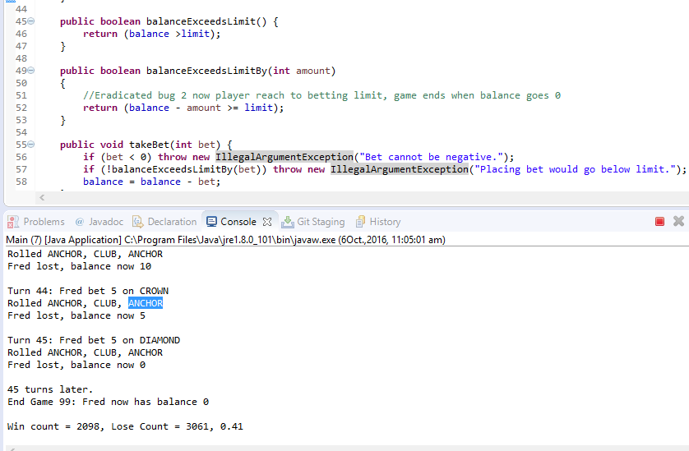

**Bug 3:** Odds in the game do not appear to be correct.

Crown and Anchor games have an approximate 8% bias to the house. So the win : (win+lose) ratio should approximately equal 0.42. This does not appear to be the case.

