

**Government of Karnataka**

**Department of collegiate and technical education**

**Government polytechnic college Harihar-577601**

**IoT-Based Smart Factory System System with Sensor Integration and Cloud Connectivity**

**Group Members:**

1. **Capstone project lead:**

**Cohort Owner:**

Gopalkrishna BE(E&C), M.Tech(VLSI Design), MISTE

Gagan M Kakol (170EC20017)

1. **Document Lead:**

Kavya N (170EC20022)

1. **Development Lead:**

Ishrath Khanum (170EC20020)

Karthik B M (170EC20021)

Abstract: The smart factory project uses an ESP8266 microcontroller and Thinger.io platform to create an automated system. It incorporates five sensors, including an IR sensor, flame sensor, DHT11 temperature and humidity sensor, light sensor, and load cell. The system also features three to five actuators such as a fan, motor, LED, and buzzer. The LCD display provides real-time information. The project enhances automation, efficiency, and safety in a factory environment through remote monitoring and control.

Introduction: The IoT-based smart factory system with sensor integration and cloud connectivity aims to revolutionize traditional manufacturing processes by leveraging the power of Internet of Things (IoT) technologies. This project focuses on creating a connected and intelligent factory environment by integrating various sensors and actuators with cloud-based platforms. The system enables real-time monitoring and control of the factory operations, facilitating enhanced efficiency, productivity, and safety. By leveraging sensor data and cloud-based analytics, the project aims to optimize factory processes, identify potential issues, and make data-driven decisions for improved operational performance.

Working Principle: -

1. The smart factory project works on combination of sensors and actuators to create an automated system.
2. The sensors, including the IR sensor, flame sensor, DHT11 temperature and humidity sensor, and load cell, continuously monitor various parameters in the factory on the thinger.io dashboard.
3. The sensor data is processed by the ESP8266 microcontroller, which communicates with the Thinger.io platform via Wi-Fi connectivity.

Circuit diagram:

1. The Thinger.io platform acts as a central hub for collecting, and analyzing the sensor data in real-time, providing instructions into the factory operations.
2. Based on the sensor readings, the system instruct actions through the actuators such as controlling the fan, motor, and buzzer.

**Circuit Diagram: -**

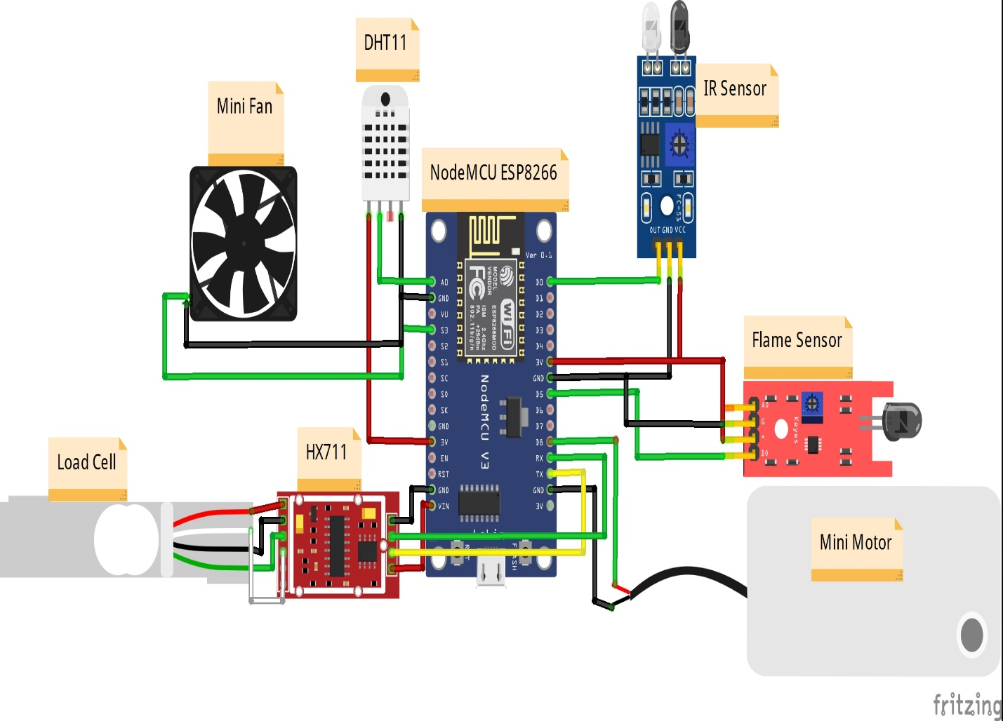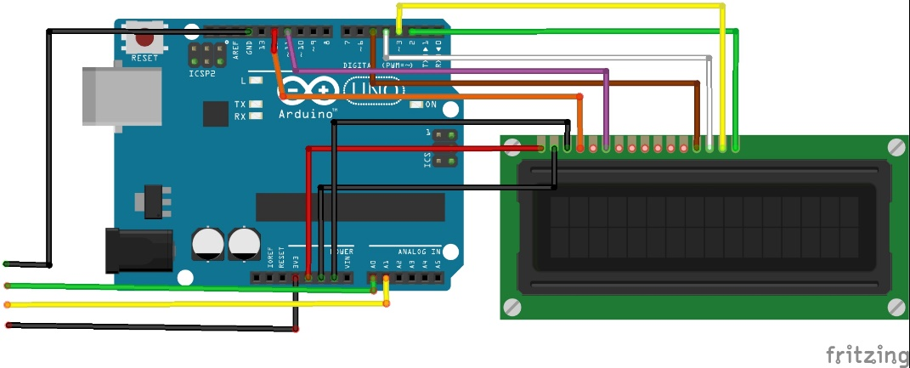

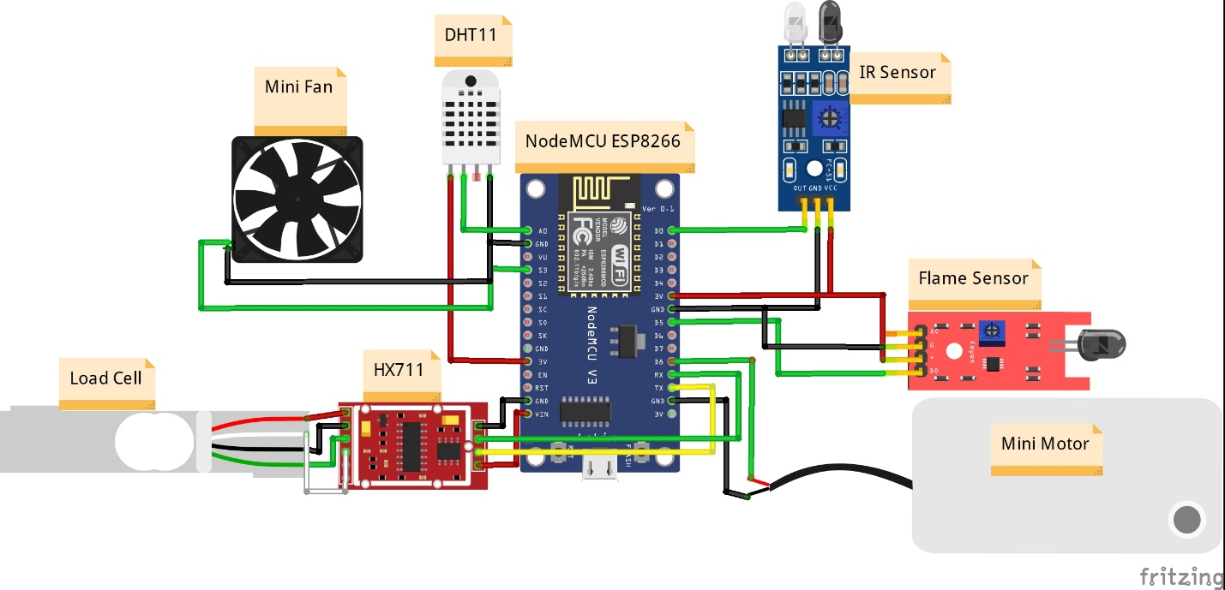

Objectives:

1. In an IoT-based smart factory system that integrates various sensors and actuators for automation and monitoring purposes.
2. Enable remote monitoring and control of the factory environment to enhance efficiency, productivity, and safety.
3. Uses sensor data to optimize factory processes, identify errors or any other issues, and make informed or message sent to the maintenance engineer for improved performance.
4. Improved conveyor belt to count the products automatically and informs the operator to improved operational performance
5. To improve the shipping the Weighing scale machine is used to vehicle tracking for maintain the quality products without any damage
6. For workers safety the safety fire extinguisher is implemented to enhance efficiency of factory

**Block Diagram:-**

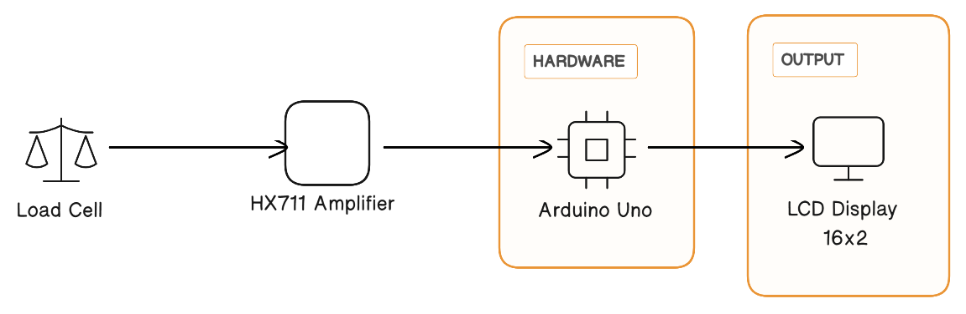

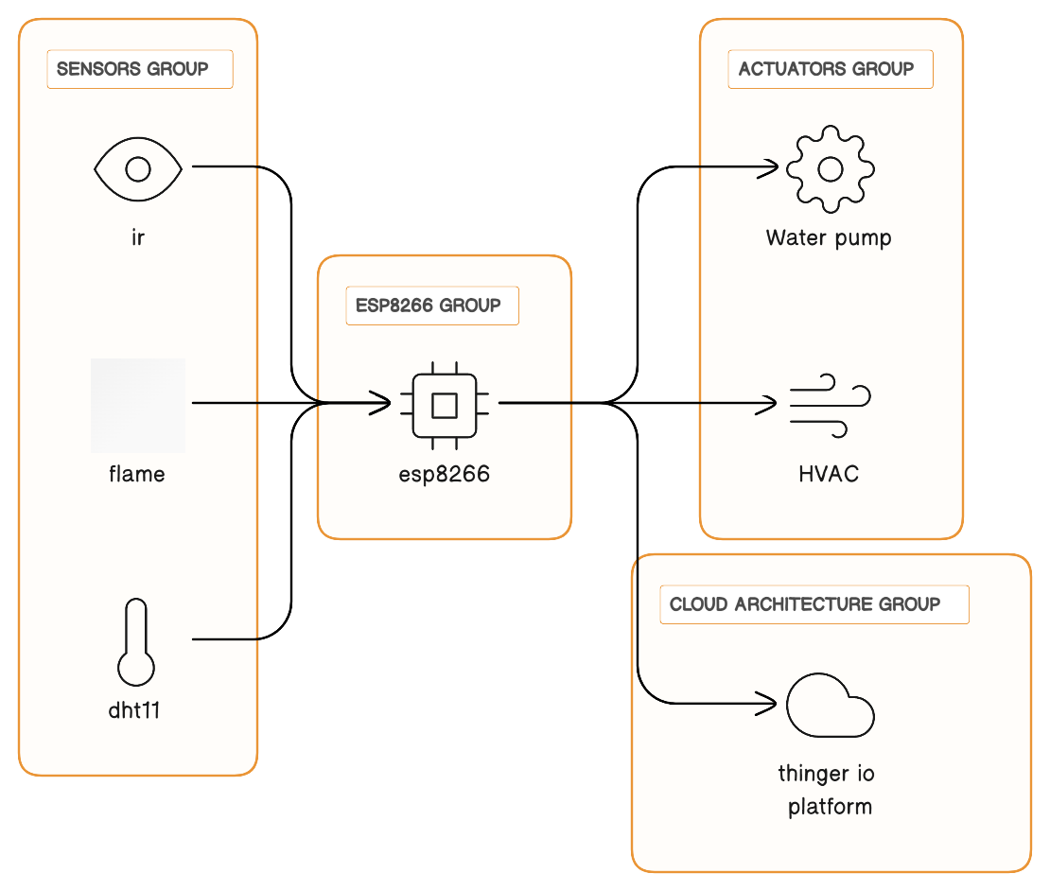

**Result:-**

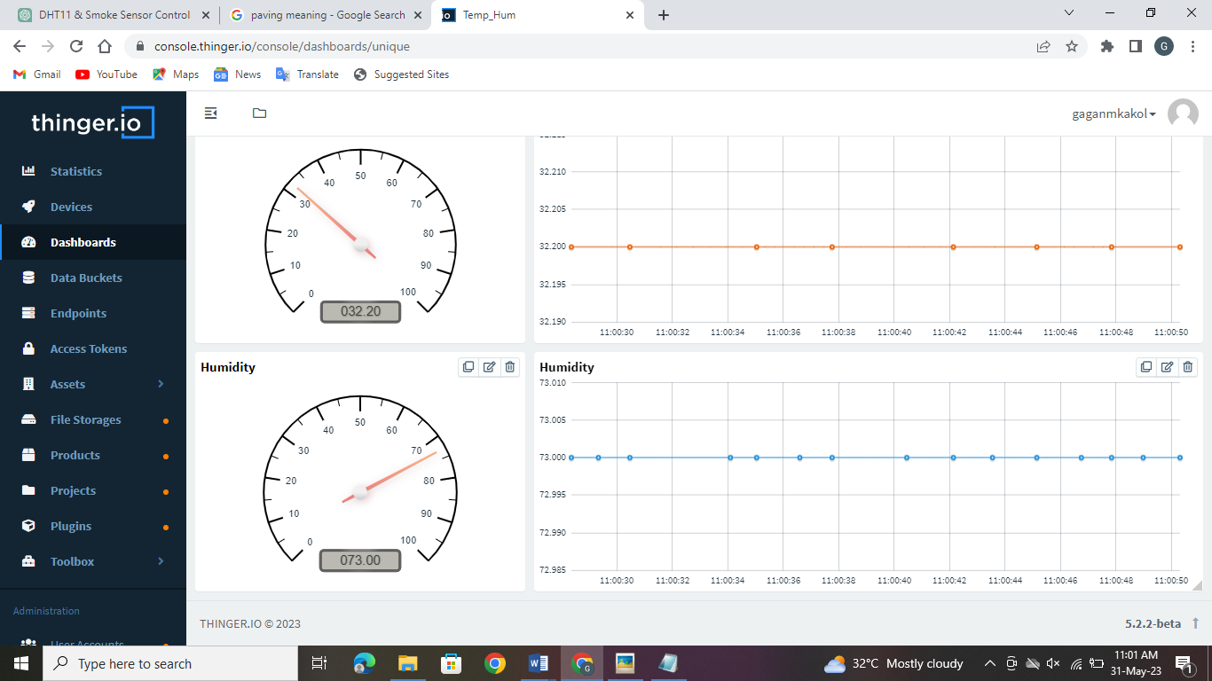

Conclusion: -

The smart factory project successfully demonstrates the integration of an ESP8266 microcontroller, Thinger.io platform, and a range of sensors and actuators to create an automated and intelligent system. The project enables remote monitoring and control of the factory environment, enhancing efficiency, safety, and productivity. Real-time data visualization and analysis provided by Thinger.io facilitate informed decision-making and optimization of factory processes. The project showcases the potential of IoT technologies in revolutionizing factory automation and paving the way for smarter and more efficient manufacturing facilities.