**Major Project – Developing a Business System**

Group 37

Gagandeep Singh - 8990191

Harjot Singh - 9047603

Mehak Kakkar - 9052586

Computer Applications Development

ACSIT, Conestoga College

INFO8003: Systems Concepts, Analysis, and Design Course

Prof. Meyer Tanuan

March 04, 2025

Contents

1. Introduction 4

2. Using a Collaborative Tool 5

Level 2 Subheading 5

3. Forming a Development Team 6

4. Preliminary Research 7

5. Brainstorming 7

6. Research – Web Market Analysis 8

7. Description 9

8. Technical Requirements 11

9. Personas 13

10. Use Cases 16

11. Use Case Activity Diagram 24

12. Entities 25

13. Content Plans 26

14. Prototypes 27

15. Class Diagram 30

16. Implementation - Developing the Agile Plan 31

17. Presentation 32

18. Conclusion 33

References 34

Developing a Business System

for

Nature’s Organisation

# Introduction

**Nature’s organization** is an NGO that is responsible for providing the things and equipment related to agriculture and plants. They came up with a new idea for a project which they named PlantIQ. In this project they will be providing the free dripping systems for the local offices, old age homes, at homes of people with disabilities, etc. With PlantIQ app and iot automated dripping system, water can be given to the plants without the person physically there. More about the concept will not be discussed but the main thing that we are going to do will be discussed in this document. Now, with the new project, the NGO wants to create a management system for events and volunteers, by using which they can hold events related to the PlantIQ project and donate the dripping systems to the needy.

This document outlines the planning, design, and system analysis for a proposed Nonprofit Organization Management System (NOMS). The system aims to support nonprofit organizations in managing events, coordinating volunteers, tracking donations, processing grant applications, and generating impact reports.

# 2. Using a Collaborative Tool

A sample Level 1 Heading is **Part 1. Using a collaborative tool**. The headings are tagged with styles to create and maintain a Table of Contents properly. For a quick tour, refer to an Office 365 YouTube video (Microsoft 365, 2021).

## Level 2 Subheading

The headings and subheadings can be customized. For details, refer to “How to customize headings in MS Word” video (Erin Wright Writing, 2019).

# 3. Forming a Development Team

|  |  |  |  |
| --- | --- | --- | --- |
| **Tasks** | **Harjot Singh** | **Mehak Kakkar** | **Gagandeep Singh** |
| Brainstorming | **🔵** | **🔵** | **🔵** |
| Research | **🔵** |  |  |
| Business Model |  | **🔵** |  |
| Market Analysis and Personas |  |  | **🔵** |
| Use Cases | **🔵** |  | **🔵** |
| Entity Relationship Diagram | **🔵** | **🔵** |  |
| Class Diagram | **🔵** |  |  |
| Content Plans |  | **🔵** | **🔵** |
| Prototype Mock-ups |  | **🔵** | **🔵** |
| Code Development | **🔵** |  | **🔵** |
| Testing (Unit, Integration, Regression, Acceptance and Usability) | **🔵** | **🔵** | **🔵** |
| Documentation | **🔵** | **🔵** | **🔵** |

# 

#### **Agile Development Roles**

* **Product Owner**: Harjot Singh

Responsible for defining the product vision, managing the product backlog, and prioritizing features based on stakeholder needs and business goals.

* **Scrum Master**: Gagandeep Singh

Facilitates Scrum ceremonies, ensures the team adheres to Agile principles, removes roadblocks, and acts as a coach for team efficiency.

# 4. Preliminary Research

To comprehend the environment and technology underlying smart irrigation systems, nonprofit engagement platforms, and sustainability solutions, we carried out a thorough investigation using online resources. We looked at ideas including communal gardening tools, automation powered by the Internet of Things, and volunteer-led environmental projects.

* **Smart irrigation technologies:**

To maximize watering, smart irrigation solutions use sensors and automation to track temperature, weather, and soil moisture. They guarantee healthier plant development, save time, and lessen water waste. Smart controllers, mobile app connection, and soil sensors are typical parts.

* **Event management systems**

Events like volunteer meetings, planting drives, and workshops on community gardening can be planned, scheduled, and managed with the use of an event management system. It has functions like creating events, registering attendees, tracking them, sending out reminders, and gathering feedback.

* **Payment methods:**

For donations, kit purchases, or premium services, the app may offer safe payment methods like PayPal, credit/debit cards, and mobile wallets. Safe and easy transactions can be ensured by integration with services such as Stripe or Razor Pay.

# 

# 5. Brainstorming

In brainstorming part, we conducted a meeting and came up with pictures and ideas to include in the event management application.

We will be making web application that works on both pc and mobile phones and features that we came up in brainstorming session

* **Registrate:** Registration of volunteers, event managers and donars.
* **Event scheduling:** Event managers can create an event through the application and volunteers can join the event when its visible.
* **Impact Reporting:** Anyone will be able to read impact reports that are created after the event has successfully completed.
* **Map Integration: Users** can view the event on map.
* **Volunteer Signup**: Volunteer can sign themselves for event through app.
* **Donor Tracking:** The contribution of donors can be track in an event.
* **Mobile app integration:** Real-time notifiaction about newly created event and other important notices.
* **Admin Panel:** Event managers can ask for donation and the admins will movw forward their request and make public to the donors.
* **User Management:**Admin can also do user management.
* **Web Games:** Users can play games in the application to get more engaged.
* **Payment System Integration** so that anyone can donate through application to NGO.

# 6. Research – Web Market Analysis

**Similar Applications in Market:**

**1.CropX (Web Site)**

A commercial smart farming platform that optimizes irrigation through the use of soil sensors and cloud-based analytics.

Features include an analytics dashboard, irrigation automation, and soil moisture monitoring.

Limitation: Not intended for volunteer work or nonprofit use; mostly for large farms.

**2.Hunter Industries' Hydrawise**

An intelligent irrigation controller for landscaping in homes and businesses.

Features include a mobile app, weather-based changes, and a Wi-Fi controller.

Limitation: No nonprofit features; landscaping is the main focus rather than community projects or agriculture.

**3.The non-profit CRM Bloomerang**

Nonprofits can manage volunteers, donations, and fundraising via CRM software.

Limitation: No environmental monitoring or Internet of Things integration.

**4.RainMachine**

An open API-accessible smart watering system for home gardens.

Limitation: No integrated user management system and restricted scalability.

**Features Needed by PlantIQ**

* Smart Irrigation Control
* Donor and Volunteer Management
* Grant and Event Tracking
* Mobile Web App
* Environment Dashboard impact

**What Makes PlantIQ Different**

* It integrates CRM tools for nonprofits with IoT-enabled smart irrigation.
* Community-driven: Designed with local farmers, volunteers, and donors in mind.
* It emphasizes environmental awareness and impact.
* It incorporates a reporting system to demonstrate to stakeholders the project's efficacy.

**Why It Makes Sense to Create PlantIQ**

* PlantIQ uses water efficiently to address the climate catastrophe.
* It encourages volunteers and local communities to participate in sustainability.
* It connects grassroots initiatives and technology.
* It supports the expanding trend of charitable partnerships with green technology.

# 7. Description

The proposed Event Management System is designed specifically to support the mission of a nonprofit organization that donates automatic plant watering drip systems to elderly individuals, people with disabilities, and workplaces promoting green spaces. The application serves as a digital backbone, streamlining the planning, execution, and follow-up of donation events while aligning with the broader goal of promoting sustainable urban greening and eco-consciousness. Socially, it empowers marginalized communities by making plant care accessible, promoting inclusivity, and encouraging environmental stewardship. From a business standpoint, the system enhances operational efficiency, reduces overhead costs, and improves transparency—key elements for trust-building with donors and partners.

**Refined System Description**

This event management application acts as an all-in-one platform where NGO staff can create, manage, and monitor outreach events for device distribution. It allows teams to coordinate logistics such as location mapping, volunteer assignments, time slots, inventory control, and real-time updates. Whether it’s organizing a drive in an old-age home, installing systems in an office garden, or delivering devices to the homes of people with mobility challenges, the app ensures that each event is handled with precision and empathy. With an intuitive interface and automation of routine tasks, the system reduces manual workload and increases the reach of every campaign**.**

**Key Features**

**Event Scheduling and Calendar Integration:** Create recurring or one-time events with location, time, and resource tagging.

**Volunteer and Staff Management:** Assign roles, shifts, and provide checklists to streamline onsite support.

**Beneficiary Profiles:** Maintain records of recipients including needs, addresses, and installation status.

**Inventory and Logistics Tracking:** Track devices, accessories, transportation, and availability in real-time.

**Impact Analytics Dashboard:** Monitor the number of systems donated, regions covered, water saved, and CO₂ offset**.**

**Donation and Fundraising Module:** Link campaigns to specific events, allowing sponsors to donate for a cause.

**Automated Notifications and Feedback:** SMS/email alerts for volunteers, reminders, and post-event surveys.

**Mobile App Integration:** Enable on-the-ground coordination, QR scanning of installed devices, and field reports**.**

**Accessibility Features:** Voice support, large text modes, and multi-language options for disabled and elderly users

**Revenue Streams**

While the core application is for nonprofit use, sustainability is built through the following revenue models:

**Corporate Sponsorships:** Partner with eco-conscious companies to fund events and co-brand activities.

**Subscription Model for CSR Users:** Offer a version of the platform to companies running green CSR events.

**Freemium Tiers:** Basic use for small NGOs, with advanced reporting and tools in premium tiers.

**Government Grants and NGO Tech Funding:** Secure funding from green-tech and accessibility-focused public programs.

**Branded Campaigns and Data Reports:** Charge for custom analytics and branded impact reports.

**Future Goals**

The long-term goal is to evolve the application into a scalable SaaS platform that can be used by multiple nonprofits and community groups globally. Future versions may include AI-driven suggestions for event timing, beneficiary prioritization based on need and climate conditions, and blockchain-powered transparency for donations. Integration with IoT devices for real-time watering feedback is also envisioned. Ultimately, the platform aims to support 1 million installations by 2030, helping cities grow greener, inclusive ecosystems.

**Relation to the Theme**

The app is deeply rooted in the theme of “sustainable social inclusion through technology.” By enabling efficient organization of eco-friendly events and focusing on communities that are often overlooked such as the elderly and people with disabilities the app bridges environmental efforts with compassionate outreach. It turns each event into a small act of empowerment, and each drip system into a symbol of care showing how technology can nurture both nature and human dignity.

# 8. Technical Requirements

What special device hardware features would the app require?

* **Sensors measuring Soil Moisture:** This will examine moisture content of plants soil and provides real-time data to hub and app.
* **Light and temperature sensors:** This will observe the environment effects on health of plants. It also helps to alert for modifying water scheduling.
* **System of Water Pump and Dripper:** It is automatically controlled through the app or in response to sensor thresholds. It ensures that each plant is watered precisely.
* **Smart Hub (Bluetooth/Wi-Fi): It** connects every pump and sensor, communicate with mobile app and can set up volunteer-run facilities.
* **Portable Water Tank:** Plumbing is substituted with a refillable tank. It has level sensors to alert users when the level is low.

What special input controls would you develop for this application?

* **Slider for the moisture threshold:** It enables users to modify the soil moisture

level at which the watering system should start.

* **Toggle the manual override:** In the event of an emergency or test, manually turn the watering on and off.
* **Calendar of Watering Schedules:** Watering schedules can be set or viewed visually.
* **Panel for Sensor Mapping:** Assigning sensors to plant zones using a drag-and-drop interface is particularly useful in schools or community gardens.
* **Volunteer Log Entry:** Watering, cleaning, or tank refilling are examples of jobs that can be completed while setting a timer or manually recording volunteer hours.
* **Input for Donor Recognition:** For inclusion in app/community reports, provide donor names and possible donation purposes (such as "Sensor Kit Donation").

What constraints or advantages to do with context are involved in this  
app?

**Constraints:**

* **Indoor Use Restrictions:** Unless weatherproofed, the system's use in outdoor community gardens is limited because it is primarily intended for indoor settings.
* **Dependency on Water Source:** Users must keep an eye on it and refill it manually because it depends on a refillable water tank.
* **Level of Comfort with Technology:** The app needs to be very accessible and user-friendly because some elderly or members of the community may not be tech-savvy.
* **Source of Power:** Rechargeable batteries or steady electricity will be needed for the hub and sensors, which could be problematic in off-grid environments.

**Benefits:**

* **Volunteer-friendly and nonprofit:** Intended for communal or community-run areas where several people can work together, such as elder living facilities, shelters, or schools.
* **Scalable:** Over time, additional plants, sensors, or volunteers can be added thanks to the modular architecture.
* **Not Needed for Plumbing:** The setup is flexible and easy to move because the tanks can be filled up again and again. It works great in classes, office corners, and small indoor gardens.
* **Effects on the Environment:** Helps the environment by using water efficiently, and the data can be used to show how the community's actions have affected the environment.

# 9. Personas

### 1.RICHARD (Non-Profit Manager)

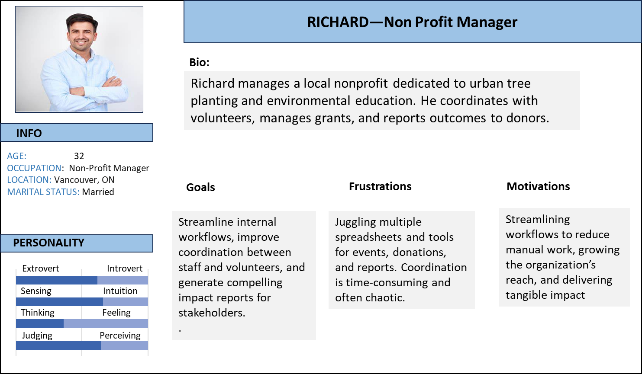

### 2.SARAH (Green Donor)

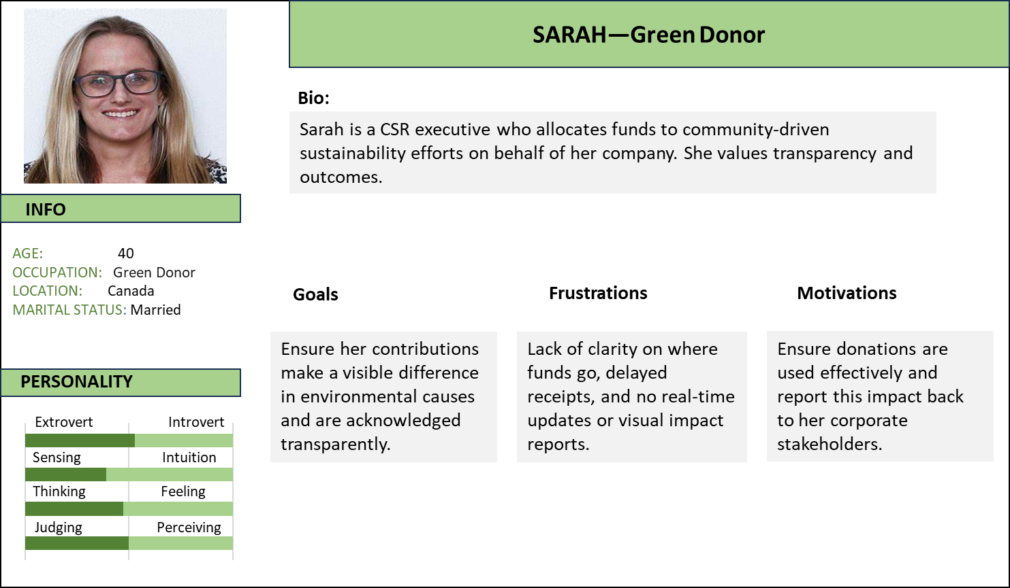

### 3.KIANA (Environmental Studies)

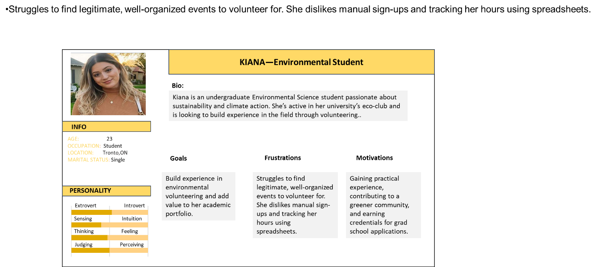

# 10. Use Cases

|  |  |
| --- | --- |
| **Use Case Name** | **Description** |
| Create Event | Organizer creates a new event |
| Register Volunteer | New volunteer registers via form |
| Submit Grant Application | Org applies for a grant |
| Record Donation | Donor submits donation |
| Generate Impact Report | Org generates PDF report for a project |
| Schedule Volunteer Shifts | Assign volunteers to specific time slots |
| Update Donor Preferences | Donor updates their communication preferences |
| Track Event Attendance | Monitor who attended each event |
| Upload Grant Supporting Docs | Attach documents during grant application |
| Send Donor Thank You Emails | Auto-send emails after donation  **Detailed Use Cases:**  **Use Case 1: Event managers create event**  **Use Case Name:** Event managers create event.   |  |  |  | | --- | --- | --- | | **UC Name** | Event managers create event |  | | **Description** | To create an event |  | | **Actor** | User |  | | **Flow** | User | System | | **1.** | User logs into the system. | System authenticates the credentials and loads the Event Manager dashboard. | | **2.** | User clicks on “Create Event” from the dashboard. | System displays a blank event creation form with fields for title, description, date, location, and more. | | **3.** | User fills in event details such as:  - Event Title | The system saves the entered information in a temporary session. | | **4.** | Users upload images or flyers for the event. | System checks file type and size, then displays a preview. | | **5.** | User sets the registration deadline and enables reminder notifications. | System validates that the deadline is before the event date and schedules reminders accordingly. | | **6.** | User clicks on “Save and Publish”. | System validates all data, checks for event overlaps, then stores the event in the database. | | **7.** | System confirms the event is successfully created. | System sends out notifications to volunteers and displays the new event on: The Event Calendar  The Home Page and The Mobile App |       **Use Case 2: Volunteer joining an event**   * **Use Case Name:** Volunteer joining an event  |  |  |  | | --- | --- | --- | | **UC Name** | Volunteer joining an event |  | | **Description** | Event joined by volunteer |  | | **Actors** |  |  | | **Flow** | **User** | **System** | | **1.** | User (Volunteer) logs into the system using their registered account. | System authenticates the credentials and redirects the user to the event dashboard. | | **2.** | User (Volunteer) navigates to the event listing page. | System displays a list of upcoming events with key details like location, date, and available spots. | | **3.** | User (Volunteer) selects an event they wish to join by clicking the “Join” or “Sign Up” button for the event. | System checks if there are available spots for volunteers. If spots are available, it prompts the user to confirm their participation. | | **4.** | User (Volunteer) confirms participation by clicking the “Confirm” button. | System registers the volunteer for the event and updates the event’s volunteer count. | | **5.** | User (Volunteer) receives a confirmation notification about the successful sign-up. | System sends an email/SMS confirmation with event details (location, date, time) and sends a reminder prior to the event. | | **6.** | . | System updates the event page to reflect the new volunteer and adjusts the available spots if necessary. | | **7.** | User (Volunteer) can track their upcoming events in the system’s volunteer dashboard. | System displays all events the volunteer is signed up for, including a “Details” link for more information. | |

# 11. Use Case Activity Diagram

Activity diagram to be based on “Generate Impact Report” use case.

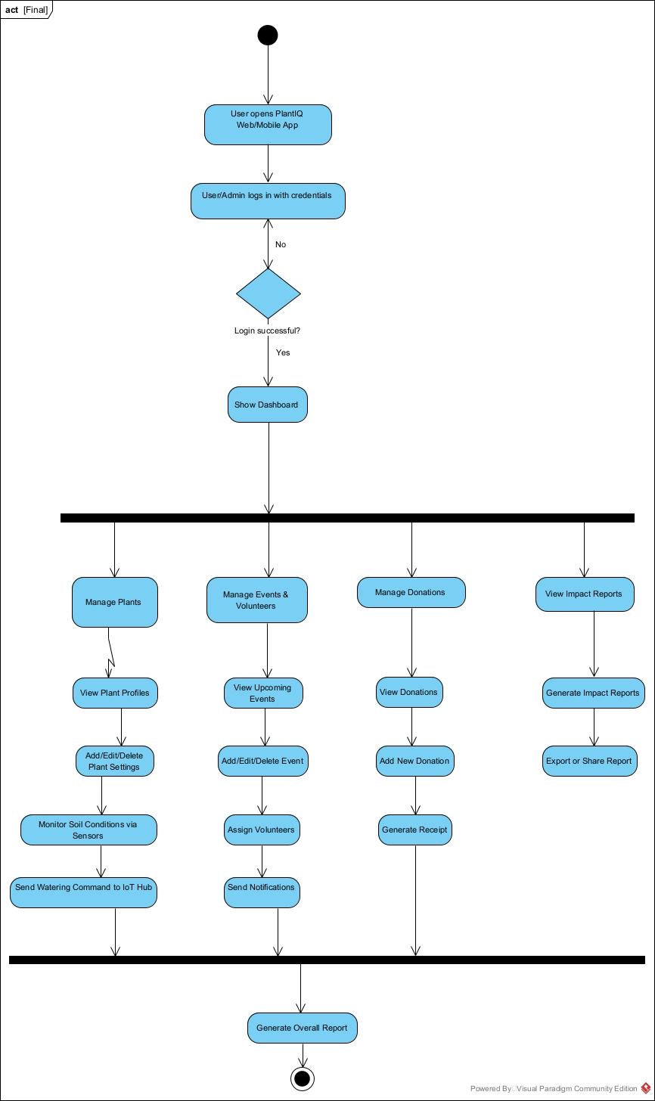

# 12. Entities

# 13. Content Plans

### **Purpose of Content Plan:**

To ensure all content and features displayed in the web/mobile application match the UI prototypes and meet user expectations through clearly defined, structured content for each screen.

### **Page-by-Page Content Plan (Mapped One-to-One with Prototypes)**

|  |  |  |
| --- | --- | --- |
| **Page Name** | **Content Included** | **Target User** |
| **Home Page** | Project introduction, mission statement, featured stats (events, plants watered), CTA buttons for “Donate” and “Register as Volunteer” | Public Users |
| **Login Page** | Email and password fields, role selector (Admin/Volunteer/Event Manager), login button, forgot password link | All Users |
| **Event Registration** | Event list (with title, date, location), register button, volunteer form (name, email, interests), confirmation message | Volunteers |
| **Event Manager Screen** | Create/edit/delete events, view registered volunteers, assign shifts, send notifications, event calendar view | Event Managers |
| **Volunteer Screen** | View assigned events, manage profile, submit volunteer log/hours, receive messages or event updates | Volunteers |
| **Donation Receipt Page** | Confirmation of donation (amount, donor name, payment method), downloadable receipt (PDF), thank-you message | Donors |

### **Content Guidelines**

* **Consistency:** Each page follows the same layout structure for ease of navigation.
* **Accessibility:** Designed to support users with disabilities (large fonts, clear contrast, screen reader support).
* **Responsive Design:** Content scales correctly for desktop, tablet, and mobile views.
* **User-Centered Language:** Warm, encouraging tone to reflect the nonprofit and community values.

# 

# 14.Prototypes

# A screenshot of a donation form

# A screenshot of a phone

# A screenshot of a phoneA white screen with a black and red textA screenshot of a phoneA screenshot of a phone

# 15. Class Diagram

# 16. Implementation - Developing the Agile Plan

#### **Project Title:**

PlantIQ – IoT-Based Automated Plant Watering System for Nature’s Organisation

#### **Team Members:**

Gagandeep Singh, Harjot Singh, Mehak Kakkar

### **1. Project Vision**

To develop a scalable, IoT-driven smart irrigation and NGO management platform that automates plant watering and supports volunteer, event, and donation management through a user-friendly web/mobile interface.

### **2. Agile Methodology Selected:**

**Scrum** – With 2-week sprints, daily stand-ups, sprint reviews, and retrospectives.

### **3. Implementation Timeline (Total Duration: 8 Weeks)**

|  |  |  |
| --- | --- | --- |
| **Sprint** | **Duration** | **Goals** |
| Sprint 1 | Week 1-2 | Requirements gathering, persona creation, system architecture, basic UI wireframes |
| Sprint 2 | Week 3-4 | Database schema design, backend setup (Node.js + MongoDB), IoT controller prototype |
| Sprint 3 | Week 5-6 | Frontend integration (React/Express), user authentication, volunteer/event modules |
| Sprint 4 | Week 7-8 | IoT automation logic, testing, final deployment, documentation, and demo preparation |

### **4. User Roles and Personas**

* **Admin:** Manages plant profiles, donation data, and events.
* **Volunteer:** Registers for activities, views events.
* **Donor:** Can donate, track impact reports.
* **Technician:** Monitors IoT sensors and devices remotely.

### **5. Product Backlog (Key Features)**

* User login and role-based access
* Admin dashboard (CRUD for plants, events, donations)
* Volunteer registration and scheduling
* IoT smart watering control and soil monitoring
* Donation processing and impact reporting
* Notification system for events and alerts

### **6. Sprint Planning**

* Each sprint begins with a backlog review and task estimation using story points.
* Daily stand-up meetings (15 mins) to track progress and resolve blockers.
* Sprint Review with stakeholders at the end of each sprint.
* Retrospective to improve future sprint execution.

### **7. Tools Used**

* **Project Management:** Jira / Trello
* **Design & Diagrams:** Visual Paradigm
* **Version Control:** GitHub
* **Development:** Node.js, MongoDB, Express.js, React
* **Communication:** Slack, Zoom

### **8. Risk Management**

|  |  |
| --- | --- |
| **Risk** | **Mitigation Strategy** |
| IoT hardware delays | Use simulators/emulators during early sprints |
| Scope creep | Lock backlog after Sprint 2 with buffer time |
| Team availability issues | Use pair programming and share tasks flexibly |

### **9. Definition of Done (DoD)**

* Code committed and merged with no major bugs
* Tested on multiple devices (web and IoT)
* Reviewed by team and stakeholders
* Fully documented and demo-ready

# 17. Presentation

This presentation delivers a concise overview of the Nonprofit Organization Management System (NOMS), highlighting its purpose, core features, and social impact. It begins by outlining the current challenges faced by nonprofits, including limited resources, fragmented tools, and manual processes.

The key features showcased include:

* **Event Management** – Simplified creation and tracking of events
* **Volunteer Coordination** – Seamless registration, scheduling, and hour tracking
* **Donor CRM** – Efficient donation tracking and donor engagement
* **Grant Management** – Streamlined grant application and monitoring
* **Impact Reporting** – Data-driven reports for transparency and decision-making

The presentation includes walkthroughs of two major use cases: **Submitting a Grant Application** and **Generating an Impact Report**. It concludes by emphasizing the system’s user-centric design, future scalability, and its potential to empower small-to-medium nonprofit organizations.

# 18. Conclusion

This document will be assembled into a final PDF submission, complete with diagrams and appendices. A nonprofit organization devoted to sustainable smart irrigation using the Internet of Things can improve and streamline its operations with the help of the "Nature's Organization – PlantIQ" business system. The system intends to provide the organization with effective tools to manage its projects by integrating modules for event administration, volunteer coordination, donor and grant tracking, and impact reporting. By utilizing cutting-edge digital technologies and data-driven insights, PlantIQ enhances the nonprofit's outreach and stakeholder engagement while also supporting internal operations. This project supports the organization's objective of encouraging environmental responsibility and community involvement by laying a solid foundation for future scalability and innovation through careful planning and agile development techniques.

# References

1. https://www.techtarget.com/whatis/definition/brainstorming

2. https://www.visual-paradigm.com/guide/uml-unified-modeling-langua ge/what-is-class-diagram/

3. https://www.visual-paradigm.com/guide/data-modeling/what-is-entit y-relationship-diagram/

4. https://en.wikipedia.org/wiki/Persona_(user_experience)

5. Use Case Diagram: - https://lucid.app/lucidchart/5dbc26f2-d00a-44f4-89e8-b9e5e8443813 /edit?invitationId=inv_b2d804e1-27ec-424b-a2ef-015a8fb53225