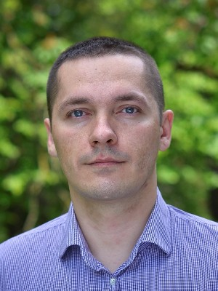
Haharin Andrii

Front-end web developer

Birth: 12/12/1984 (32 year)
Live: Ukraine, Rivne
Phone: 098 854-91-72
Email: gagarin.web@gmail.com

Experience

Front-end web developer
01.2017 (now)
Gekos inc.
Node.js, Express.js, Mongodb, gulp.js, jquery-ajax, bootstrap

Web developer
01.2010 - 02.2017 (7 years)
Inc "RACM" (building company)
Lan, Wlan, Repairs, Administration servers, Support corp site

System engeneer
10.2008 - 09.2010 (2 years)
Inc "Orgservice" (ІТ)
Lan, Route, Windows-Linux

Training

Specialist
09.2006 - 07.2010
Internationa University of Economics and Humanities, Kibernetics, Applied Mathematics.

Coorses
IT STEP Rivne, Software engineer (2015, 30)
IT STEP Rivne, Front-end Developer (2016, 12)

Skills
Linux Mint-Ubuntu-Centos
HTML5 – 6 years.
CSS3 – 6 years.
Bootstrap, Foundation, Materialize – 3 years.
Javascript ( es2015, es6 ) – 2 year.
Lodash.js и Underscore.js – 2 years.
JQuery и Ajax – 2 years.
Chart.js – 1 year.
Gulp.js – 1 year.
Backbone.js – 1 year.
React.js – begginer 1 year.
Webpack – 1 year.
Redux – 1 year.
Google Map API – 1 year.
Leaflet.js – 1 year.
Git ( github, bitbucket, gitlab ) – 2 year.
AngularJS – begginer ½ year.
Angular2 – begginer ½ year.
Typescript – begginer ½ year.
Ionic – begginer ½ year.

Language
English — low
Russian — expert
Ukrainian — expert

