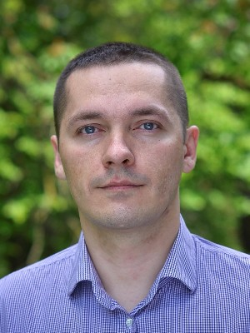
Haharin Andrii

Front-end web developer

Birth: 12/12/1984 (32 year)
Live: Ukraine, Rivne
Phone: 098 854-91-72
Email: gagarin.web@gmail.com

Experience

Front-end web developer
01.2017 – 05.2017 (5 month)
Gekos inc.
Node.js, Express.js, Mongodb, gulp.js, jquery-ajax, bootstrap

Web developer
01.2010 - 02.2017 (7 years)
Inc "PACM" (building company)
Lan, Wlan, Repairs, Administration servers, Support corp site

System engeneer
10.2008 - 09.2010 (2 years)
Inc "Orgservice" (ІТ)
Lan, Route, Windows-Linux

Training

Diploma of Specialist
09.2006 - 07.2010
International University of Economics and Humanities, Cibernetics, Applied Mathematics.

Courses
IT STEP Rivne, Software engineer (2015, 30)
IT STEP Rivne, Front-end Developer (2016, 12)

Skills
Linux Mint-Ubuntu-Centos
HTML5 – 6 years.
CSS3 – 6 years.
Bootstrap, Foundation, Materialize – 3 years.
Javascript (ecma5,ecma6) – 2 year.
Lodash.js – 2 years.
JQuery и Ajax – 2 years.
Chart.js – 1 year.
Gulp.js – 1 year.
React.js – 1 year.
Webpack – 1 year.
Redux – 1 year.
Socket.io – 0.5 year.
Google Map API – 1 year.
Leaflet.js – 1 year.
Node.js – 1 year.
Mongodb – 1 year.
Git ( github, bitbucket) – 2 year.

Language
English — Pre-Intermediate
Russian — Advanced
Ukrainian — Advanced

