RT 125

Week 05 Project

Alphabet Book

Make: 5in x 5in alphabet book

**CUT OUT THE IMAGES**

1. Download the Alphabet images: *Art125_Project_M05_imgs.zip* from ilearn.
2. Cut out the supplied alphabet images in *Photoshop*. To do this, select the images and mask. In most cases, you can use the dropdown Select > subject to quickly grab the subject of the image. Refine any places that were not selected or were accidentally selected with the other selection tools. Mask out the subjects using the mask button at the bottom of the Layers panel.
3. Save these files as a PSD (photoshop document.) ***Save them in a safe place near where you will save your InDesign document in step the next step.***

**SETUP THE BOOK**

1. Open a new document in InDesign. Set the page size to 5in x 5in. Set the bleed to be ⅛ inch (.125 inch). **Be sure to click the facing pages checkbox.**
2. Set the margins of master page A by double-clicking master page A, and going to the dropdown Layout > Margins & Columns… and set the margins of the page to be ½ inch (.5 inch)  
   *NOTE: Setting the master page allows you to set margins to all pages that are assigned to that page.*

**INSTALL THE FONTS**

1. Go to <https://fonts.adobe.com/> and login with your adobe or school credentials. (the same account you use for your adobe products)
2. Search for “Museo”
3. Activate Museo Slab and Museo Sans by clicking on the font family and clicking the activate all fonts switch. This will activate the Museo font families in all adobe software using that same login used in step 1.

**FORMAT THE BOOK**

1. While on master page A, add page numbers to all pages. Create a text box. Go to the dropdown Type > Insert Special Character > Marker > Current page number. Place the page number in the bottom right-hand corner as shown in the mockup below. Set the font to Museo Slab 300. Set the size to 8pt.  
   (See INSTALL THE FONTS above to...install the fonts)
2. Place a subject saved from SETUP THE BOOK Step 1 into one of the pages. Subjects should alternate with every page. (I.e. Apple on the left, ball on the right, car on the left, etc.)
3. Place a solid color behind the subject using the shape tool and send the box to the back using Object > Arrange > send to back.   
   *NOTE: Consider using a unified color palette from color.adobe.com*
4. On the opposite page from the subject, add a large letter (A, B, C, etc.) in a font set to Museo Slab 900 - 150 pt.   
   *NOTE: Consider making a paragraph style for the is in the paragraph styles panel. That way you can apply the font settings easier on each page.*
5. Include the following facts (listed below the image) on each page in a text box. Set the text Museo Sans 300 - 10/16.  
   NOTE: Consider making a paragraph style for the is in the paragraph styles panel. That way you can apply the font settings easier on each page.
6. Complete all 26 letters. The cover page (page 1) should at least have:
   1. Title
   2. By “Your Name”
   3. Any other design of your choosing (optional)

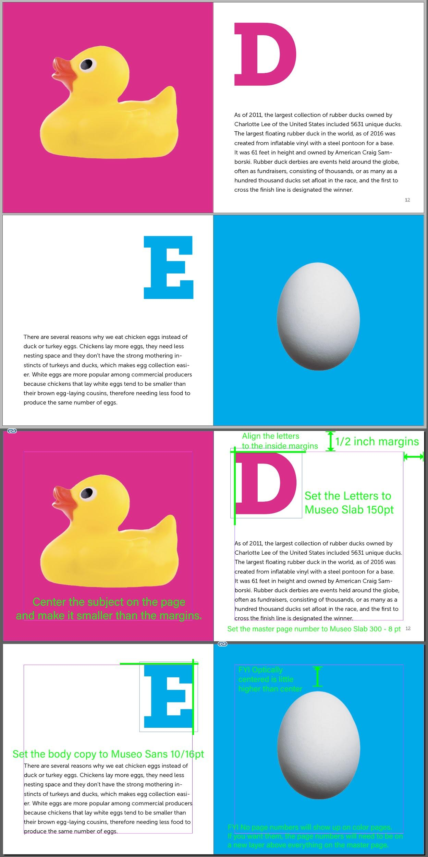

**EXPORT THE BOOK**

1. Go to file > export…
2. Name your file with your name on it thusly: Art125_YourNameHere_M05_Project
3. Select “Adobe PDF (Interactive)” from the “Format:” dropdown
4. Click “save”
5. In the “Export to Interactive PDF” pop-up, select the “compression” word to the left.
6. Set Resolution (ppi) to 96.
7. Select “export”
8. Upload the resulting PDF to ilearn.

**BOOK CONTENT**

Apple

Apples are part of the rose family, just like pears and plums. There are more than 2,500 varieties of apples grown in the U.S. That means if you had an apple a day, it would take you nearly seven years to eat each kind. Furthermore, there are more than 7,500 varieties of apples grown around the world. It would take you more than 20 years to try them all if you ate one a day!

Baseball

The unofficial anthem of American baseball, “Take Me Out to the Ballgame,” is traditionally sung during the middle of the 7th inning. It was written in 1908 by Jack Norworth and Albert von Tilzer, both of whom had never been to a baseball game.

Car

60 million cars are produced every year. That’s 165,000 a day, 6,875 an hour, and 115 a minute. 1 billion cars are currently in use around the world. That’s around one car for every seven people on Earth. The average car contains over 30,000 unique parts. When you think about it, it’s a miracle they don’t break down more often.

Duck

As of 2011, the largest collection of rubber ducks owned by Charlotte Lee of the United States included 5631 unique ducks. The largest floating rubber duck in the world, as of 2016 was created from inflatable vinyl with a steel pontoon for a base. It was 61 feet in height and owned by American Craig Samborski. Rubber duck derbies are events held around the globe, often as fundraisers, consisting of thousands, or as many as a hundred thousand ducks set afloat in the race, and the first to cross the finish line is designated the winner.

Egg

There are several reasons why we eat chicken eggs instead of duck or turkey eggs. Chickens lay more eggs, they need less nesting space and they don’t have the strong mothering instincts of turkeys and ducks, which makes egg collection easier. White eggs are more popular among commercial producers because chickens that lay white eggs tend to be smaller than their brown egg-laying cousins, therefore needing less food to produce the same number of eggs.

Flower

Not all flowers smell good. One of the world's rarest, largest, smelliest, and the strangest looking flower is the *titan arum* or the corpse flower. It is called the corpse flower because it smells like rotting flesh. The bloom is over 8 feet tall and 12 feet in circumference. They smell that way in order to attract flies, their preferred pollinator. People have been known to pass out from the smell!

Grapes

The word "berry" actually meant "grape" in Old English. Today, a grape is still defined as a type of berry in botanical terms. This means that each fruit comes from a single flower on the grapevine. The nutrients in grapes may help protect against cancer, eye problems, cardiovascular disease, and other health conditions.

Horse

Horses have the largest eyes of any land mammal. Newborn foals can run within hours of birth. When horses look like they’re laughing, they’re actually engaging in a special nose-enhancing technique known as “flehmen,” to determine whether a smell is good or bad. Horses can see color, though they are better at seeing yellows and greens than purples and violets.

Ice Cream

A brain freeze occurs when temperature sensors on the roof of your mouth trigger nerves. Those nerves send a message to your brain that signal heat loss. This is what brings on that massive headache halfway through eating your ice cream. To combat brain freeze, hold your tongue or bottom of your tongue against the roof of your mouth. This will help warm your sensors and get your brain out of panic mode. The real word for brain freeze is sphenopalatine ganglion neuralgia.

Jar

The Mason jar was named after its inventor John Landis Mason. He invented and patented it in 1858. Mason was a tinsmith and invented the lid first. Ball Canning is one of the most popular of the Mason Jar brands. They make 17 jars per second! Mason Jars are very collectible – one went for over $1000 on Etsy. If you laid all the Mason Jars that were sold in 2015 end to end they would circle the earth.

Kite

The smallest kite in the world which actually flies is 5mm. The largest number of kites flown on a single line is 11,284, this record is held by a Japanese kite maker. The longest kite in the world is 3394 ft, more than a kilometer! The largest kite in the world is the Megabite 180 ft x 76 ft. The fastest recorded speed of a kite is over 120 mph. The record for the highest single kite flown is 12,471ft. That’s over two miles high! The world record for the longest ‘kite fly’ is 180 hours.

Leaf

A leaf is an above-ground plant organ. Its main functions are photosynthesis and gas exchange. A leaf is often flat, allowing it to absorb maximum light, and thin so that the sunlight can get to the chloroplasts in the cells. Most leaves have stomata, which open and close. They regulate carbon dioxide, oxygen, and water vapor exchange with the atmosphere.

Moon

The Moon (or Luna) is the Earth’s only natural satellite and was formed 4.6 billion years ago around some 30–50 million years after the formation of the solar system. The Moon is in synchronous rotation with Earth meaning the same side is always facing the Earth. The Moon is moving approximately 3.8 cm away from our planet every year. It is estimated that it will continue to do so for around 50 billion years. By the time that happens, the Moon will be taking around 47 days to orbit the Earth instead of the current 27.3 days.

Nest

Nest building is often driven by a biological urge in pregnant animals to protect one's offspring known as the nesting instinct. Animals build nests to protect their eggs, their offspring, or themselves from danger. The simplest nest structures are adapted to hide eggs from predators, shield them from the sun or other environmental factors, or simply keep them from being scattered in ocean currents. In some cases, nests also help provide safety in numbers for egg-laying animals.

Owl

It’s a myth that owls can rotate their heads 360 degrees. The birds can actually turn their necks 135 degrees in either direction, which gives them 270 degrees of total movement. According to scientists, bone adaptations, blood vessels with contractile reservoirs, and a supporting vascular network allow the owls to turn their heads that far without cutting off blood to the brain.

Pumpkin

The largest pumpkin ever grown weighed 1,140 pounds. The largest pumpkin pie ever made was over five feet in diameter and weighed over 350 pounds. It used 80 pounds of cooked pumpkin, 36 pounds of sugar, 12 dozen eggs, and took six hours to bake. In early colonial times, pumpkins were used as an ingredient for the crust of pies, not the filling. Pumpkins were once recommended for removing freckles and curing snake bites.

Quilt

Quilting can date back to 3400 BC. The oldest quilt still around today is The Tristan Quilt dated around 1360-1400. The term "quilt" comes from the Latin Culcita, meaning a stuffed sack. The world’s largest quilt is the AIDS Memorial Quilt. Some quilts were created out of necessity, while others were encoded with secret messages and symbols.

Robot

The term ‘robot’ comes from the Czech word ‘Robota’, that means ‘Drudgery’ or ‘hard work’ and ‘forced labor’. A Nano-robot is a microscopic robot that is 50–100 nm wide. They can be used efficiently for drug delivery in the human bloodstream along with delicate surgical procedures that can support standard surgery. The term “Android” refers only to a male looking robot. In contrast, the proper term for a female robot is “Gynoid” where they appear widely in science fiction film and art.

Snake

Snakes, like all reptiles, are ectotherms. They rely on external sources (like the sun) to give them energy. They will move between basking in the sun and hiding in the shade to keep their bodies at their preferred temperature. Without warmth, snakes do not have enough energy to digest their food or move around. Snakes do not hibernate but enter a state of reduced metabolic rate called brumation during cooler weather periods. Many snakes stop eating during winter and conserve energy by not moving around as much. On a warm sunny day in the middle of winter snakes may still come out and bask.

Tortoise

Tortoises have been around for over 200 million years – longer than lizards, birds, mammals, crocodiles, and snakes. Some turtles and tortoises can live to over 100 years old – and beyond! One such tortoise was Harriet, who is said to have originally been found and looked after by Charles Darwin from 1835 and later arrived at Australia Zoo. She died there in 2006 and was believed to have been 175 at the time. Turtles can live in most climates that are warm enough for them to breed. They live on all continents except Antarctica.

Umbrella

Word umbrella comes from the Latin word "umbros" which means shade or shadow. The modern-day widespread acceptance of umbrellas started to spread across Europe in the middle of the 18th century. Up until that point, umbrellas were viewed as a female fashion accessory. The first man who publicly carried an umbrella was Englishman Jonas Hanway. His influence finally introduced an umbrella to the male population of England, and soon after the entire world.

Violin

Playing the violin burns approximately 170 calories per hour. The most expensive violin in the world was made by Giuseppe Guarneri in 1741. This extravagant violin was appraised with a value of $18 million. Violin bows typically contain 150 to 200 hairs. They can be made up of a variety of materials including nylon and horsehair.

Watermelon

Watermelon is one of the only foods to be classified as both a fruit and a vegetable. Watermelon has a greater concentrated source of lycopene in comparison to tomatoes. In the United States amongst different melons, watermelon is the most consumed. There are more than 1,200 varieties of different watermelons. Square watermelons were popularized in Japan where they would grow them in glass boxes to hold their shape.

XRay

Roentgen named his discovery X-strahlen—strahlen being German for “beam” or “ray,” and “x” being used in mathematics to indicate an unknown quantity. Even though we now know much more about how x-rays work, their name has retained a sense of their original mystery. The rays have also been called “Roentgen's rays,” and the images they produce are sometimes known as “roentgenograms.” Like many scientists, Roentgen started out by experimenting on his wife. One of his first x-rays—if not the first—was of his wife Anna Bertha's hand with her wedding ring on her finger.

Yoyo

There's a Greek vase painting from around 500 BC that shows a boy playing with a yo-yo — that's over 1,500 years old! They made their yo-yos from wood, metal, and terracotta. During the 18th century, the yo-yo became very popular all over Europe but they had their own names for it. In Britain, they called it a bandalore or a quiz. In France, it was known as an incroyable or a coblentz. Everyone liked playing with yo-yos and there are reports of young King Louis XVII playing with one, Napoleon and his army had yo-yos at their famous Battle of Waterloo, and even the Prince of Wales played with them.

Zebra

So why do zebras have stripes? Well, scientists aren’t entirely sure. Their stripes perhaps serve to dazzle and confuse predators and biting insects or to control the animal’s body heat. Because each individual’s stripes are unique, their stripes may also have a social purpose, helping zebras to recognize one other. Within a herd, zebras tend to stay together in smaller family groups, made up of a dominant male, several mares, and their foals.