This application allows the experimentation with the algorithm in various ways:

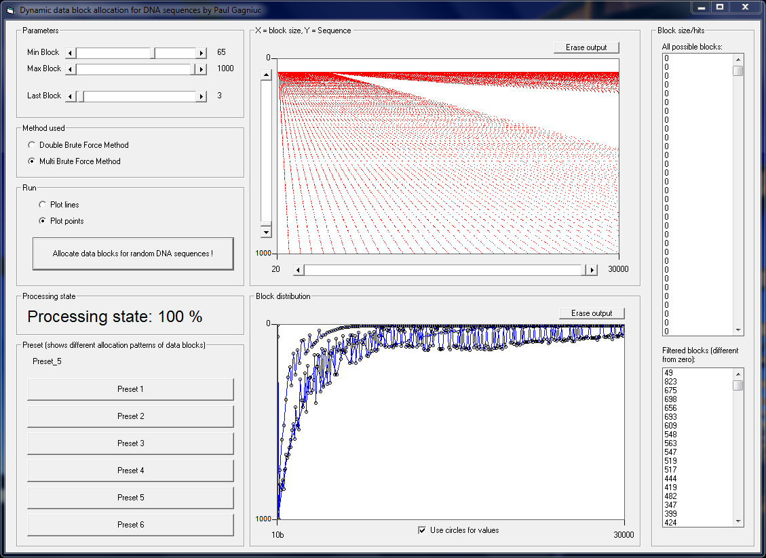

This application is a simple and intuitive implementation which uses DBA algorithm:

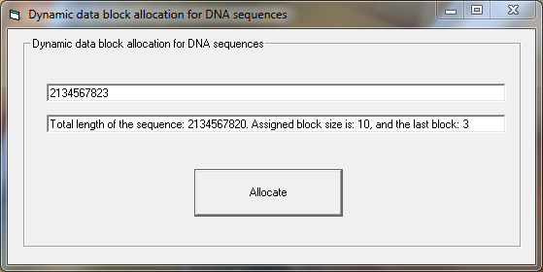

This application is a practical, more complex implementation which uses DBA algorithm:

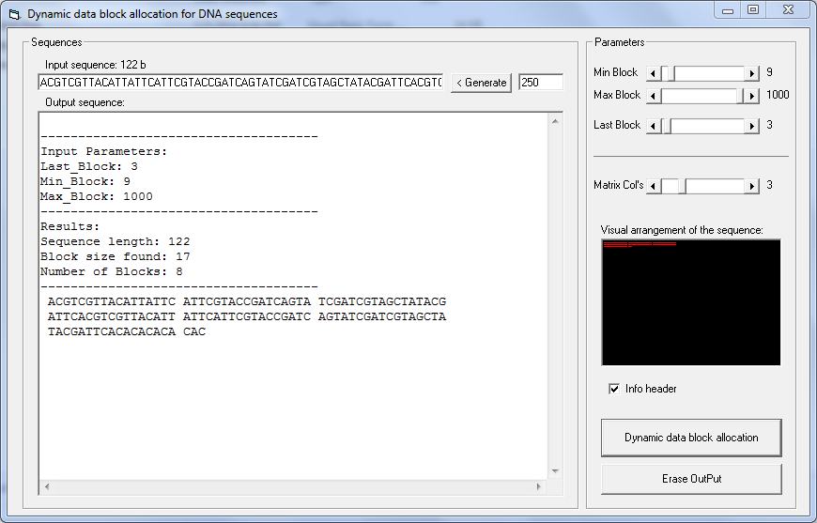

Playing with DBA algorithm

Some results obtained through the above application by using a series of combinations of parameters:

**Case 1**

-------------------------------------

Input Parameters:

Last_Block: 3

Min_Block: 9

Max_Block: 1000

-------------------------------------

Results:

Sequence length: 122

Block size found: 17

Number of Blocks: 8

-------------------------------------

ACGTCGTTACATTATTC ATTCGTACCGATCAGTA TCGATCGTAGCTATACG

ATTCACGTCGTTACATT ATTCATTCGTACCGATC AGTATCGATCGTAGCTA

TACGATTCACACACACA CAC

**Case 2**

-------------------------------------

Input Parameters:

Last_Block: 5

Min_Block: 9

Max_Block: 1000

-------------------------------------

Results:

Sequence length: 122

Block size found: 13

Number of Blocks: 10

-------------------------------------

ACGTCGTTACATT ATTCATTCGTACC GATCAGTATCGAT CGTAGCTATACGA TTCACGTCGTTAC ATTATTCATTCGT

ACCGATCAGTATC GATCGTAGCTATA CGATTCACACACA CACAC

**Case 3**

-------------------------------------

Input Parameters:

Last_Block: 1

Min_Block: 9

Max_Block: 1000

-------------------------------------

Results:

Sequence length: 122

Block size found: 11

Number of Blocks: 12

-------------------------------------

ACGTCGTTACA TTATTCATTCG TACCGATCAGT

ATCGATCGTAG CTATACGATTC ACGTCGTTACA

TTATTCATTCG TACCGATCAGT ATCGATCGTAG

CTATACGATTC ACACACACACA C

**Case 4**

-------------------------------------

Input Parameters:

Last_Block: 1

Min_Block: 9

Max_Block: 1000

-------------------------------------

Results:

Sequence length: 122

Block size found: 11

Number of Blocks: 12

-------------------------------------

ACGTCGTTACA TTATTCATTCG TACCGATCAGT ATCGATCGTAG CTATACGATTC

ACGTCGTTACA TTATTCATTCG TACCGATCAGT ATCGATCGTAG CTATACGATTC

ACACACACACA C

**Case 5**

-------------------------------------

Input Parameters:

Last_Block: 5

Min_Block: 9

Max_Block: 1000

-------------------------------------

Results:

Sequence length: 122

Block size found: 13

Number of Blocks: 10

-------------------------------------

ACGTCGTTACATT ATTCATTCGTACC GATCAGTATCGAT CGTAGCTATACGA TTCACGTCGTTAC

ATTATTCATTCGT ACCGATCAGTATC GATCGTAGCTATA CGATTCACACACA CACAC

**Case 6**

-------------------------------------

Input Parameters:

Last_Block: 7

Min_Block: 9

Max_Block: 1000

-------------------------------------

Results:

Sequence length: 122

Block size found: 23

Number of Blocks: 6

-------------------------------------

ACGTCGTTACATTATTCATTCGT ACCGATCAGTATCGATCGTAGCT

ATACGATTCACGTCGTTACATTA TTCATTCGTACCGATCAGTATCG

ATCGTAGCTATACGATTCACACA CACACAC

**Case 7**

-------------------------------------

Input Parameters:

Last_Block: 7

Min_Block: 9

Max_Block: 1000

-------------------------------------

Results:

Sequence length: 122

Block size found: 23

Number of Blocks: 6

-------------------------------------

ACGTCGTTACATTATTCATTCGT ACCGATCAGTATCGATCGTAGCT ATACGATTCACGTCGTTACATTA

TTCATTCGTACCGATCAGTATCG ATCGTAGCTATACGATTCACACA CACACAC

**Case 8**

-------------------------------------

Input Parameters:

Last_Block: 3

Min_Block: 6

Max_Block: 1000

-------------------------------------

Results:

Sequence length: 122

Block size found: 7

Number of Blocks: 18

-------------------------------------

ACGTCGT TACATTA TTCATTC GTACCGA TCAGTAT CGATCGT AGCTATA CGATTCA CGTCGTT

ACATTAT TCATTCG TACCGAT CAGTATC GATCGTA GCTATAC GATTCAC ACACACA CAC

**Case 10**

-------------------------------------

Input Parameters:

Last_Block: 5

Min_Block: 6

Max_Block: 1000

-------------------------------------

Results:

Sequence length: 122

Block size found: 9

Number of Blocks: 14

-------------------------------------

ACGTCGTTA CATTATTCA TTCGTACCG ATCAGTATC GATCGTAGC TATACGATT CACGTCGTT ACATTATTC

ATTCGTACC GATCAGTAT CGATCGTAG CTATACGAT TCACACACA CACAC

**Case 9**

-------------------------------------

Input Parameters:

Last_Block: 5

Min_Block: 6

Max_Block: 1000

-------------------------------------

Results:

Sequence length: 122

Block size found: 9

Number of Blocks: 14

-------------------------------------

ACGTCGTTA CATTATTCA TTCGTACCG ATCAGTATC GATCGTAGC TATACGATT CACGTCGTT ACATTATTC ATTCGTACC

GATCAGTAT CGATCGTAG CTATACGAT TCACACACA CACAC

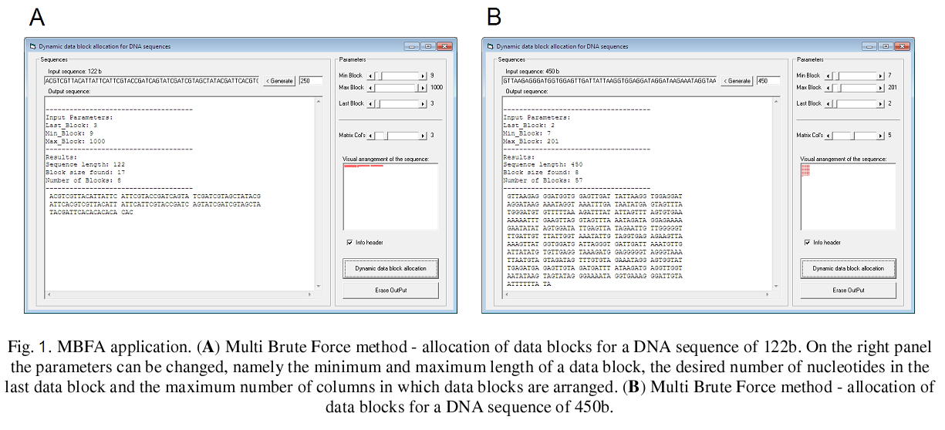

Source:

P. Gagniuc and C Ionescu-Tirgoviste, Dynamic block allocation for biological sequences, Proc. Rom. Acad., Series B, 2013, 15(3), p. 233-240.