**Gahasa Timothius B.P. Purba (11419048)**

**Zico Andreas Aritonang (11419049)**

**Cheaper and Faster Detection of COVID-19 Virus Using GeNose C19**

# **INTRODUCTION**

1. Background

COVID-19 (coronavirus disease 2019) is a new type of disease caused by a virus from the coronavirus class, namely SARS-CoV-2 which is also often called the Corona virus.

According to data released by the Task Force for the Acceleration of Handling of COVID-19 of the Republic of Indonesia, the number of confirmed positive cases until March 1, 2021 is 1,334,634 people with a death of 36,166 people.

Prevention of Covid-19 transmission not only requires health protocols by wearing masks, maintaining distance, and washing hands with soap (3M), but also testing, tracing and treatment. By knowing positive people, isolation and proper handling can be carried out so that transmission can be prevented. Therefore, a fast and effective way is needed to find out if someone has been confirmed positive for COVID-19.

This paper examines the use of GeNose C19 in detecting COVID-19. Will also be explained How GeNose C19 works, this paper also explains whether this tool is effective and efficient in detecting COVID-19 so that it can later replace rapid test and PCR test.

1. Review of Literature

Kuwat (2020) explains that with the Genose equipment, prospective passengers who want to travel by train no longer need to undergo PCR or antigen tests by swab. Prospective passengers just need to blow their breath into the plastic Genose series to find out whether they have been exposed to COVID-19 or not.

GeNose researcher dr. Nurputra (2020) said, GeNose has gone through a series of test tests, so this tool is considered effective in knowing early whether someone has COVID-19 or not. "This is different from other medical devices, we are based on Artificial Intelligence (AI), we use a data base to train them to be smarter in reading data," said Nurputra.

GeNose is considered to have several weaknesses in detecting the corona virus. Testing using GeNose on a smoker or someone who consumes strong-smelling foods can reduce the effectiveness of GeNose. Users or patients who will use GeNose are also advised not to consume anything half an hour before the test. "The GeNose [test] requires smoking, eating and drinking that stings, so this is not for initial screening, but for research under certain conditions," said Hermawan (2020).

Islam, Ullah, Mahmud & Raju (2020) analyze the recent technologies that evolved is breathing aid devices used to support the patients who have acute respiration problems due to pneumonia associated diseases like COVID-19, asthma, and dry coughing.

The most used devices which are utilized for COVID-19 treatment are oxygen therapy device, ventilator, and CPAP device. The developed systems are demonstrated in terms of the working principle, the construction procedure, the used hardware components, cost analysis, and comparative advantages and disadvantages. In order to find the best technology, GeNose C19 is made as a more advanced and effective detector of COVID-19.

The presence of GeNose C19 in Indonesia raises many questions about the accuracy of that COVID-19 detection tool. Existing research has not been able to show detailed results regarding GeNose C19. GeNose C19 is shown to the public without showing any existing permissions and licenses. Therefore, many people still doubt the effectiveness of GeNose C19 in detecting COVID-19. How GeNose C19 works is also still not widely known to people. Currently people still choose to use rapid test and PCR test that is usually known to detect COVID-19.

1. Statement of Research Problem

Research Question 1:

Is GeNose C19 been licensed?

Research Question 2:

How accurate has the GeNose C19 compared to the Rapid Test and the Swab Test?

Research Question 3:

Does GeNose C19 detect the presence of the SARS-CoV2 virus that causes COVID-19?

Research Question 4:

Can GeNose C19 identify people infected with the mutated COVID-19 virus?

1. Purpose of Research

The purposes of this study were:

1. To explore how Genose C19 works in detecting COVID-19.
2. To explore how fast and effective Genose C19 has been in detecting COVID-19.
3. Significant of Research

This research of this study helps people to understand the way the most effective COVID-19 detection technology, namely GeNose C19 functions.

# **METHODOLOGY**

Due to limited time issues, that make it impossible to wear qualitative or with interviews, so in this study, we used a quantitative method. We build 10 questions for our questionnaire, and give rate 1-5 to ease the respondents to give their responses to our close ended questions. The questionnaire was distributed to Diploma 4 Students, Class of 2019, in Del Institute of Technology as a population that have been approximately 65 students. Then we selected 30 sample respondents from Diploma 4 Students, Class of 2019, in Del Institute of Technology as our population using simple random technique.

* 1. Quantitative Research

The method used in this research was the quantitative method. The reason why the method was used is as we could see every respondent should have equal probability to be chosen as our respondent so that the data collected became more accurate.

Also, for the simplicity and effectiveness, the method was suitable to use because we wanted to prove our assumptions accurate and reliable. And Due to limited time issues, that make it impossible to wear qualitative or with interviews.

* 1. Data Collection

The type of data we collected for this study was primary data because the data was based on the responses from our respondents. In this research, the population of our research was Diploma 4, Class 2019 of Software Engineering Students in IT Del.

We used a questionnaire to collect the data. We asked the students, so in this number of ways, we can be sure that the data collected corresponds to our research.

Earlier we discussed what questions we would ask in our questionnaire. Then we shared a questionnaire with other students.

The statistical method we use for this data is descriptive statistics. This methodology is valid and accurate. Through this method, we collect data and then present data and information according to our research.

# **RESULTS**

In this study, we used a quantitative method. We build the questions for our questionnaire, and give rate 1-5 to ease the respondents to give their responses to our close ended questions. We will select 30 sample respondents as the population using simple random technique. But before that, first we tested the validity of our questionnaire using IBM SPSS, from the test, we got the results that the responds to the questionnaire that have submitted has met the assumption of validity with Pearson Correlation exceeded r table by approximately 0.707.

* 1. Respondents on their knowledge about GeNose C19

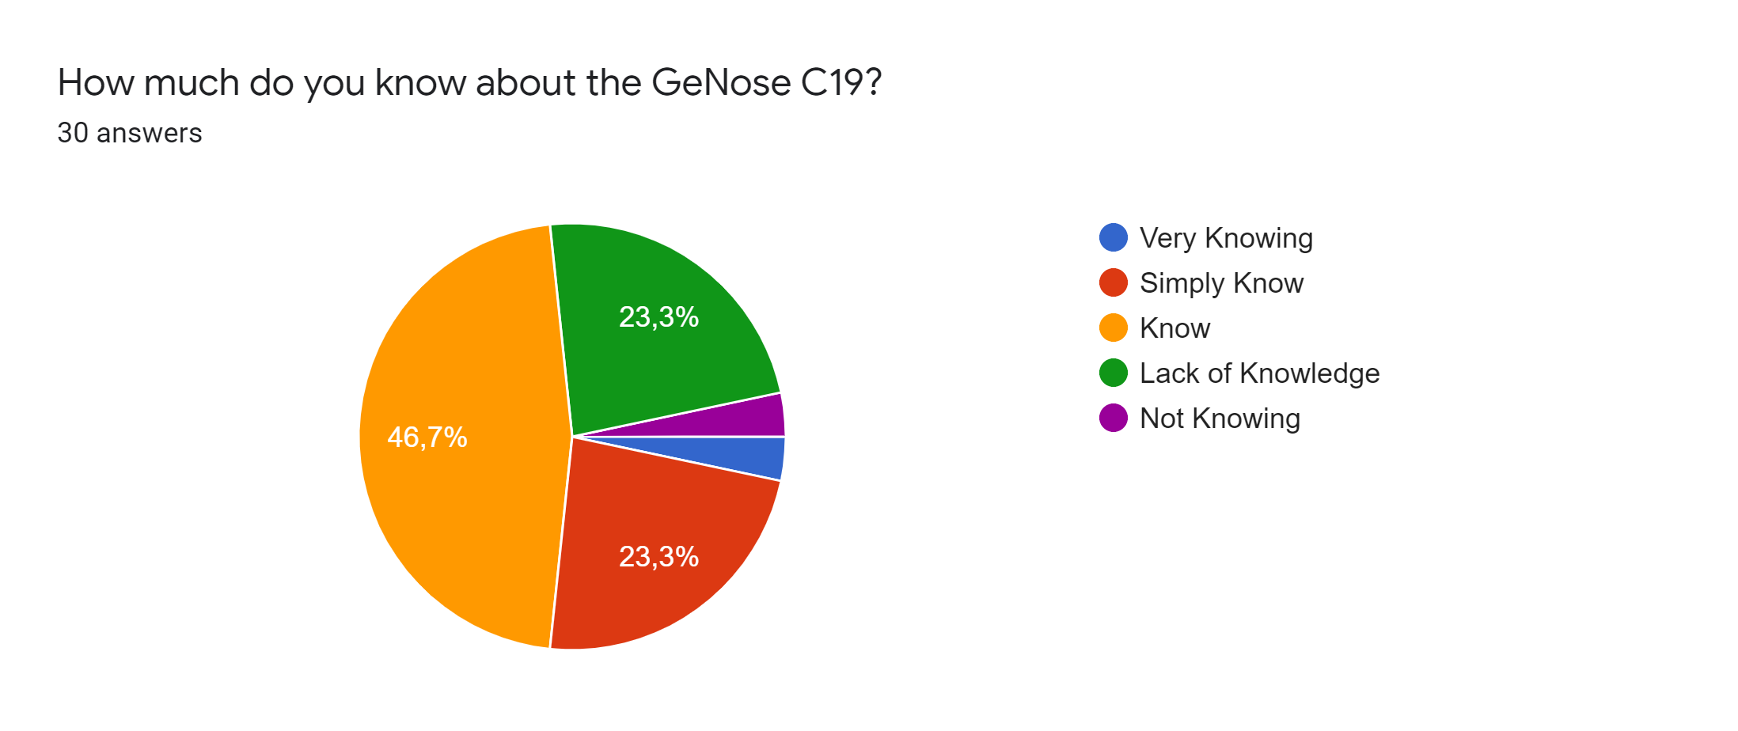

1. Respondents on their knowledge about GeNose C19

Based on the research question above, 46.7% were know about GeNose C19, 23.3% know enough, 23.3% didn’t know enough, 3.3% very know about GeNose C19 and 3.3% doesn’t know at all about it. These results came from respondents who had respond the questionnaire.

* 1. Respondents on their approval if GeNose C19 replace Rapid Test or Swab Test

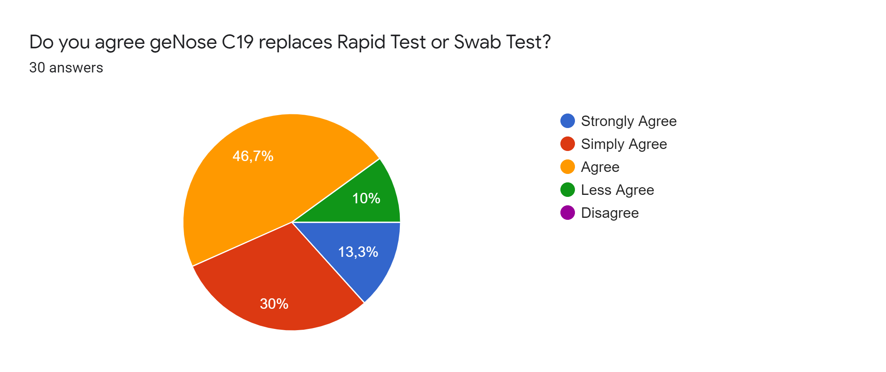

2. Respondents on their approval if GeNose C19 replace Rapid Test or Swab Test

As is shown from Figure 2, 46.7% have agreed if GeNose C19 replace Rapid Test or Swab Test, 30% not agree, 13.3% very agree, 10% less agree, and nothing were doesn’t agree if GeNose C19 replace Rapid Test or Swab Test.

* 1. Respondents on the accuracy of GeNose C19 in detecting COVID-19

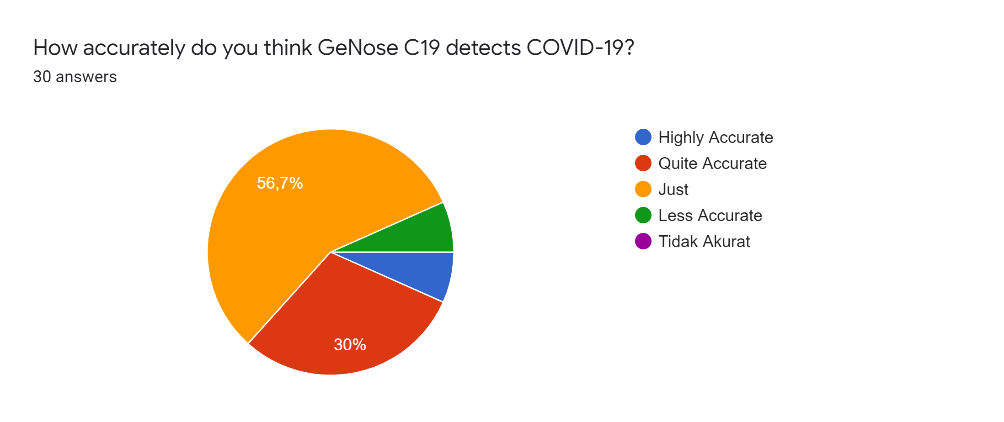

3. Respondents on the accuracy of GeNose C19 in detecting COVID-19

Of the total respondents, 56.7% of respondents rated that GeNose C19 was accurate in detecting COVID-19, 30% said it enough accurate, 6.7% said it very accurate and less accurate, However, there are nothing said it doesn’t accurate.

* 1. Respondents on the effectivity in using GeNose C19 in detecting COVID-19

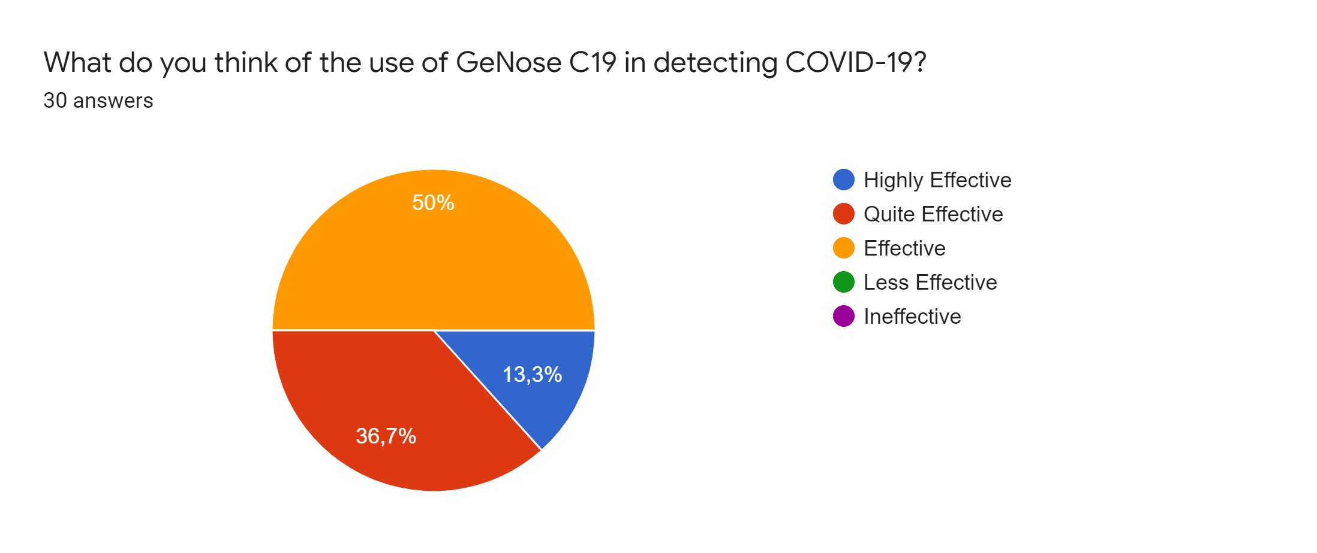

4. Respondents on the effectivity in using GeNose C19 in detecting COVID-19

The chart shows that 50% of the respondents said that GeNose C19 using is effective for detecting COVID-19 and the remaining 50% thinks it is very effective and quite effective. While there is nothing who said that GeNose C19 is less effective or even not effective on detecting COVID-19 .

* 1. Respondents on the services using GeNose C19 technology are adequate in detecting COVID-19

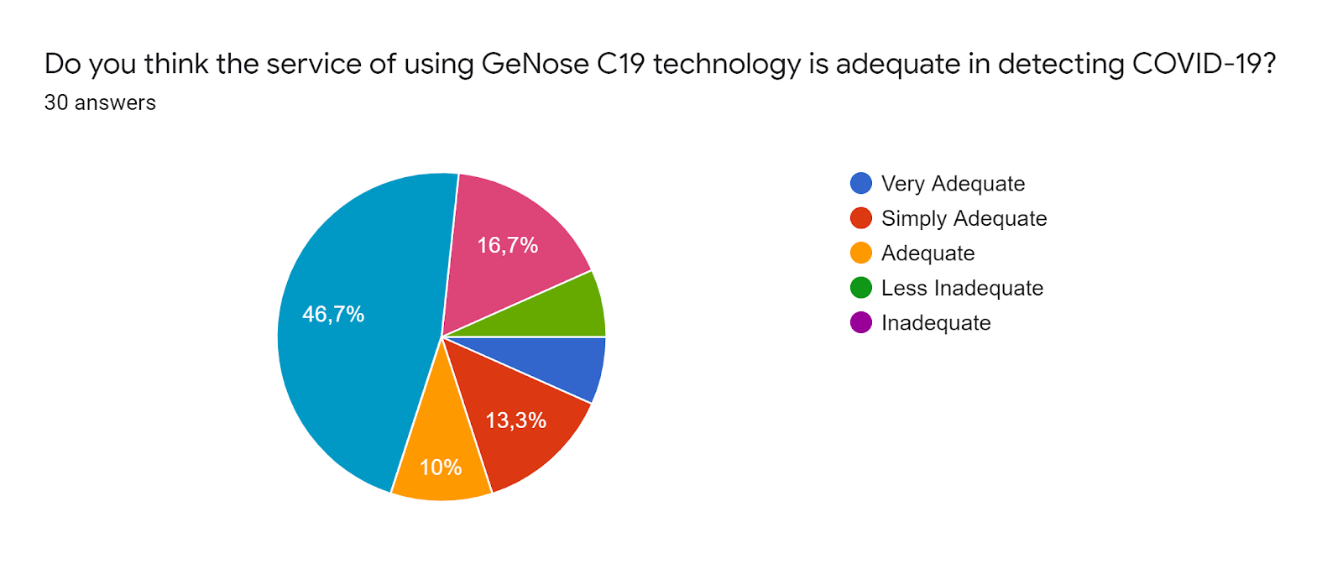

5. Respondents on the services using GeNose C19 technology are adequate in detecting COVID-19

Based on the research question above, 46.7% of respondents agreed that this technology was very adequate in detecting the corona virus and 10% of the results said the technology was adequate.

* 1. Respondents on recommending GeNose C19 technology in detecting COVID-19

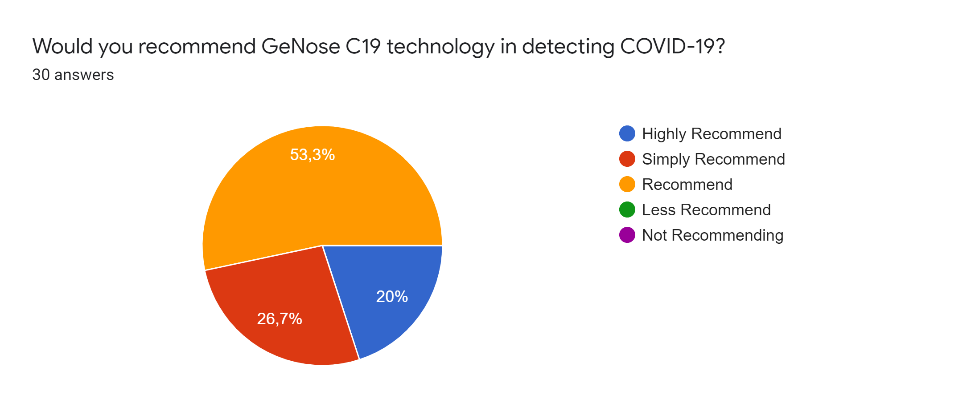

6. Respondents on recommending GeNose C19 technology in detecting COVID-19

As shown from Figure 6, 53.3% thought that GeNose C19 was recommended in detecting COVID-19, 26,7% said it enough recommended, 20% said it very recommended, while there is nothing who said that GeNose C19 is less recommended or even not recommended GeNose C19 in detecting COVID-19 .

* 1. Respondents on using GeNose C19 at the airport as a condition of travel in pandemic

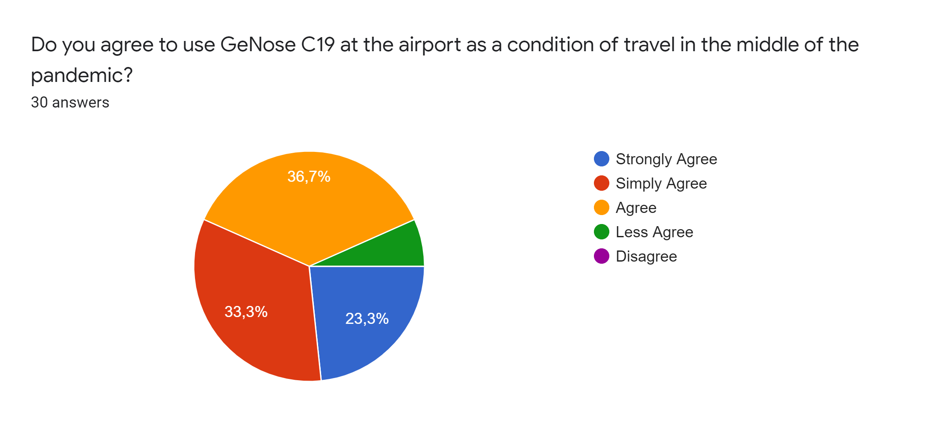

7. Respondents on using GeNose C19 at the airport as a condition of travel in pandemic

Of the total respondents,23.3% strongly agree that it is a good idea to test the GeNose C19 as a condition of travel. However, 6% refused the idea of to test the GeNose C19 as a condition of travel.

* 1. Respondents on the GeNose C19 safety as a COVID-19 detector

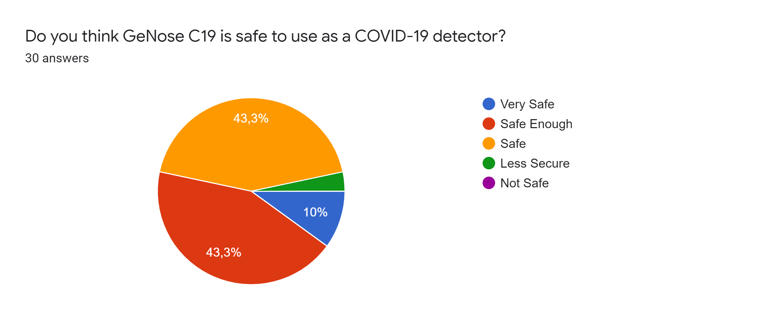

8. Respondents on the GeNose C19 safety as a COVID-19 detector

The chart shows 43.3% agreed the GeNose was safe for use detecting corona virus and 3,4% were still said less safe of the technology of GeNose C19. while there is nothing who said that GeNose C19 is even not safety GeNose C19 in detecting COVID-19 .

* 1. Respondents on the cost of GeNose C19 as a COVID-19 detector

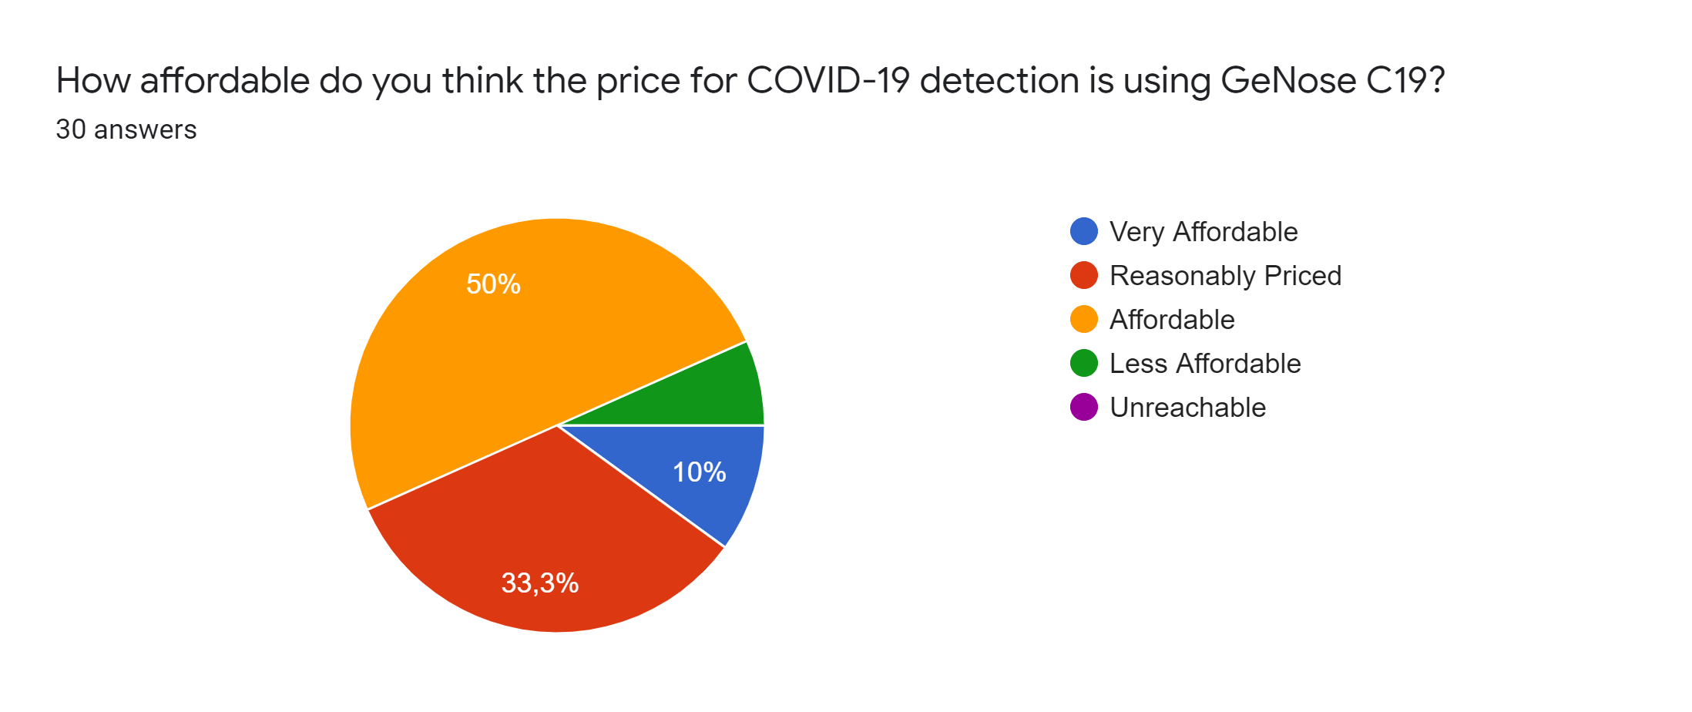

9. Respondents on the cost of GeNose C19 as a COVID-19 detector

Based on the research question above, 50% were respondents said the cost of test GeNose C19 was affordable and 33.3% were said less affordable to pay. while there is nothing who said that GeNose C19 is even not reachable able GeNose C19 in detecting COVID-19 .

* 1. Respondents on the speed of GeNose C19 in detecting COVID-19

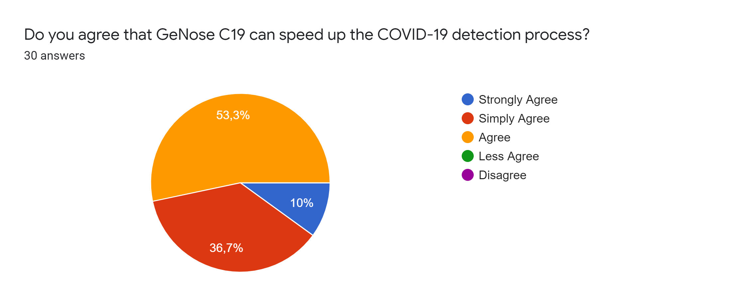

10. Respondents on the speed of GeNose C19 in detecting COVID-19

As is shown from Figure 10, 53.3% have thought that GeNose C19 can speed up detection. 10% of the results very agree that GeNose C19 can speed up. Even though no one said that GeNose C19 could not even accelerate the detection of COVID-19.

# **DISCUSSION**

Our reason for conducting this research is to find a fast and effective way that is needed to find out if someone has been confirmed positive for COVID-19. After that we found that there is another method recommended by experts, named GeNose C19 which is a tool to detect COVID-19 through breath. We conducted this research in 2 months, and the discussion held by Zoom Meeting or Google Meet. We also giving questions and give rate 1-5 to ease the respondents to give their responses to our close ended questions in the form of questionnaires distributed to Diploma 4 Students, Class of 2019, in Del Institute of Technology with descriptive statistical methods.

We used quantitative descriptive design when collecting data. This methodology is valid and accurate. The data that we have collected are based on questions in the form of valid questionnaires. After that we collected 30 responses from the form. Then the data is calculated, processed, and presented using statistical rules.

GeNose C19 is the better way to detect COVID-19 that cheaper and more effective compared with other detector like PCR and Swab Test. In short, our research provides an alternative to the shortcomings of previous studies such as research conducted by Islam, Ullah, Mahmud & Raju (2020) that analyze the recent technologies that evolved is breathing aid devices used to support the patients who have acute respiration problems due to pneumonia associated diseases like COVID-19, asthma, and dry coughing. And also, GeNose researcher dr. Nurputra (2020) that said, GeNose has gone through a series of test tests, so this tool is considered effective in knowing early whether someone has COVID-19 or not.

Based on the review of literature and the data that we have collected, we conclude that most of all respondents know about GeNose C19 and agree that GeNose C19 is safe and effective for detecting COVID-19. This can be proven based on the results of our research using a questionnaire that GeNose C19 is effective in detecting COVID-19.

REFERENCES

Ai, T., Yang, Z., Hou, H., Zhan, C., Chen, C., Lv, W., Tao, Q., Sun, Z., & Xia, L. (2020). Correlation of Chest CT and RT-PCR Testing for Coronavirus Disease 2019 (COVID-19) in China: A Report of 1014 Cases. *Radiology*, *296*(2), E32–E40. https://doi.org/10.1148/radiol.2020200642

Dong, Y., Dong, Y., Mo, X., Hu, Y., Qi, X., Jiang, F., Jiang, Z., Jiang, Z., Tong, S., Tong, S., & Tong, S. (2020). Epidemiology of COVID-19 among children in China. *Pediatrics*, *145*(6). https://doi.org/10.1542/peds.2020-0702

Islam, M. M., Ullah, S. M. A., Mahmud, S., & Raju, S. M. T. U. (2020). Breathing Aid Devices to Support Novel Coronavirus (COVID-19)Infected Patients. *SN Computer Science*, *1*(5), 1–8. https://doi.org/10.1007/s42979-020-00300-1

Li, Q., Guan, X., Wu, P., Wang, X., Zhou, L., Tong, Y., Ren, R., Leung, K. S. M., Lau, E. H. Y., Wong, J. Y., Xing, X., Xiang, N., Wu, Y., Li, C., Chen, Q., Li, D., Liu, T., Zhao, J., Liu, M., … Feng, Z. (2020). Early Transmission Dynamics in Wuhan, China, of Novel Coronavirus–Infected Pneumonia. *New England Journal of Medicine*, *382*(13), 1199–1207. https://doi.org/10.1056/nejmoa2001316

Natasa, A. (2020). *GeNose Innovation Steps Up to the Diagnostic Test Phase*. https://www.ugm.ac.id/en/news/20271-genose-innovation-steps-up-to-the-diagnostic-test-phase

Ruan, Q., Yang, K., Wang, W., Jiang, L., & Song, J. (2020). Clinical predictors of mortality due to COVID-19 based on an analysis of data of 150 patients from Wuhan, China. *Intensive Care Medicine*, *46*(5), 846–848. https://doi.org/10.1007/s00134-020-05991-x

UGM. (2020). *The Chairman of Covid-19 Research and Innovation Consortium: UGM GeNose Can Be an Alternative for PCR Test*. https://www.ugm.ac.id/en/news/20086-the-chairman-of-covid-19-research-and-innovation-consortium-ugm-genose-can-be-an-alternative-for-pcr-test

UGM. (2021). *Minister of Research and Technology: GeNose Reducing Import Dependency on Covid-19 PCR Tools*. https://www.ugm.ac.id/en/news/20633-minister-of-research-and-technology-genose-reducing-import-dependency-on-covid-19-pcr-tools

Wu, Z., & McGoogan, J. M. (2020). Characteristics of and Important Lessons from the Coronavirus Disease 2019 (COVID-19) Outbreak in China: Summary of a Report of 72314 Cases from the Chinese Center for Disease Control and Prevention. *JAMA - Journal of the American Medical Association*, *323*(13), 1239–1242. https://doi.org/10.1001/jama.2020.2648