Show evidence of using a CURL request with a JSON object to update the teacher data through the WebAPI instead of the teacher interface.

1. Create json file and input data

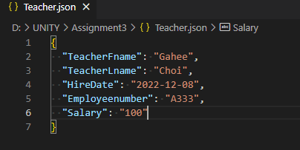

1. Curl request sent

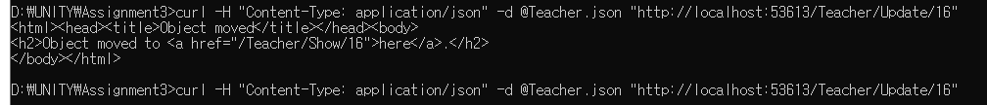

3. Updated

