| **A**  **PROJECT REPORT ON** |
| --- |
|  |
|  |
| Travel Management System |
|  |
|  |
| SUBMITTED IN  PARTIAL FULFILLMENT OF  **DIPLOMA IN ADVANCED COMPUTING (PG-DAC)** |
|  |
|  |
|  |
|  |
|  |
|  |
|  |
| **Submited By**  **Abhishek Kumar Gahlaut** |
|  |
|  |
| **UNDER THE GUIDENCE OF**  **DIGVIJAY BHUNJE** |
|  |
|  |
|  |
| **AT**  **SUNBEAM INSTITUTE OF INFORMATION TECHNOLOGY,**  **PUNE** |

|  | |
| --- | --- |
| **SUNBEAM INSTITUTE OF INFORMATION TECHNOLOGY,**  **PUNE.** | |
|  | |
|  | |
|  | |
|  | |
| **CERTIFICATE** | |
|  | |
| This is to certify that the project | |
|  | |
| Travel Management System | |
|  | |
| **Has been submitted by**  **Abhishek Kumar Gahlaut** | |
|  | |
|  | |
|  | |
|  | |
| In partial fulfillment of the requirement for the Course of **PG Diploma in Advanced Computing (PG-DAC FEB2020)** as prescribed by The **CDAC** ACTS, PUNE. | |
|  | |
|  | |
| Place: Pune | Date: 23-JAN-2021 |
|  | |
|  | |
|  | |
|  | |
|  | |
| **Digvijay Bhunje** | **Vinay Kushwaha** |
| **Project Guide** | **Alumni Mentor** |

**ACKNOWLEDGEMENT**

With immense pleasure and great respect I take this opportunity to express my deep sense of gratitude to my project guide **Digvijay Bhunje , Sunbeam Institute Of Information Technology** , for this valuable guidance , inspiration , constant encouragement and motivation throughout the project work.

I also express my sincere gratitude towards **Nitin Kudhale , Director , Sunbeam Institute Of Information Technology** , for his motivation throughout the project work.

Last but not least , I am very much thankful to my parents , friends , and colleagues who directly or indirectly help at every stage to complete this work.

Mr. **Abhishek Kumar Gahlaut**

**ABSTRACT**

The Main objective of “Travel Management System” project is to make the travel easy and comfortable for the user’s right from finding the routes and buses to till the booking of the tickets. In this project, we have four modules Admin, User, Visitor and Agency.

In this project Admin will login with the default username and password and admin has authority to manage user and agencies. Admin has authority to edit, update, delete user’s and agencies. Agency will add the services like train, flights and buses at particular routes and add travel details and assign the route id’s and service id’s times in different routes. Agency will also add the different services while adding services agency will fix the ticket price and the capacity of seats.

Finally, the user will register and login and find the required services and he will search the services by giving all details like date of journey, source and destination. After booking the booking information will be displayed. After booking successfully, the booking confirmation will be shown.

If the user feels any feedback need to give, user can provide feedback to agency.

**INDEX**

|  | **INTRODUCTION** | 1 |
| --- | --- | --- |
|  | 1.1 Introduction | 7 |
|  | **PRODUCT OVERVIEW AND SUMMARY** | 8 |
|  | 2.1 User | 9 |
|  | 2.2 Admin |  |
|  | 2.3 Agency |  |
|  | **REQUIREMENTS** | 10 |
|  | 3.1 Hardware |  |
|  | 3.2 Software |  |
|  | 3.3 Technology |  |
|  | **PROJECT DESIGN** | 11 |
|  | 4.1 Use Case For User |  |
|  | 4.2 Use Case For Admin | 12 |
|  | 4.3 Use Case For Agency | 13 |
|  | 4.4 ER Diagram | 14 |
|  | 4.5 Database Design | 15 |
|  | 4.2.2 Data Flow Diagram (DFD) | 16 |
|  | **TEST REPORT** | 22 |
|  | **CONCLUSION** | 23 |
|  | **REFERENCES** |  |

**LIST OF TABLES**

| **Section** | **Table Title** | **Page** |
| --- | --- | --- |
| **1.** | **User** | 11 |
| **2.** | **Admin** | 12 |
| **3.** | **Agency** | 13 |
|  |  |  |
|  |  |  |
|  |  |  |

**LIST OF FIGURES**

| **Section** | **Figure Title** | **Page** |
| --- | --- | --- |
| **Fig 1** | **User Use Case Diagram** | 11 |
| **Fig 2** | **Admin Use Case Diagram** | 12 |
| **Fig 3** | **Agency Use Case Diagram** | 13 |
| **Fig 4** | **Er Diagram** | 14 |
| **Fig 5** | **DFD Diagram** | 16 |
| **Fig 6** | **Dashboard Screen Shots** | 18 |
|  |  |  |
|  |  |  |
|  |  |  |
|  |  |  |
|  |  |  |
|  |  |  |

**INTRODUCTION**

The Travel Management System is a web based application. The main purpose of “Travel Management System ” is to provide a convenient way for a customer to book flights, train and buses for travelling purposes. The objective of this project is to develop a system that automates the processes and activities of a travel agency. In this project, we will make an easier task of searching places and for booking train, flight or bus. In the present system a customer has to approach to find details of train, flight or bus and book tickets. This often requires a lot of time and effort.

| PRODUCT OVERVIEW AND SUMMARY |
| --- |

The project Travel Management System. Most of the people in this world like to travel from one place to another no matter whether it is a small or large distance. Some people like to travel by train, flight, bus or by any other means of transport. This travel and tourism application is designed for the travel agency in which there is an option of doing the railway or air ticket reservation in order to reach the intended destination. The travel system is one of website will help the customers to book the air ticket or the railway tickets through this application of the travel agency. Booking of tickets will be done with a great ease and without any difficulty. This will be one of the interesting projects that one can work on and implement in real time world. The user interface must be simple and easy to understand.

That project can be included in the “TMS” website synopsis are as follows:

# User: user will register and login and find the required services and he will search the services by giving all details like date of journey, source and destination. After booking the booking information will be displayed. If the user feels any feedback need to give, user can provide feedback to agency

# Admin: Admin will login with the default username and password and admin has authority to manage user and agencies. Admin has authority to edit, update, delete user’s and agencies.

# Agency: Agency will add the services like train, flights and buses at particular routes and add travel details and assign the route id’s and service id’s times in different routes. Agency will also add the different services while adding services agency will fix the ticket price and the capacity of seats.

REQUIREMENTS

**Hardware**

**OS** - Linux

**System specs** – 8GB/256GB/1TB

**Processor** - i3

**Software**

**Editing** **IDE** - Ecllipse , VS Code.

**Web** **Browser** - chrome , firefox.

**Online Repository** - GitLab

**Technology**

**Backend -** Spring Boot

**Frontend** - Angular

**Database** - MySql

**PROJECT DESIGN**

**| Use Case for User**: Book bus, Book flight, Book train

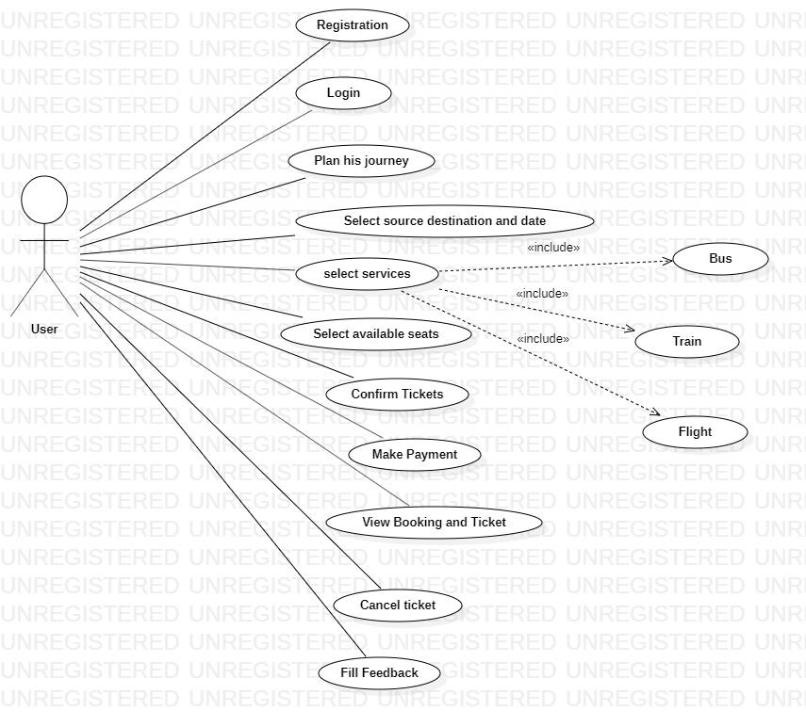

fig.(1)

**| Use Case for Admin**:

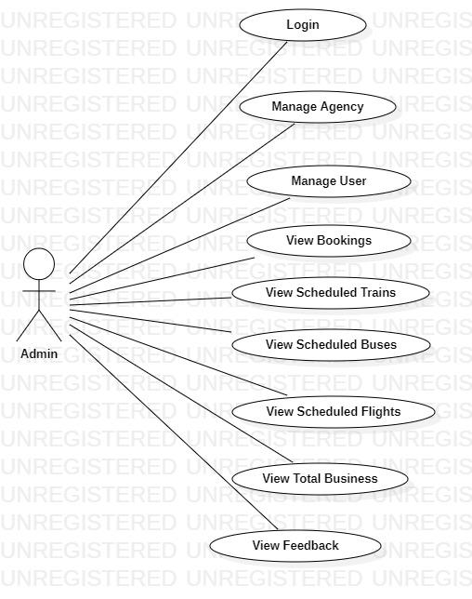

fig.(2)

**| Use Case for Agency**:

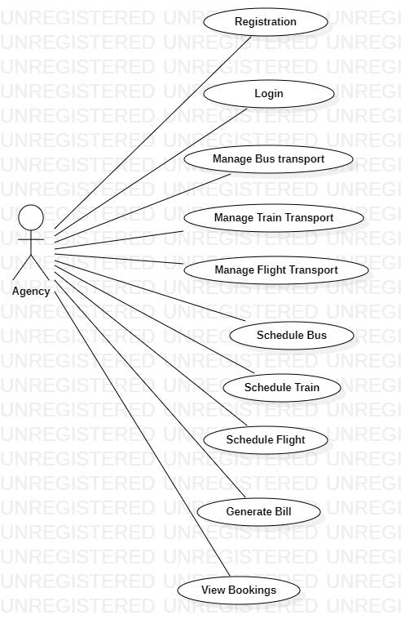

fig.(3)

**ER Diagram**

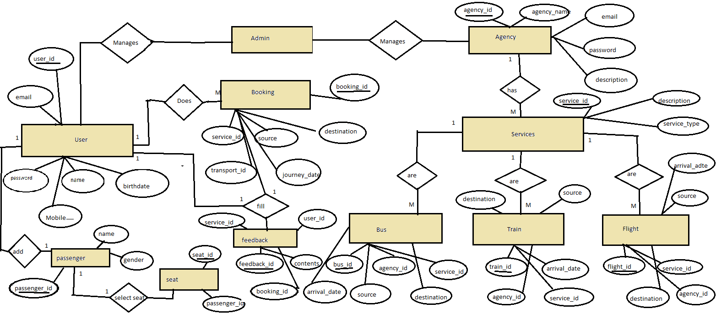

fig. (4)

**Database Design**

fig. (4)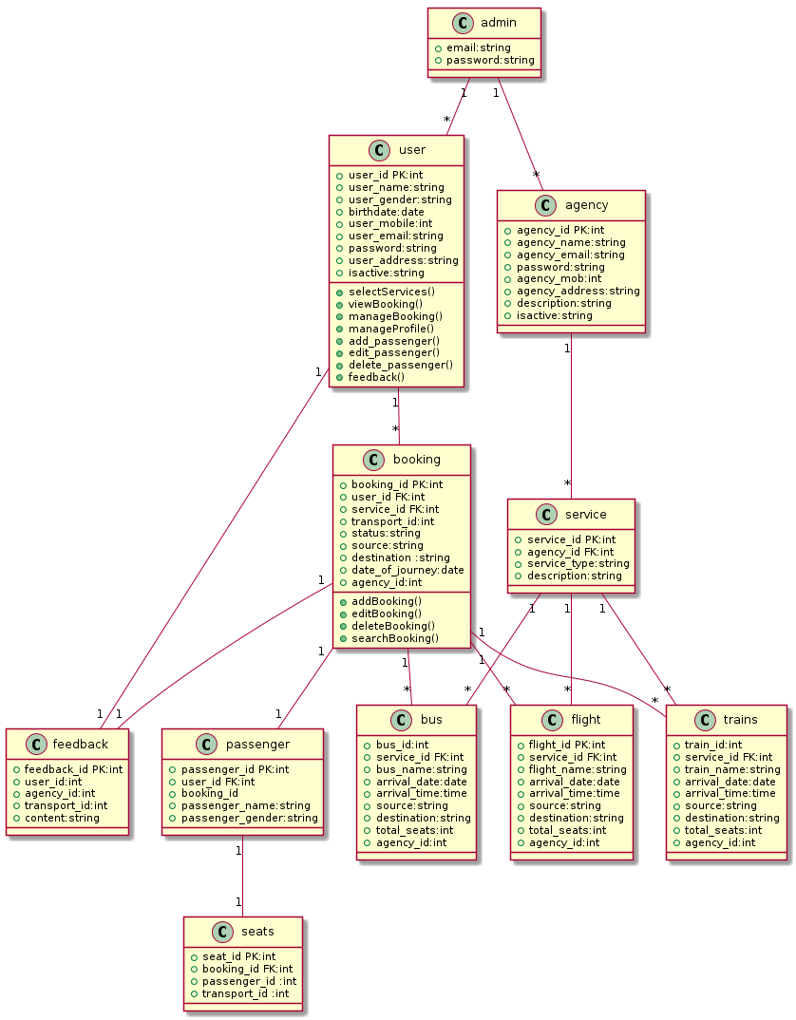

**DFD Diagram**

fig. (5)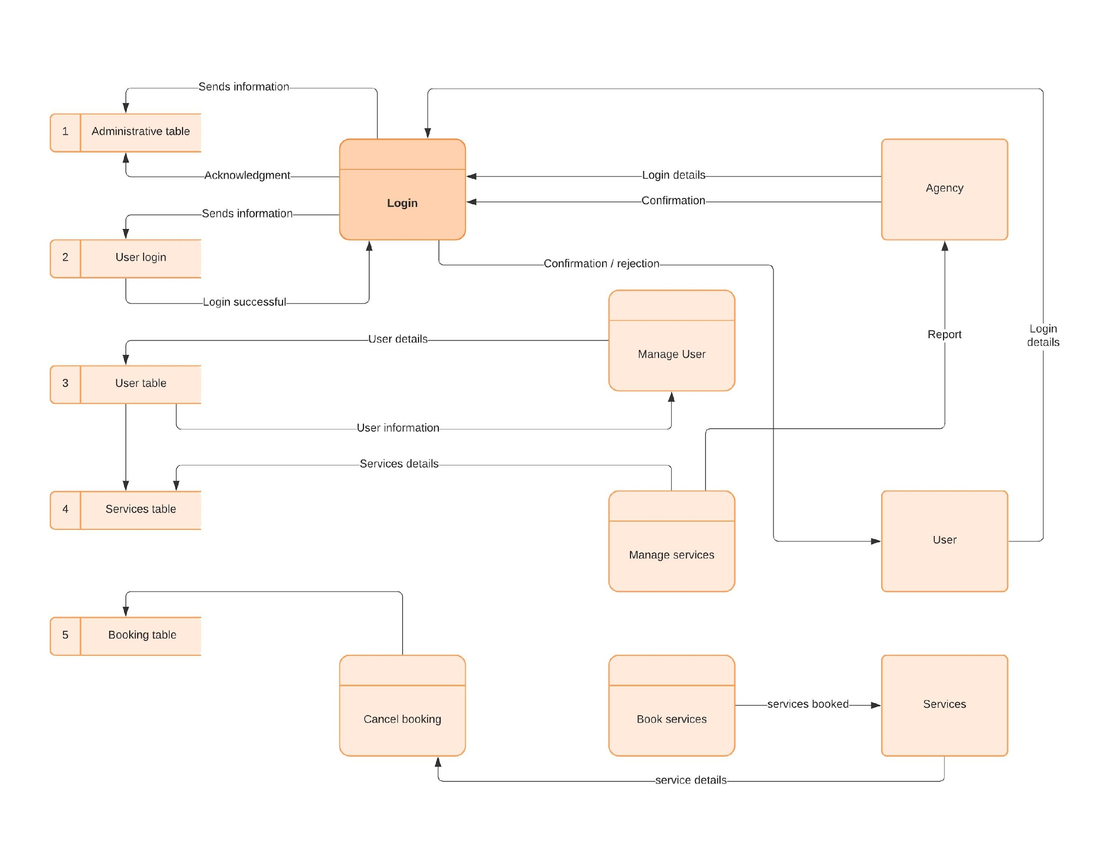

**level 0 (DFD)**

fig. (6)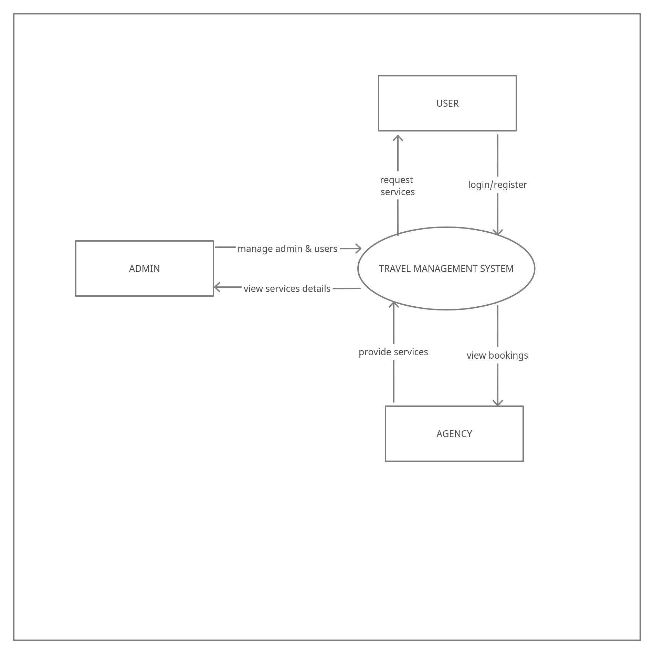

**Project Screenshot**

**Home Page And Login:**

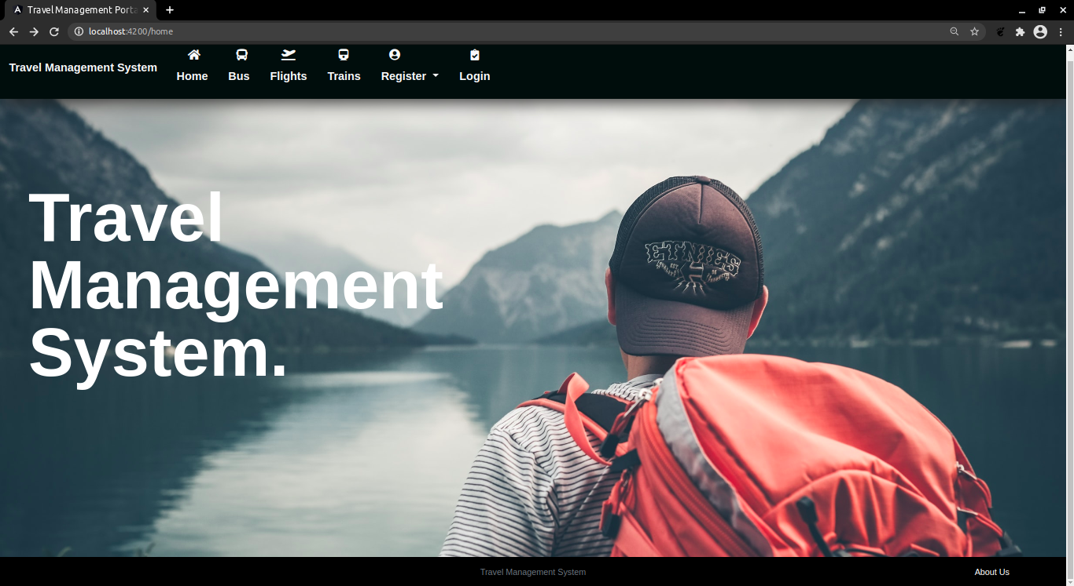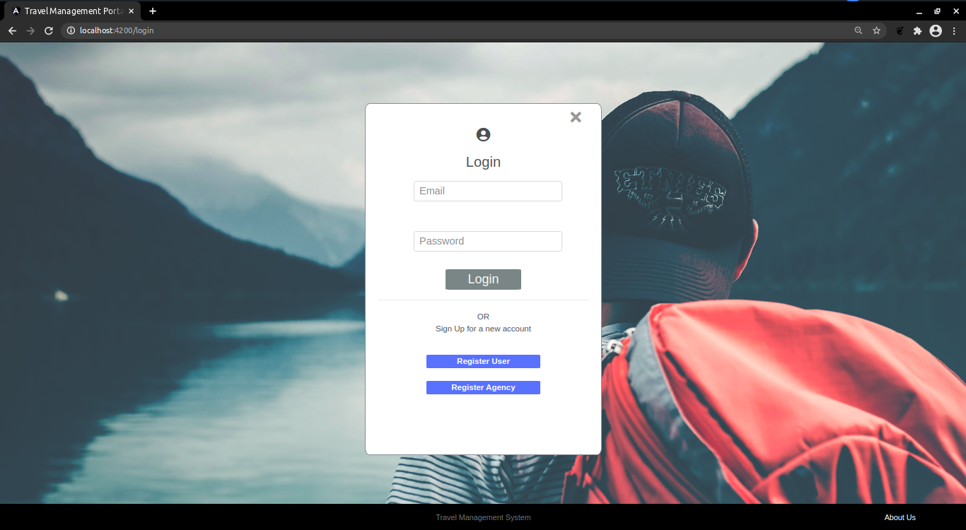

**User:**

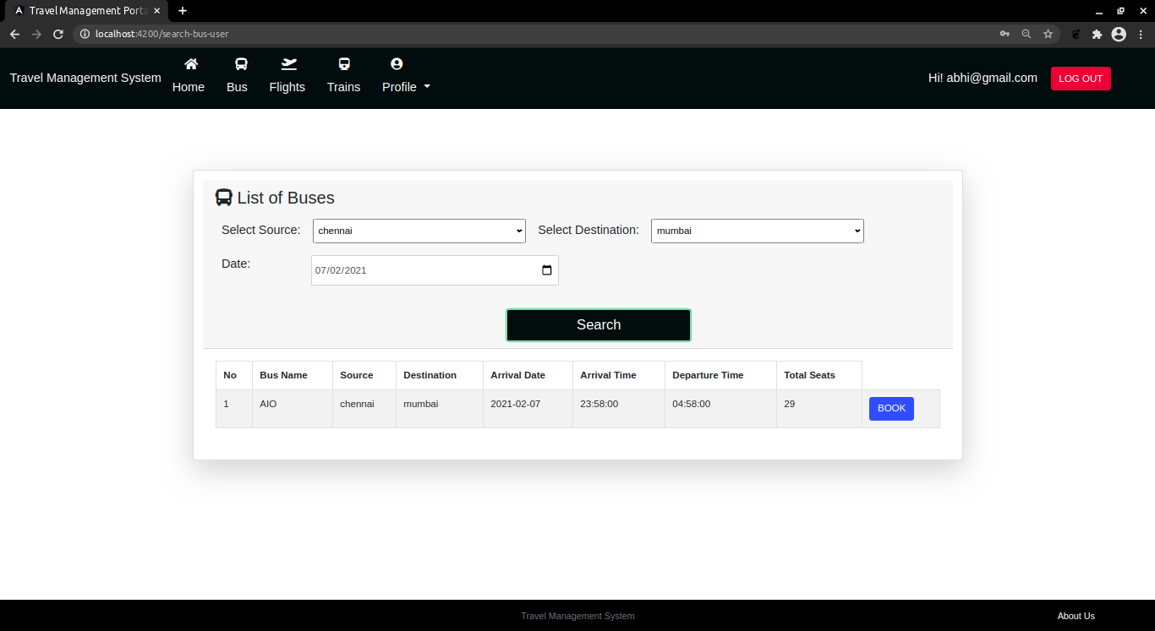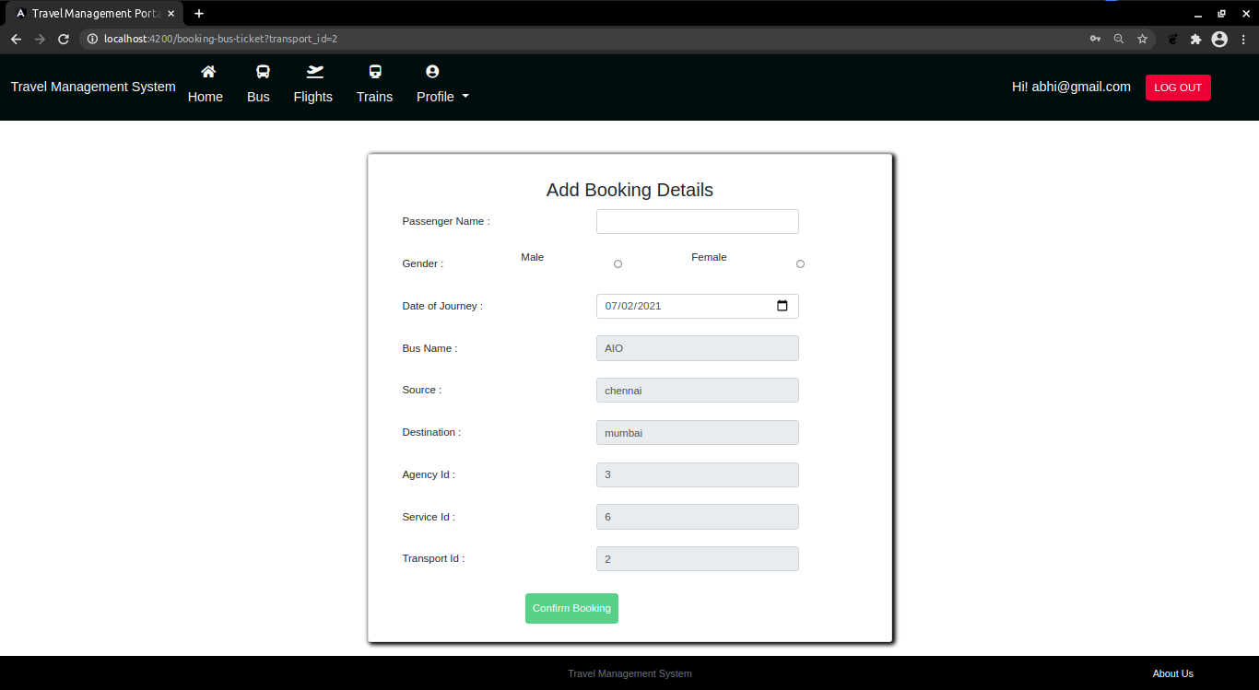

**Admin:**

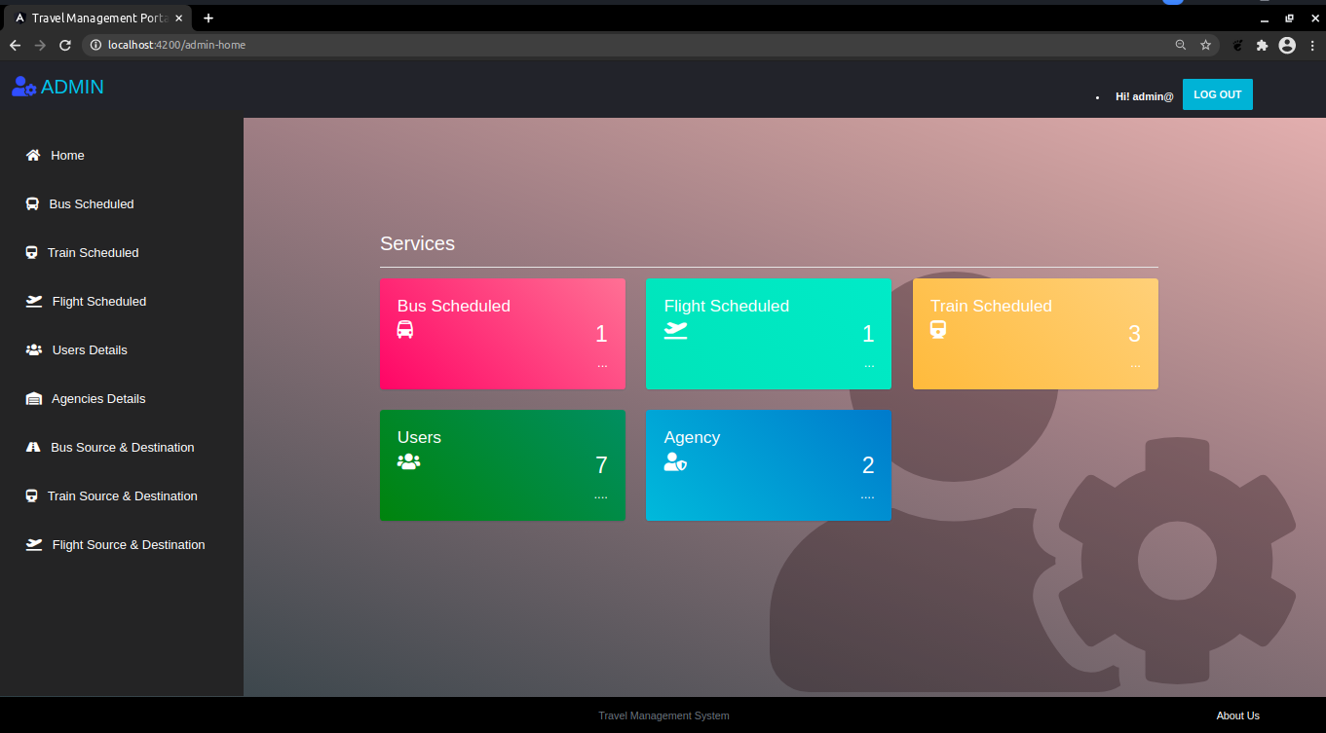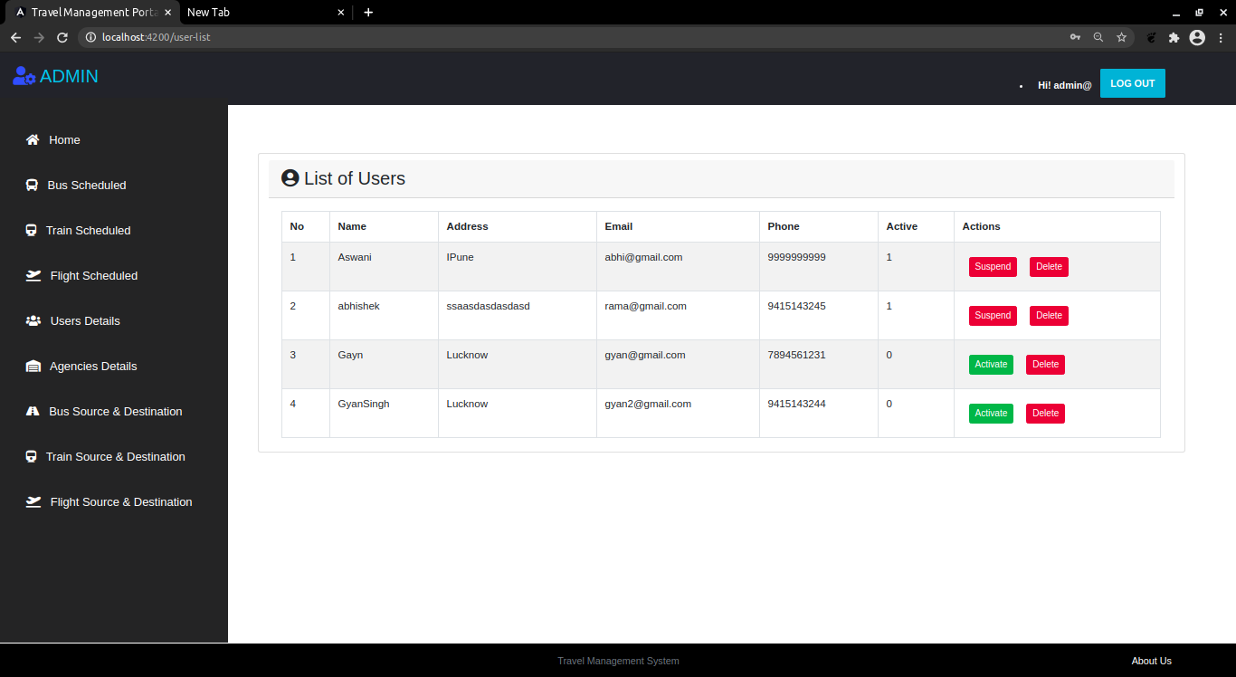

**Agency:**

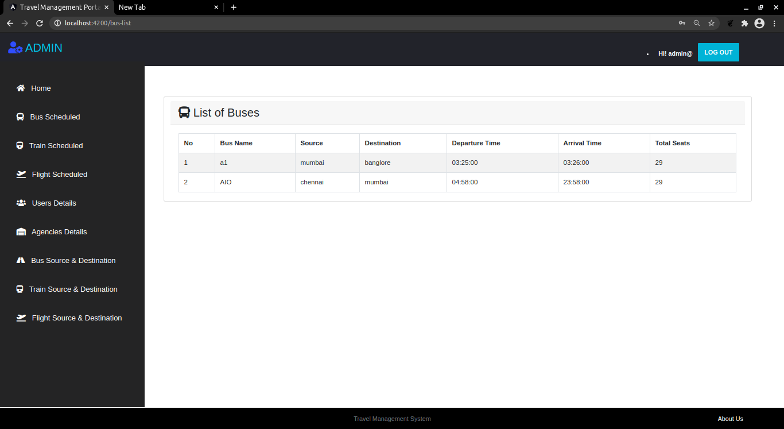

**TEST REPORT**

**Backend**

All the Tables from the pojos of the are created Successfully.

All the repos are created successfully.

All the services of particular pojos are created successfully.

All the Controllers are created successfully.

All the methods mentioned in the Controller are Working as per expected and got Genuine Result.

**Frontend**

All the Dashboard Component are created successfully.

All the routing are done.

Navigation of pages are done successfully, as per Requirement.

All the Component for the Departments created successfully.

All the services are created successfully.

All the methods in services are working as per requirement and got Genuine result.

**CONCLUSION**

Any agency can make use of it for saving customer details in database.

This application can easily implemented under various situations.

We can add new features as and when we require.

Re-usability of this application is also possible.

**REFERENCES**

1. <https://getbootstrap.com/docs/4.0/>

2. <https://www.geeksforgeeks.org/>

3. <https://stackoverflow.com/>

4. Sunbeam Notes

5. Helper codes

6. Recorder Lectures provided by Sunbeam