Open Channel Hydraulics Analysis Tool

Overview
This is HYDRAULICS_CODE.m, a MATLAB/GNU Octave script built to handle the heavy lifting of Open Channel Hydraulics analysis.
Instead of solving complex flow problems by hand, this tool uses iterative numerical methods (like fsolve and fzero) to crunch the numbers for you. Whether you are looking for flow depths, velocities, or energy states, this script covers a wide range of flow regimes and channel geometries.
It runs entirely in the Command Line Interface (CLI). Think of it as a guided calculator: it asks you for inputs step-by-step, helping you model everything from simple normal flows to complex, rapidly varying structures like hydraulic jumps or bridge constrictions.

What It Can Do
The tool is broken down into three main calculation modules, depending on the type of flow you are analyzing:

1. Gradually Varying Flow (GVF)
This module helps you map out water surface profiles over a distance.
- Regime Detection: It automatically figures out if your flow is Subcritical (Mild Slope), Supercritical (Steep Slope), or Critical.
- Profile Calculation: You can calculate exactly how much distance is needed to transition from one depth to another.
- The theory behind: It uses the step method to integrate the dynamic equation of gradually varying flow.

2. Normal Flow (Uniform Flow)
This is your baseline calculator for steady conditions. It solves for Normal Depth (y_{n}), Critical Depth (y_{c}), and the Froude Number (Fr).
- Supported Shapes: Rectangular, Triangular, Circular, and Trapezoidal (accepts Chezy or Manning inputs).
- Complex Shapes: It can even handle composite shapes like triangles combined with semicircles.
- Key Outputs: Beyond depth(normal and critical depth), it provides Critical Slope (S_{c}) and Specific Energy (E_{c}).

3. Rapidly Varying Flow (RVF) & Structures
This module handles the "drama"—local phenomena where flow changes quickly. By applying Momentum and Specific Energy principles, it analyzes:
- Weirs: Handles broad-crested weirs, including checks for upstream/downstream depths and modular limits.
- Constrictions & Expansions: Calculates what happens when the channel suddenly chokes or widens.
- Sluice Gates: Computes the force on the gate, energy dissipation, and where the hydraulic jump will occur.
- Bridges & Piers: Checks for choking and backwater effects caused by bridge supports.
- Spillways & Energy Dissipators: Analyzes flow over spillways and the drag forces caused by baffle blocks.

Getting Started

Prerequisites
You will need MATLAB or GNU Octave to run this.
- MATLAB Users: You likely already have the standard Optimization Toolbox installed.
- Octave Users: Make sure you have the optim package loaded so the solvers (fsolve/fzero) work correctly.

Installation & Usage
- Download: Ensure HYDRAULICS_CODE.m is in your working directory.
- Run: Open MATLAB/Octave and execute the script: HYDRAULICS_CODE
- Navigation: Follow the command prompt instructions. The menu system uses numerical inputs to select options.
  - Example: Enter 1 for GVF, 2 for Normal Flow, etc.
Fig 1, code input
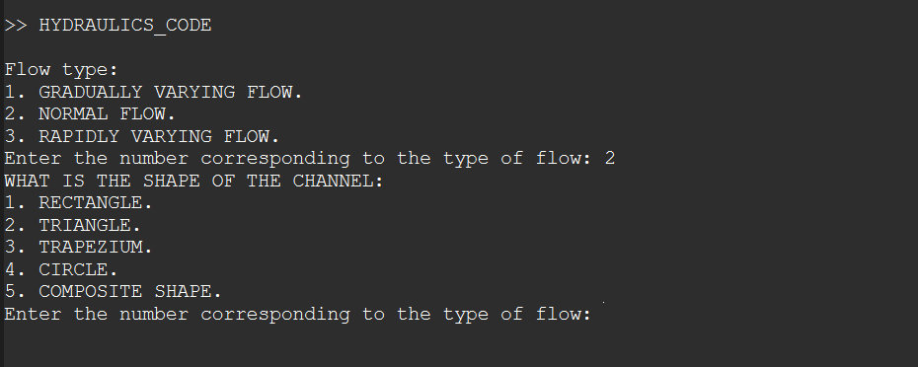

Input Parameters Guide
Ensure all inputs are in SI Units (Meters, Seconds, Cubic Meters).

Parameter | Symbol | Unit | Description
Discharge | Q | m^3/s | Total volumetric flow rate.
Manning's n | n | - | Roughness coefficient of the channel.
Slope | S | m/m | Longitudinal bed slope of the channel.
Width | b | m | Channel bottom width.
Depth | y or h | m | Flow depth.
Gravity | g | m/s^2 | Hardcoded as 9.81.

Technical Implementation

Numerical Solvers
The script relies heavily on root-finding algorithms to solve implicit hydraulic equations (such as the Manning's equation for unknown depth):
- fzero: Used for single-variable non-linear equations.
- fsolve: Used for more complex non-linear systems or when initial guesses are required.

Mathematical Models
- Manning's Equation: For uniform(normal) flow calculations.
- Froude Number (Fr): Used to classify flow as Subcritical (Fr < 1), Critical (Fr = 1), or Supercritical (Fr > 1).
- Specific Energy Equation: E = y + (V^2)/(2g) used for transitions (humps, constrictions).
- Momentum Equation: M = Q^2/gA + z*A used for hydraulic jumps and external forces (drag).

Disclaimer
This project was developed for independent research into Computational Hydraulics. While it uses standard engineering formulas, it is intended for educational and analysis purposes.
Important: Always verify your results against hand calculations or established software (like HEC-RAS) before using them for critical engineering designs.

Project developed for independent research into Computational Hydraulics.

