Short title: Amaranthus Seedbank

Seedbank Longevity of Dioecious Weedy Amaranthus

Author One¹, Author Two², and Author Three³

ORCID iD is required for corresponding author. Provide details for each author of professional affiliation at the time the research was conducted, using this format:
¹Author Job Title (ORCID 0000-000x-xxxx-xxxx), Department (if applicable), Institution, City, State, Province or Territory abbreviation, Country; ²Author Job Title, Department (if applicable), Institution, City, State, Province or Territory abbreviation, Country; and ³Department (if applicable), Institution, City, State, Province or Territory abbreviation, Country

Author for correspondence:
Corresponding Author Name; Email: xxx@institution.edu

Abstract
The dioecious weedy Amaranthus, Palmer amaranth (Amaranthus palmeri S. Watson) and waterhemp (Amaranthus tuberculatus (Moq.) Sauer), have similar morphological traits and exhibit aggressive growth. These species are currently overlapping territories and increasing weed management complexity, which warrants investigation on their ecological basis for their persistence and adaption to cropping systems. A 60-month field study was conducted across Texas to assess the viability of Palmer amaranth and waterhemp seeds buried at 5- and 25-cm depths. A bayesian logistic regression model was fitted to the data. A model selection based on aproximate leave-one-out cross validation was perform to evaluate which factors — species, burial depth and location — influenced seed viablity over time. Results showed that burial depth did not significantly influenced seed viability, while species slighly varied across College Station, Corpus Christi and Lubbock, Texas. The seed viability of both Palmer amaranth and waterhemp sharply decreased in the first 12 burial months across Texas locations. The difference among species-location combinations was not substantial. The time to reach 50% of viable seeds ranged from 5.7 months of waterhemp at College Station to 8.9 months of Palmer amaranth at Lubbock. In addition, the model estimated that for all species-location combinations 99% reduction in seed viability ocurred in less than 48 months. In general, Palmer amaranth had slighly greater longevity than waterhemp. This study suggests that burial depth does not impact seed viability, and Palmer amaranth and waterhemp have short viability once buried in the soil. As a result, depletion of Palmer amaranth and waterhemp seedbank is possible when aggressive short-term weed management tactics are coupled with long-term preventive strategies. These findinds support the developing of integrated weed management strategies to reduce Palmer amaranth and waterhemp pressure to cropping systems in Texas and other geographies.
Keywords: amaranthus, burial depth, integrated weed management, palmer amaranth, persistence, seedbank, seed viability, waterhemp,

Introduction
Amaranthus species are widely distributed across the tropical and temperate regions of the world. The genus currently includes 92 accepted species (Royal Botanic Gardens Kew 2025), classified into three subgenera, Amaranthus, Albersia and Acnida (Mosyakin and Robertson 1996). These subgenera are primarily distinguished by origin, morphology and reproductive biology. Species within Amaranthus and Albersia are predominant monoecious — having both male and female flowers on the same plant — and include cultivated grain amaranths, leafy vegetables and several weedy species, including redroot pigweed (Amaranthus retroflexus L.) and spiny amaranth (Amaranthus spinosus L.) (Mosyakin and Robertson 1996). In contrast, the subgenus Acnida is entirely dioecious, with each individual plant being either male of female (Sauer 1967). This group includes agressive weeds, such as Palmer amaranth (Amaranthus palmeri S. Watson) and waterhemp (Amaranthus tuberculatus (Moq.) Sauer), which are notable for their rapid growth, prolific seed production, and resistance to multiple herbicide modes of action (Roberts and Florentine 2022; Ward et al. 2013; Waselkov et al. 2020). Their biological and ecological traits have made them two of the most troublesome weeds in modern agriculture.
Although their shared reproductive biology and similar morphology, Palmer amaranth and waterhemp are native to distinct regions of North America. Palmer amaranth originates from the Somoran Desert (Ward et al. 2013), while waterhemp is indigenous to the US Midwest (Steckel 2007). This geographical separation may, in part, explain their ecological dominance across different US cropping systems. Palmer amaranth is especially problematic in cotton fields across the southern US, whereas waterhemp is a major weed in corn and soybean production in the US Midwest (Waselkov et al. 2020). The evolution of these native plants as dominant weeds in US row crops is largely driven by a combination of species biology and modern agricultural practices. The widespread adoption of genetically modified crops (e.g., glyphosate-resistant crops) and heavy reliance on herbicide have simplified weed management strategies. As a result, the repeated use of similar control methods has led to weed shifts and accelerated the adaptation of these agressive Amaranthus species into cropping systems.
Both Palmer amaranth and waterhemp have shown a remarkable capacity to adapt to modern agriculture by evolving herbicide resistance. Thus far, Palmer amaranth and waterhemp have evolved resistance to multiple herbicide sites-of-action, including single population stacking four to seven-way resistance (Carvalho-Moore et al. 2025; Hamberg et al. 2024). Beyond their reproducible traits, which contributes to outcrossing and potential gene flow (Oliveira et al. 2018), these species can easily outcomplete crops (Hager et al. 2002; Roberts and Florentine 2022). Moreover, the aggressiveness of dioecious Amaranthus is reported in their plasticity (Oliveira et al. 2022), and capacity to generate offspring, a single plant can produce several hundred of seeds (Schwartz et al. 2016). The prolific seed production of Amaranthus species is a primary factor contributing to their expansion beyond their native ranges. In this first quarter of the century, Palmer amaranth and waterhemp spread was documented into numerous US states (Singh et al. 2020) and even into other continents (Matzrafi et al. 2025; Roberts and Florentine 2022). Both species now overlap in multiple US states. Beyond their evolutionary adaptation to modern agriculture, these species have expanded rapidly through human-mediated mechanisms, including contaminated animal feed, conservation reserve programs and shared farm machinery and other equipment (Waselkov et al. 2020; Yu et al. 2021). In addition, it is reported long seed dispersal, including Palmer amaranth and waterhemp, through wildlife migration (Farmer et al. 2017). Newly introduced Amaranthus species have been found to carry herbicide-resistant traits (Faleco et al. 2022; Kohrt et al. 2017). Once introduced to a new location, Amaranthus seeds are often buried in the soil, where they can persist and establish for extended periods, increasing weed management complexity and costs to control. This warranty studies investigating whether Palmer amaranth and waterhemp dispersal success and fast adaptation in cropping systems is also driven by seedbank longevity and persistence.
The persistence of buried seeds in soil depends on both genetic and environmental factors. Morphological traits, such as coat thickness and their capacity to remain dormant and viable over extended periods (Egley and Chandler 1978). For example, velvetleaf (Abutilon theophrasti Medik.) seeds have shown greater viability and persistence than redroot pigweed after 5.5 years of burial, a difference attributed to their degree of hard seediness (Egley and Chandler 1983). In addition, external factors are critical in seedbank persistence. These factors include burial depth, weather conditions, soil texture, microbial activity, soil management practices and their interactions (Gallandt 2006; Gómez et al. 2014; Wagner and Mitschunas 2022). Seeds of Amaranthus, including Palmer amaranth and waterhemp, species are small in size and easily buried in soil. (Steckel et al. 2007) demonstrates that waterhemp seedbank persistence varied according to soil management practices. Tillage systems promote deeper burial, increasing seed longevity; whereas no-till systems retained seeds near the soil surface, which favors their emergence (Steckel et al. 2007). Similar results have been documented with Palmer amaranth (Korres et al. 2018). In general, no-till practices may lead to higher seedling recruitment from surface seedbank (Bàrberi and Lo Cascio 2001). In contrast, deeper burial may reduce seed germination but enhance dormancy and persistence. Tillage systems are part of integrated weed management and are a recommended practice to reduce Amaranthus species emergence (Leon and Owen 2006). However, the type of tillage equipment and method, reduced or deep, can significantly affect seed placement in the soil profile. While, some studies have shown that burial depth did not impact Amaranthus species viability (Egley and Chandler 1978; Jha et al. 2014), others have showed its influence on viability and persistence (Korres et al. 2018; Sosnoskie et al. 2013). This variability is likely due to differences in depth placement, environmental conditions, duration of burial, and geographic location. Seedbank studies are labor-intensive and challenging due to time required to complete. Despite the challenges, research on seedbank is critical for enhancing our knowledge of weed persistence, reducing reliance on herbicide, and promoting more sustainable weed management practices. Yet, variability in seedbank dynamics across environments and management systems remains poorly understood, particularly in Southern US cropping systems.
A comprehensive study was implemented at three locations in Texas to evaluate the impact of burial depth on dioecious Amaranthus species. Palmer amaranth and waterhemp are currently listed as the most economically important weeds in agronomic crops across the United States. In Texas, Palmer amaranth is an endemic weed, while waterhemp is relatively a newly introduced weed infesting row crops (Werner et al. 2020). This study was designed to investigate the interaction among location, species, and burial depth on seed viability and longevity of these two aggressive weed species. We hypothetized that the seed viability of Palmer amaranth and waterhemp would be similar, but vary within location and burial depth. Therefore, the objective of this study was to evaluate seed longevity of Palmer amaranth and waterhemp buried at 5 and 25 cm deep over a 60-month period at three locations, including College Station, Corpus Christi and Lubbock, Texas. The study was conducted under field conditions representing different agroecosystem regions in Texas. The findings of this research will aid in establishing integrated weed management programs in regions facing increasing pressure from dioecious weed Amaranthus.
Materials and Methods
Plant Material
The Palmer amaranth and waterhemp biotypes used in this study originated from College Station, Texas. These populations are known to pursuit acetolactate synthase and 5-enolpyruvylshikimate-3-phosphate synthase inhibitor herbicide resistance. The seeds were collected in 20XX, cleaned, shipped to the other experimental locations, and stored separately at 5 C until the onset of the experiment.
Site Description
The experiments were conducted from April 2016 to April 2021 at Texas A&M University Farm in College Station (30.54° N, 96.43° W), at Texas A&M AgriLife Research and Extension Center in Corpus Christi (27.78° N, 97.56° W) and at Texas A&M AgriLife Research and Extension Center in Luddock (33.69° N, 101.82° W), representing east-central, south-central and plains region of Texas, respectively (Figure 1). The soil type in Corpus Christi was XXXX, in Corpus Christi was XXX and in Lubock was XXX . In these three region cotton is a predominant crop. At each location, experiments were set up as a randomized complete block design with four replication and arranged in a split-split-plot design. The main plot was two depth of seed burial, including 5 and 25 cm; the sub-plot was the six timing of burial duration, which is 6, 12, 24, 36, 48, and 60 months; and the sub-sub-plot was species, Palmer amaranth and waterhemp. A second experimental run was established adjacent to the first run in October 2018, in a 36-month burial duration, including 6, 12, 24, and 36 months seed burial timing. Monthly air temperature and precipitation were obtained using download_daymet funtion from the daymetr Daymetr package in R (Hufkens et al. 2018). Weather data was documented from 2016 through 2021 across the three locations (Figure 2).
The experimental unit was established using polyvinyl chloride (pvc) cage of 30-cm diameter × 5 cm-depth, with a 2.5-cm lip remaining above the soil surface. Polyvinyl chloride was used to delineate experimental units and to ensure the Palmer amaranth and waterhemp seeds remain intact during the experiment. Two hundred seeds of each species were thoroughly mixed with weed-free soil collected from 20 cm depth at each experimental location. The seed-soil mix were placed in durable nylon micro-mesh bags (10 cm × 15 cm) and completely sealed prior to burial at required depths. A total of 96 bags were buried in late March 2016 in respective soil depth at each location. Each pvc was covered with a mesh to avoid external influence (e.g., rodents and birds) in the experiment.
When a given time-period of burial was reached, micro-mesh bags containing seeds of each species were carefully removed from respectively treatments, placed in brown bags and stored at 4 C. Micro-mesh bags were placed in a box and shipped to the Weed Research laboratory at Texas A&M University for seed viability analysis. In the laboratory, micro-mesh bags with seeds were opened, gently washed, and the seeds recovered from each envelope were transferred to petri dishes. They were then treated with 100 ppm (w/v) captan.
The seeds were incubated under conditions previously identified as favorable for each species, and seed viability was assessed through a series of three tests. Initially, seeds underwent a four-week incubation period, during which the number of germinated seeds was noted. Subsequently, non-germinated seeds from the first test had their seed coats pierced at the radicle end, and these seeds were then subjected to another seven days of incubation. The number of pierced seeds that germinated was recorded. Lastly, non-germinated seeds from the preceding test were treated with 0.3% (w/v) triphenyl tetrazolium chloride (TTC). After an additional seven days of incubation in TTC, the seeds were dissected, and those with pink to red embryos were identified and recorded as viable. Details of the recovery and testing procedure were previously documented (Egley and Chandler 1978, 1983).
The total count of viable seeds comprised the sum of germinated seeds before piercing, germinated seeds after piercing, and seeds with embryos staining pink to red with TTC. The total number of viable seeds (v) comprised the sum of germinated seeds before piercing (g₁), germinated seeds after piercing (g₂), and seeds with embryos staining pink to red with TTC (t). The weed seed germination (%) was calculated as follows:

where is the weed seed germination (%) without piercing, the number of recovered weed seeds that germinated without piercing, and n is the number of buried weed seeds; while the weed seed viability (%) was calculated as follows:

where V is the weed seed viability, v the number of viable seeds (g₁ + g₂), and n is the number of buried weed seeds. The seeds that decayed during burial or weren’t recovered from the soil were noted as non-viable.
Statistical analysis
The statistical analysis were performed using R statistical software version 4.5.1 (R Core Team 2025). After initial assessment, data from the two run were nested prior analysis. Seed viability over time was fitted using a three-parameter Bayesian nonlinear logistic regression model using the brms package (Bürkner 2017), which interfaces with Stan for Bayesian inference (Carpenter et al. 2017). The model equation was:

where Y is seed viability, d is the upper limit, b is the slope, x is the month after burial, and e is the inflection point, representing the time required for viable seeds to decrease by 50% compared to upper limit.
Weakly informative priors were used for model parameters — d, b, e — specific as N(1, 1), N(0.1, 0.1) and N(12, 5), respectively. In biological terms, these priors represens a typical seed viability upper limit at 1 (100%) and standard deviation (sd) of 0.1, seed decay at 0.1 (sd 0.1) and time for 50% reduction in viable seeds at 12 months (sd = 5). Prior sensitive analysis were performed using alternative, less informative priors; however, these resulted in poorer model convergence and unrealistic parameter estimates. Moreover, the model was fitted using four Markov Chain Monte Carlo chains, each with 4000 iterations (2000 warm up), and covergence was confirmed by R̂ < 1.01 and visual inspection of trace plots (Gelman and Rubin 1992; Vehtari et al. 2017). Posterior predictive check were conducted to assess model fit.
The effective time (ET) for reaching 80, 50 and 1% of viable seeds were estimated deriving the fitted Bayesian nonlinear logistic regression model. The ET value was estimated from posterior draws of the fitted Bayesian non-linear model parameters (d, b and e) distributions. It represents the estimated duration (month after burial) required for seed viability to decline to a selected seed viability value (V = 80%, 50%, 1%). The ET values were calculated at each posterior draw using the inverse of the fitted logistic equation:

where V is the target seed viability (%). This equation provided full posterior distributions for each ET estimate, from wich medians and 95% credible intervals (CI) were summarized. These distributions reflect uncertainly in the model parameters, and the (CI) represent the range within the ture ET value is likely to fall, givin the data and model (Makowski et al. 2019).
Pairwise comparisons between treatments were conducted using the difference between the corresponding posterior ET distributions. The probability that one treatment had a higher ET than another, Pr(A > B), was calculated as the proportion of posterior samples where this difference was positive. Values near 0.5 indicate minimal difference, while probabilities approaching 0 and 1 reflect strong evidence for differences in seed viability between treatments (McElreath 2020).
Model selection. To evaluate the influence of species, burial depth and location on seed viability over time, we compared a series of nested non-linear models using an information-theoretic approach based on aproximate leave-one-out cross validation (LOO-CV) (Yates et al. 2023), implemented via the loo package in R (Vehtari et al. 2017). The Full model included an interaction term between species, burial depth and location (species × burial depth × location), while the additive model excluded interaction and included only main effects (species + burial depth + location) without interaction. In addition, reduced models excluded either location, burial depth, species or all factors (intercept-only). Model comparisons were based on differences in expected log predictive density (ELPD). In Bayesian model evaluation, the ELPD represents the expected log-probability that the model assigns to future observations, given the data it was trained on (Vehtari et al. 2017), described as:

where y_{i} is the i-th observed data point; y_{-i} is the data with y_{i} left out (leave-one-out), p(y_{i} | y_{-i}) is the predictive density of y_{i} given the rest of the data, sum is over all n data points. The ELPD measures how well the model predicts; thus, a model with higher ELPD has a better model prediction. The ELPD for each modle was calculated using the using add_criterion function of the brms package in R. Each ELPD estimate is accompanied by a standard error (SE), described as:

where n is the number of observations, ELDP_{i} is the contribution for the i-th data point, and Var is the variance of the pointwise contributions across all observations. A small value of SE shows the ELPD estimate is precise.
When comparing two models, the difference in ELPD (ΔELPD = ELPD_{model A} - ELPD_{model B}) and SE(ΔELPD) was performed using loo_compare function of loo package in R. The ΔELPD is interpreted relative to the SE(ΔELPD). When |ΔELPD| < SE(ΔELPD), there is little to no difference in model predictive performance; when|ΔELPD| ~ 2 × SE(ΔELPD), there is moderate evidence; and when|ΔELPD| ≥ 4 × SE(ΔELPD) there is strong evidence that one model provides better predicting performance (Vehtari et al. 2017).
Goodness of fit. A Bayesian R² (R²_{Bayes}) was conducted to quantify the proportion of variability explained by the models while accounting for posterior uncertainly (Gelman et al. 2019). The R²_{Bayes} was performed using the bayes_R2 function of the brms package in R, using the equation:

where ŷ is the predicted values from the model and ϵ unexplained residual variance. The R²_{Bayes} ranges from 0 to 1 with values closer to 1 indicating better predictive performance. The R²_{Bayes} estimates were reported along with their 95% CI, providing a range which the true proportion of explained variance is likely to lie.
Results and Discussion
Influence of species, burial depth and location on weed seed viability
The Full model, which included interactions among species, burial depth and location was compared against a series of Reduced models to find the major factors affecting seed viability over time in Texas (Table 1). Comparison of the Full to Reduced 1 model (additive effects only) resulted in a |ΔELPD| of 20.5 (SE of 13.2), indicating low to moderate support for the Full model and suggesting that interactions among factors were likely important. Next, the Full was compared to Reduced 2 model (species × burial depth; excluded location), the|ΔELPD|was 40.6 (SE of 15.1), providing moderate support for the Full model. This result highlight that location was an important factor for the model fit. In contrast, the Full model was compared to Reduced 3 model (species × location), which yielded |ΔELPD| of 14.4 (SE 12.6), indicating weak or negligible support for the burial depth as a main effect (Table 1). Thus, Reduced 3 model was retained for further comparison.
Next, Reduced 3 was compared to Reduced 4 (location only), the |ΔELPD| was 30.5 (SE 12.6), suggesting moderate support for including species effects. Finally, Reduced 3 was compared to Reduced 5 model (intercept-only model), which resulted in a|ΔELPD| of 50.7 and SE of 15.5, providing moderate evidence in favor of both species and location. In general, model selection process revealed that species and location interaction was the main factors influencing seed viability over time, while burial depth contributed little to model performance. As a result, data were averaged across burial depths (5 × 25 cm), and analysis focused on differences between species and location. Our initial hypothesis, that seed viability over time would be similar between Palmer amaranth and waterhemp but vary with location and burial depth, was rejected.
The model suggests that seed viability differ significantly by species and location but not by burial depth across Texas. This finding aligns partially with previous research, which documented that the impact of burial depth on seed viability vary depending on species, depth placement and environmental conditions. For example, burying seeds of 20 weed species, including redroot pigweed, at 8, 23 and 38 cm had little to no influence on seed longevity in Mississippi (Egley and Chandler 1983). In contrast, Palmer amaranth seed depth effect was a critical factor influencing seed viability of Palmer amaranth in Georgia, where seeds buried at 1, 2.5, 10 and 40 cm showed significant differences in persistence (Sosnoskie et al. 2013). Similarly, it was reported viability Palmer amaranth and waterhemp seeds buried at 15 cm (5 to 5.3%) slighly higher than seeds on soil surface (4.1 to 4.3%) after 36 months (Korres et al. 2018). Also, (Steckel et al. 2007) observed that waterhemp seeds was less persistent at soil surface compare to deeper burial depths. In general, deeper soil burial provides a more stable environmental conditions for seed, protecting them from temperature, moisture fluctuations, microbial decay, light exposure, and predation (Chee-Sanford et al. 2006). These conditions can slow down seed deterioration and maintain viability over longer periods. In contrast, seeds near the soil surface experience more variable environmental conditions that can enhance recruitment, reduce dormancy or accelerate death.
The little influence of burial effect in our study may reflect regional and soil similarities across Texas locations. Although differences in cumulative precipitation was documented (Figure 2A), the study was established in generally fine-texture soils that supports moderate moisture retention, which may have contributed to the uniform seed decay conditions. Or, it is likely that the depth range used (5 and 25 cm) was not sufficient to detect strong differences in seed viability, and that more pronounced effects might occur in the top soil layers. Further research is needed to understand the causes of the variability in weed seed viability by burial depth, and to identify which factors, such as soil profile, weather conditions, and microbial activity, are critical influencing weed seed persistence.
Although our study did not detect a significant soil burial depth effect, from 5 to 25 cm depth, deeper seed plancement may still promote persistence under certain environments and soil management conditions. Previous research has shown that Amaranthus species tend to persist more under tillage regime, whereas in no-tillage systems, where seeds often remain at the soil surface, both waterhemp and Palmer amaranth can become problematic due to higher germination and survival rates (Steckel et al. 2007; Ward et al. 2013). These weedy Amaranthus species are known to thrive under minimal soil disturbance, allowing seeds to remain in favorable conditions for emergence (Refsell and Hartzler 2009; Steckel et al. 2007). As a result, management practices affecting seed placement in the soil profile are critical for long-term control of Palmer amaranth and waterhemp.
Longevity of Palmer amaranth and waterhemp seedbanks
Both Palmer amaranth and waterhemp are dioecious species, belong to the same genus and produce morphologically similar seedling and seeds, making them challenging to distinguish (Oliveira et al. 2018; Venkataraju et al. 2024). Given these similarities, little or no difference was initially expected between the two species. However, model selection indicated that species effects were present, with seed viability varying slightly across locations.
Seed viability for both Palmer amaranth and waterhemp declined steeply within the first 12 months after burial across all Texas locations (Figure 3). The 95% CI of posterior estimates for the time to reach 80% viable seeds (ET₈₀) ranged from 1.4 to 6.4 months across species and locations (Figure 4A). At ET₈₀, the Palmer amaranth at Lubbock (PA-LBK) exhibited the highest early seed longevity, 5.7 months, which was significantly longer (Pr>0.95) than all other species-location combinations (Figure 4B). A similar trend was observed at ET₅₀, where the median posterior estimate ranged from 5.3 months for waterhemp at Corpus Christi (WH-CC) to 8.9 months for PA-LBK (Figure 4C). In general, Palmer amaranth, except when buried in College Station (PA-CS), showed greater persistence than waterhemp during the early burial period. However, both species reduced their seed viability by 50% in less than 10 months of seed burial, indicating a rapid decay rate for buried Amaranthus seeds under Texas field conditions.
Long-term seedbank persistence, measured as the time to reach 1% seed viability (ET₁), showed variation among locations (Figure 4E). The longest persistence was estimated at 32.6 months [95% CI: 25.5 - 40.0] for Palmer amaranth at Corpus Christi (PA-CC). The second highest longevity was observed for Palmer amaranth at College Staion (PA-CS) and WH-CC, which achieved 1% seed viability approximately 8 months earlier than PA-CC (Pr>0.95) (Figure 4F). Although PA-LBK had the longest ET₈₀ and ET₅₀, it reached ET₁ at 19.9 months, differing significantly (Pr=0.95) only from the WH-LBK, which had the shortest ET₁ at 16.9 months [95% CI: 14.1 - 27.7]. It is striking that both species buried in Lubbock had the shortest persistence. The estimated 95% CI for ET₁ across species ranged from 14.1 to 22 in Lubbock, 16.7 to 29.6 in College Station and 19.2 to 40 months in Corpus Christi. The lower persistence in Lubbock may be attributed to the lowest cumulative precipitation (Figure 2A) and highest temperature amplitude (Figure 2B) among locations during the study period. It is likely that reduced moisture and temperature variation accelarate seed germination, mortality or microbial decay. These findings demonstrate that Amaranthus seed longevity is influenced by both species and geographic burial environment, with site-specific variation a critical factor in seedbank persistence.
Our study suggests that buried seeds of Palmer amaranth and waterhemp lose 99% of their seed viability in less than 48 months. This relatively short persistence suggests that their ecological dominance in cropping systems is primarily due to their prolific seed production rather than extended seedbank longevity. Species such as velvetleaf is documented with longer seedbank persistence (Lueschen et al. 1993). Buried velveltleaf seeds in soil can alternate between permeable and impermeable states, which increases longevity (Lueschen and Andersen 1980). However, persistence alone does not determine weediness. Velvetleaf, despite its long-lived seedbank and commonly found weed, is not currently considered a major management challenge. In contrast, short-lived seeds of Palmer amaranth and waterhemp, coupled with their high fecundity and adaptability, make them difficult to control once established.
The relatively rapid loss in seed viability observed here supports the use of weed management tactics that prevent seed return to the soil. Integrated weed management programs — such as early weed detection, prevention of weed germination with cover crops, control of germinated seedlings using effective herbicides, monitoring and limiting seed return from weed escapes through harvest weed seed control — could substantially reduce Amaranthus seedbanks within four years. This was demonstrated in Minnesota, where newly introduced Palmer amaranth populations were successfully eradicated under a zero-tolerance approach (Yu et al. 2021). Nevertheless, weed monitoring is important as germination of redroot pigweed, an Amaranthus species, was reported after 40 years of seed burial (Darlington and Steinbauer 1961). In addition, as a prolific seed producer, even a residual 1% of viable seeds may sustain reinfestation. Thus, consistent multi-year efforts to prevent seed input remain essential for long-term management of Palmer amaranth and waterhemp in Texas cropping systems and other geographies.
This study demonstrated that Palmer amaranth and waterhemp seedbank declined to near zero within four years at both 5 and 25 cm burial depth. These findings shed a light on ecological basis for the persistence and adaptation of these species to cropping systems. Moreover, this result indicates that seedbank management of established Palmer amaranth and waterhemp populations in row crops is feasible when effective and intergrated weed management strategies are implemented. Preventive and long-term practices that minimize seed production and dispersal should remain a priority for integrated weed management.
Acknowledgments
Individuals who contributed to the research but who do not meet the criteria for authorship may be acknowledged in this section.

Funding
Authors must disclose all funding received to support the research described in the manuscript by describing and acknowledging funding sources in this section. Where no specific funding was provided for research, provide the following statement: "This research received no specific grant from any funding agency, commercial or not-for-profit sectors."

Competing Interests
A competing interest declaration is required. Competing interests are situations that could be perceived to exert an undue influence on the content or publication of an author’s work. They may include, but are not limited to, financial, professional, contractual, or personal relationships or situations. If the manuscript has multiple authors, include competing interest declarations relevant to all contributing authors. Example: “Competing interests: Author 1 is employed at organization A, Author 2 is on the Board of company B and is a member of organization C. Author 3 has received grants from company D.” If no competing interests exist, the declaration should state “Competing interests: The author(s) declare none."

References
Bàrberi P, Lo Cascio B (2001) Long-term tillage and crop rotation effects on weed seedbank size and composition. Weed Res 41:325–340
Bürkner P-C (2017) brms: An R Package for Bayesian Multilevel Models Using Stan. J Stat Softw 80:1–28
Carpenter B, Gelman A, Hoffman MD, Lee D, Goodrich B, Betancourt M, Brubaker M, Guo J, Li P, Riddell A (2017) Stan: A Probabilistic Programming Language. J Stat Softw 76:1–32
Carvalho-Moore P, Norsworthy JK, Barber LT, Meiners I, Porri A (2025) Full-season herbicide programs to control a seven-way-resistant Palmer amaranth accession under soybean technologies. Weed Technol:1–28
Chee-Sanford JC, Ii MMW, Davis AS, Sims GK (2006) Do microorganisms influence seed-bank dynamics? Weed Sci 54:575–587
Darlington HT, Steinbauer GP (1961) The Eighty-Year Period for Dr. Beal’s Seed Viability Experiment. Am J Bot 48:321–325
Egley GH, Chandler JM (1978) Germination and Viability of Weed Seeds After 2.5 Years in a 50-Year Buried Seed Study. Weed Sci 26:230–239
Egley GH, Chandler JM (1983) Longevity of Weed Seeds After 5.5 Years in the Stoneville 50-Year Buried-Seed Study. Weed Sci 31:264–270
Faleco FA, Oliveira MC, Arneson NJ, Renz M, Stoltenberg DE, Werle R (2022) Multiple herbicide resistance in waterhemp (Amaranthus tuberculatus) accessions from Wisconsin. Weed Technol 36:597–608
Farmer JA, Webb EB, Pierce II RA, Bradley KW (2017) Evaluating the potential for weed seed dispersal based on waterfowl consumption and seed viability. Pest Manag Sci 73:2592–2603
Gallandt ER (2006) How can we target the weed seedbank? Weed Sci 54:588–596
Gelman A, Rubin DB (1992) Inference from Iterative Simulation Using Multiple Sequences. Stat Sci 7:457–472
Gómez R, Liebman M, Munkvold G (2014) Weed seed decay in conventional and diversified cropping systems. Weed Res 54:13–25
Hager AG, Wax LM, Stoller EW, Bollero GA (2002) Common waterhemp (Amaranthus rudis) interference in soybean. Weed Sci 50:607–610
Hamberg RC, Yadav R, Hartzler R, Owen MDK (2024) Confirmation of a four-way herbicide-resistant Palmer amaranth (Amaranthus palmeri) population in Iowa. Weed Sci 72:330–338
Hufkens K, Basler D, Milliman T, Melaas EK, Richardson AD (2018) An integrated phenology modelling framework in r. Methods Ecol Evol 9:1276–1285
Jha P, Norsworthy JK, Garcia J (2014) Depletion of an Artificial Seed Bank of Palmer Amaranth (Amaranthus palmeri) over Four Years of Burial. Am J Plant Sci 05:1599–1606
Kohrt JR, Sprague CL, Nadakuduti SS, Douches D (2017) Confirmation of a Three-Way (Glyphosate, ALS, and Atrazine) Herbicide-Resistant Population of Palmer Amaranth (Amaranthus palmeri) in Michigan. Weed Sci 65:327–338
Korres NE, Norsworthy JK, Young BG, Reynolds DB, Johnson WG, Conley SP, Smeda RJ, Mueller TC, Spaunhorst DJ, Gage KL, Loux M, Kruger GR, Bagavathiannan MV (2018) Seedbank Persistence of Palmer Amaranth (Amaranthus palmeri) and Waterhemp (Amaranthus tuberculatus) across Diverse Geographical Regions in the United States. Weed Sci 66:446–456
Leon RG, Owen MDK (2006) Tillage systems and seed dormancy effects on common waterhemp (Amaranthus tuberculatus) seedling emergence. Weed Sci 54:1037–1044
Lueschen WE, Andersen RN (1980) Longevity of Velvetleaf (Abutilon theophrasti) Seeds in Soil under Agricultural Practices. Weed Sci 28:341–346
Lueschen WE, Andersen RN, Hoverstad TR, Kanne BK (1993) Seventeen Years of Cropping Systems and Tillage Affect Velvetleaf (Abutilon theophrasti) Seed Longevity. Weed Sci 41:82–86
Makowski D, Ben-Shachar MS, Lüdecke D (2019) bayestestR: Describing Effects and their Uncertainty, Existence and Significance within the Bayesian Framework. J Open Source Softw 4:1541
Matzrafi M, Scarabel L, Milani A, Iamonico D, Torra J, Recasens J, Montull JM, Llenes JM, Gazoulis I, Tataridas A, Rubin B, Pardo G, Cirujeda A, Marí AI, Mennan H, Kanatas P, Dogan MN, Beffa R, Travlos I (2025) Amaranthus palmeri S. Watson: A new threat to agriculture in Europe and the Mediterranean region. Weed Res 65:e12596
McElreath R (2020) Statistical Rethinking: A Bayesian Course with Examples in R and STAN. 2nd ed. New York: Chapman and Hall/CRC. 612 p
Mosyakin SL, Robertson KR (1996) New infrageneric taxa and combinations in Amaranthus (Amaranthaceae). Ann Bot Fenn 33:275–281
Oliveira MC, Gaines TA, Patterson EL, Jhala AJ, Irmak S, Amundsen K, Knezevic SZ (2018) Interspecific and intraspecific transference of metabolism-based mesotrione resistance in dioecious weedy Amaranthus. Plant J 96:1051–1063
Oliveira MC, Jhala AJ, Bernards ML, Proctor CA, Stepanovic S, Werle R (2022) Palmer Amaranth (Amaranthus palmeri) Adaptation to US Midwest Agroecosystems. Front Agron 4
R Core Team (2025) R: A Language and Environment for Statistical Computing. R. Vienna, Austria: R Foundation for Statistical Computing
Refsell DE, Hartzler RG (2009) Effect of Tillage on Common Waterhemp (Amaranthus rudis) Emergence and Vertical Distribution of Seed in the Soil. Weed Technol 23:129–133
Roberts J, Florentine S (2022) A review of the biology, distribution patterns and management of the invasive species Amaranthus palmeri S. Watson (Palmer amaranth): Current and future management challenges. Weed Res 62:113–122
Royal Botanic Gardens Kew (2025) Amaranthus L. https://powo.science.kew.org/taxon/urn:lsid:ipni.org:names:327362-2
Sauer JD (1967) The Grain Amaranths and Their Relatives: A Revised Taxonomic and Geographic Survey. Ann Mo Bot Gard 54:103–137
Schwartz LM, Norsworthy JK, Young BG, Bradley KW, Kruger GR, Davis VM, Steckel LE, Walsh MJ (2016) Tall Waterhemp (Amaranthus tuberculatus) and Palmer amaranth (Amaranthus palmeri) Seed Production and Retention at Soybean Maturity. Weed Technol 30:284–290
Singh V, Garetson R, McGinty J, Dotray P, Morgan G, Nolte S, Bagavathiannan M (2020) Distribution of herbicide-resistant waterhemp ( Amaranthus tuberculatus ) across row crop production systems in Texas. Weed Technol 34:129–139
Sosnoskie LM, Webster TM, Culpepper AS (2013) Glyphosate Resistance Does Not Affect Palmer Amaranth (Amaranthus palmeri) Seedbank Longevity. Weed Sci 61:283–288
Steckel LE (2007) The Dioecious Amaranthus spp.: Here to Stay. Weed Technol 21:567–570
Steckel LE, Sprague CL, Stoller EW, Wax LM, Simmons FW (2007) Tillage, Cropping System, and Soil Depth Effects on Common Waterhemp (Amaranthus rudis) Seed-Bank Persistence. Weed Sci 55:235–239
Vehtari A, Gelman A, Gabry J (2017) Practical Bayesian model evaluation using leave-one-out cross-validation and WAIC. Stat Comput 27:1413–1432
Venkataraju A, Arumugam D, Kiran R, Peters T (2024) Automated approaches for the early stage distinguishing of Palmer amaranth from waterhemp. Front Agron 6
Wagner M, Mitschunas N (2022) Soil Microbial Effects on Weed Seedbank Persistence. Pages 244–270 in Persistence Strategies of Weeds. John Wiley & Sons, Ltd
Ward SM, Webster TM, Steckel LE (2013) Palmer Amaranth (Amaranthus palmeri): A Review. Weed Technol 27:12–27
Waselkov KE, Regenold ND, Lum RC, Olsen KM (2020) Agricultural adaptation in the native North American weed waterhemp, Amaranthus tuberculatus (Amaranthaceae). PLOS ONE 15:e0238861
Werner K, Sarangi D, Nolte S, Dotray P, Bagavathiannan M (2020) Late-season surveys to document seed rain potential of Palmer amaranth (Amaranthus palmeri) and waterhemp (Amaranthus tuberculatus) in Texas cotton. PLOS ONE 15:e0226054
Yates LA, Aandahl Z, Richards SA, Brook BW (2023) Cross validation for model selection: A review with examples from ecology. Ecol Monogr 93:e1557
Yu E, Blair S, Hardel M, Chandler M, Thiede D, Cortilet A, Gunsolus J, Becker R (2021) Timeline of Palmer amaranth (Amaranthus palmeri) invasion and eradication in Minnesota. Weed Technol 35:802–810
Table 1. Model comparison based on expected log predictive density (ELPD) and standard error (SE) across nested formulations of species, burial depth, and location effects on seed viability of Palmer amaranth and waterhemp. Models were evaluated under 5 cm and 25 cm burial depths at three experimental sites, College Station, Corpus Christi and Lubbock, Texas. Goodness of fit based on Bayesian R² was provided for each model.
 |  | Model selection |  |  |  |  | Goodness of fit
Model | Term | ELPD | SE(ELPD) | ΔELPD vs Best | SE(ΔELPD) | Retainedª | R²_{Bayes} [95% CI^{b}]
Full | species × burial depth × location | 430.7 | 36.2 | 0 | 0 | Full (initial) | 0.896 [0.891-0.900]
Reduced 1 | species + burial depth + location | 410.2 | 35.3 | -20.5 | 13.2 | Full | 0.889 [0.885-0.893]
Reduced 2 | species × burial depth | 390.1 | 33.7 | -40.6 | 15.1 | Full | 0.882 [0.877-0.886]
Reduced 3 | species × location | 416.3 | 35.6 | -14.4 | 12.6 | Reduced 3 | 0.890 [0.885-0.894]
Reduced 4 | location | 385.7 | 35.8 | -30.5 | 12.6 | Reduced 3 | 0.879 [0.873-0.883]
Reduced 5 |  | 365.5 | 33.8 | -50.7 | 15.5 | Reduced 3 (final) | 0.872 [0.866-0.876]
ª When |ΔELPD| < SE(ΔELPD), there is little to no difference in model predictive performance; when |ΔELPD| ~ 2 × SE(ΔELPD), moderate evidence; and when|ΔELPD| ≥ 4 × SE(ΔELPD) strong evidence for the better predicting model.
^{b} Credible Intervals
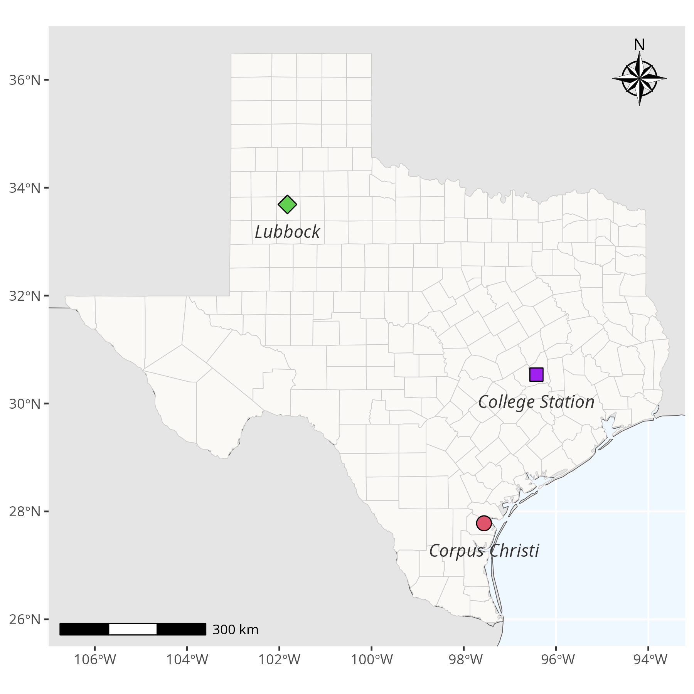

Figure 1. Map showing the experimental locations in College Station, Corpus Christi, and Lubbock, Texas, where the Palmer amaranth and waterhemp seed viability study was conducted.
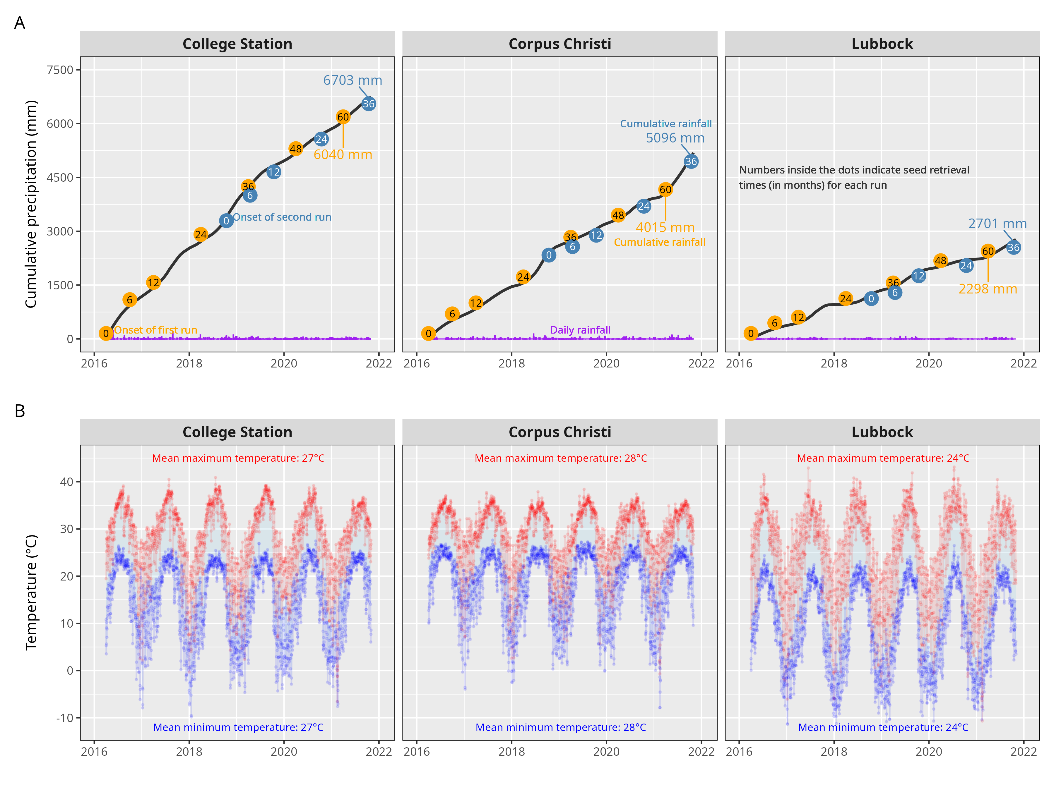
Figure 2. Cumulative precipitation (A) and temperature (B) recorded during the period of Palmer amaranth and waterhemp seed viability study in College Station, Corpus Christi and Lubbock, Texas.

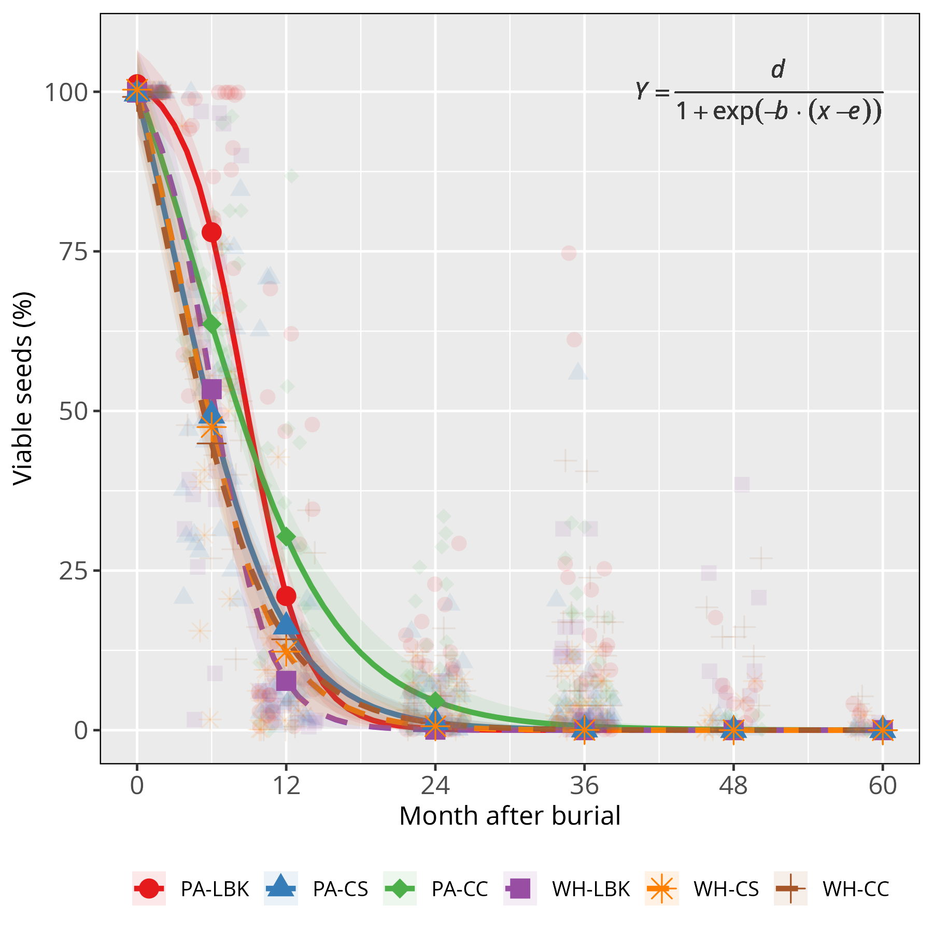

Figure 3. Bayesian nonlinear logistic regression model showing viable seeds of species and location interaction over a 60-month period. For simplicity, Palmer amaranth at Lubbock (PA-LBK), Palmer amaranth at College Station (PA-CS), Palmer amaranth at Corpus Christi (PA-CC), waterhemp at Lubbock (WH-LBK), waterhemp at College Station (WH-CS), waterhemp at Corpus Christi (WH-CC).
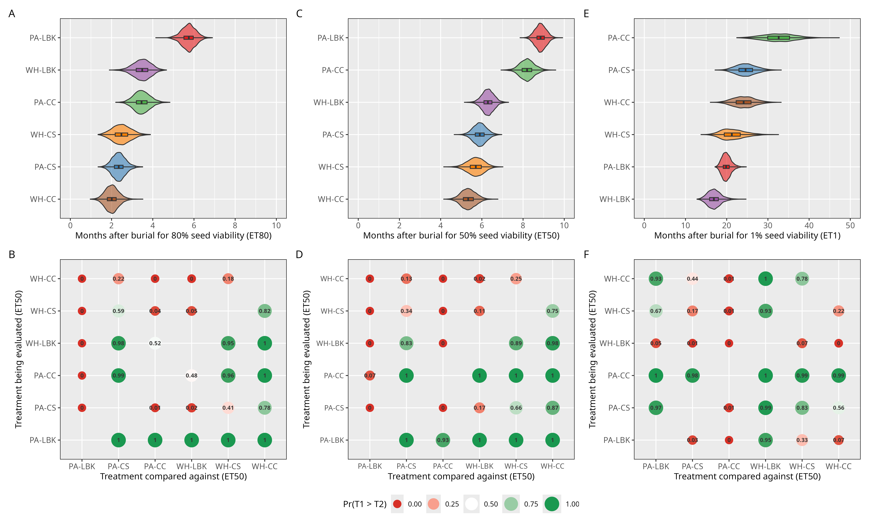
Figure 4. Violin plots with embedded box plots showing posterior distributions of ET₈₀ (A), ET₅₀ (C), and ET₁ (E) estimates for species-location combinations. A heat map summarizes pairwise comparison probabilities (Pr) between treatments of ET₈₀ (B), ET₅₀ (D), and ET₁ (F), indicating the likelihood that one treatment has a higher ET than another. For simplicity, Palmer amaranth at Lubbock (PA-LBK), Palmer amaranth at College Station (PA-CS), Palmer amaranth at Corpus Christi (PA-CC), waterhemp at Lubbock (WH-LBK), waterhemp at College Station (WH-CS), waterhemp at Corpus Christi (WH-CC).

