**Streamlit Documentation**

Objective Function for a Clinic maximizing profit:

Where:

* = Trading
  + = Sales | Basic Scaling
  + = Sales | Consultation
  + = Sales | Periodontal Treatment
  + = Sales | Restoration
  + = Sales | Tooth Extraction
* = Sales Discount
  + = Sales Discount | Basic Scaling
  + = Sales Discount | Consultation
  + = Sales Discount | Periodontal Treatment
  + = Sales Discount | Restoration
  + = Sales Discount | Tooth Extraction
* = Debit Charge
  + = Debit Charge | Basic Scaling
  + = Debit Charge | Consultation
  + = Debit Charge | Periodontal Treatment
  + = Debit Charge | Restoration
  + = Debit Charge | Tooth Extraction
* = Trading Count
  + = Sales Count | Basic Scaling
  + = Sales Count | Consultation
  + = Sales Count | Periodontal Treatment
  + = Sales Count | Restoration
  + = Sales Count | Tooth Extraction
* = Cost of Goods Sold
  + = Cost of Goods Sold | Basic Scaling
  + = Cost of Goods Sold | Consultation
  + = Cost of Goods Sold | Periodontal Treatment
  + = Cost of Goods Sold | Restoration
  + = Cost of Goods Sold | Tooth Extraction
* = Other Income
* = Operating Expenses
* = Other Expenses | Sum of:
  + Operational Expense
  + Advertising & Promotion Expense
  + Wages & Salaries Expense
  + Bank Administration Expense
  + Legal Expense
  + Utility Expense
  + Transportation Expense
  + Consumption Expense
  + PBB Expenses
  + Entertainment Expense
  + Internet Expense
  + Rent Expense
  + Training Expense
  + Office Supply Expense
  + Clinic Supply Expense
  + Other Expense
  + Renovation Expense
  + Software Expense
  + Waste Disposal Expense
* = Total General Expenses | Sum of:
  + Depreciation of Equipment Clinic Expense
  + Depreciation of Equipment Non Clinic Expense
  + Bank Tax Expense
  + PPh 21 Expense
  + PPh 23 Expense
  + PPh 4(2) Expense
  + VAT Expense

Optimizing Revenue per month:

Assumption example:

* Work 8 hours/day x 22 days/month = 176 hours
* Total Worker/labor = 4
* Total Hour/Month = 176 x 4 = 704 hours
* All of expense for a month



Subject to:

Custom projection Financial Simulation:

Subject to:

Where :

· *yn*= Service revenue (already deducted by sales discount, debit charge and COGS)

· *xi*= Number of services performed

· *tn*= Service time in hours

Streamlit Simulation:  
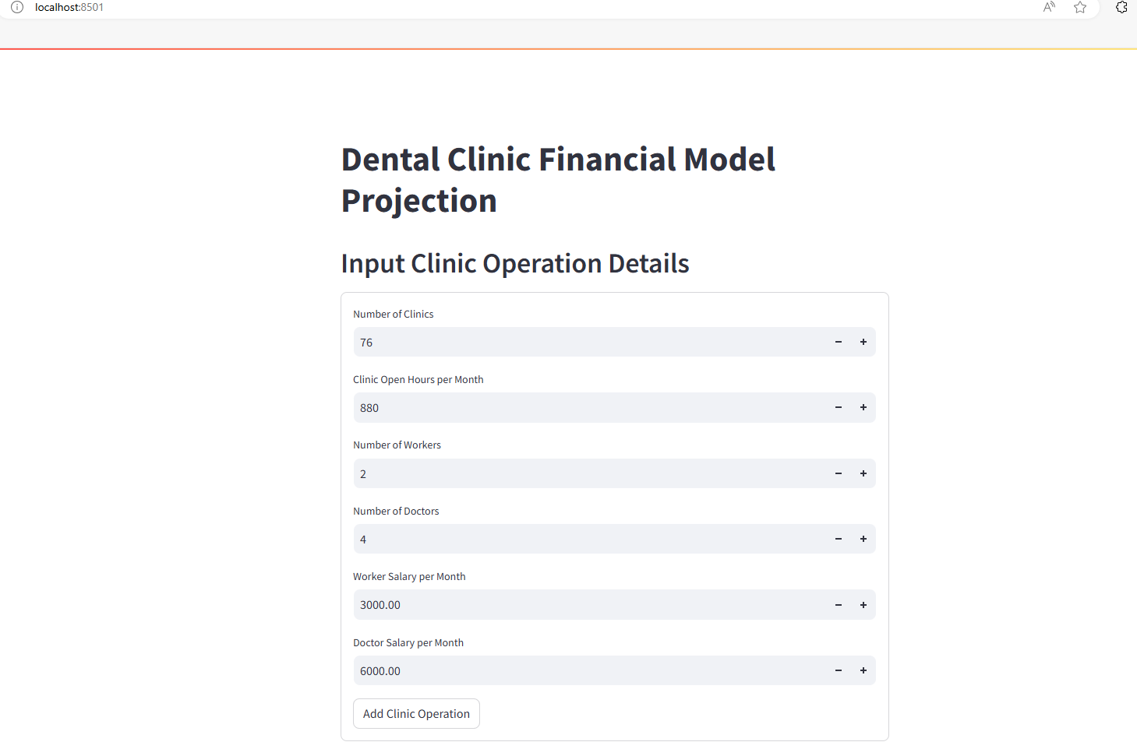

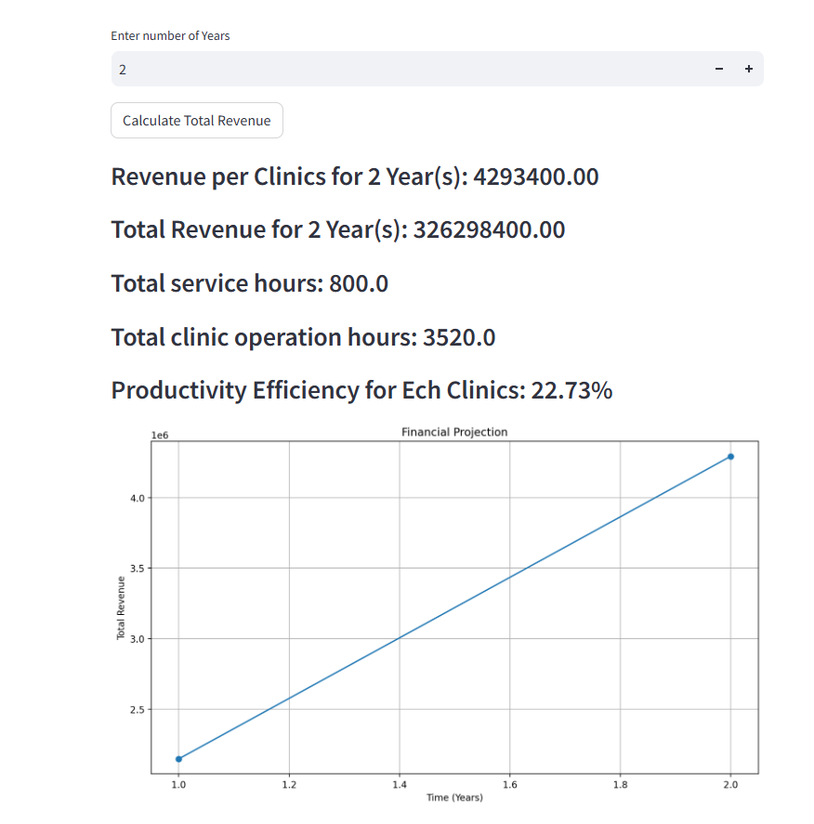

Optimization Page:

* Using Genetic Algorithm  
    
  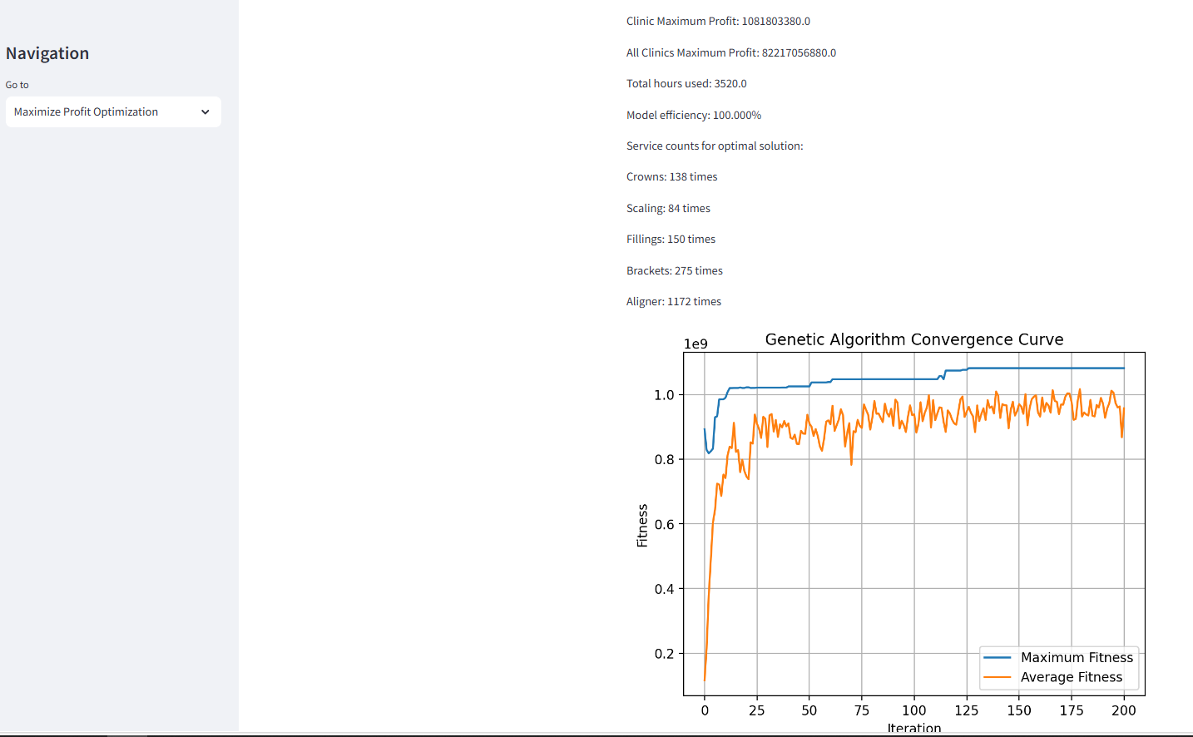

Best Result example::

Best individual: [3197, 595, 456, 117, 1336, 0, 0, 1, 0, 2, 1, 0, 0, 0, 0, 0, 0, 0]

Maximum Profit: 2060713333.0

Maximum Profit for All clinics: 156614213308.0

Total hours used: 3519.783

Model Efficiency: 99.99%

Basic Scaling (0.7 hours): 3197 times -> Total: 2237.900 hours

Dental Spa (0.3 hours): 595 times -> Total: 178.500 hours

Prevention Seal (0.333 hours): 456 times -> Total: 151.848 hours

Consultation (0.5 hours): 117 times -> Total: 58.500 hours

Membership Consultation Perk (0.667 hours): 1336 times -> Total: 891.112 hours

Mouth Guard (0.75 hours): 0 times -> Total: 0.000 hours

Wear Protect (0.75 hours): 0 times -> Total: 0.000 hours

Advanced Gum Treatment (1.0 hours): 1 times -> Total: 1.000 hours

Basic Gum Treatment (0.75 hours): 0 times -> Total: 0.000 hours

Basic X-ray (0.083 hours): 2 times -> Total: 0.166 hours

Advanced Filling (0.5 hours): 1 times -> Total: 0.500 hours

Basic Filling (1.083 hours): 0 times -> Total: 0.000 hours

Root Canal Treatment (1.5 hours): 0 times -> Total: 0.000 hours

Premium Bridge (1.5 hours): 0 times -> Total: 0.000 hours

Premium Crown (1.5 hours): 0 times -> Total: 0.000 hours

Dental Post & Core (1.5 hours): 0 times -> Total: 0.000 hours

Additional Root (1.0 hours): 0 times -> Total: 0.000 hours

Basic Tooth Extraction (0.667 hours): 0 times -> Total: 0.000 hours

* Clinics information input to formulate the maximum profit optimization model

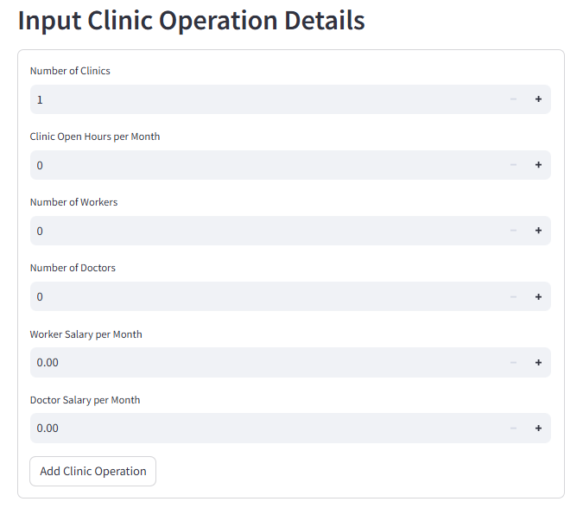

* Add csv upload to upload service list data

We can upload service list data to the app to make the process more convenient, the app will take data with column name of:  
 [‘Treatment Menu names’, ‘Price’, ‘Duration’, ‘COGS’, ‘Discount Rate’, ‘Debit Charge’]

Before upload we need to choose duration type (Minutes/Hour), our data using minute

We can use Service_list.xlsx file in this G-Drive AI Team/Financial Model/Used Data

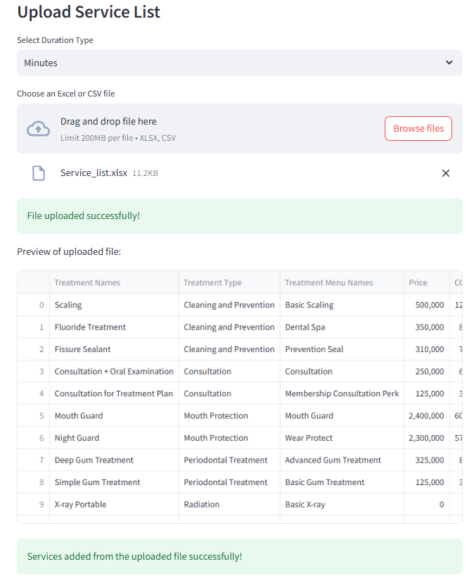

* Costs/Expenses data input

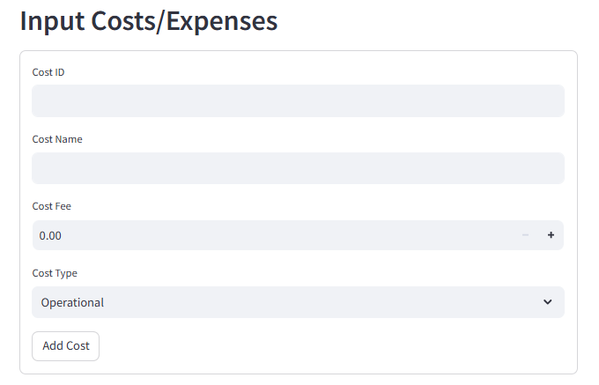

* Two models
  + General Model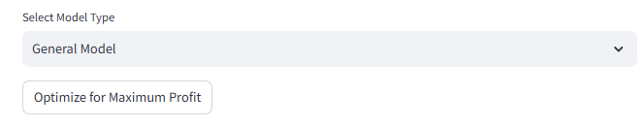

Model Focus on the best service with profit to duration ratio so those model will appear more than model with lower profit to duration ratio.

* + Model based on bias of historical data

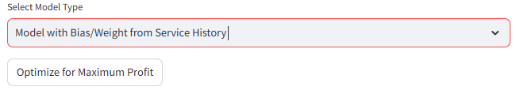

The model will focus on the most service counted at the historical data, we used one of the dental history treatment in 2023, for future if customer have other service history data then they can upload the csv data to the app

* Add another model with patient limit per doctor

