Technical University of Cluj-Napoca
Faculty of Electronics, Telecommunications, and Information Technology

STATE OF THE ART
IoT System for Honeybee Colonies

Student Author: Gavril George-Eduard Date: 16.07.2025
Coordinator: Conf. Lorant SZOLGA

Table of Contents
1 Introduction 3
2 Trends 3
3 Analysis of Methods Used to Measure Hive Parameters 5
3.1 Temperature and Humidity measurement 5
3.2 Weight Sensor 5
3.3 Gas sensor 5
3.4 ESP32 as the Central Unit of the IoT System 5
4 Proposed Solution 6
4.1 Block diagram 6
4.2 Advantages and Limitations of the proposed system 6
4.2.1 Advantages of the proposed system 6
4.2.2 Limitations and Technical challenges 7
4.3 Cost Analysis 7
5 References 8

Introduction
Honeybees play a crucial role in food production and ecosystem maintenance, however in recent years due to several factors such as climate change, pesticide use, habitat loss, parasites, diseases and human interference, there has been a decline in honeybees’ population.
This project aims to implement an Internet of Things (IoT) based system to monitor the population of honeybees with minimal human interference. The system implemented is able to measure humidity, temperature, and weight of the hives, whilst also monitoring the colony’s activity. In addition to internal hive conditions, the system tracks the rate at which honeybees enter or exit the hive, providing insights into foraging behaviour. Furthermore, external sensors and alerts can be used to identify potential threats to the hive, such as the presence of parasites or invasive predators like hornets.
This document contains details concerning the current state of the art involving IoT-based monitoring systems for apiculture. A variety of sources from several journals have been accumulated and their contents analysed in this comparative paper, then a novel solution proposed by the authors.

Trends
To determine a colony’s health there are 3 key factors to consider: weight, temperature, and humidity. These factors, as shown in the table on the next page, are the most commonly monitored when considering the design of an apicultural monitoring system.
By monitoring the weight of a hive, we can determine the colony’s productivity, health, longevity, nutritional status, swarming, robbing, winter feeding, etc.
Temperature is critical to the bee’s health. It directly affects their physiology and behavior. Bees need specific temperature ranges for various activities such as flight, foraging and brood rearing.
Humidity is crucial for bees’ health and survival, impacting brood development, honey production, and even pest control within the hive. Honeybee eggs require a specific humidity range to hatch successfully. To produce honey, bees need to evaporate excess moisture from nectar, this process being influenced by general humidity in the hive.
Other factors to look out for are noise, traffic and swarming. The buzzing sound produced by honeybees is used for communication within the hive. Changes in the buzz pattern may indicate stress, swarming behavior, the absence of a queen or even the presence of intruders such as hornets and parasites. Colony traffic, specifically the movement of bees in and out of the hive, is a good indicator of the colony’s productivity and overall health status. Swarming is a very important part of a colony’s life; it’s the process where a honeybee colony splits into two, with the old queen and half the workers leaving to establish a new colony. This process is done because of several factors such as overcrowding, resource scarcity or poor hive conditions.
The table on the next page shows which papers monitored the parameters described above. Some papers made use of additional parameters, which have been noted.

Table 1. Matrix of useful parameters
Article reference | Humidity | Temperature | Weight | Dieseases | Pesticides | Predators | Swarming | Traffic | Sounds | Population
[2015][1] |  |  | x | x
[2016][1] | x | x | x
[2017][1] | x | x |  |  |  |  | x
[2019][1] | x | x
[2019][2] |  |  |  | x | x | x |  | x | x
[2019][3] | x | x | x
[2019][4] | x | x | x
[2019][5] | x | x | x
[2019][6] | x | x |  |  |  |  |  |  | x
[2019][7] | x | x | x |  |  |  | x |  | x
[2019][8] | x | x | x
[2019][9] |  |  |  |  |  |  |  |  | x
[2020][1] | x | x | x |  |  |  |  | x | x
[2021][1]
[2021][2] | x | x | x | x |  |  |  |  | x
[2023][1] | x | x | x |  |  |  |  | x
[2023][2] | x | x | x
[2023][3] | x |  | x
[2023][4] | x | x
[2023][5] |  | x | x
[2024][1] | x | x | x
[2024][2] | x | x | x |  |  |  |  |  |  | x
[2024][3]
[2024][4] | x | x
[2024][5] | x | x | x |  |  |  |  |  | x
[2024][6] | x | x | x
[2025][1] |  |  |  |  |  | x | x | x
[2025][2] |  |  | x |  |  |  |  | x | x
[2025][3] | x | x | x
[2025][4] | x | x | x |  |  |  | x |  | x
TOTAL | 22 | 22 | 20 | 3 | 1 | 2 | 4 | 5 | 9 | 1

As shown above, the most monitored parameters are humidity, temperature and weight. Other parameters have been monitored less such as population, parasites, predators.

Analysis of Methods Used to Measure Hive Parameters

Temperature and Humidity measurement
There are quite a few sensors used to measure the temperature and humidity, but the most prominent ones are DHT22 ([ [1], [2], [3], etc.) and DHT11 ( [4], [5], [6], etc.). When choosing between which one to use for beehive monitoring, DHT22 is the better option having a temperature range of -40 – 80 degrees Celsius with an accuracy of +/- 0.5 degrees Celsius compared to DHT11 having a temperature range of 0-50 degrees Celsius with a temperature accuracy of +/- 2 degrees Celsius. The humidity range of DHT22 is 0%-100% RH with an accuracy of +/- 2-3% RH compared to DHT11 having a humidity range of 20%-80% with a humidity range of +/- 5% RH. DHT11 has a few advantages over the DHT22 model, those are the fact that its sampling rate is 1 Hz compared to 0.5 Hz of DHT22 and the fact that it’s overall cheaper, however for more accurate and advanced readings the DHT22 is the superior choice.

Weight Sensor
The loadcell is the prominent choice regarding measuring the weight of a beehive. The variations in output voltage of the loadcell is consistently sampled with a 24-bit analog to digital converter HX711. It converts the tiny voltage changes from a load cell into digital values that a microcontroller can read. It usually amplifies the signal by x128 because the loadcells produce a very small voltage, in the range of millivolts.

Gas sensor
The only gas sensors used are MQ2 ([1], [2]) and MQ135 ( [7], [8]). Compared to the MQ135 gas sensor which can monitor air quality inside the hive, the MQ2 gas sensor is mostly used for detecting fire/smoke/gas leaks nearby.

ESP32 as the Central Unit of the IoT System
When building a monitoring system for a beehive, the ESP32 microcontroller is the best choice, having the capability of holding multiple different sensors.
The ESP32 is a low-cost, and high-performance microcontroller with built-in Wi-Fi and Bluetooth. It’s widely used in IoT (Internet of Things) applications due to its versatility and features.
Its key features are:
- Dual-core 32-bit Xtensa CPU, up to 240 MHz
- Built-in Wi-fi (802.11 b/g/n) and Bluetooth (Classic + BLE)
- 34 GPIO pins for sensors, actuators, etc.
- Multiple 12-bit ADC channels for analog sensor input and a few DAC outputs
- Supports common protocols to communicate with various modules
- Deep sleep options for energy-efficient monitoring
- Very affordable (~5-10€), depending on the board version

Proposed Solution

Block diagram
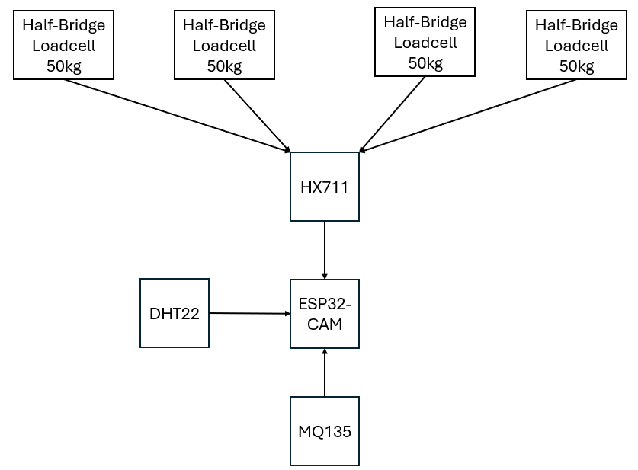
Figure 1. Block diagram of the proposed system

The block diagram illustrated above is a rough sketch for the final system. It has 4 Half-Bridge Loadcells with a maximum capacity of 50 kg, positioned on each corner of the hive to ensure high-accuracy weight measurement. These 4 loadcells will be connected to an analog-to-digital converter (HX711) converting the minute voltage changes from the loadcells into digital values that a microcontroller can read.
To monitor the internal environment of the hive, a DHT22 sensor is employed to measure the temperature and humidity levels. Additionally, an MQ135 gas sensor is used to detect poor ventilation, overcrowding, or stress within the colony by specifically monitoring for abnormal levels of CO₂ (Carbon Dioxide) and NH₃ (Ammonia).
All these components will be connected to the microcontroller (ESP32-CAM) acting as both the data processor and communication hub. The ESP32-CAM comes equipped with the OV2640 camera sensor, which is a compact, low-power, and cost-effective camera module ideal for embedded IoT systems. The camera will be used to monitor the bees inside the hive, alerting the beekeeper of swarming and the possibility of intruders such as pest or predators.

Advantages and Limitations of the proposed system

Advantages of the proposed system
One of the key advantages of the proposed honeybee monitoring system is its ability to function remotely, allowing beekeepers to keep track of the colonies without much effort and fewer disturbances. This not only saves time and effort but also supports a healthier hive environment by limiting unnecessary openings and stress on the bees. Maintaining low stress levels in honeybee colonies is crucial since it can influence their ability to survive, reproduce, and perform essential tasks like pollination, which affect both environmental and agriculture.
Another advantage of the system would be its use of easily available components and easily reproducible. While the system does require a certain level of technical knowledge, particularly in electronics, sensor integration and programming, once the initial prototype is built and tested, it can be replicated across additional hives without much effort. This makes the system scalable, even if the initial setup requires some time and troubleshooting.

Limitations and Technical challenges
One of the main limitations of the system is its accuracy. Although efforts have been made to improve measurement precision, such as using four loadcells placed at the corners of the hive instead of a single central loadcell, this does not guarantee 100% accurate readings. Sensor measurements can still be affected by factors such as improper placement within the hive, environmental conditions like weather changes, and interference from hive activity.
Another notable limitation of the system is its dependence on wireless connectivity. Many beekeeping sites are located in rural or remote areas, where Wi-Fi coverage may be weak or completely unavailable. This in turn can interrupt transmission or delay real-time monitoring. While alternatives like LoRa offer long-range, low-power communication, they typically require installation of a dedicated gateway, which adds both costs and complexity to the setup.

Cost Analysis
To evaluate the financial feasibility of the proposed system, a detailed cost breakdown of its components was created. The design aimed to remain low-cost and accessible, while still prioritizing the functionality and efficiency of each selected component.
Based on the table above, the total cost of building the proposed system is relatively low (187.02 RON), making it a feasible option for small-scale or individual use. This budget-friendly approach also opens the possibility for replicating the setup across multiple hives, depending on the user’s needs and available resources.
Table 2. Cost analysis
Component | Description | Quantity | Price(RON)
ESP32-CAM | Main Control Unit | 1 | 120
DHT22 | Temperature and Humidity sensor | 1 | 30
MQ135 | Gas sensor | 1 | 12
HX711 | Analog-to-digital converter | 1 | 4.5
Half-Bridge Loadcell (50kg) | Weight measurement sensor | 4 | 20.52
 |  | Total price= | 187.02

References

[1] | M. M. B. K. M. M. A. A. Zulkhairi Mohd Yusof, "Improvement of Honey Production: A Smart Honey Bee Health Monitoring System," 2019.
[2] | M. A. A. R. M. F. H. A. R. N. Md Sadad Mahamud, "Mouchak - An IoT Basted Smart Beekeeping System Using MQTT," 2019.
[3] | G. J. L. P. J. J. A. J. D. J. P. C. Karan I, "BeeSense-A Smart Beehive Monitoring System for," 2024.
[4] | V. Krishnasamy, "An IoT-Based Beehive Monitoring System for Real-Time Monitoring of Apis cerana indica," 2023.
[5] | A. A. R. M. R. K. Vijay Gaikwad, "Smart Beehive Monitoring System using IoT," 2024.
[6] | S. G. R. Isidro Zavaleta Ochoa, "Internet of Things: Low Cost Monitoring BeeHive System using Wireless Sensor Network," 2019.
[7] | C. A. P. N. S. B. C. Nisal Liyanage, "IoT-Based Smart Beehive Monitoring System," 2024.
[8] | C. M. N. Tudor Pica, "IoT Beehive Monitoring System," 2024.

