

UMR in Bordereau Summary Screen Functional Specification

Table of Contents

1. Overview 2

2. User Guidance 3

2.1 Knowledge Base 3

2.2 Tooltips 3

3. Non-Functional Requirements 4

3.1 Performance 4

3.2 Scale 4

4. Technical Implementation 5

4.1 Componentary 5

5. Impact Assessment 6

5.1 Existing Functionality 6

5.2 Existing Data 6

5.3 Data Warehouse 6

5.4 Reporting 6

5.5 Permissions 6

5.6 User Training 6

# UMR in Bordereau Summary Screen

The header area of Bordereau Summary and Error screens is to be altered to the below design to include UMR. If there is more than one UMR, then it is to be comma separated per below design. If there are more UMRs that fit on screen, then it is to end with ‘…’ and a hoverover tooltip will display all UMRs associated with the Bordereau.

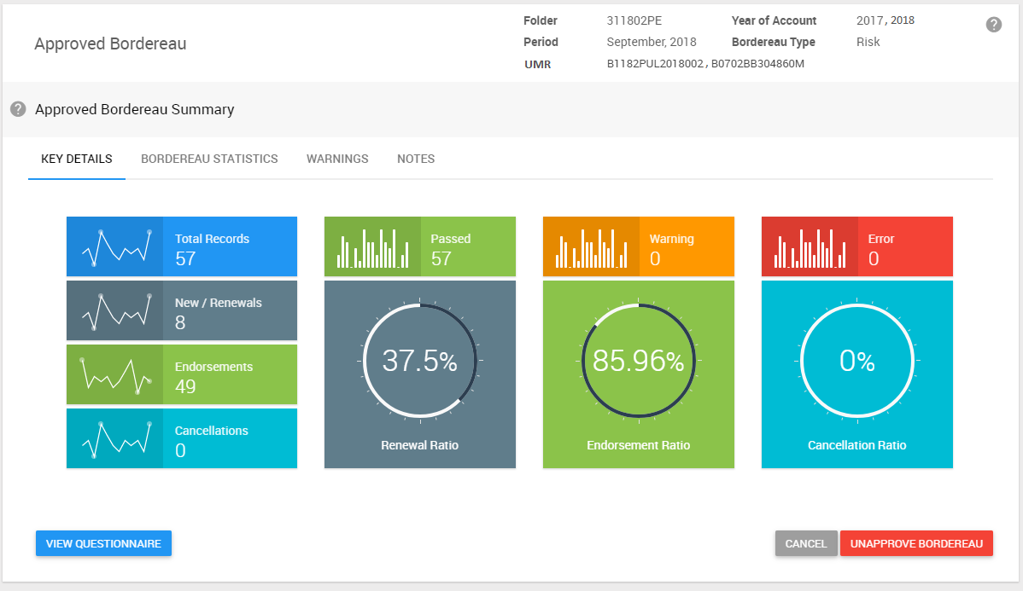

# User Guidance

## Knowledge Base

No updates are required.

## Tooltips

Details of the tooltips to be provided are documented in the relevant sections of this specification.

# Non-Functional Requirements

## Performance

Standard page load times apply.

## Scale

There are no limitations

# Technical Implementation

## Componentary

The standard Telerik Controls, which are used throughout Tide at present, are used to deliver this new functionality.

# Impact Assessment

## Existing Functionality

This specification provides new functionality that builds on top of existing functionality.

## Existing Data

No impact on existing data.

## Data Warehouse

No impact or changes required.

## Reporting

Reports may separately be specified that use data relating to Tasks.

## Permissions

There are no impacts to permissions.

## User Training

On-screen help will need to be updated as per this specification.