**Practical No: 3**

Name: sanket pradiprao gaikwad

Reg.no : 2020BIT036

1. **Searching Algorithm**
2. Linear search

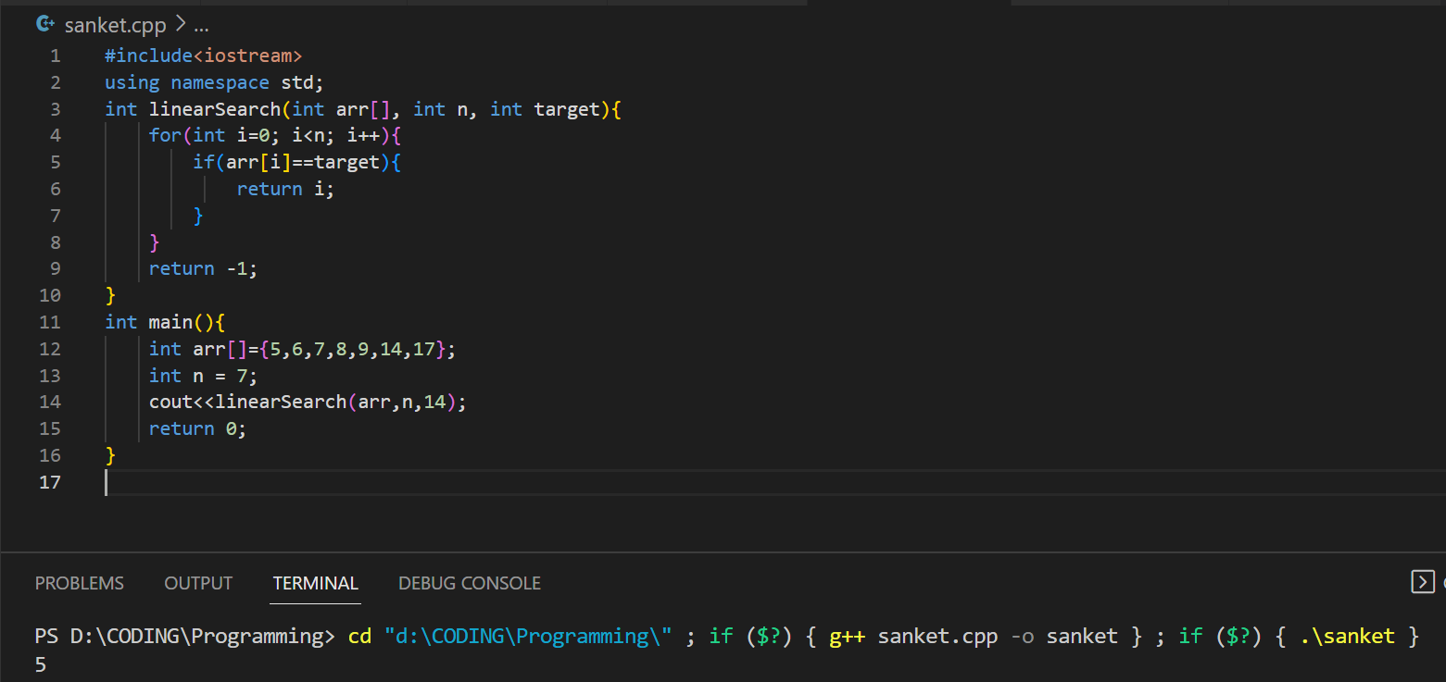

1. Binary search:

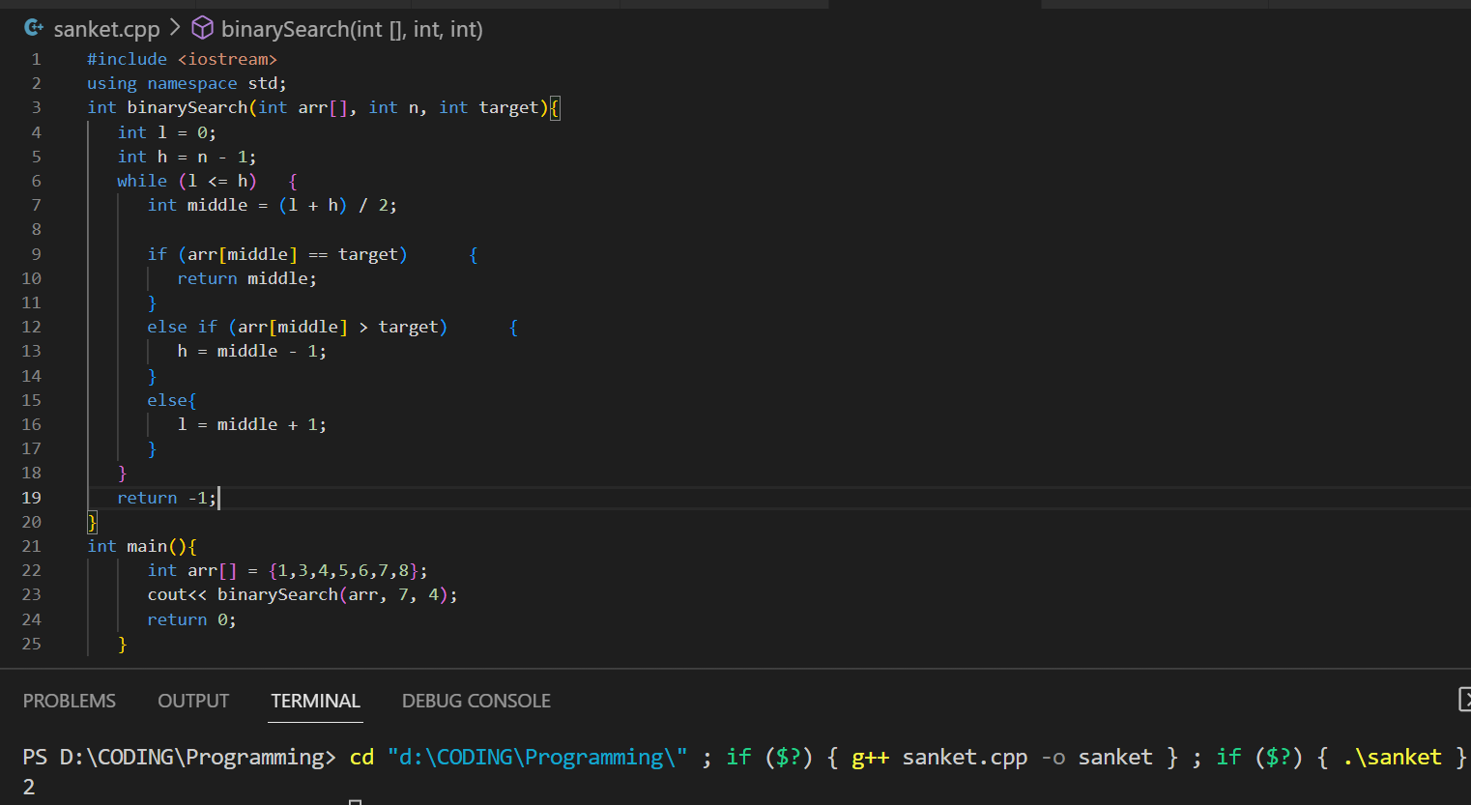

1. Recursive Search:

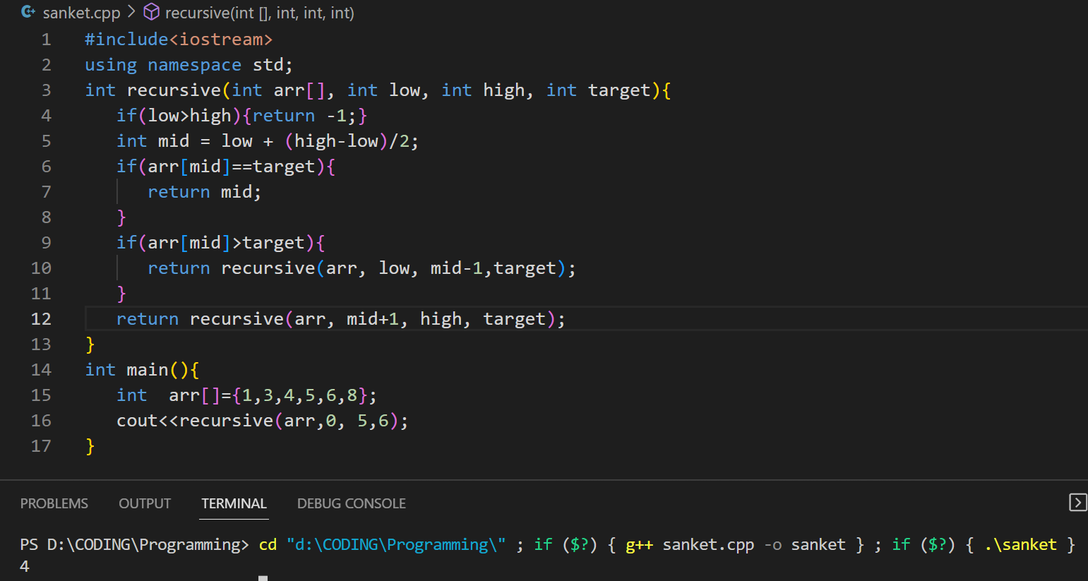

1. Sorting Algorithm:
2. Insertion sort:

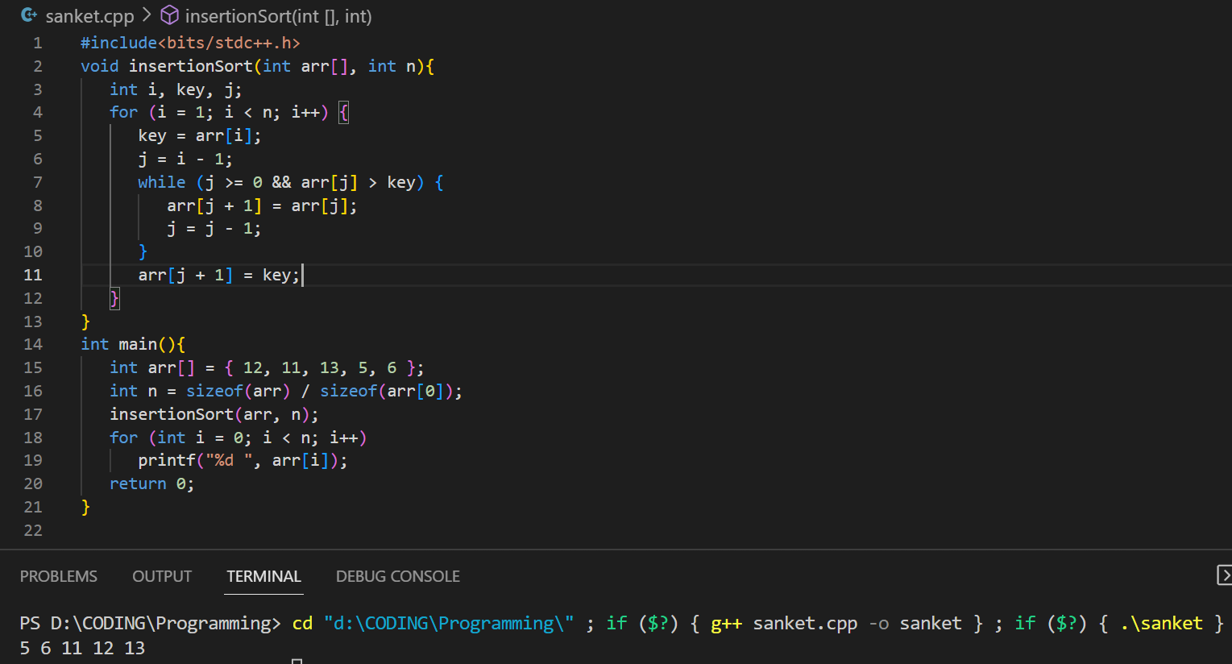

1. Selection sort:

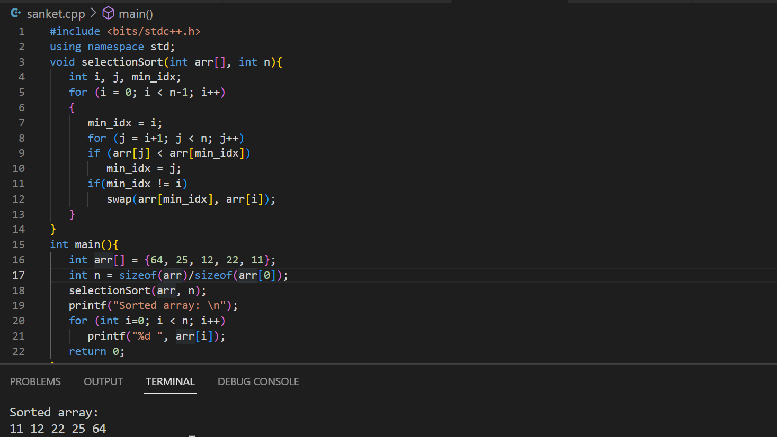

1. Bubble Sort:

