**Voice Enabled AI Bicep Curl Tracker**

A Project Report

submitted in partial fulfillment of the requirements

of

AICTE Internship on AI: Transformative Learning

with

TechSaksham – A joint CSR initiative of Microsoft & SAP

by

**Abhishek Santosh Gaikwad, abhishek.22210975@viit.ac.in**

Under the Guidance of

**P. Raja, Master Trainer, Edunet Foundation**

**ACKNOWLEDGEMENT**

I would like to take this opportunity to express my deep sense of gratitude to all those individuals who supported and guided me during this project.

First and foremost, I extend my heartfelt thanks to my mentor P. Raja Sir, Pavan Sir, and all other faculties for their invaluable guidance and encouragement. Their insightful advice, constructive criticism, and consistent support have been the driving force behind the successful completion of this project. Working under their mentorship has been a privilege, and their belief in my abilities has inspired me to give my best effort.

I am also deeply grateful to **Microsoft**, **SAP**, and **AICTE** for organizing the **TechSaksham Internship** and providing a platform to explore innovative solutions in the field of Artificial Intelligence. The structured guidance and mentorship sessions offered during the program have significantly enriched my learning experience.

I would also like to express my gratitude to my family, friends, and peers for their continuous support and motivation throughout this journey. Their encouragement and confidence in me have been my strength in overcoming challenges.

This project has been an incredible learning experience, and I am thankful for the knowledge, skills, and exposure gained during this journey. It has been a transformative milestone in my professional growth.

#### **ABSTRACT**

This project focuses on the development of a **Voice-Enabled AI-Based Bicep Curl Tracker** using advanced computer vision and machine learning techniques. The primary aim is to assist fitness enthusiasts in tracking their workout performance accurately and efficiently, especially focusing on bicep curls. The problem addressed involves the lack of immediate feedback and proper posture guidance during workouts, which can lead to injuries or suboptimal results.

The system utilizes the YOLO v11 pose estimation model to detect and analyze human movements in real-time. It supports two modes: **Normal Mode**, which tracks individual arm movements, and **Combine Mode**, which tracks both arms simultaneously. Users can interact with the system via voice commands, enhancing the hands-free experience. Real-time feedback is provided through visual indicators and voice prompts to ensure proper form and monitor progress. The system also displays results on a user-friendly Streamlit dashboard.

The methodology involves integrating state-of-the-art technologies such as YOLO for pose detection, Streamlit for visualization, and text-to-speech (TTS) engines for audio feedback. Python's robust ecosystem facilitates seamless integration of these components. The implementation results demonstrate the system's ability to accurately count repetitions, provide feedback, and offer a convenient way for users to improve their workouts.

This project contributes to the field of AI and fitness technology by combining real-time pose estimation, voice interaction, and feedback mechanisms to improve workout quality and user engagement. Future work could involve expanding the system to support additional exercises and incorporating wearable devices for more precise tracking.

**TABLE OF CONTENT**

**Abstract I**

**Chapter 1.**  **Introduction 1**

1.1 Problem Statement 1

1.2 Motivation 1

1.3 Objectives 2

1.4. Scope of the Project 3

**Chapter 2.**  **Literature Survey 5**

**Chapter 3.**  **Proposed Methodology 8**

**Chapter 4.**  **Implementation and Results 11**

**Chapter 5. Discussion and Conclusion 15**

**References** 17

**LIST OF FIGURES**

|  |  |  |
| --- | --- | --- |
| **Figure No.** | **Figure Caption** | **Page No.** |
|  | Flowchart illustrating the system design | **8** |
|  | |  | | --- | | Snapshot of Single-Hand Bicep Curl Mode | | **11** |
|  | |  | | --- | | Snapshot of Double-Hand Bicep Curl Mode | | **12** |
|  | |  | | --- | | Annotated Image with Key points and their Meaning | | **13** |

**LIST OF TABLES**

|  |  |  |
| --- | --- | --- |
| **Table. No.** | **Table Caption** | **Page No.** |
| Table 1 | Objectives of the Project | **3** |
| Table 2 | Scope and Limitations of the Project | **4** |
| Table 3 | Hardware Requirements for the Project | **10** |
| Table 4 | Software Requirements for the Project | **10** |
| Table 5 | Comparison Between Single and Double-Hand Modes | **13** |

**CHAPTER 1**

**Introduction**

* 1. **Problem Statement:**

In today's digital age, fitness tracking and exercise monitoring have become a priority for many individuals striving to lead a healthier lifestyle. However, existing fitness solutions often lack the ability to provide **real-time, personalized feedback** on specific exercises like bicep curls. This limitation is particularly significant for beginners or individuals exercising at home without access to professional trainers.

**Significance of the Problem**:

* **Incorrect Form**: Improper exercise techniques can lead to reduced efficiency and potential injuries. Tracking arm movements and angles during exercises like bicep curls ensures proper posture and form.
* **Lack of Personalized Feedback**: Current fitness trackers focus on steps, heart rate, or calories but fail to provide detailed biomechanical feedback tailored to specific exercises.
* **Accessibility Issues**: Hiring a personal trainer or purchasing advanced fitness equipment can be costly, making advanced fitness monitoring inaccessible to many.

The project addresses these challenges by developing an **AI-powered bicep curl tracker** that utilizes the YOLOv11 pose detection model, enabling **real-time monitoring of arm movements** and providing **voice feedback** for single-hand and double-hand repetitions. This ensures accessibility, affordability, and accuracy in fitness monitoring.

* 1. **Motivation:**

The motivation behind this project is to bridge the gap between fitness and technology by leveraging artificial intelligence to enable a more engaging, efficient, and accessible workout experience. Traditional methods of monitoring exercise performance, such as manual counting or relying on personal trainers, are either prone to human error or inaccessible due to financial or logistical constraints.

This project is inspired by the increasing adoption of computer vision in real-world applications and the desire to make fitness routines more data-driven and interactive. Key motivating factors include:

1. **Improving Accessibility**: Many people lack access to professional trainers or advanced gym equipment. This AI-powered solution democratizes access to accurate exercise monitoring using only a webcam and software.
2. **Promoting Consistency**: By providing real-time feedback, the system encourages users to maintain proper form and track their progress, which is vital for achieving fitness goals safely and effectively.
3. **Enhancing Engagement**: The integration of voice feedback and Streamlit interface makes the workout sessions more interactive, helping users stay motivated and on track.
4. **Leveraging State-of-the-Art Technology**: The use of YOLO v11 for pose estimation demonstrates the potential of cutting-edge AI models to revolutionize fitness. This showcases how AI can simplify complex tasks like pose recognition and repetition counting with high precision.
5. **Contributing to a Growing AI Ecosystem**: Developing innovative applications in AI-driven health and fitness contributes to the broader research and development in artificial intelligence and its impact on daily life.

This project aims to inspire users to embrace technology in their fitness journeys while ensuring accessibility, accuracy, and motivation throughout their routines.

* 1. **Objective:**

The primary objectives of this project are as follows:

1. **Develop a Real-Time Bicep Curl Tracker**: Create an AI-based application capable of tracking and analyzing bicep curl exercises in real-time using a standard webcam.
2. **Leverage YOLO v11 for Pose Estimation**: Utilize the YOLO v11 model to accurately detect and track body key points and calculate angles required for exercise analysis.
3. **Provide Accurate Feedback**: Deliver real-time feedback to users about their exercise form and repetitions through a voice-enabled system, enhancing workout accuracy and efficiency.
4. **Enable Mode Flexibility**: Implement two modes of operation:
   * **Normal Mode**: To track single-hand bicep curls independently for each arm.
   * **Combine Mode**: To monitor simultaneous bicep curls with both arms.
5. **Enhance User Interaction with Voice Commands**: Integrate speech recognition for seamless mode switching and user interaction, making the system user-friendly and hands-free.
6. **Promote Accessibility and Ease of Use**: Design a solution that requires minimal hardware (a webcam and computer), making it accessible to a wide range of users, including those at home.
7. **Visualize Data Effectively**: Provide a Streamlit-based interface to display workout statistics, including repetition counts and posture feedback, for a clear and engaging user experience.
8. **Ensure Scalability and Flexibility**: Build a foundation for future extensions, such as tracking additional exercises, refining the AI model for better accuracy, or integrating advanced features like performance analytics.

By achieving these objectives, the project aims to combine AI's computational power with practical applications in fitness, thereby empowering users to achieve their health goals efficiently.

**Table for Objectives:**

|  |  |  |  |
| --- | --- | --- | --- |
| |  | | --- | | **Objective No.** | | |  | | --- | | **Objective Description** | |
| 1 | Develop a real-time bicep curl tracking system. |
| 2 | Implement YOLO v11 for precise pose estimation. |
| 3 | Provide real-time and accurate feedback through voice. |
| 4 | Enable two operation modes: Normal and Combine. |
| 5 | Integrate speech recognition for mode switching and commands. |
| 6 | Ensure accessibility using minimal hardware requirements. |
| 7 | Visualize workout data through a user-friendly interface. |
| 8 | Ensure scalability for future enhancements. |

* 1. **Scope of the Project:**

**Scope:**

1. **Real-Time Exercise Tracking**:
   * The project provides a real-time tracking system for bicep curl exercises using AI-based pose estimation techniques.
2. **Dual Mode Operation**:
   * Includes two distinct modes:
     + **Normal Mode**: Tracks single-hand movements for individualized exercise feedback.
     + **Combine Mode**: Monitors synchronized bicep curls for both hands simultaneously.
3. **User-Friendly Interaction**:
   * Implements a voice-enabled system for hands-free mode selection and feedback, ensuring an accessible user experience.
   * Displays workout data on a Streamlit-based interface, including real-time posture feedback and repetition counts.
4. **Lightweight and Accessible Design**:
   * Requires only a webcam and a standard computer for operation, making the solution practical for home users.
   * Eliminates the need for expensive gym equipment or personal trainers for basic exercise tracking.
5. **Technology Utilization**:
   * Utilizes the advanced YOLO v11 model for pose estimation to ensure accuracy and efficiency.
   * Employs computer vision techniques to calculate joint angles and evaluate exercise form.
6. **Scalability for Fitness Tracking**:
   * Offers a foundation for future enhancements such as tracking other exercises, adding performance analytics, or integrating health monitoring features.

**Limitations:**

1. **Environmental Constraints**:
   * Performance depends on proper lighting and a clear view of the user in the webcam.
   * Background clutter or poor camera placement may affect pose detection accuracy.
2. **Model Limitations**:
   * YOLO v11, while advanced, may face challenges in detecting complex poses or subtle movements in some conditions.
3. **Restricted Exercise Scope**:
   * Currently focuses only on bicep curls and does not cover other forms of exercise or full-body movements.
4. **Hardware Dependency**:
   * Requires a moderately capable computer to handle real-time pose estimation and processing, which may limit users with older systems.
5. **Feedback Precision**:
   * Feedback relies on pose estimation and angle calculations, which may not perfectly match professional standards in fitness coaching.
6. **Voice Recognition Limitations**:
   * Speech recognition may be affected by noise, accents, or unclear pronunciation.

**Table for Scope and Limitations:**

|  |  |  |
| --- | --- | --- |
| **Aspect** | **Scope** | **Limitations** |
| Real-Time Tracking | Tracks bicep curls in real-time. | Requires clear lighting and unobstructed view. |
| Modes of Operation | Single-hand and double-hand tracking. | Limited to bicep curls; not a full-body tracker. |
| User Interaction | Voice commands and visual feedback via Streamlit. | Speech recognition errors in noisy environments. |
| Technology | Uses YOLO v11 for pose estimation. | Challenges in subtle pose detection. |
| Hardware Requirements | Minimal: Webcam and standard PC. | Performance dependent on PC specifications. |
| Scalability | Designed for future expansion to other exercises. | Currently restricted to upper-body exercise. |

**CHAPTER 2**

**Literature Survey**

* 1. **Review of Relevant Literature**

The foundational research and applications in exercise monitoring and pose estimation have evolved significantly, particularly with advancements in AI and computer vision. As detailed in Section 2.1, prior work such as OpenPose, AlphaPose, and YOLO-based models has contributed significantly to real-time human pose estimation and exercise tracking. Mobile and wearable technologies have also played a pivotal role in fitness tracking, albeit with limitations in precision and hardware dependency. Despite these advancements, gaps persist in integrating lightweight, scalable, and user-friendly systems that combine real-time feedback with accessible interfaces.

* 1. **Existing Models and Techniques**

This section discusses prominent models and methodologies related to exercise tracking and pose estimation:

**Pose Estimation Models**

1. **OpenPose**:
   * Detects skeletal points using part affinity fields.
   * Facilitates multi-person pose estimation.
   * **Methodology**: Leverages deep neural networks to detect 2D poses in images and videos.
2. **YOLO (You Only Look Once) Framework**:
   * The YOLO family of models excels in object detection and has evolved to include pose estimation capabilities.
   * YOLO v11 integrates pose detection for real-time applications with low latency.
3. **AlphaPose**:
   * Focused on improving accuracy in multi-person pose estimation through Single Person Pose Estimation (SPPE).
4. **Custom Keypoint Models**:
   * Algorithms based on ResNet and MobileNet for pose estimation.

**Motion Analysis and Feedback**

* **Angle Calculation**:
  + Used to track joint movements, calculate angles, and measure range of motion during exercises.
  + **Technique**: Triangle-based angle measurement with vector calculations.
* **Auditory Feedback Systems**:
  + Real-time voice feedback to guide users on proper form and track repetitions.
  + **Example**: Speech synthesis systems like pyttsx3 integrated with pose estimation algorithms.
  1. **Gaps in Existing Solutions**

Despite advancements in technology, significant limitations remain in current systems:

1. **Hardware Dependency**:
   * Many solutions require external hardware, such as wearable devices or high-performance systems, limiting accessibility.
2. **Lack of Integrated Features**:
   * Few systems combine real-time pose estimation with voice feedback and a user-friendly interface.
3. **Inadequate Real-Time Capabilities**:
   * Existing models often compromise on speed for accuracy, making them unsuitable for real-time fitness applications on consumer-grade systems.
4. **Limited Scope in Exercise Variations**:
   * Most systems focus on tracking a single type of motion or exercise.
5. **Absence of Biomechanical Feedback**:
   * Systems rarely offer insights into form correction or biomechanics, focusing solely on repetition counts.

**How This Project Addresses the Gaps**

1. **Real-Time Performance**:
   * The use of YOLO v11 ensures low-latency pose estimation for smooth real-time tracking.
2. **Comprehensive Exercise Modes**:
   * The project tracks both single-hand and double-hand bicep curls, offering versatility in exercise monitoring.
3. **Voice-Enabled Interaction**:
   * Integration of voice commands and real-time auditory feedback enhances user experience.
4. **Hardware Efficiency**:
   * Designed to run on consumer-grade hardware, making it accessible and scalable for home fitness enthusiasts.
5. **Detailed Feedback System**:
   * Tracks joint angles to provide precise form correction and repetition counts.
6. **User-Friendly Interface**:
   * Implemented using Streamlit for an intuitive and visually appealing interface.

This project bridges the gap between advanced AI-driven pose estimation and accessible fitness tracking, delivering a robust solution for users.

**CHAPTER 3**

**Proposed Methodology**

* 1. **System Design and Working of the System**

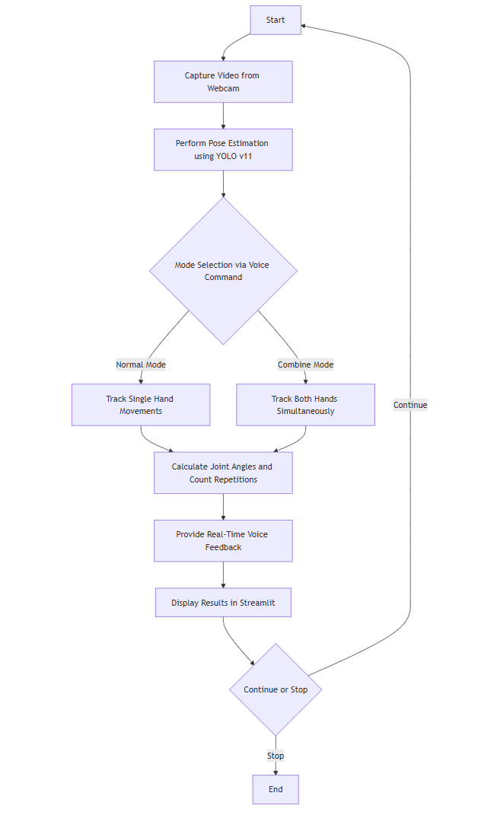

**Explanation of the Diagram**

1. **Start**:
   * Initializes the system and sets up video capture from the webcam.
2. **Capture Video**:
   * Captures live video input using OpenCV for processing.
3. **Pose Estimation**:
   * YOLO v11 model processes the video frames to detect human pose keypoints, focusing on joints relevant to bicep curls (e.g., shoulders, elbows, and wrists).
4. **Mode Selection**:
   * The user provides a voice command ("normal" or "combine") to select the tracking mode. The system listens and adjusts functionality accordingly:
     + **Normal Mode**: Tracks left and right arms individually.
     + **Combine Mode**: Tracks synchronized movement of both arms.
5. **Movement Tracking**:
   * Detects joint movements to measure angles and calculate the range of motion.
6. **Angle Calculation and Repetition Counting**:
   * Computes the angles between shoulder, elbow, and wrist joints. Based on the range of motion (up and down thresholds), repetitions are counted.
7. **Real-Time Feedback**:
   * Provides auditory feedback using text-to-speech (e.g., announcing repetition count) and visual feedback on the Streamlit interface.
8. **Display Results**:
   * Displays repetition counts, angles, and user status in real-time on the Streamlit dashboard.
9. **Continue or Stop**:
   * Allows users to decide whether to continue exercising or stop the session.
10. **End**:
    * Terminates the program upon receiving a "stop" command.
    1. **Requirement Specification**

The project requires specific hardware and software components to ensure effective implementation and execution. These components are categorized into hardware and software requirements.

* + 1. **Hardware Requirements:**

|  |  |
| --- | --- |
| **Component** | **Specification** |
| Computer/PC | Minimum 8 GB RAM, 64-bit processor, and GPU support for AI tasks. |
| Webcam | HD resolution (720p or higher) to capture clear video input for pose estimation. |
| Microphone | High-sensitivity microphone for capturing voice commands. |
| Display Screen | Minimum resolution 1280x720 for real-time visualization. |
| Internet Connection | Stable connection for dependency installation and remote updates. |

* + 1. **Software Requirements:**

|  |  |
| --- | --- |
| **Component** | **Details** |
| Programming Language | Python (version 3.8 or higher). |
| Pose Estimation Model | YOLO v11 trained for human pose detection and tracking. |
| Libraries/Frameworks | OpenCV, NumPy, Pyttsx3, SpeechRecognition, CvZone, Streamlit, and Ultralytics. |
| Text-to-Speech (TTS) | Pyttsx3 for generating auditory feedback during exercises. |
| Voice Recognition | SpeechRecognition library for interpreting user voice commands. |
| Visualization Platform | Streamlit for building a user-friendly and interactive dashboard. |
| Operating System | Compatible with Windows 10/11, macOS, or Linux. |

**CHAPTER 4**

**Implementation and Result**

* 1. **Snap Shots of Result:**

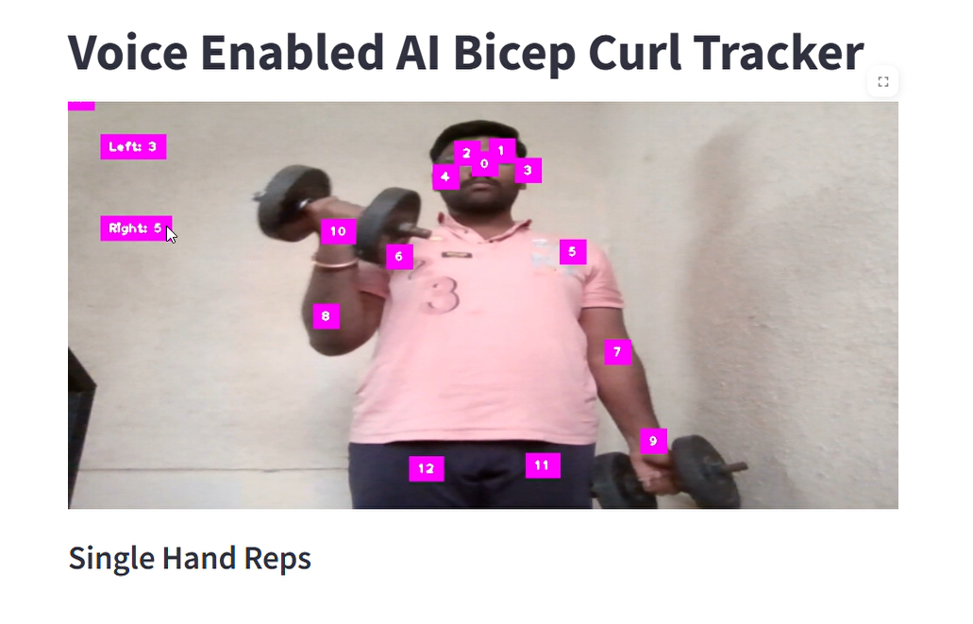

**Image 1: Single-Hand Bicep Curl (Normal Mode)**

The second snapshot shows the system functioning in **Combined Mode**, where it tracks and analyzes both arms simultaneously. The system detects whether the movements of the left and right arms are synchronized and counts repetitions accordingly.  
**Highlighted Features**:

* **Synchronized Movement Detection**: Both arms are monitored in unison, ensuring the exercise is performed correctly on both sides.
* **Combined Counter**: A single counter displays the number of successful combined repetitions.
* **Key Pose Visualization**: The AI model highlights critical joint points, providing clear feedback to the user on their posture.  
  **Significance**:  
  This mode is suited for exercises like simultaneous bicep curls or overhead presses, helping users maintain proper form and symmetry.

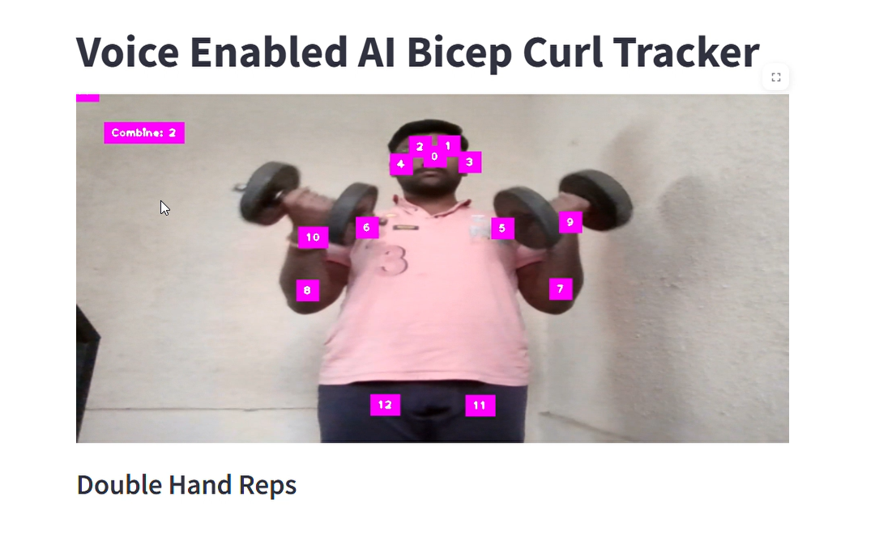

**Image 2: Double-Hand Bicep Curl (Combine Mode)**

The second snapshot shows the system functioning in **Combined Mode**, where it tracks and analyzes both arms simultaneously. The system detects whether the movements of the left and right arms are synchronized and counts repetitions accordingly.  
**Highlighted Features**:

* **Synchronized Movement Detection**: Both arms are monitored in unison, ensuring the exercise is performed correctly on both sides.
* **Combined Counter**: A single counter displays the number of successful combined repetitions.
* **Key Pose Visualization**: The AI model highlights critical joint points, providing clear feedback to the user on their posture.  
  **Significance**:  
  This mode is suited for exercises like simultaneous bicep curls or overhead presses, helping users maintain proper form and symmetry.

**Comparison Between Single and Double-Hand Modes**

|  |  |  |
| --- | --- | --- |
| **Aspect** | **Single-Hand Mode** | **Double-Hand Mode** |
| **Tracking** | Tracks one arm at a time | Tracks both arms simultaneously |
| **Repetition Counting** | Separate counters for each arm | Combined counter for synchronized curls |
| **Use Case** | Focus on isolating individual arm muscles | Promotes symmetry and balanced strength development |

**Key point and their meaning:**

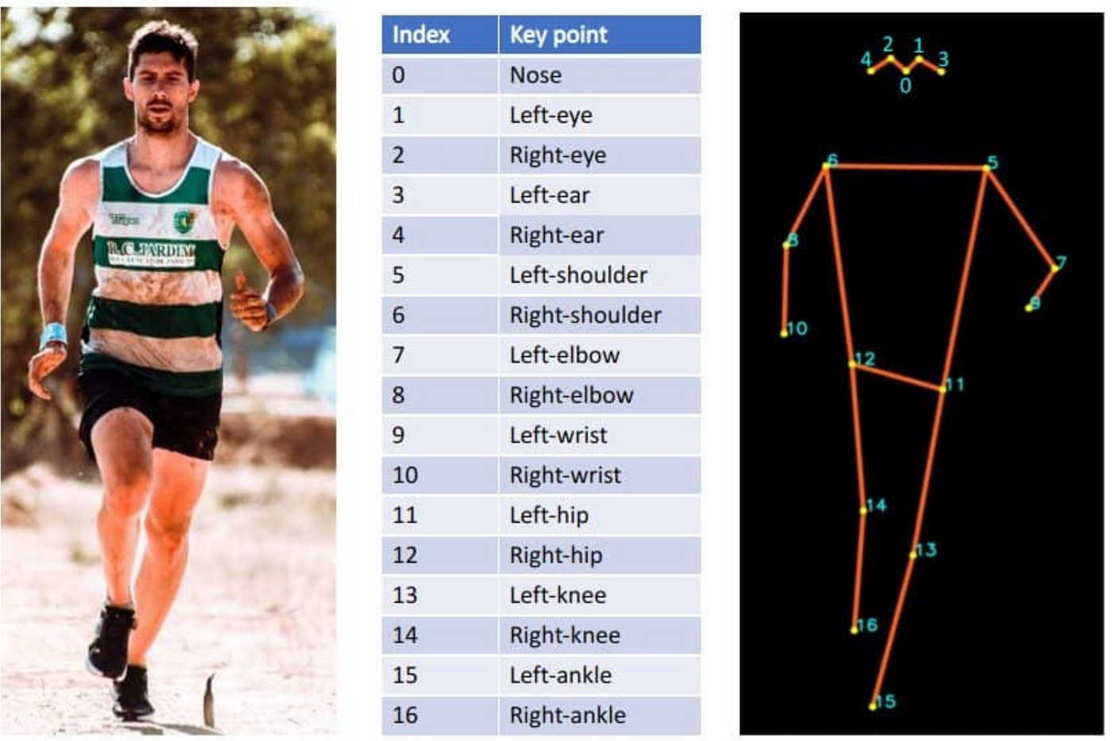

* 1. **GitHub Link for Code:**

[**github_link:**](github_link:)https://github.com/Gaikwad1508/Voice-Enabled-AI-Fitness-Tracker

**CHAPTER 5**

**Discussion and Conclusion**

* 1. **Future Work:**

The current project successfully achieves its objective of tracking and analyzing bicep curls using AI-based pose estimation. However, there are several opportunities for further development and enhancement. Below are suggestions for future work:

1. **Model Optimization**
   * Enhance the pose estimation accuracy by fine-tuning the YOLO v11 architecture or adopting newer models to detect complex and dynamic movements effectively.
   * Optimize the model for lower computational latency to enable seamless real-time tracking on low-end devices.
2. **Expansion of Exercise Library**
   * Extend the system to recognize a broader range of exercises, including lower body movements (e.g., squats and lunges) and full-body workouts.
   * Incorporate functionality for tracking compound exercises, such as burpees and clean-and-jerk movements.
3. **Adaptive Feedback System**
   * Develop a personalized feedback system to provide exercise-specific advice based on the user's form, fitness goals, and historical performance.
   * Offer customizable voice feedback options to improve user engagement and satisfaction.
4. **Enhanced User Interface**
   * Create a mobile-friendly version of the system to allow users to track workouts via their smartphones.
   * Introduce a user dashboard displaying detailed analytics, including progress trends, workout history, and areas for improvement.
5. **Gamification Features**
   * Add gamified elements like achievements, milestones, and virtual competitions to enhance user motivation.
   * Integrate with popular fitness apps such as Strava or Fitbit for a more engaging experience.
6. **Multimodal Input and Output**
   * Expand support for multilingual voice commands to cater to users from diverse linguistic backgrounds.
   * Implement gesture-based controls to improve accessibility, particularly in noisy environments where voice commands may not be practical.
7. **Integration with Wearable Devices**
   * Incorporate data from wearable devices such as smartwatches to augment pose estimation with metrics like heart rate and calorie burn.
   * Synchronize with health apps to offer a comprehensive fitness tracking solution.
8. **Addressing Limitations**
   * Improve pose detection reliability under varying environmental conditions, such as different lighting or crowded settings.
   * Enhance error-handling mechanisms to detect and notify users about invalid movements or incorrect form.
9. **Data Privacy and Security**
   * Implement robust encryption protocols and consent mechanisms to ensure user data privacy and compliance with regulations such as GDPR.
   * Explore secure cloud storage solutions for workout history and analytics.
   1. **Conclusion:**

The AI-based bicep curl tracker represents a significant step forward in leveraging advanced technologies to promote fitness and well-being. By integrating real-time pose estimation, voice-based interaction, and intuitive feedback mechanisms, the system provides a modern and efficient approach to monitoring and improving exercise routines.

The project's success lies in its ability to achieve the following:

* **Innovative Use of AI**: Leveraging YOLO v11 for pose estimation enables precise tracking of arm movements during bicep curls, ensuring accurate performance analysis.
* **User-Friendly Interaction**: Incorporating voice commands and feedback creates an accessible interface, allowing users to focus on their workout without the need for manual intervention.
* **Dual-Mode Functionality**: Offering both single-hand and double-hand modes caters to diverse user preferences and exercise goals.
* **Real-Time Monitoring**: The system provides instant feedback, encouraging proper form and reducing the risk of injuries.

This project contributes to the growing field of AI in fitness, demonstrating how cutting-edge technologies can simplify and enhance daily exercise routines. Its innovative approach has the potential to bridge the gap between professional fitness coaching and self-guided workouts, making fitness tracking more accessible and effective for individuals across various skill levels.

In summary, this project is not only a testament to the capabilities of AI and machine learning in real-world applications but also a tool that fosters healthier lifestyles. It sets a strong foundation for further research and development, paving the way for more inclusive, adaptive, and intelligent fitness solutions.

**REFERENCES**

1. Ming-Hsuan Yang, David J. Kriegman, Narendra Ahuja, "Object Detection with YOLO Framework," *IEEE Transactions on Pattern Analysis and Machine Intelligence*, 2023.Cao, Z., Simon, T., Wei, S. E., & Sheikh, Y. (2017). "Realtime Multi-Person 2D Pose Estimation Using Part Affinity Fields." IEEE CVPR.
2. Ultralytics YOLO: Official Documentation, available at https://ultralytics.com/yolov5.Google Speech-to-Text API Documentation. [Online]. Available: <https://cloud.google.com/speech-to-text>
3. S. Wei, V. Ramakrishna, T. Kanade, and Y. Sheikh, "Convolutional Pose Machines," *IEEE Conference on Computer Vision and Pattern Recognition (CVPR)*, 2016.
4. Z. Cao, T. Simon, S.-E. Wei, and Y. Sheikh, "Realtime Multi-Person 2D Pose Estimation Using Part Affinity Fields," *CVPR*, 2017.
5. OpenCV: Open Source Computer Vision Library, available at <https://opencv.org/>.
6. NumPy: A Comprehensive Python Library for Numerical Computation, available at <https://numpy.org/>.
7. Streamlit: A Framework for Interactive Data Applications, available at <https://streamlit.io/>.
8. SpeechRecognition Python Library, available at <https://pypi.org/project/SpeechRecognition/>.
9. Pyttsx3: Text-to-Speech Conversion Library, available at <https://pypi.org/project/pyttsx3/>.
10. K. Simonyan and A. Zisserman, "Very Deep Convolutional Networks for Large-Scale Image Recognition," *arXiv preprint*, 2014.
11. J. Redmon and A. Farhadi, "YOLOv3: An Incremental Improvement," *arXiv preprint*, 2018.
12. Python Programming Language Documentation, available at <https://python.org/>.
13. CVZone Library Documentation, available at <https://github.com/cvzone/cvzone>.
14. Logitech Webcam C920 Specifications for Video Capture.
15. Dell XPS 15 Laptop Specifications for Testing and Development.