**SMART STICK BLIND USING ARDUINO**

A capstone project Proposal

Present to the Faculty of the

College of Computer Studies and Information

Technology

Southern Leyte State University-Tomas Oppus Campus

In Partial Fulfillment of the Requirements

For the Degree of Bachelor of Science in

Information Technology

**By:**

Jhomari Olandria

Kim Subang

Erica R. Fuentes

Ma Trishia Aseniero

Divine Grace Serito

September 2023

**Table of Contents**

Title Page…………………………………………………………………………………………1

Abstract……………………………………………………………………………………2

Table of Contents……………………………………………………………………………………3

List of Figures…………………………………………………………………………….4

List of tables………………………………………………………………………………5

**Chapter 1: Introduction**

Project Context

Purpose and Description of the Project

Objectives of the Project

Scope and Limitation of the Project

**Chapter II: Review of Related Literature**

Review of Related Literature and Studies

**Chapter III: Technical Background**

The Technical of the Project

Details of the Technologies to be used

Proposed Project Plan

Architectural Layout

**BIBLIOGRAPHY**

**APPENDICES**

Abstract

Technologies are rapidly evolving, allowing people to live healthier and simpler lives. Sightless people are unable to carry out their everyday activities, such as walking down the street, visiting friends or relatives, or doing some other mundane tasks. As a result, the smart stick is a stick that can assist a person in walking safely without fear of colliding with another person or solid objects is proposed as a solution to this major issue. It is a development of the traditional blind stick as it acts as a companion for the blind when walking by sending audio alerts to the blind via a headphone connected to the phone with obstacles (water/walls/stairs / muddy ground) and also enables him to make a phone call to ask for help. EasyEda software was used for designing and simulating electrical circuits, was used to model the electric circuit. This system functions similarly to a white cane in that it assists blind people in scanning their surroundings for obstacles or orientation marks. This system will be mounted on a white cane with an ultrasonic sensor, and a water sensor to detect changes in the environment. Ultrasonic sensors detect obstacles in front of it using ultrasonic wave reflection, water detection sensors detect whether there is a puddle.List of Figures

**Chapter 1 – Introduction**

**Project Context**

The Smart Blind Stick using Arduino is an innovative assistive technology project designed to enhance the mobility and safety of visually impaired individuals. Visual impairment can significantly impact a person's ability to navigate their surroundings independently. This project aims to address this challenge by creating a smart, sensor-equipped walking cane that provides real-time information about the user's environment, helping them avoid obstacles and navigate safely.

**Purpose and Description of the Project**

The primary purpose of the Smart Blind Stick project is to improve the quality of life for visually impaired individuals by empowering them with a device that offers increased mobility, safety, and independence. The project involves the integration of various sensors, microcontrollers, and software to create a user-friendly and cost-effective solution.

Description of the Project:

* The project involves the design and development of a walking cane equipped with sensors and an Arduino microcontroller.
* The cane will be capable of detecting obstacles and providing feedback to the user through audio or tactile cues.
* Additionally, the cane will have features like GPS navigation and connectivity to a mobile app for advanced functionality.
* The device will be lightweight, portable, and easy to use, ensuring it can be seamlessly integrated into the daily lives of visually impaired individuals.

**Objectives of the Project**

* Obstacle Detection: Implement sensors such as ultrasonic, infrared, or LiDAR to detect obstacles and provide real-time feedback to the user.
* User-Friendly Interface: Create a simple and intuitive user interface that allows the visually impaired user to operate and customize the cane easily.
* Audio and Tactile Feedback: Integrate audio cues (e.g., beeps or spoken messages) and tactile feedback (e.g., vibrations) to convey information about the environment and obstacles.
* GPS Navigation: Develop a GPS module that enables users to set destinations and receive navigation guidance through the cane.
* Mobile App Integration: Establish connectivity between the cane and a mobile app, enabling users to access additional features and receive updates.
* Long Battery Life: Optimize power management to ensure the cane has a long lasting battery, reducing the need for frequent recharging.

**Scope and Limitations of the Project**

**Scope:**

* The project will focus on developing a prototype of the Smart Blind Stick using readily available sensors and components.
* The cane will provide obstacle detection, audio feedback, and basic navigation capabilities.
* The mobile app will offer connectivity and additional features like location sharing and updates.
* The project will be designed to be affordable and accessible to a wide range of users.

**Limitations:**

* The prototype may have limitations in terms of the range and accuracy of obstacle detection.
* Advanced features like indoor navigation may not be fully implemented in the initial prototype.
* The project may face challenges related to real-world testing and user feedback.
* Commercial production and distribution of the Smart Blind Stick may require further development and regulatory compliance.

**Chapter II – Review of Related Literature Related**

According to Dhanuja,Farhana and Savitha (2018), - This paper describes ultrasonic blind walking stick with the use of arduino. According to WHO, 30 million peoples are permanently blind and 285 billion peoples with vision impairment . If u notice them , you can very well know about it they can’t walk without the help of other. One has to ask guidance to reach their destination. They have to face more struggles in their life daily life. Using this blind stick , a person can walk more confidently. This stick detects the object in front of the person and give response to the user either by vibrating or through command. So, the person can walk without any fear.

As stated by Romadhon and Husein (2020), The development of technology requires the innovation of a device that can be used to help the blind as a road guide. This device is kind of the white cane to help blind people to scan their surroundings for obstacles or orientation marks. This device is equipped with an ultrasonic sensor, a water sensor, and a pulse heart sensor that will be mounted on a white cane to determine changes in the environments. Ultrasonic sensors are used to detect obstacles in front of it by utilizing ultrasonic wave reflection, water detection sensors to find out if there is a puddle or flooded ahead, and pulse heart sensors to monitor the condition of the user. It works, If there are obstacles and inundation conditions then the use of electronic modules such asthe MP3 module is a component that plays an important role for the user, the use of the MP3 module is used to provide direction with sound output, while the GPS module to provide location information from the user.

Blindness is the lack Smart of vision caused due to physiological or neurological factors resulting into visual disability. Blindness can be temporary or permanent and partial or complete blindness causing a person to become dependent on others for help. In today’s world even the disable people want to be independent and do not want to seek help from others. Smart Blind Stick is an innovative device, which is an initiative to help blind people to resolve the problems faced by them in their daily life. Smart Blind Stick is a system device which incorporates several features namely- obstacle detection, navigation, panic button and moisture detector. The main objective of the device is to help blind people to walk with complete relieve and self-dependency. The blind stick is integrated with three ultrasonic sensors, panic switch, navigation switch, and Bluetooth and soil moisture detector along with Arduino UNO. The Smart Blind Stick automatically detects the obstacle in front of the person by use of sensors present in the systems, it also incorporates moisture detection at its bottom in order to detect the moisture of the soil or ground so that the person will be aware if it’s feasible to walk on that particular ground. (Grover, Hassan, Yashaswi and Shinde, 2020)

According to Tirupal, Murali, Sandeep,S.Kumar and C. Kumar (2021), The main aim of this paper is to assist blind persons without human need. Notably, the visually impaired individuals convey a hand that stays with them at whatever point they need help. Once in a while in any event, when they utilize this stick, there is no assurance that the visually impaired people are protected and get in arriving at their destinations. There might be a deterrent in their way yet isn’t experienced by the individual with the assistance of the stick. Notably, the visually impaired individuals convey a hand that stays with them at whatever point they need help. Once in a while in any event, when they utilize this stick, there is no assurance that the visually impaired people are protected. There might be an obstruction in their way however isn't experienced by the individual with the assistance of the stick. Thus, the people may be injured if the obstacle is big enough or dangerous. Thus, in this paper, a blind stick is designed and developed to assist the blind person and provide them a clear path. The system consists of an ultrasonic sensor fixed to the user's stick. While the user moves the stick in the forward direction, the ultrasonic sensor with Arduino mega fixed to the stick tries to detect the obstacle if any present in the path. If the sensor recognizes the obstacle, the output of the recipient triggers, and this change will be identified by the microcontroller since the output of the receiver is given as inputs to the microcontroller. This stick recognizes the article before the individual and offers a reaction to the client either by vibrating or through the order. In this way, the individual can walk with no fear.

**Chapter III – Technical Background**

The smart stick for the blind as the name suggests is a device for the visually impaired to guide the user to respective destination and avoiding to collide with the obstacles. It uses two ultrasonic sensors HC SR 04 to detect the depth below or the obstacles in between. Along with that it uses Arduino as the main controller. And 1sheeld as the Bluetooth interface between the controller and smartphone. Whenever there is any obstacle in front. The sensor will detect the distance from the obstacle and send to the controller. The controller will then convert in audio format.

Hardware Components:

**Arduino Board:** The project typically starts with an Arduino board (e.g., Arduino Uno, Arduino Nano, or Arduino Mega) as the main controller. Arduino is chosen for its ease of programming and compatibility with various sensors and modules.

**Ultrasonic Sensor:** An ultrasonic sensor (e.g., HC-SR04) is used to detect obstacles in front of the blind person. It emits ultrasonic waves and measures the time taken for

the waves to bounce back to calculate the distance to the obstacle.

**Vibrating Motor:** A vibrating motor is used to provide haptic feedback to the user. It can vibrate with different intensities to indicate the proximity and location of obstacles.

**Buzzer**: A buzzer can be included to provide audible alerts to the user in addition to vibrations.

**Gyroscope and Accelerometer (Optional)**: These sensors can be added for more advanced features, such as detecting changes in direction or alerting the user about uneven terrain.

**Bluetooth Module (Optional):** A Bluetooth module (e.g., HC-05 or HC-06) can be used for remote monitoring and control of the device via a smartphone app.

**Power Source:** You'll need a suitable power source, which can be a rechargeable battery or a set of regular batteries.

Software Components:

**Arduino IDE:** You'll use the Arduino Integrated Development Environment to write and upload the code to the Arduino board.

**Programming**: You'll write Arduino code to read data from sensors (ultrasonic, gyroscope, accelerometer) and control the vibrating motor, buzzer, and optional Bluetooth module. The code will include logic for obstacle detection and providing feedback to the user.

**Bluetooth Communication (Optional):** If you include a Bluetooth module, you'll need to write code to establish a connection with a smartphone app. The app can provide additional information and control options.

**Data Processing:** Depending on the sensors used, you may need to process sensor data to make it more meaningful to the user, e.g., converting distance measurements into proximity alerts.

**User Interface (Optional):** If you build a smartphone app, you'll need to create a user interface for displaying information and allowing the user to configure settings.

**Details of the Technologies to be used** :

**Arduino Microcontroller:** Arduino is the heart of the system. You can use Arduino boards like the Arduino Uno, Arduino Nano, or Arduino Mega to control and process data from various sensors and modules.

**Ultrasonic Sensors:** Ultrasonic sensors, such as HC-SR04, are used for obstacle detection. They emit ultrasonic waves and measure the time it takes for the waves to bounce back from nearby

objects. This data is used to determine the distance to obstacles.

**Vibration Motors:** Vibration motors can be attached to the blind stick to provide haptic feedback to the user. The intensity of vibrations can indicate the proximity of obstacles.

**Audio Feedback Module:** A speaker or a buzzer can be used to provide auditory feedback to the user. Different sounds or tones can signify various conditions, like detecting an obstacle or crossing a road.

**Gyroscope and Accelerometer:** These sensors help in detecting the orientation and movement of the blind stick. They can be used to determine if the user is walking straight or veering off course.

**Bluetooth Module:** Adding a Bluetooth module, such as HC-05 or HC-06, allows you to connect the blind stick to a smartphone or a wearable device for additional features like GPS navigation, remote control, or data logging.

**Battery and Power Supply:** A rechargeable battery or a power supply is essential to power the Arduino and other components. The choice of battery depends on the power requirements and the desired runtime of the device.

**Casing and Handle:** The blind stick should have a comfortable handle and a durable casing to protect the electronics and sensors.

**Programming**: You'll need to write code for the Arduino to read sensor data, process it, and provide feedback to the user through vibration, sound, or other means. Arduino's integrated development environment (IDE) is commonly used for programming.

**User Interface**: If you're using a smartphone app as part of the system, you'll need to design a user-friendly interface for controlling the blind stick, receiving navigation instructions, and displaying information to the user.

**Obstacle Avoidance Algorithm**: Implement an algorithm that processes data from sensors and determines the best way to guide the user around obstacles.

**Accessibility Features:** Consider adding accessibility features such as voice commands, speech recognition, or tactile markings on the stick handle for enhanced user experience.

**Safety Features:** Implement safety features like a panic button or a fall detection system to alert caregivers or emergency services in case of emergencies.

Proposed Project Plan

Project Plan: Smart Blind Stick Using Arduino

Phase 1: Project Initiation (1-2 weeks)

Project Definition

* Define the project scope, objectives, and deliverables.
* Identify the target user group (visually impaired individuals).

Team Formation

* Assemble a project team, including developers, designers, and testers.

Research and Requirements

* Conduct research on existing smart blind stick solutions.
* Gather user requirements through surveys or interviews.

Hardware and Software Selection

* Select the Arduino board model and other hardware components.
* Choose software tools and development environments.

Phase 2: Design and Planning (2-3 weeks)

System Architecture Design

* Create a high-level architecture for the smart blind stick.
* Define the interaction between hardware and software components.

Sensor Integration

* Design the layout for integrating ultrasonic sensors, vibration motors, and other sensors.
* Determine the placement of these sensors on the blind stick.

User Interface Design

* If applicable (for smartphone apps or user interfaces), design the user interface.
* Focus on accessibility and user-friendly design.

Algorithm Development

* Develop algorithms for obstacle detection and avoidance.
* Consider the use of gyroscopes and accelerometers for orientation detection.

Phase 3: Prototyping and Development (4-6 weeks)

Hardware Assembly

* Assemble the physical components of the smart blind stick.
* Ensure proper connections and power supply.
* Programming
* Write code for the Arduino to read sensor data, process it, and provide feedback to the user.
* Implement obstacle avoidance and navigation algorithms.

Testing and Debugging

* Test individual components and the integrated system.
* Debug and optimize the code for accuracy and efficiency.

Phase 4: Integration and User Testing (2-3 weeks)

Integration of Components

* Integrate all hardware and software components into a functional prototype.
* Verify that sensors, motors, and the user interface work together seamlessly.

User-Testing

* Conduct usability testing with visually impaired individuals.
* Gather feedback on the device's effectiveness and user-friendliness.

Phase 5: Refinement and Finalization (2-3 weeks)

Feedback Incorporation

* Analyze user feedback and make necessary improvements to the device and user interface.

Documentation

* Document the hardware and software design, assembly instructions, and user guide.

Final Testing

* Perform comprehensive testing to ensure the device meets quality standards.

Phase 6: Deployment and Support (Ongoing)

Deployment

* Prepare the smart blind stick for deployment to users.
* Provide training and support to users.

Maintenance and Updates

* Plan for regular maintenance and updates to address issues and add new features.

Phase 7: Evaluation and Future Development (Ongoing)

Evaluation

* Continuously gather user feedback and monitor device performance.
* Evaluate the impact of the smart blind stick on users' lives.

Future Development

* Consider future enhancements such as integrating machine learning for advanced obstacle recognition or expanding compatibility with other devices.

Architectural Design of the Proposed System Process Flow of the Proposed Project

**Appendices**

Composition of the Capstone Advisory Board (CAB) Request for Approval of the Possible Capstone Project Title Application for Panel Presentation and Discussion Capstone Project Review and Evaluation Form

Compliance Checklist

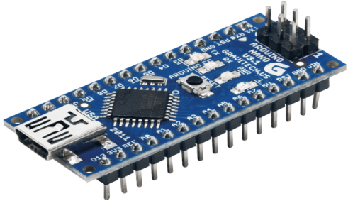**Figure 1:**

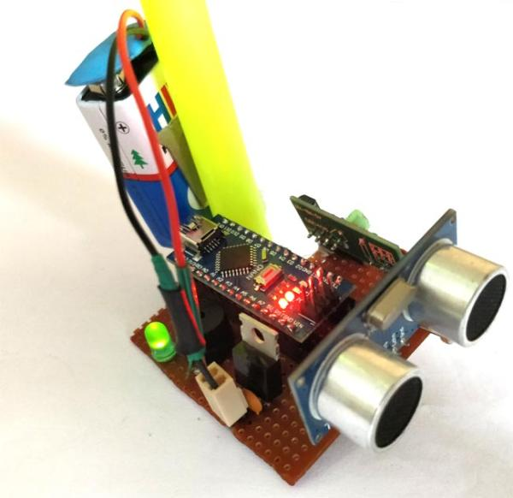**Figure 2:**

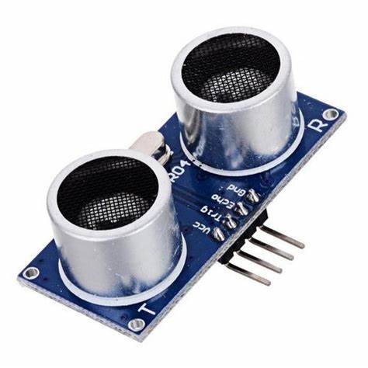**Figure 3:**

**Figure 4:**

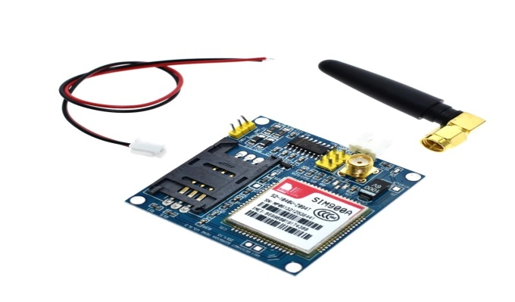

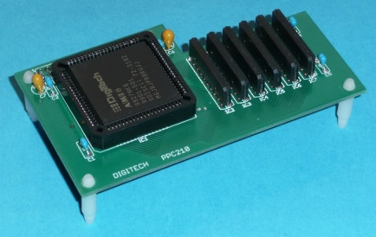**Figure 5:**

**Figure 6:**

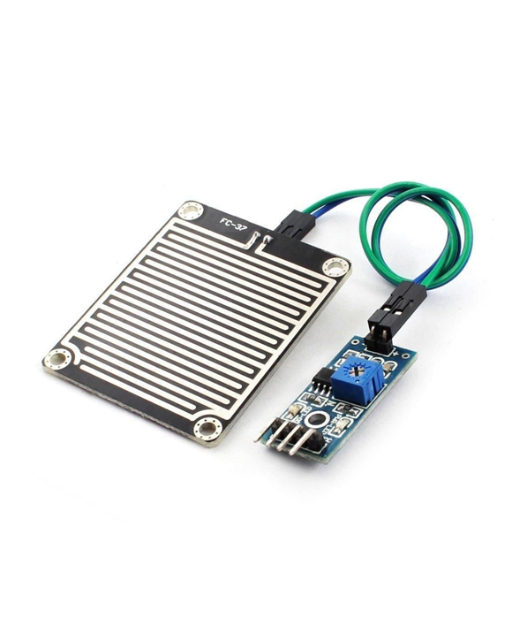

**Architectural Layout**

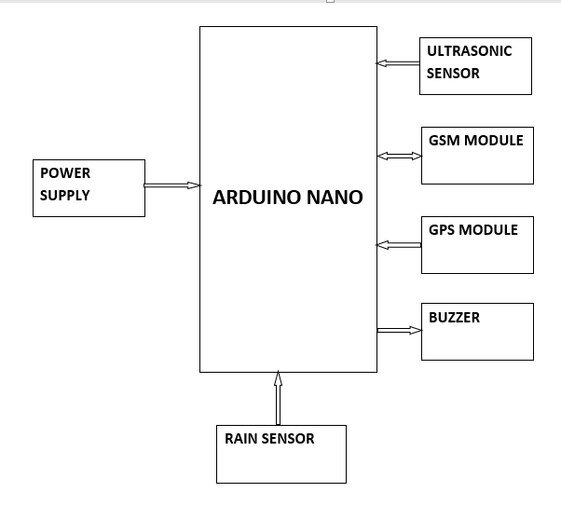

REFERENCES

S. Suhaeb, "Implementation of GPS-Based Location Display System on the Train as an Automatic Guide", in Journal of Scientific Pinisi, Vol. 2, No. 2, page.131-136, 2016.

J. V. Narayanrao, "Safety Stick For Blind People Using Microcontroller", in International Journal of Engineering Development and Research, Volume 4, Issue 2, 2016.

S.Ullah, S. Ahmed,W. Ahmad and L. Jan, "Sensor Based Smart Stick for Blind Person Navigation", in International Journal of Scientific & Engineering Research, Volume 9, Issue 12, December-2018.

A. Tekade, M. Sonekar, M. Ninave and P. Dongre, "Ultrasonic Blind Stick with GPS Tracking System", in International Journal of Engineering Science and Computing, March 2018.

R. Dhanuja, F. Farhana and G. Savitha, "Smart Blind Sitck Using Arduino", in International Research Journal of Engineering and Technology (IRJET), Volume: 05 Issue: 03 March 2018.

. Jeevana, R. K. Sundar, K. Pravin S. Preethi and R. Karthik, "Design of Intelligent Stick -Guide for the Blind", in IJSRD -International Journal for Scientific Research & Development, Vol. 6, Issue 01, 2018.

J. P. Bhadarka, P. S. Patel, Y. R. Pal and H. S. Parmar, "Smart Stick Design for Blind Person using Arduino Controller", in IJSRD -International Journal for Scientific Research & Development, Vol. 4, Issue 02, 2016.

3