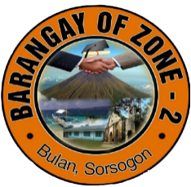Republic of the Philippines

Province of Sorsogon

Municipality of Bulan

Barangay Zone 2

**HOUSEHOLD RECORDS**

|  |  |  |  |  |  |  |
| --- | --- | --- | --- | --- | --- | --- |
| **#** | **Fullname** | **Household Number** | **Purok** | **Gender** | **Birthdate** | **Marital Status** |
| 1 | Mark Tahimik na | 101 | Purok 1 | Male | 2022-10-04 | Married |
|  |  |  |  |  |  |  |
|  |  |  |  |  |  |  |