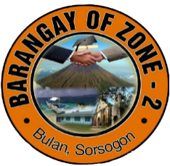Republic of the Philippines

Province of Sorsogon

Municipality of Bulan

Barangay Zone 2

**HOUSEHOLD RECORDS**

|  |  |  |  |  |  |  |
| --- | --- | --- | --- | --- | --- | --- |
| **#** | **Household Number** | **Fullname** | **Purok** | **Gender** | **Birthdate** | **Marital Status** |
| ${n#1} | ${h_number#1} | ${name#1} | ${purok#1} | ${gend#1} | ${bdate#1} | ${status#1} |
|  |  |  |  |  |  |  |