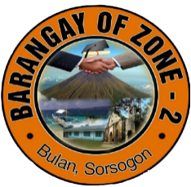Republic of the Philippines

Province of Sorsogon

Municipality of Bulan

Barangay Zone 2

**HOUSEHOLD RECORDS**

|  |  |  |  |  |  |  |
| --- | --- | --- | --- | --- | --- | --- |
| **#** | **Household Number** | **Fullname** | **Purok** | **Gender** | **Birthdate** | **Marital Status** |
| 1 | ${h_number#1} | Roth Thomas | ${purok#1} | ${gend#1} | ${bdate#1} | ${status#1} |
| 2 | ${h_number#2} | Joy Ferrell | ${purok#2} | ${gend#2} | ${bdate#2} | ${status#2} |
| 3 | ${h_number#3} | Kirk Workman | ${purok#3} | ${gend#3} | ${bdate#3} | ${status#3} |
| 4 | ${h_number#4} | Patrick Mcneil | ${purok#4} | ${gend#4} | ${bdate#4} | ${status#4} |
|  |  |  |  |  |  |  |