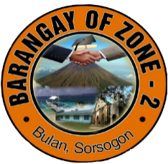Republic of the Philippines

Province of Sorsogon

Municipality of Bulan

Barangay Zone 2

**HOUSEHOLD RECORDS**

|  |  |  |  |  |  |  |
| --- | --- | --- | --- | --- | --- | --- |
| **#** | **House Number** | **Fullname** | **Purok** | **Gender** | **Birthdate** | **Marital Status** |
| ${n} | ${h_number} | ${name} | ${purok} | ${gend} | ${bdate} | ${status} |
|  |  |  |  |  |  |  |