KMIP Module Design
on top of a PKCS#11 HSM

Architecture & Sequence Design Document

Version 1.0 · June 14, 2026
Classification: Internal

Table of Contents
1 Introduction & Scope
2 Standards Overview
3 High-Level Architecture
4 Component Design
5 KMIP ↔ PKCS#11 Operation Mapping
6 Key Attribute & Metadata Model
7 Key Lifecycle State Machine
8 Sequence Diagrams
8.1 SD-01 System Initialization & HSM Login
8.2 SD-02 Create Symmetric Key
8.3 SD-03 Create Key Pair
8.4 SD-04 Get (Retrieve Key Material)
8.5 SD-05 Encrypt Operation
8.6 SD-06 Key Lifecycle (Activate → Revoke → Destroy)
8.7 SD-07 Locate Operation
8.8 SD-08 Authentication & Authorization
9 Transport & TLS Configuration
10 Authentication Mechanisms
11 Metadata Store Schema
12 Error Handling & Result Codes
13 Security Considerations
14 Implementation Roadmap
15 References

1. Introduction & Scope
This document describes the architecture and detailed design for a KMIP (Key Management Interoperability Protocol) server module built on top of a PKCS#11-compliant Hardware Security Module (HSM). The goal is to expose a standards-compliant KMIP interface to any KMIP client while delegating all cryptographic operations and key storage to a hardware-backed PKCS#11 token.

Scope:
- KMIP versions covered: 1.4 and 2.1 (with 3.0 PQC extensions noted).
- PKCS#11 (Cryptoki) version: 2.40 / 3.0.
- Transport: TLS 1.3 over TCP (port 5696).
- Authentication: mTLS + KMIP credential (username/password, device credential).
- Managed objects: Symmetric Keys, Asymmetric Key Pairs, Certificates, Secret Data, Opaque Objects.

2. Standards Overview

2.1 KMIP
KMIP is an OASIS standard (first published October 2010) defining a vendor-neutral wire protocol for creating, registering, retrieving, and destroying cryptographic objects. Messages are encoded in TTLV (Tag–Type–Length–Value) binary format and transported over TLS. Current stable version is 2.1 (December 2020); version 3.0 adds post-quantum algorithms (ML-KEM, ML-DSA, SLH-DSA).

2.2 PKCS#11 (Cryptoki)
PKCS#11, maintained by OASIS (formerly RSA Labs), defines a C-language API to hardware and software cryptographic tokens. HSMs expose a PKCS#11 shared library (.so / .dll). All key material remains inside the HSM boundary; applications receive only opaque handles (CK_OBJECT_HANDLE).

Standard | Body | Current Version | Key Concepts
KMIP | OASIS | 2.1 (3.0 draft) | TTLV encoding, managed objects, operations, profiles
PKCS#11 | OASIS | 3.0 | Cryptoki API, sessions, slots, tokens, mechanisms
TLS | IETF | 1.3 (RFC 8446) | mTLS, AEAD cipher suites, perfect forward secrecy
X.509 | IETF | RFC 5280 | Certificate format, chain validation

3. High-Level Architecture
The system is structured as a layered stack. KMIP clients connect over TLS to the KMIP Server Layer, which translates operations into PKCS#11 calls against the HSM, and maintains a Metadata Store for KMIP-specific attributes that have no PKCS#11 equivalent.

┌──────────────────────────────────────────────────────┐
│ KMIP Clients (any vendor) │
│ Storage Arrays │ Tape Libraries │ Apps │ Databases │
└──────────────────────────┬───────────────────────────┘
│ KMIP over TLS 1.3 (port 5696)
┌──────────────────────────▼───────────────────────────┐
│ KMIP Server Layer │
│ ┌──────────┐ ┌──────────┐ ┌──────────┐ ┌────────┐ │
│ │ TTLV │ │ Protocol │ │ Lifecycle│ │ Auth │ │
│ │ Parser │ │ Dispatch │ │ Engine │ │ ACL │ │
│ └──────────┘ └──────────┘ └──────────┘ └────────┘ │
└────────────────────┬─────────────┬────────────────────┘
│ PKCS#11 │ SQL
┌──────────▼──────┐ ┌───▼──────────────────┐
│ PKCS#11 Shim │ │ Metadata Store │
│ (C_GenerateKey │ │ (UUID, hKey, state, │
│ C_Encrypt …) │ │ dates, attributes) │
└──────────┬──────┘ └──────────────────────┘
│ HSM Driver
┌──────────▼──────────────────┐
│ HSM Hardware │
│ (key gen, crypto, storage) │
└─────────────────────────────┘

4. Component Design

TTLV Parser / Serializer
Encodes and decodes KMIP messages in binary TTLV (Tag–Type–Length–Value) format. Must handle nested Structures, TextStrings, ByteStrings, Integers, Enumerations, DateTimes, and BigIntegers. Also supports JSON and XML alternative encodings (KMIP Additional Message Encodings spec).

Protocol Dispatcher
Routes each incoming Batch Item to the correct operation handler based on the Operation enumeration. Supports batch requests (multiple operations per TLS frame) and async polling via the Poll operation.

Lifecycle Engine
Implements the KMIP state machine: Pre-Active → Active → Deactivated → Compromised → Destroyed. Enforces date-based transitions (Activation Date, Deactivation Date). Calls the Metadata Store for state persistence.

Auth / ACL Module
Validates mTLS client certificates and KMIP Credential structures (UsernamePassword, DeviceCredential, AttestationCredential). Maps identities to KMIP principals and enforces CryptographicUsageMask per operation.

PKCS#11 Shim
Wraps the vendor PKCS#11 shared library. Manages slot/token enumeration, session pooling (C_OpenSession / C_CloseSession), login (C_Login), and provides a clean Go/Rust/C API to the layers above.

Metadata Store
Stores KMIP-specific attributes that PKCS#11 does not natively support: Unique Identifier (UUID), Activation Date, Deactivation Date, State, Name, Link, Application Specific Information, Revocation Reason, and PKCS#11 handle reference. SQLite for single-node; PostgreSQL for HA.

5. KMIP ↔ PKCS#11 Operation Mapping
The following table shows how each KMIP operation maps to one or more PKCS#11 Cryptoki function calls. Operations marked 'Metadata only' require no HSM call.

KMIP Operation | PKCS#11 Call(s) | Notes
Create (symmetric) | C_GenerateKey | Template built from CryptoAlg + KeyLength
Create Key Pair | C_GenerateKeyPair | Two handles returned: hPub, hPriv
Register | C_CreateObject | Client supplies key material
Import (v2.0+) | C_CreateObject / C_UnwrapKey | Optionally unwrap if wrapped
Get | C_GetAttributeValue(CKA_VALUE) | Only if CKA_EXTRACTABLE = TRUE
Export (v2.0+) | C_WrapKey or C_GetAttributeValue | Wrapping key UUID specified
Locate | C_FindObjectsInit + C_FindObjects | Cross-reference with Metadata Store
Destroy | C_DestroyObject | HSM zeroizes key material
Activate | Metadata only | State → Active; no HSM call needed
Revoke (deactivate) | C_SetAttributeValue(CKA_ENCRYPT=F) | Restrict usage on HSM
Revoke (compromise) | C_SetAttributeValue + C_DestroyObject | Compromise + optional destroy
Encrypt | C_EncryptInit + C_Encrypt | IV/AAD passed in KMIP request
Decrypt | C_DecryptInit + C_Decrypt | Tag verified for AEAD modes
Sign | C_SignInit + C_Sign | Mechanism = CKM_RSA_PKCS, CKM_ECDSA…
Signature Verify | C_VerifyInit + C_Verify
MAC | C_SignInit (HMAC mechanism) | CKM_SHA256_HMAC etc.
MAC Verify | C_VerifyInit (HMAC mechanism)
Derive Key | C_DeriveKey | ECDH, HKDF mechanisms
Re-key | C_GenerateKey + C_DestroyObject (old) | New UUID linked to old
Get Attributes | C_GetAttributeValue | Merge with Metadata Store
Set Attribute | C_SetAttributeValue | For mutable PKCS#11 attrs only
Query | C_GetInfo + C_GetMechanismList | Capabilities discovery
Discover Versions | Metadata only | Returns supported KMIP versions
RNG Retrieve | C_GenerateRandom | HSM TRNG output
RNG Seed | C_SeedRandom | Optional on HSMs

6. Key Attribute & Metadata Model
PKCS#11 stores a limited set of attributes on the token. The Metadata Store extends this with KMIP-specific fields. The mapping below shows where each KMIP attribute lives.

KMIP Attribute | Stored in | PKCS#11 Attribute
Unique Identifier | Metadata Store | CKA_ID (cross-reference)
Name | Metadata Store | CKA_LABEL (primary name only)
Object Type | Metadata Store | CKA_CLASS
Cryptographic Algorithm | PKCS#11 Token | CKA_KEY_TYPE
Cryptographic Length | PKCS#11 Token | CKA_VALUE_LEN
Cryptographic Usage Mask | PKCS#11 Token | CKA_ENCRYPT, CKA_DECRYPT, CKA_SIGN…
State | Metadata Store | Derived from CKA_ENCRYPT / CKA_DECRYPT
Initial Date | Metadata Store | —
Activation Date | Metadata Store | —
Deactivation Date | Metadata Store | —
Destroy Date | Metadata Store | —
Compromise Occurrence Date | Metadata Store | —
Revocation Reason | Metadata Store | —
Link | Metadata Store | CKA_ID of linked object
Sensitive | PKCS#11 Token | CKA_SENSITIVE
Extractable | PKCS#11 Token | CKA_EXTRACTABLE
Always Sensitive | PKCS#11 Token | CKA_ALWAYS_SENSITIVE
Never Extractable | PKCS#11 Token | CKA_NEVER_EXTRACTABLE
Application Specific Info | Metadata Store | —
Custom Attribute | Metadata Store | —

7. Key Lifecycle State Machine
KMIP defines six lifecycle states. Transitions are triggered by KMIP operations or by date-based policies evaluated at request time.

[CREATE / REGISTER]
│
▼
┌──────────┐ Activate() ┌──────────┐
│Pre-Active│────────────────▶│ Active │
└──────────┘ └────┬─────┘
│ │
│ Revoke(Compromise) │ Revoke(Normal)
│ ▼
│ ┌─────────────┐
│ │ Deactivated │
│ └──────┬──────┘
│ │
▼ Revoke(Comp.) │
┌───────────┐◀──────────────────┘
│Compromised│
└─────┬─────┘
│ Destroy()
▼
┌───────────────────┐
│Destroyed Compromis│
└───────────────────┘
Any state ──Destroy()──▶ Destroyed

From State | KMIP Operation | To State | HSM Action
(none) | Create / Register | Pre-Active | C_GenerateKey / C_CreateObject
Pre-Active | Activate | Active | None (metadata only)
Active | Revoke(Superseded) | Deactivated | C_SetAttributeValue(Encrypt=F)
Active / Pre-Active | Revoke(Compromised) | Compromised | C_SetAttributeValue(all=F)
Deactivated | Revoke(Compromised) | Compromised | C_SetAttributeValue(all=F)
Any | Destroy | Destroyed | C_DestroyObject
Compromised | Destroy | Destroyed Compromised | C_DestroyObject (record kept)

8. Sequence Diagrams
The following sequence diagrams illustrate the message flows between KMIP Client, KMIP Server, PKCS#11 Shim, HSM Hardware, and Metadata Store for the most important operations.

8.1 System Initialization & HSM Login
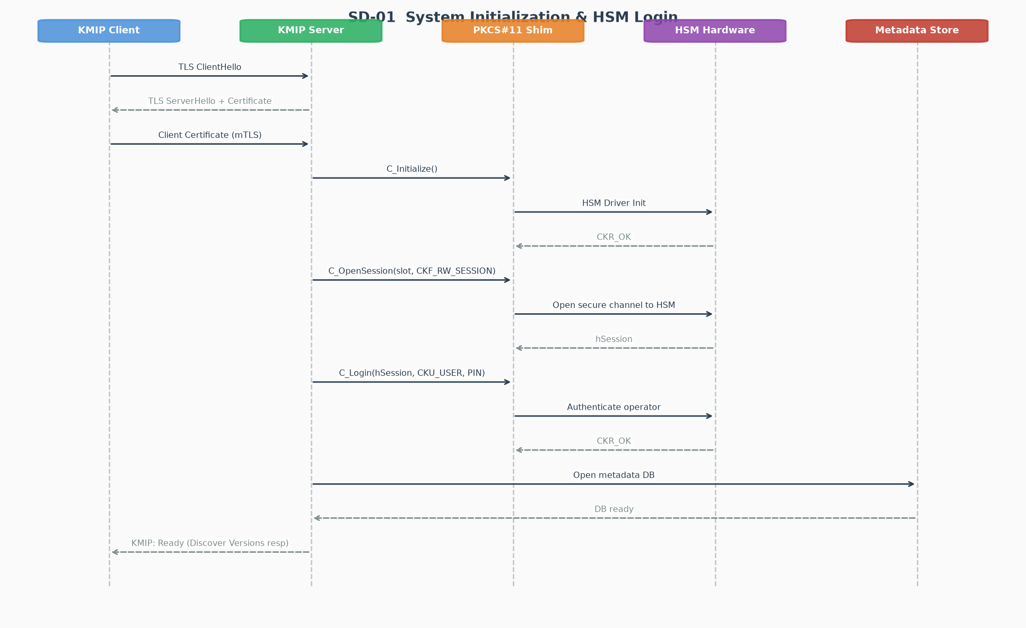
Figure: SD-01 — System Initialization & HSM Login

8.2 Create Symmetric Key
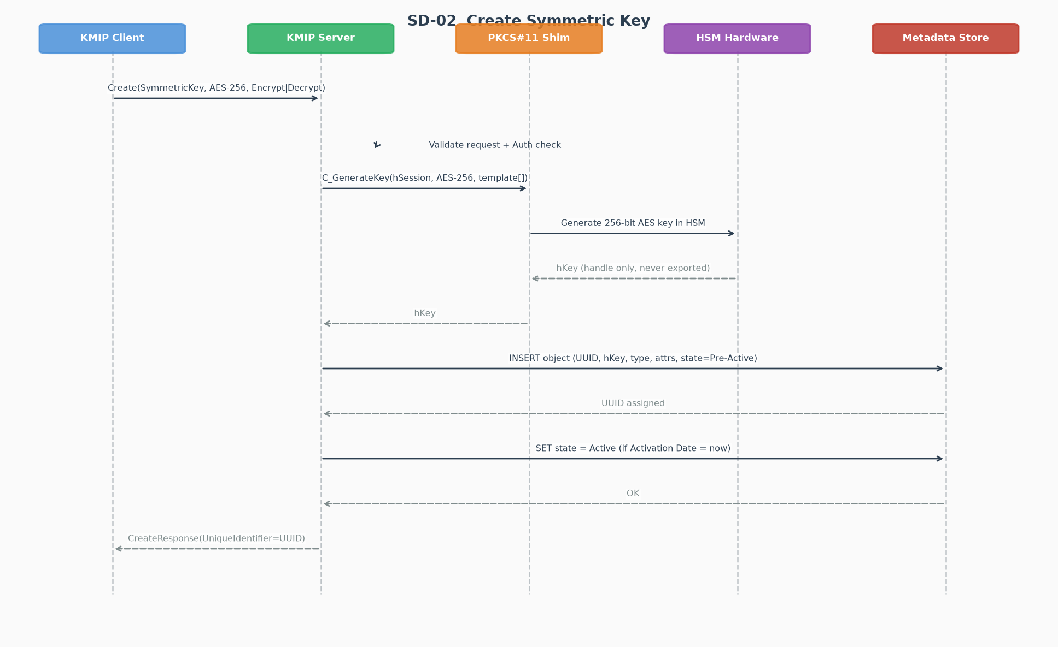
Figure: SD-02 — Create Symmetric Key

8.3 Create Key Pair (Asymmetric)
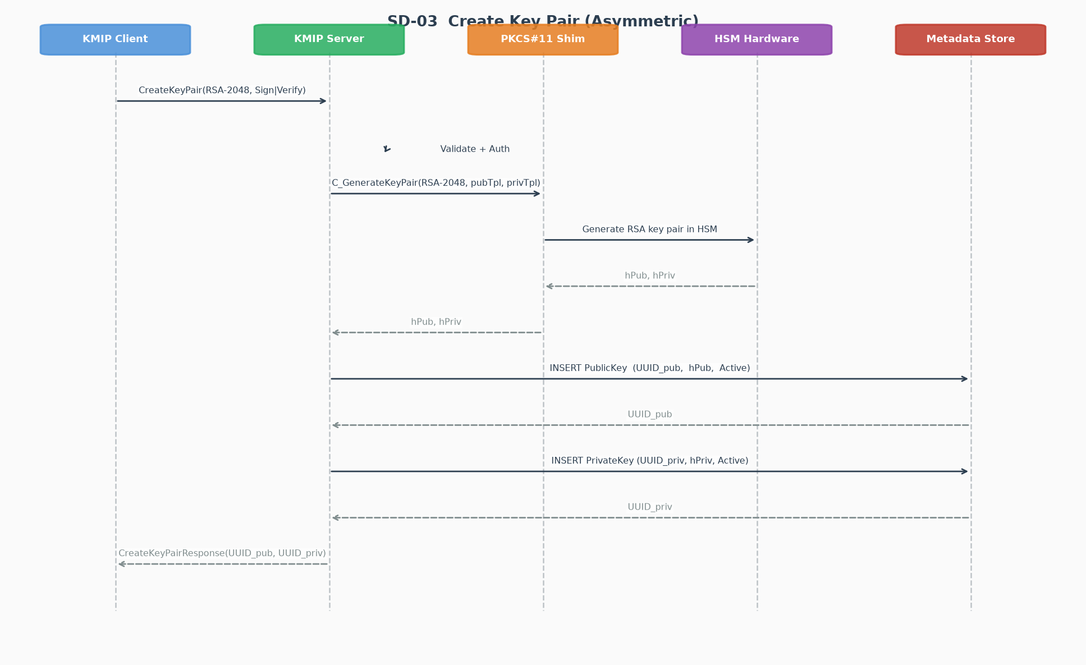
Figure: SD-03 — Create Key Pair (Asymmetric)

8.4 Get — Retrieve Key Material
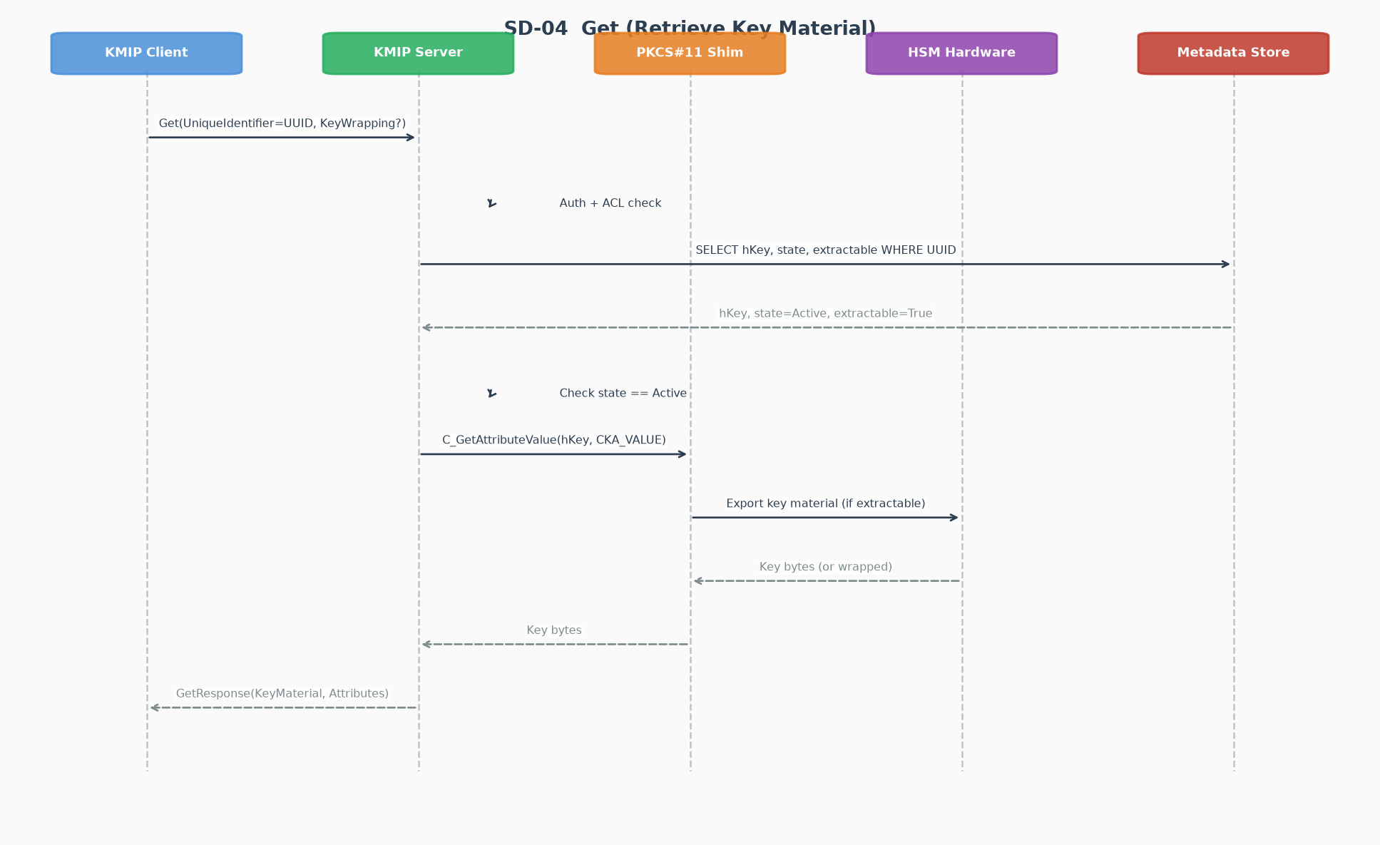
Figure: SD-04 — Get — Retrieve Key Material

8.5 Encrypt Operation
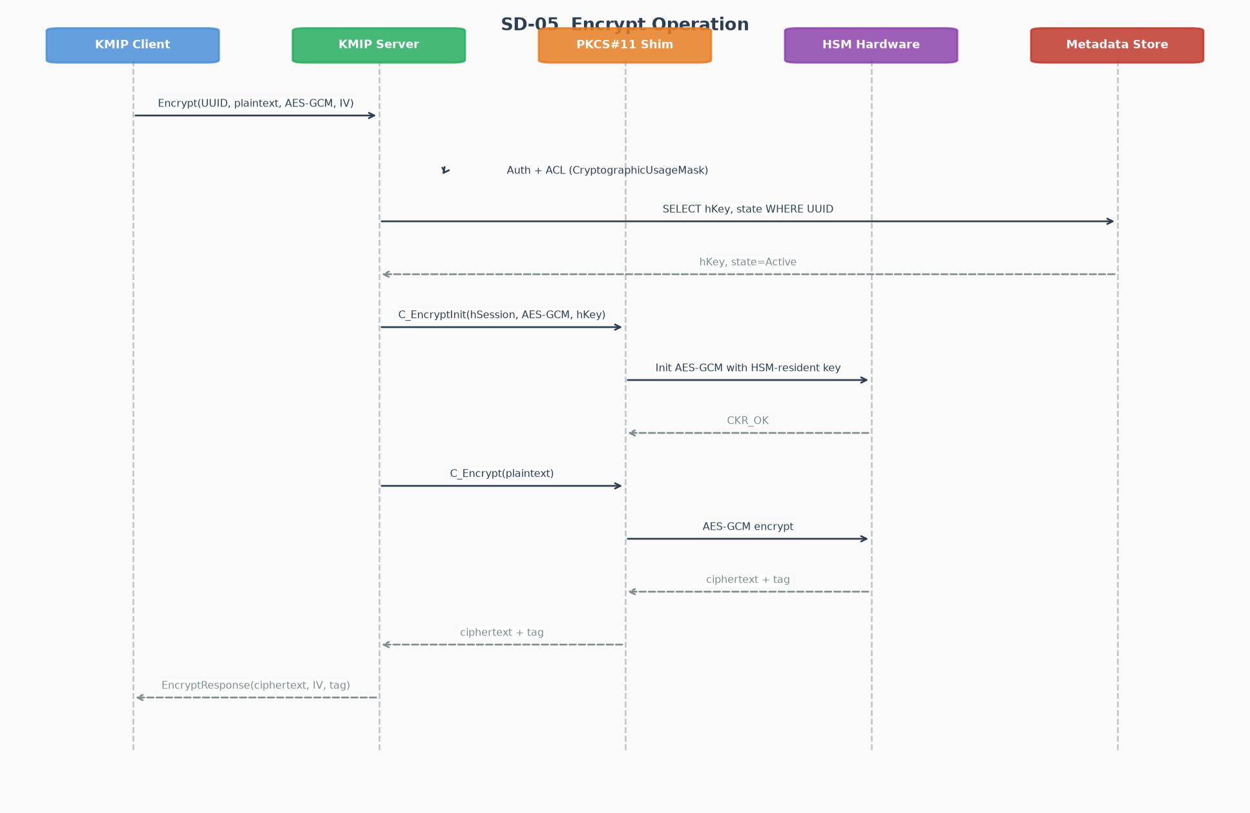
Figure: SD-05 — Encrypt Operation

8.6 Key Lifecycle (Activate → Revoke → Destroy)
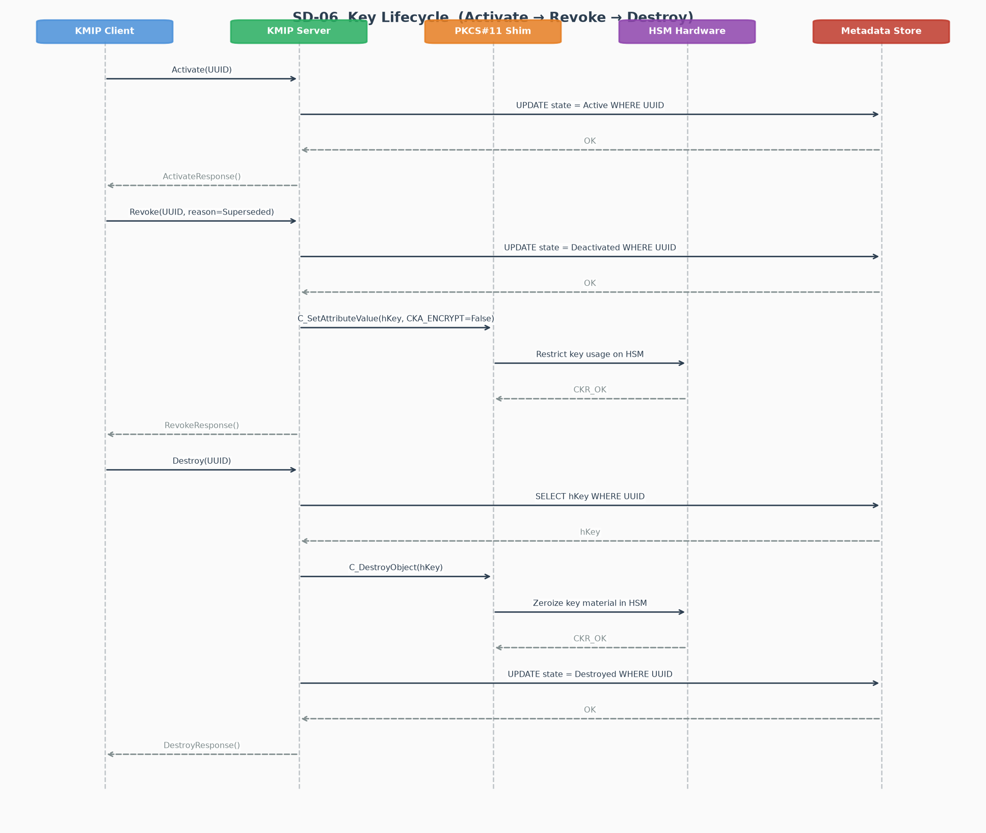
Figure: SD-06 — Key Lifecycle (Activate → Revoke → Destroy)

8.7 Locate Operation
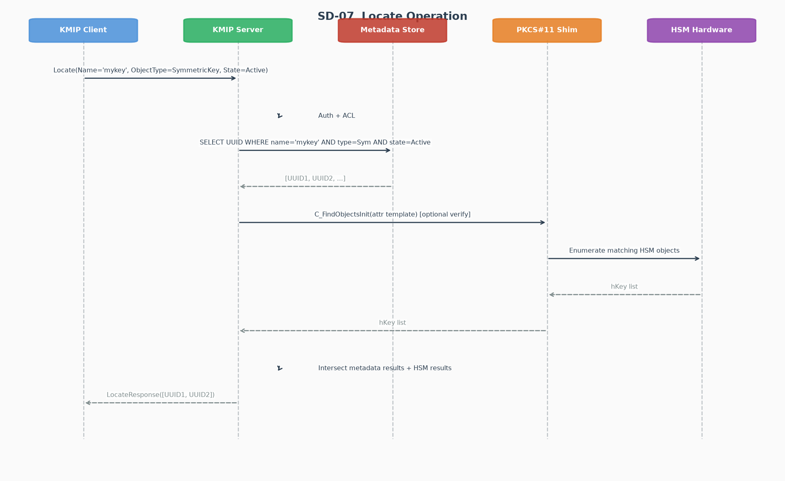
Figure: SD-07 — Locate Operation

8.8 Authentication & Authorization Flow
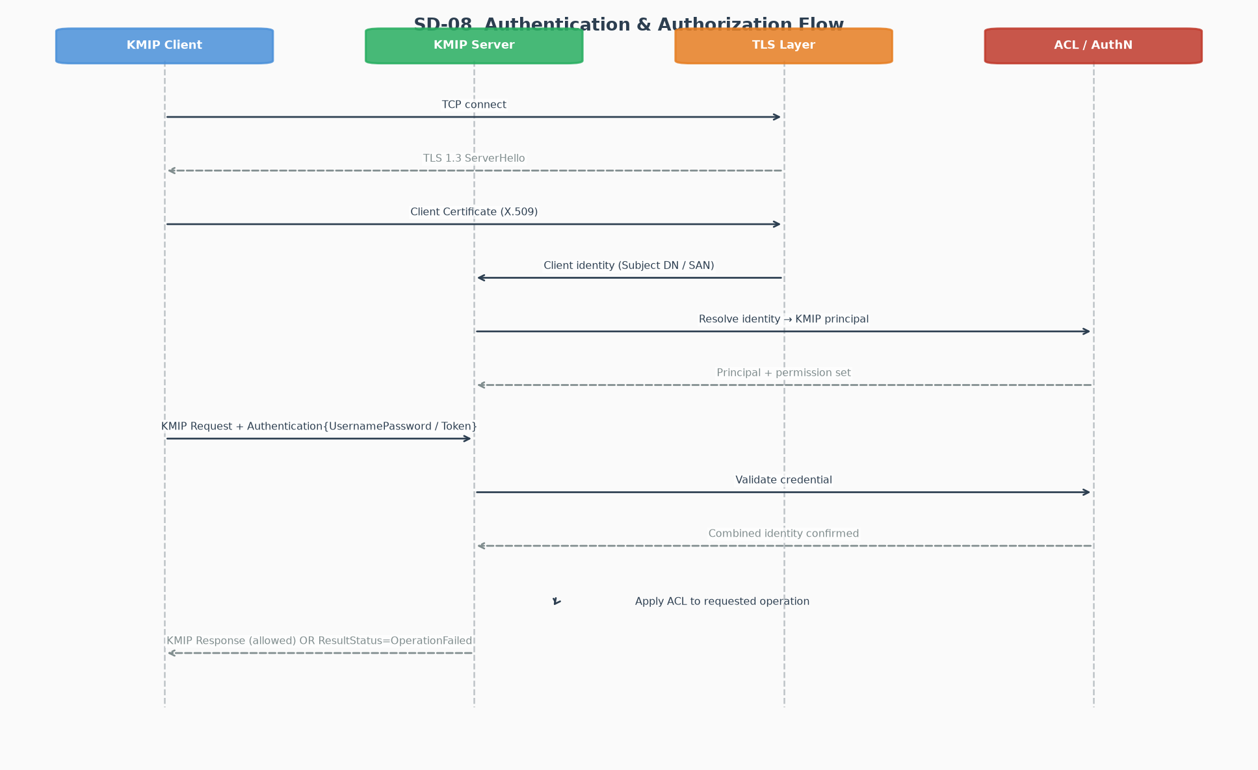
Figure: SD-08 — Authentication & Authorization Flow

9. Transport & TLS Configuration
Parameter | Value
Default TCP port | 5696 (IANA assigned to KMIP)
TLS version | TLS 1.3 (minimum); TLS 1.2 allowed for legacy clients
Client authentication | Mutual TLS (mTLS) — mandatory
Cipher suites (TLS 1.3) | TLS_AES_256_GCM_SHA384, TLS_CHACHA20_POLY1305_SHA256
Certificate format | X.509 v3 with SubjectAltName
Session resumption | TLS 1.3 session tickets; max lifetime 24 h
KMIP over HTTPS | Optional — same TTLV payload over HTTPS/443
PQC (KMIP 3.0) | TLS 1.3 + Kyber/ML-KEM hybrid key exchange

10. Authentication Mechanisms
Authentication is two-layered: channel-level (TLS) and application-level (KMIP Credential). Both layers are evaluated; the server uses the intersection of identities to determine the effective KMIP principal.

Credential Type | KMIP Structure | Use Case
Mutual TLS | TLS client certificate (X.509) | Machine / service authentication
UsernameAndPassword | Credential{UsernamePasswordCredential} | Human operator authentication
Device Credential | Credential{DeviceCredential} | IoT / embedded device authentication
Attestation | Credential{AttestationCredential} | TPM / hardware attestation
One-Time Password | Credential{OneTimePasswordCredential} | MFA scenarios
Hashed Password | Credential{HashedPasswordCredential} | Legacy system integration

11. Metadata Store Schema
The Metadata Store persists KMIP-specific attributes not natively held in PKCS#11. Two primary tables are required.

Table: kmip_objects
CREATE TABLE kmip_objects (
uuid TEXT PRIMARY KEY, -- KMIP Unique Identifier
object_type TEXT NOT NULL, -- SymmetricKey | PublicKey | PrivateKey | ...
pkcs11_handle BIGINT, -- CK_OBJECT_HANDLE (0 = metadata-only)
pkcs11_slot INT, -- CK_SLOT_ID
state TEXT NOT NULL, -- PreActive | Active | Deactivated | Compromised | Destroyed
cryptographic_algorithm TEXT,
cryptographic_length INT,
usage_mask TEXT, -- JSON array of allowed operations
initial_date TIMESTAMP,
activation_date TIMESTAMP,
deactivation_date TIMESTAMP,
destroy_date TIMESTAMP,
compromise_date TIMESTAMP,
revocation_reason TEXT,
sensitive BOOLEAN DEFAULT TRUE,
extractable BOOLEAN DEFAULT FALSE,
owner_identity TEXT, -- KMIP principal (from mTLS DN)
created_at TIMESTAMP DEFAULT CURRENT_TIMESTAMP
);

Table: kmip_attributes
CREATE TABLE kmip_attributes (
id SERIAL PRIMARY KEY,
object_uuid TEXT NOT NULL REFERENCES kmip_objects(uuid),
attr_name TEXT NOT NULL, -- e.g. 'Name', 'Link', 'x-custom'
attr_index INT DEFAULT 0, -- for multi-valued attrs
attr_value TEXT NOT NULL
);
CREATE INDEX idx_attr_lookup ON kmip_attributes(object_uuid, attr_name);

12. Error Handling & Result Codes
Every KMIP Batch Item response carries a ResultStatus enumeration and, on failure, a ResultReason and ResultMessage. PKCS#11 return codes must be mapped to KMIP result reasons.

PKCS#11 Return Code | KMIP Result Reason | HTTP Analogy
CKR_OK | (success) | 200 OK
CKR_PIN_INCORRECT | AuthenticationNotSuccessful | 401
CKR_USER_NOT_LOGGED_IN | NotAuthorized | 403
CKR_OBJECT_HANDLE_INVALID | ItemNotFound | 404
CKR_KEY_HANDLE_INVALID | ItemNotFound | 404
CKR_KEY_SIZE_RANGE | InvalidField (key length) | 400
CKR_MECHANISM_INVALID | InvalidMessage | 400
CKR_ATTRIBUTE_READ_ONLY | InvalidField | 400
CKR_DEVICE_ERROR | GeneralFailure | 500
CKR_TOKEN_NOT_PRESENT | GeneralFailure | 503
CKR_SESSION_COUNT | GeneralFailure (session pool full) | 503
CKR_OPERATION_NOT_INITIALIZED | OperationNotSupported | 501

13. Security Considerations
Key Material Exposure
Keys with CKA_EXTRACTABLE=FALSE never leave the HSM. The KMIP 'Get' operation on such keys MUST return ResultReason=PermissionDenied. Sensitive attribute MUST be set TRUE on all newly generated keys.

PIN / HSM Credential Protection
The HSM SO-PIN and User-PIN must be stored in a secrets manager (e.g., HashiCorp Vault, AWS Secrets Manager). Never store in plaintext config files.

Metadata Store Integrity
The Metadata Store must be encrypted at rest and backed up with integrity verification. Divergence between PKCS#11 token state and Metadata Store state must trigger an alert and reconciliation procedure.

Session Hijacking
TLS 1.3 with mTLS prevents session hijacking. KMIP request batch items must be validated atomically — partial batch success must not leave the system in an inconsistent state.

Audit Logging
Every KMIP operation (success or failure), including operator, timestamp, operation type, and object UUID, must be written to an immutable audit log.

KMIP 3.0 PQC Readiness
Plan for ML-KEM and ML-DSA by ensuring the HSM firmware supports FIPS 203/204/205 mechanisms and the TLS stack supports hybrid key exchange (X25519Kyber768Draft00 or equivalent).

14. Implementation Roadmap
Phase | Deliverable | Duration
Phase 1 | TTLV parser + serializer (all primitive types + structures) | 3 weeks
Phase 2 | PKCS#11 shim: session pool, C_GenerateKey, C_DestroyObject | 2 weeks
Phase 3 | Metadata Store schema + CRUD layer | 1 week
Phase 4 | Create, Register, Get, Destroy, Locate operations | 3 weeks
Phase 5 | Lifecycle engine (Activate, Revoke, state machine) | 2 weeks
Phase 6 | Encrypt, Decrypt, Sign, Verify, MAC operations | 2 weeks
Phase 7 | TLS 1.3 / mTLS server, Auth module, ACL | 2 weeks
Phase 8 | KMIP 2.1 compliance testing (OASIS test vectors) | 2 weeks
Phase 9 | Derive Key, Re-key, Import/Export, batch support | 2 weeks
Phase 10 | PQC extensions (KMIP 3.0 ML-KEM, ML-DSA, TLS hybrid) | 3 weeks

15. References
- [1] OASIS KMIP Specification v2.1 — https://docs.oasis-open.org/kmip/kmip-spec/v2.1/
- [2] OASIS KMIP Profiles v2.1 — https://docs.oasis-open.org/kmip/kmip-profiles/v2.1/
- [3] OASIS KMIP Usage Guide v2.1 — https://docs.oasis-open.org/kmip/kmip-ug/v2.1/
- [4] KMIP Specification v3.0 CSD01 (August 2024) — https://docs.oasis-open.org/kmip/kmip-spec/v3.0/
- [5] OASIS PKCS#11 v3.0 — https://docs.oasis-open.org/pkcs11/pkcs11-base/v3.0/
- [6] RFC 8446 — The Transport Layer Security (TLS) Protocol Version 1.3
- [7] NIST FIPS 203 — Module-Lattice-Based Key-Encapsulation Mechanism (ML-KEM)
- [8] NIST FIPS 204 — Module-Lattice-Based Digital Signature Standard (ML-DSA)
- [9] NIST FIPS 205 — Stateless Hash-Based Digital Signature Standard (SLH-DSA)
- [10] cascade-hsm-bridge (NLnet Labs) — https://github.com/NLnetLabs/cascade-hsm-bridge
- [11] P6R KMIP Server Gateway — https://support.p6r.com/p6r/docs/ksg/
- [12] OpenKMIP / PyKMIP — https://github.com/OpenKMIP/PyKMIP
- [13] KMIP Additional Message Encodings v1.0 — https://docs.oasis-open.org/kmip/kmip-addtl-msg-enc/

