Project Title:
Manage Co-curricular Activities

Project Manager:
Dr. Kazi Masudul Alam Sir
Associate Professor
Computer Science and Engineering Discipline
Khulna University, Khulna

Developed By:
Arifur Rahman(160208)
Mrityunjoy Gain(160224)

Project Details:

- Co-curricular Activities is a web-base project that deals with the co-curricular event of the university.
- User see the different events hosted by different organizer(Discipline)
- User can search event by giving different input
- User can see upcoming event and completed events separately
- There is a calendar view in the project.
- In the calendar user can see in which date which event will occur in short.
- By clicking on the date user can see the events in detail including date, time, venue etc.

Website Layout:

Log In Page:
- Here user has to log in with his/her email and password to use it.



Home Page:

- After log in, user has to click on “Co-curricular” option.
- After that he/she will see “Co-curricular Related” option.
- Clicking on “Co-curricular Related” he/she will see that user options for book shop.
- Here user will see “Manage Category”, “Manage Organizer”, “Manage Activity”, “Search”, “Calendar View”.
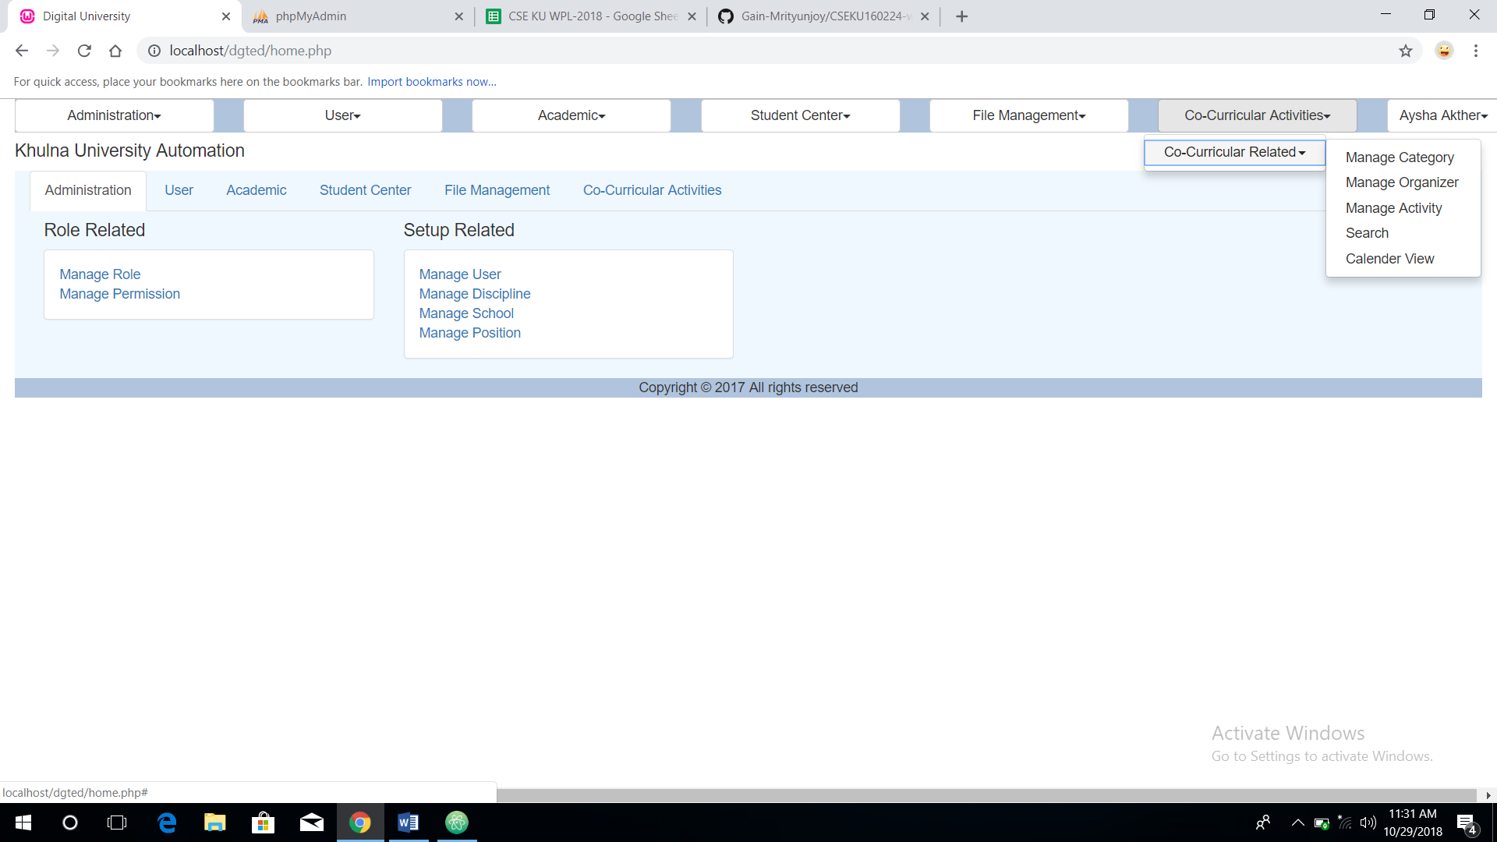

Manage Category:

- Manage Category is a feature for admin
- By clicking on “Manage Category” admin can add any type of category of event
- Here admin can edit, delete, update a category
- After adding any category, that will show on the interface

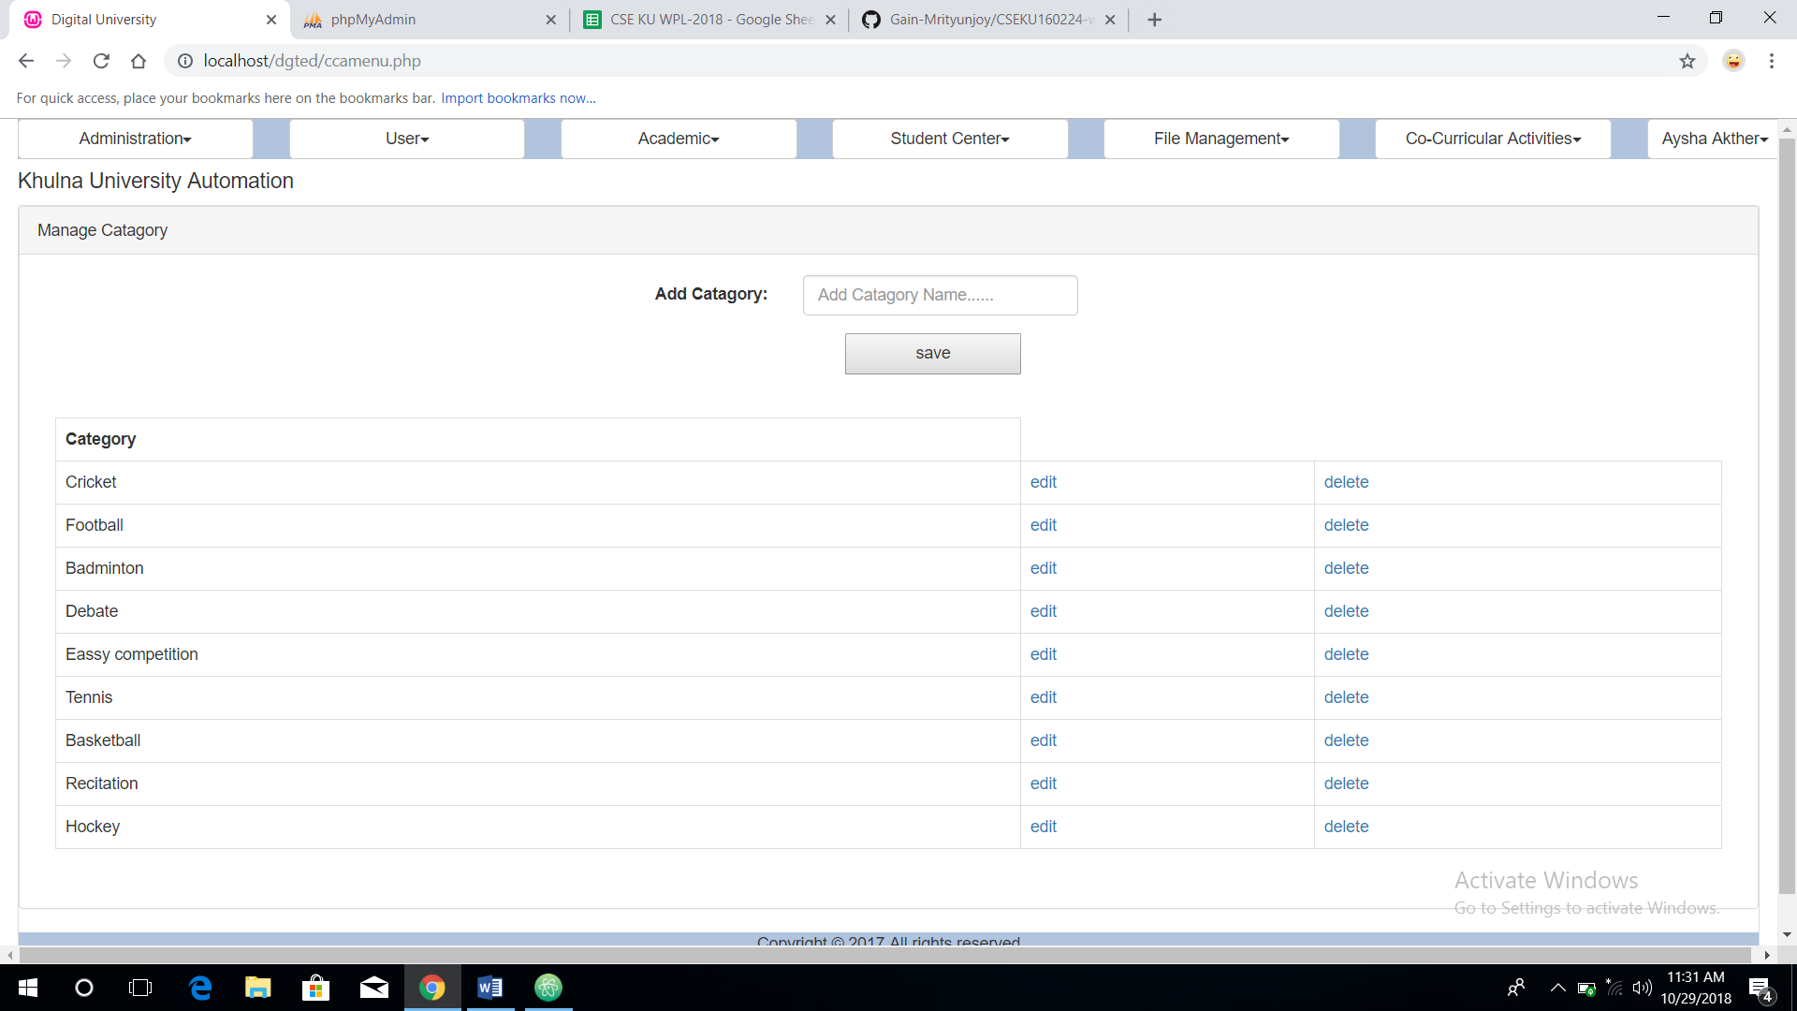

Manage Organizer:
- Here Admin or organizer can add any event organizer
- Admin can edit, update, delete any organizer

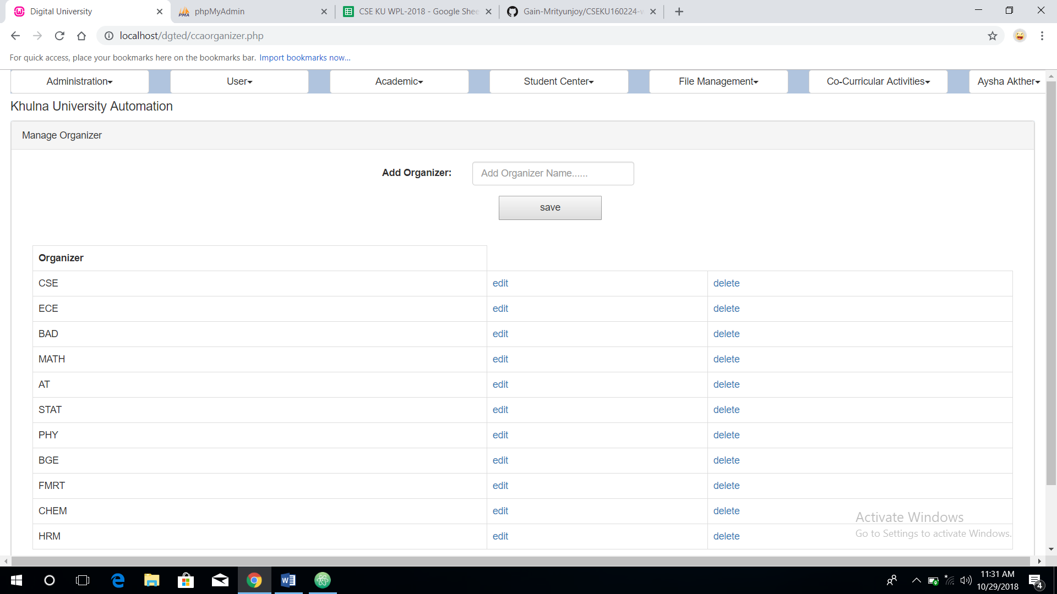

Add Activity:
- By clicking on the activity button, Admin can add any activity.
- Here admin add any activity name, organizer name, date of event, venue etc.
- After clicking ‘save’ button, then the added activity will be shown below

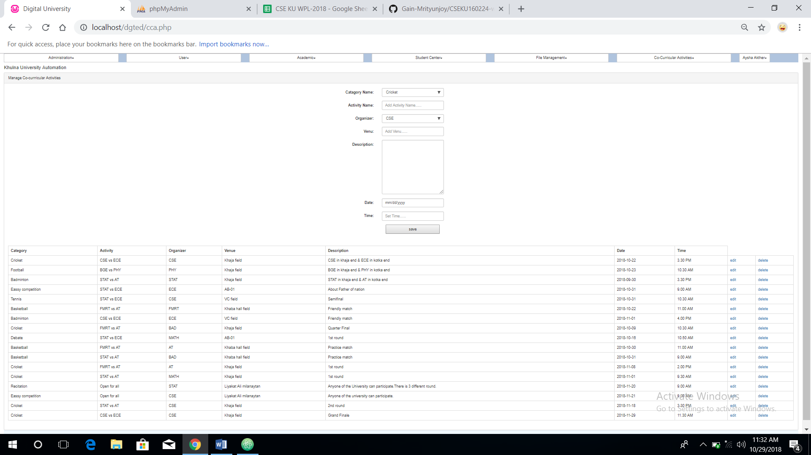

Search:
- It is a feature for user of the system
- User can search any event upcoming or completed.
- User can search by only category wise, organizer-wise, date wise.

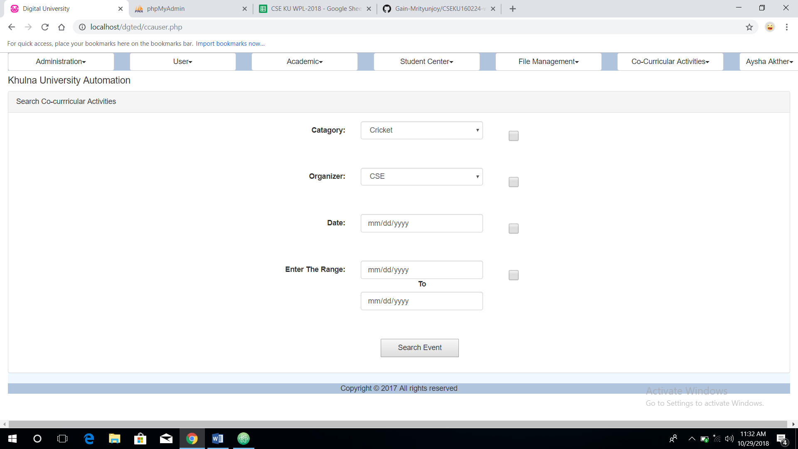

Search result
- After pressing the “Search Event” button then user can see the result of his search

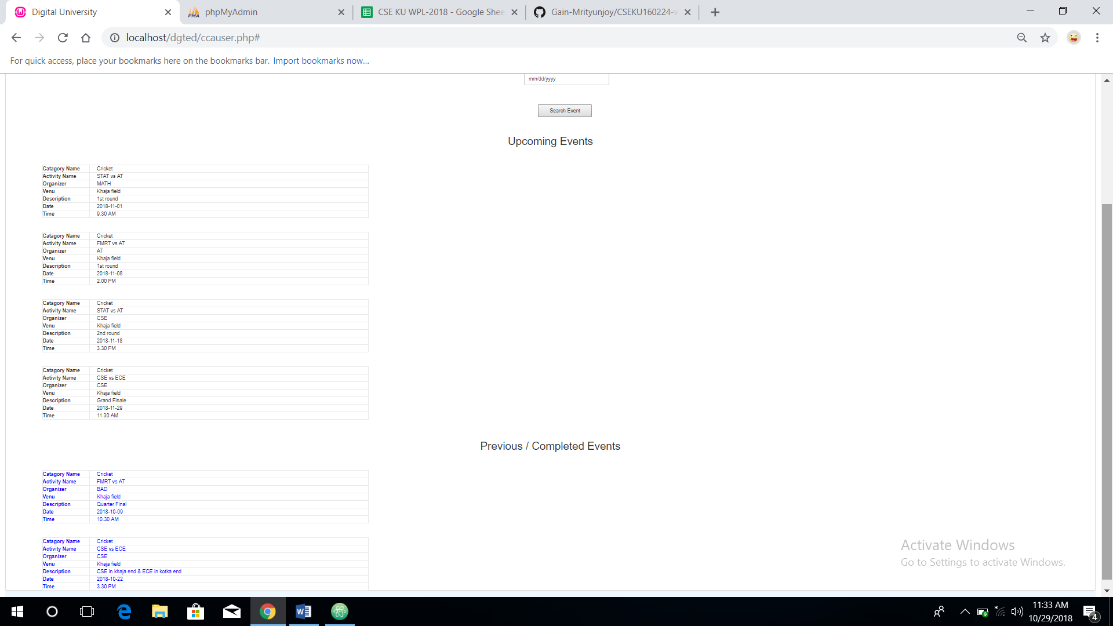

Calendar view
- Here is a calendar view
- User can find any event of any particular date
- If any event did not covered in any date, then it will show empty
- The events in any date will be shown in order
- Which event will occur in earlier, that will show earlier, and later event will be shown later
