***Rental Portal***

**Documentation**

**on**

**Schedulers**

**Version**

| **Version No.** | **Created / Updated By** | **Date** | **Changes** |
| --- | --- | --- | --- |
| 0.1 | Soumya Roy | 02 Nov 2022 | Initial document |

**Purpose**

This Document is meant to record details about the scheduled tasks that are run for the rental portal.

**Scope**

This Document covers the activities and configurations that are involved in triggering the processes of all the scheduled tasks in the Rental portal.

**InsertAssetmaster**

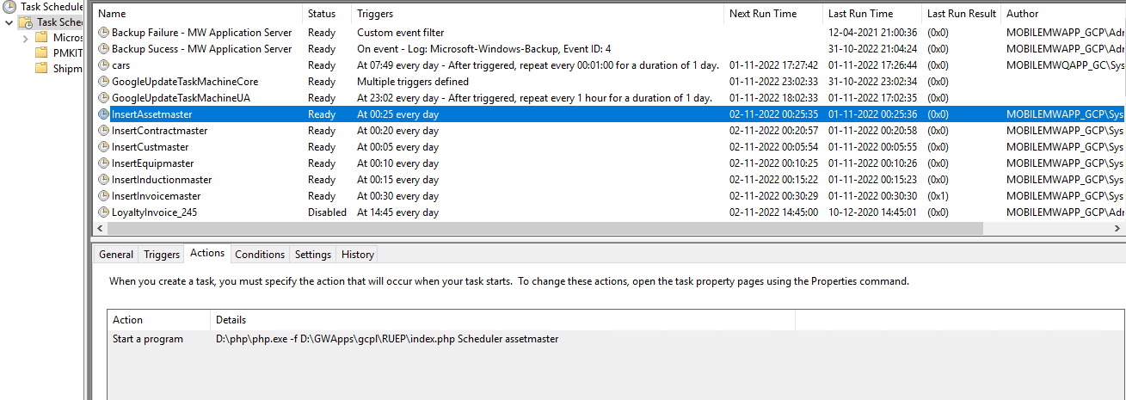

**Description :**   
Runs at 12:25 AM every day, Triggers a CI service **Scheduler > assetmaster**

**InsertContractmaster**

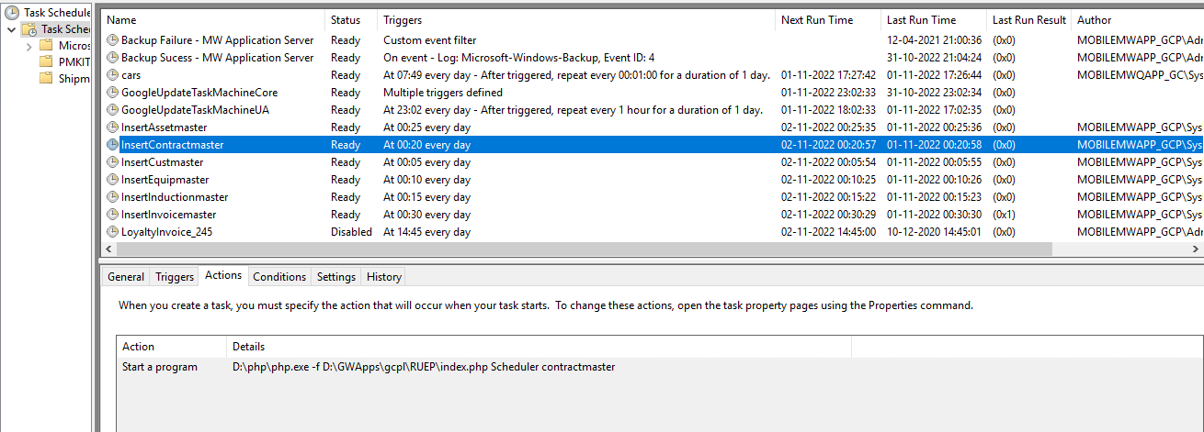

**Description :**   
Runs at 12:20 AM every day, Triggers a CI service **Scheduler > contractmaster**

**InsertCustmaster**

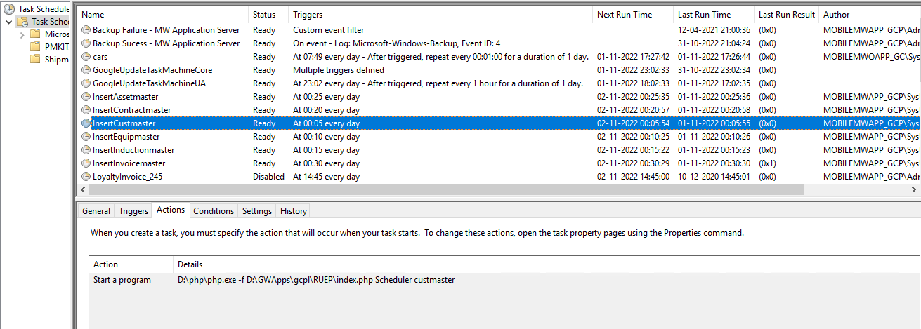

**Description :**   
Runs at 12:05 AM every day, Triggers a CI service **Scheduler > custmaster**

**InsertEquipmaster**

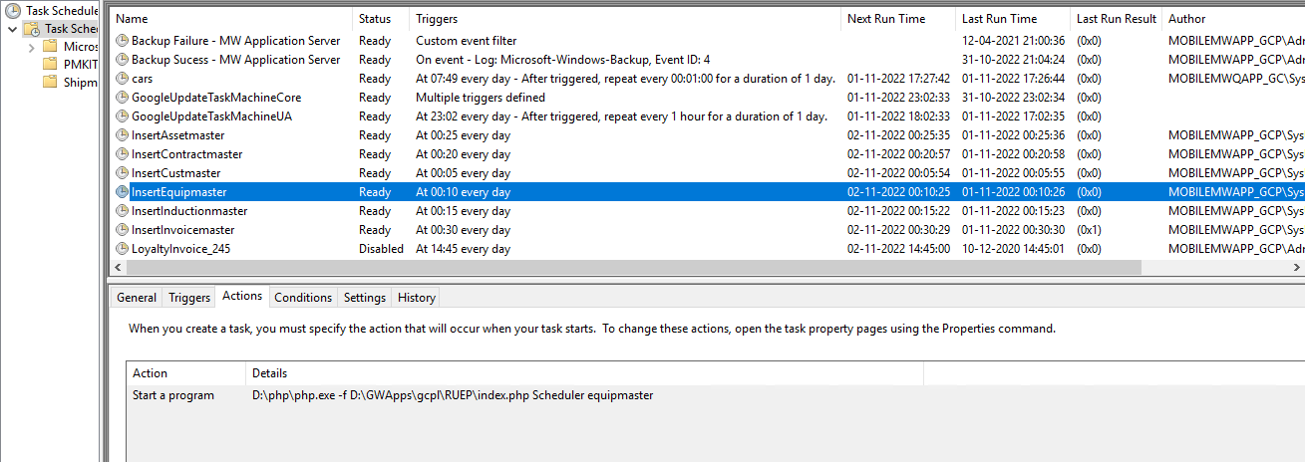

**Description :**   
Runs at 12:10 AM every day, Triggers a CI service **Scheduler > equipmaster**

**InsertInductionmaster**

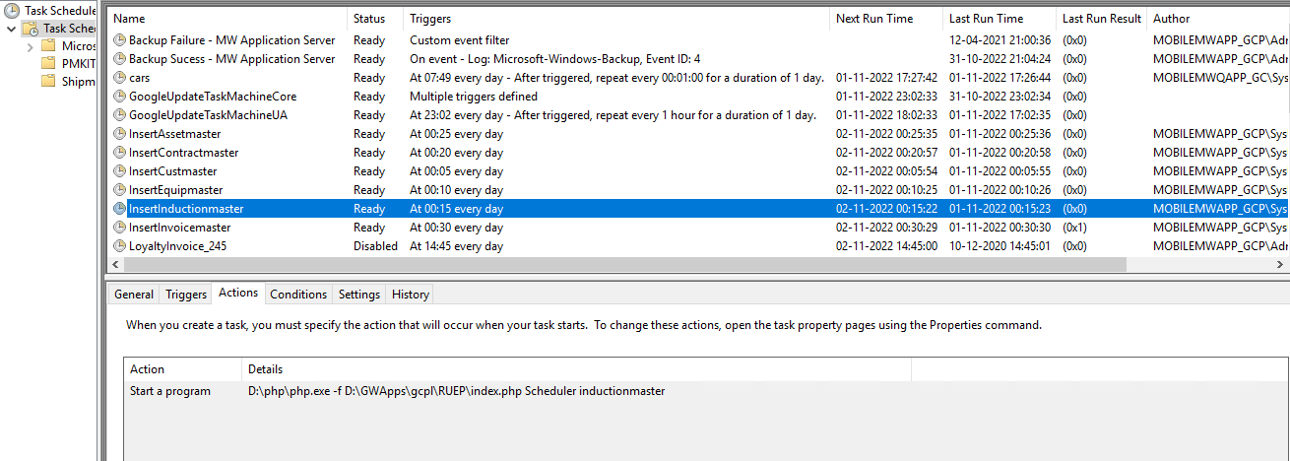

**Description :**   
Runs at 12:15 AM every day, Triggers a CI service **Scheduler > inductionmaster**

**InsertInvoicemaster**

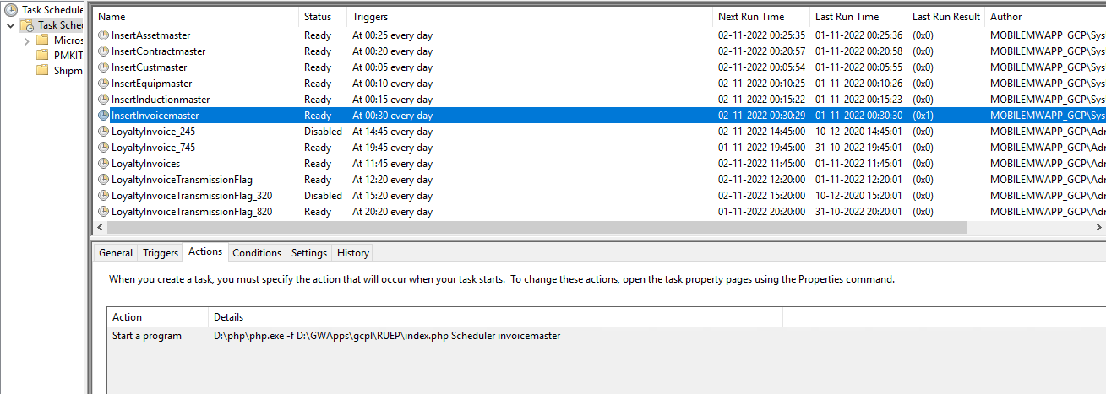

**Description :**   
Runs at 12:30 AM every day, Triggers a CI service **Scheduler > invoicemaster**

**ZipCreate**

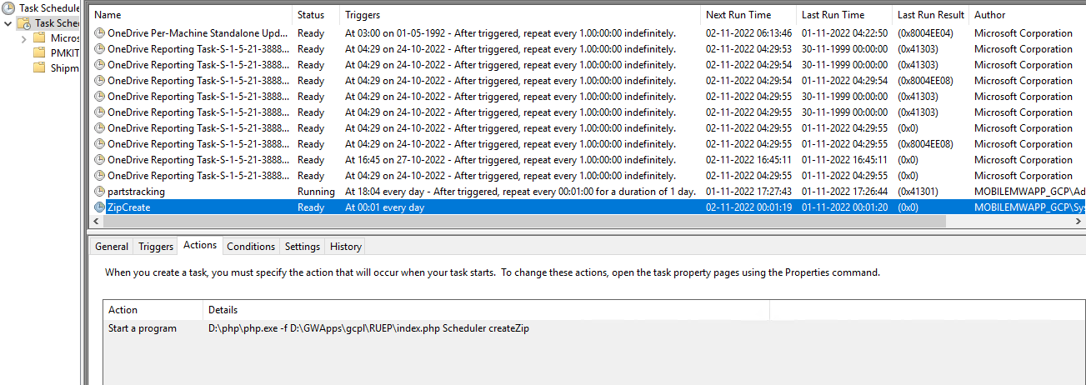

**Description :**   
Runs at 12:01 AM every day, Triggers a CI service **Scheduler > createZip**

**END**

**OF DOCUMENT**