ENVIRONMENTAL AND SOCIAL IMPACT ASSESSMENT
PROJECT REPORT
Proposed Dualling of the
Bomas–Rongai–Kiserian, Kiserian–Ngong and Karen–Ngong Roads
Nairobi and Kajiado Counties, Kenya
Proponent:
Kenya Urban Roads Authority (KURA)
Design Consultant:
APEC Consortium Limited
DRAFT FOR INTERNAL REVIEW — NOT YET SUBMITTED TO NEMA
September 2026

Note on this Revision
This Version 9 draft consolidates and reorganises the previous EIA Project Report (Version 8) using the project’s own design and engineering records — the Concept Geometric Design Report, the Land Acquisition and Major Junctions schedules, the three road-segment appreciation reports, and the design-team meeting minutes. It replaces the loose "Annex Document" extracts and the end-of-section image dumps in Version 8 with a single narrative in which each photograph/map sits next to the text it illustrates.
Three corrections carried over from the earlier drafts are flagged for the study team's attention:
- The proponent is corrected to the Kenya Urban Roads Authority (KURA), consistent with the letterhead on the design-team meeting minutes and with KURA's mandate over urban roads of this class. Versions 1, 2 and 8 had named the Kenya National Highways Authority (KeNHA); this should be verified against the actual commissioning contract before the report is finalised.
- The placeholder figures carried in Version 8 — a fabricated proponent PIN and expert registration number, a public-consultation log with specific dates and quotations, and a mitigation cost table with precise Kenya-Shilling figures — have been removed rather than restated, because none of this could be traced to an actual survey, registration, or costing exercise in the project files supplied. Sections that depend on this kind of primary data are marked "DATA GAP — TO BE COMPLETED" below rather than populated with invented figures.
- The road classification codes differ between the meeting minutes (Bomas–Kiserian as B19, Kiserian–Ngong as B50) and the Concept Geometric Design Report (Bomas–Rongai–Kiserian as B50, Kiserian–Ngong as B7). Both are reproduced where relevant; the design team should confirm the correct Kenya Roads Board classification before submission.
This draft is not submission-ready. It still requires: field-verified environmental and socio-economic baseline data, a formal public participation record, a resettlement action plan/PAP census, detailed cost estimates, and sign-off by a NEMA-registered Lead Expert. Each gap is flagged in place in the relevant chapter.

Table of Contents

Acronyms
Acronym | Meaning
AADT | Annual Average Daily Traffic
AASHTO | American Association of State Highway and Transportation Officials
CPP | Consultative Public Participation
EIA | Environmental Impact Assessment
EMCA | Environmental Management and Coordination Act, 1999
ESIA | Environmental and Social Impact Assessment
ESMP | Environmental and Social Management Plan
GRP | Grievance Redress Procedure
KNBS | Kenya National Bureau of Statistics
KeNHA | Kenya National Highways Authority
KURA | Kenya Urban Roads Authority
KWS | Kenya Wildlife Service
NEMA | National Environment Management Authority
NMT | Non-Motorised Transport
OSHA | Occupational Safety and Health Act, 2007
PAP | Project Affected Person
PSV | Public Service Vehicle
RAP | Resettlement Action Plan
ROW | Right of Way

Executive Summary
The Kenya Urban Roads Authority (KURA) proposes to dual three connected urban road corridors on the southern and south-western edge of Nairobi: Bomas–Rongai–Kiserian, Kiserian–Ngong, and Karen–Ngong. Together the corridors form a loop of roughly 35–40 km linking Bomas of Kenya, Ongata Rongai, Kiserian, Ngong Town and Karen, and they carry some of the heaviest peri-urban commuter and matatu traffic in the Nairobi metropolitan area. APEC Consortium Limited is the design consultant; this report presents the concept-stage Environmental and Social Impact Assessment (ESIA) for the combined project.
The project entails upgrading the existing single-carriageway roads to dual carriageway (predominantly 2×7.0 m carriageways with a 2.0 m median and 2.0 m shoulders), together with service roads at high-frontage-access locations, non-motorised transport (NMT) facilities of 2–5 m width, drainage, at-grade and grade-separated junctions, and associated utilities relocation. The roads are classified Class B and are being designed to a 70 km/h main-line design speed, per the Road Design Manual Part I and AASHTO guidance.
The corridors pass through a mix of institutional, commercial and residential land uses of varying density — from the low-density areas around Karen and the Nairobi National Park boundary, through the dense commercial centres of Ongata Rongai, Kiserian and Ngong Town, to peri-urban residential belts at Nkoroi, Matasia and Embulbul. Schools and higher-education institutions directly fronting the corridor include Brookhouse School, the Catholic University of Eastern Africa, Laiser Hill Academy, Marengoni Community College and an Adventist University campus at Nkoroi, among others. A right-of-way take of approximately 29.2 ha across some 70 identified sections has been quantified from the current land-acquisition schedule, concentrated at junctions, market frontages and institutional boundaries.
Given its scale, urban setting and the nature of the works (dualling, new junctions and land acquisition along an existing public road), the project falls under the "High-Risk" category requiring a full EIA study under the Environmental Management and Coordination Act (EMCA), 1999 and its Second Schedule. The main anticipated impacts are consistent with those of comparable urban road-dualling projects: construction-phase dust, noise and traffic disruption; permanent and temporary land take with attendant business and residential displacement; drainage and siltation risk at watercourse crossings (notably near the Mbagathi River and the Nairobi National Park boundary); and, positively, reduced congestion, improved road safety, shorter journey times and better access to schools, markets and health facilities once complete.
This report is a working draft. It consolidates the engineering and corridor information available from the concept design stage into a single ESIA structure, but several chapters — environmental and socio-economic baseline surveys, the formal public participation record, the resettlement action plan, detailed impact costing, and the ESMP budget — depend on field data and stakeholder processes that had not yet been completed at the time of writing. These are identified in place as data gaps for the study team to close before the report is finalised for NEMA submission.

Chapter 1: Introduction

1.1 Introduction
This report presents the Environmental and Social Impact Assessment (ESIA) for the proposed dualling of the Bomas–Rongai–Kiserian, Kiserian–Ngong and Karen–Ngong roads, three contiguous urban corridors in Nairobi and Kajiado Counties. The project is intended to improve connectivity, ease chronic traffic congestion, and support continued socio-economic development within a corridor that has urbanised rapidly on account of its proximity to Nairobi city.
In line with Section 58 of the Environmental Management and Coordination Act (EMCA), Cap 387, and the Environmental (Impact Assessment and Audit) Regulations, 2003 (as amended), an ESIA is required for projects of this nature prior to commencement. This report presents the findings of the ESIA study undertaken at concept design stage for the proposed road project, and identifies the further baseline, consultation and planning work required to complete it.

1.2 The Project Background
Kenya's road network is a critical enabler of economic growth, social development and regional integration. The transport sector is identified as a key pillar of Kenya Vision 2030, which recognises infrastructure development — and roads in particular — as central to achieving sustained economic growth and improved quality of life for citizens.
The project corridor traverses Nairobi County (Karen/Lang'ata) and Kajiado County (Ongata Rongai, Kiserian and Ngong), an area that has seen rapid population growth, urbanisation and increased settlement over the past two decades, driven largely by its proximity to Nairobi. This has produced traffic volumes — private vehicles, PSVs (matatus and shuttles), boda-bodas and pedestrians — that the existing single-carriageway roads, not designed for current demand, can no longer carry safely or efficiently.
The existing roads are characterised by narrow carriageways, inadequate drainage, deteriorating surface condition, and peak-hour congestion, contributing to long travel times, road traffic accidents and general discomfort to road users. The corridor is also a strategic link between Nairobi's southern suburbs (Karen, Lang'ata) and the rapidly growing urban centres of Ongata Rongai, Kiserian and Ngong in Kajiado County, carrying both commuter and commercial traffic.
In response, KURA proposes to upgrade the three roads to dual carriageway, incorporating drainage structures, NMT facilities, road furniture and other ancillary works. The improvement is expected to enhance road safety, reduce travel time, decongest traffic and stimulate socio-economic activity along the corridor — trade, real estate development and access to schools and health facilities.
Given the nature and scale of the proposed works, and pursuant to the Second Schedule of EMCA, which classifies road construction/upgrading projects of this kind as requiring an ESIA, the Proponent commissioned this study to evaluate the potential environmental and social implications of the project and to propose appropriate mitigation measures ahead of seeking NEMA approval.

1.3 ESIA Study Process

1.3.1 Study Objectives and Scope
The overall objective of this ESIA study is to assess the potential environmental and social impacts of the proposed road dualling and to recommend measures to avoid, minimise or mitigate adverse impacts while enhancing positive outcomes. The specific objectives are to:
- Describe the proposed project, including its location, design and activities across all phases (design, construction, operation and decommissioning).
- Review the applicable policy, legal and institutional framework governing the project.
- Establish the baseline environmental and social conditions within the project area of influence.
- Identify and engage stakeholders and Project Affected Persons (PAPs) through meaningful public participation.
- Identify, predict and evaluate the significance of potential impacts associated with the project.
- Assess project alternatives, including the "no project" option.
- Propose appropriate mitigation, avoidance and enhancement measures for identified impacts.
- Develop an Environmental and Social Management Plan (ESMP) and monitoring programme to guide implementation.

1.3.2 The General Approach
The study combines a desk-based review of the concept engineering design (alignment, cross-sections, junction layout and land-take schedules prepared by APEC Consortium Limited) with a corridor-level review of existing land use, settlement pattern and road-user profile along each of the three road segments. It is structured to be updated once field baseline surveys, socio-economic surveys and formal public consultation — none of which had been completed at the time of this draft — are carried out.

1.3.3 ESIA Activities
Activities carried out for this draft comprised: review of the concept geometric design report and design standards adopted; review of the land acquisition and major-junctions schedules; corridor familiarisation using the design team's route mapping and site imagery; and review of the design team's internal kick-off and progress meeting records.
DATA GAP — TO BE COMPLETED: Site reconnaissance with the environmental/social team, baseline environmental monitoring (air quality, noise, water quality), a socio-economic household survey, and formal stakeholder/public consultation meetings are still to be carried out and documented.

1.3.4 Reporting
This report follows the Proponent's standard ESIA project report structure (Chapters 1–11 plus References and Annexes) and is issued as a working draft for the design and environmental team's review ahead of the baseline studies described above.

1.4 ESIA Study Team
The design and ESIA study team of record, per the project's kick-off and progress meeting minutes (27 January 2026 and 5 February 2026, APEC Head Office Boardroom), comprises:
Name | Role
Eng. Gakuhah Nyamu | Team Leader
Joyline Chepkemoi | Highway Engineer
DATA GAP — TO BE COMPLETED: A NEMA-registered Lead Expert (and firm registration number) must be assigned and named here before this report can be lodged with NEMA — Version 8 left this field blank/placeholder and no registration was found among the project records supplied.

Chapter 2: Project Description

2.1 Project Location
The project comprises three contiguous road corridors on the southern and south-western edge of the Nairobi metropolitan area, spanning Nairobi County (Karen/Lang'ata) and Kajiado County (Kajiado North Sub-County — Ongata Rongai, Kiserian, Ngong; and the fringe of Kajiado West Sub-County near Kiserian):
- Bomas–Rongai–Kiserian Road (≈17.0 km): from the Bomas of Kenya / Galleria interchange on Lang'ata Road, through Ongata Rongai, to Kiserian Town at the junction with Pipeline Road.
- Kiserian–Ngong Road (≈9.7–10 km, chainage to be confirmed at detailed design): from Kiserian Town, through Matasia, to Ngong Town.
- Karen–Ngong Road (≈8.5–8.6 km): from the Karen roundabout, through Embulbul and Vet Centre, to Ngong Town, where it meets the Kiserian–Ngong Road.
The Concept Geometric Design Report classifies the three roads, per the Kenya Roads Board road classification, as Bomas–Rongai–Kiserian "B50 Kiserian–Lang'ata", Kiserian–Ngong "B7 Suswa–Ngong–Kiserian–Isinya–A8 Konza", and Karen–Ngong "UCB4 Nairobi James Gichuru–Dagoretti Corner–Ngong". The project's own design-review meeting minutes instead refer to Bomas–Kiserian as "B19" and Kiserian–Ngong as "B50".
DATA GAP — TO BE COMPLETED: The road-classification codes should be reconciled with the Kenya Roads Board register before this report is finalised — the two source documents disagree.
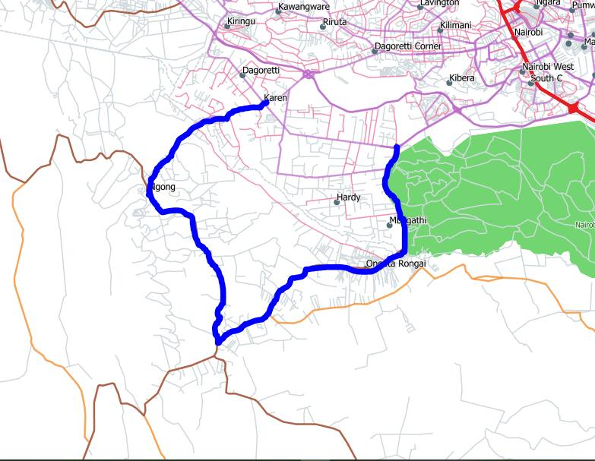  Figure 2.1: Regional context: the Bomas/Galleria–Ongata Rongai–Kiserian–Ngong–Karen loop. | 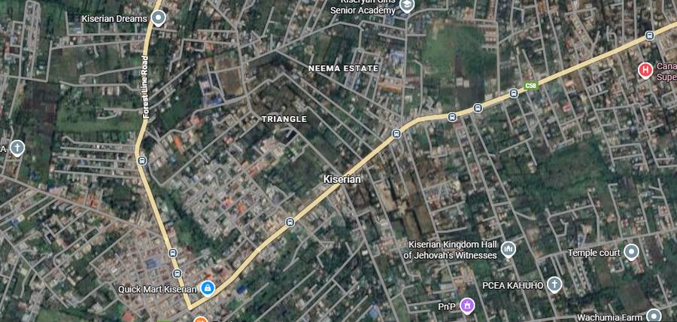  Figure 2.2: General alignment of the three project roads relative to Nairobi and Kajiado County boundaries.
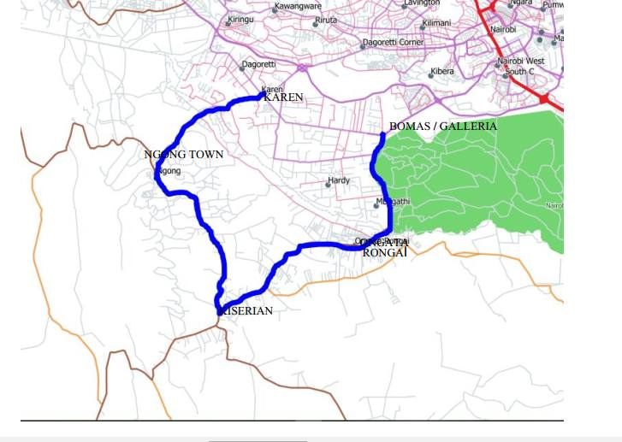  Figure 2.3: Corridor overview: Bomas/Galleria, Ongata Rongai, Kiserian, Ngong Town and Karen. | 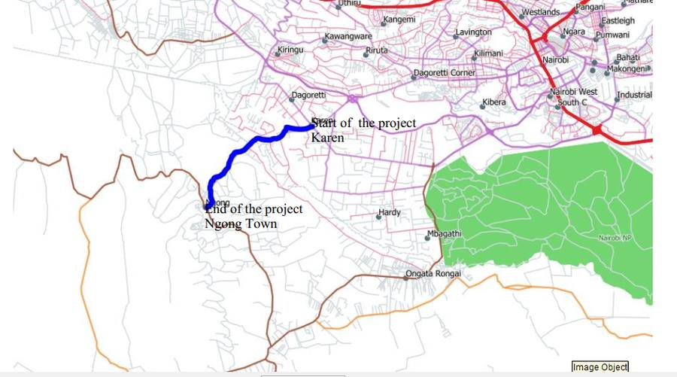  Figure 2.4: Karen–Ngong Road: start of project (Karen) to end of project (Ngong Town).

2.2 Current Road Condition
All three roads are presently narrow, single-carriageway roads carrying traffic well in excess of what they were designed for. Common conditions across the corridor include a constrained and, in many places, encroached-upon road reserve; sub-standard horizontal and vertical alignment (short curves, inconsistent gradients); the absence of continuous service lanes or non-motorised transport (NMT) facilities; and junctions and market frontages where turning traffic, pedestrians, hawkers and parked vehicles conflict directly with through traffic. Each segment is described in turn below.

2.2.1 Bomas–Rongai–Kiserian Road
The Bomas–Kiserian corridor is a critical urban–peri-urban link running from the Bomas of Kenya interchange on Lang'ata Road, in Nairobi County, to Kiserian Town in Kajiado North Sub-County. It serves daily commuter, commercial and PSV traffic, links to Magadi Road (which serves the southern Kajiado rangelands), and supports emergency, security and disaster-response movements within the Nairobi metropolitan area. It runs immediately alongside the southern boundary of Nairobi National Park for its opening kilometres, which constrains development intensity and land use on that side of the road.
Existing road reserve varies between roughly 30 and 45 m, with encroachment concentrated between the Maasai Lodge junction and Gataka junction; the section where the Rongai railway line crosses the road has an adequate reserve but needs geometric improvement to carry the heavier traffic the dualled road will bring. Service lanes and NMT facilities are absent along most of the corridor, and several junctions — Maasai Lodge Junction, Tumaini Junction, Kiserian Market, Gataka Junction and Kiserian Junction — see enough turning-movement conflict to warrant purpose-designed junction treatment rather than simple at-grade crossings.

Galleria / Brookhouse area (Km 0+000 – Km 1+000)
This opening section is a commercial and educational node anchored by Galleria Mall and Brookhouse School (a major generator of school-hour peak traffic), with low- to medium-density gated residential estates set back from the road. Utilities include KPLC power, boreholes and piped water, and roadside bus/boda-boda stages.
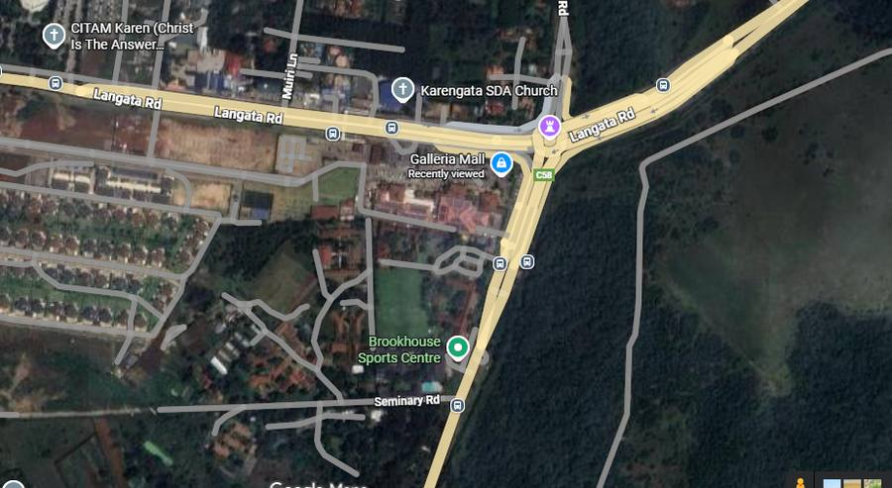  Figure 2.5: Galleria Mall and Brookhouse Sports Centre frontage on Lang'ata Road, at the corridor's Nairobi County end. | 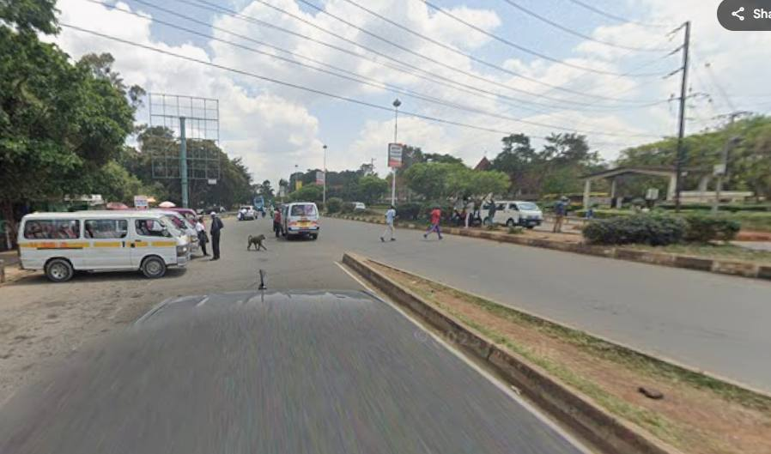  Figure 2.6: Roadside vegetation and informal crossing near the Nairobi National Park boundary, close to the project start.

CUEA Junction – Multimedia University (Km 1+000 – Km 6+000)
A major institutional and transport node anchored by the Catholic University of Eastern Africa (CUEA), GEMS Cambridge International School, Multimedia University of Kenya and The Banda School, with attendant commercial support (eateries, rental housing, retail kiosks) and high pedestrian activity at peak commuting hours.
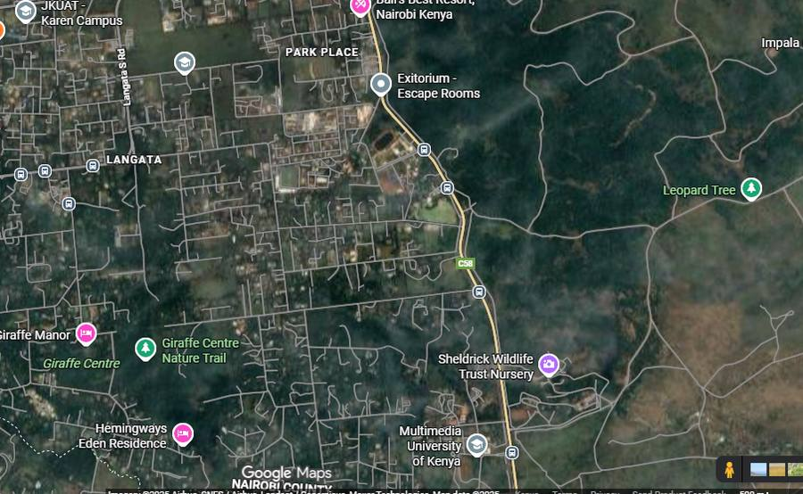  Figure 2.7: CUEA / Multimedia University of Kenya area, adjoining the Nairobi National Park and Giraffe Centre precinct. | 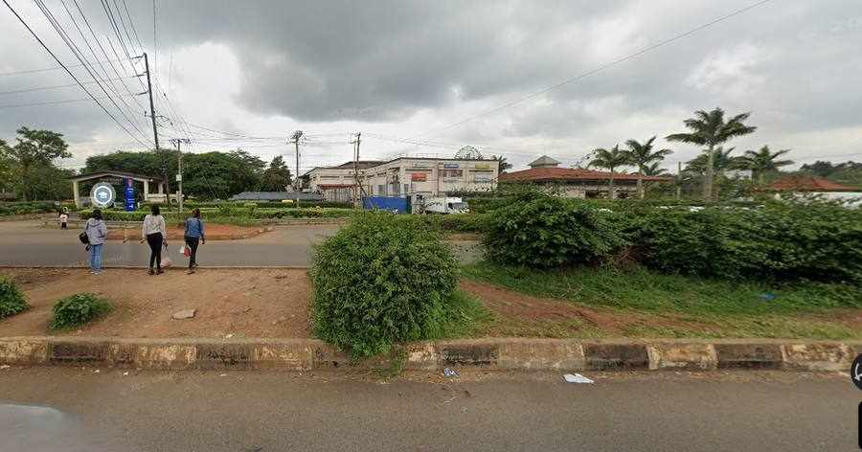  Figure 2.8: Institutional land uses (Multimedia University, Giraffe Centre) fronting the corridor near Langata.

Ongata Rongai peri-urban zone (Km 6+000 – Km 14+000)
A rapidly subdividing peri-urban belt with linear roadside development. Fuel stations (TotalEnergies, Rubis, Shell) front Magadi Road; schools include Laiser Hill Academy, St Mary's School and Acacia Park School; markets cluster around Kware and Maasai Mall; health facilities include Ongata Rongai Health Centre, Fatima Maternity Hospital, Mount Olive/Sinai Hospital and Sagatia Medical Centre. The Kware Market and Ongata Rongai Town junction (with the turn to Maasai Lodge Road) are among the busiest and most congested points on the whole project.
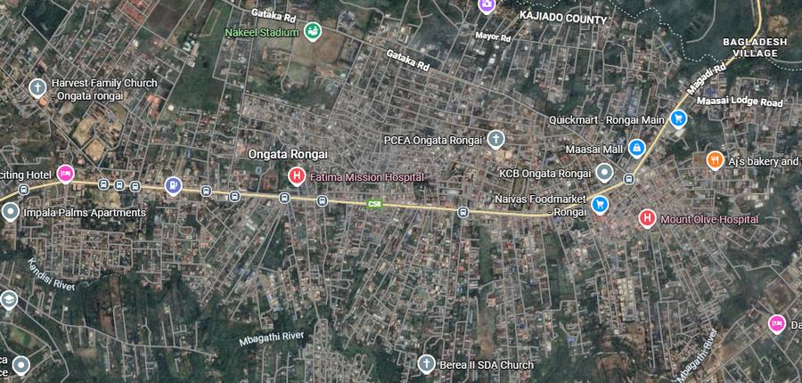  Figure 2.9: Ongata Rongai town centre: Fatima Mission Hospital, Naivas, KCB and dense roadside commercial frontage. | 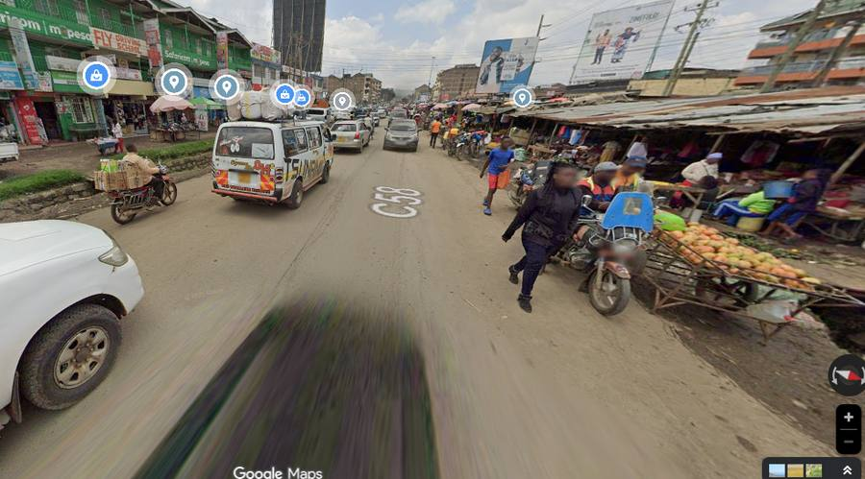  Figure 2.10: Kware Market frontage — informal trade, matatus and pedestrians sharing the carriageway edge.
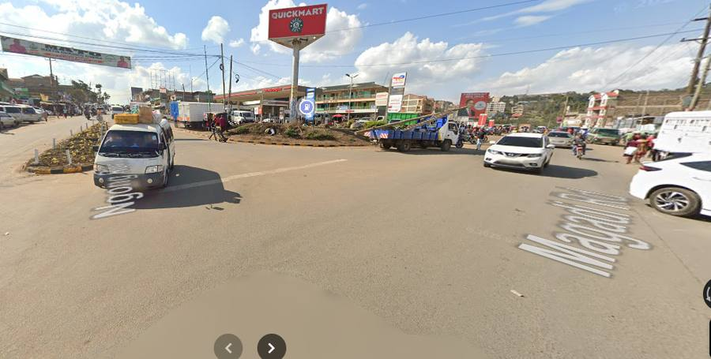  Figure 2.11: Fuel station / market junction on Magadi Road, Ongata Rongai. | 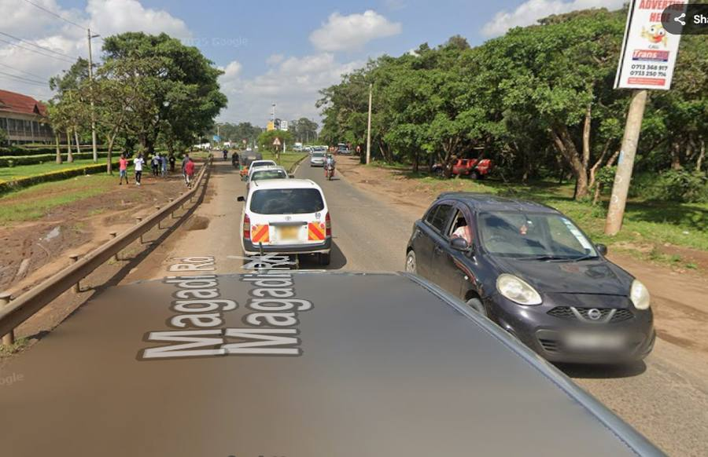  Figure 2.12: Roadside commercial strip along Magadi Road, Ongata Rongai.

Kiserian Town (Km 14+000 – Km 17+500, approx.)
The main urban node in Kajiado North: open-air markets, fuel stations (TotalEnergies, Galana/Shompole, Shell), primary/secondary schools and private academies, a police post, hotels/lodges, and dense rental/apartment housing directly fronting the road. Pedestrian and PSV activity is intense, and the section where the railway crosses the road at Kiserian is a specific safety concern raised in the corridor review.
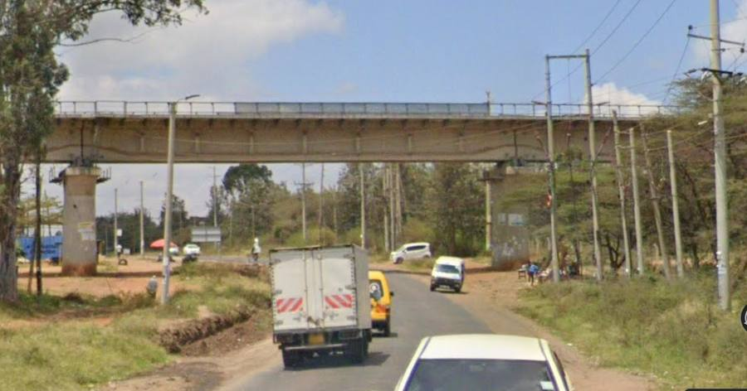  Figure 2.13: Kiserian Town — Neema Estate, Triangle and central market area, at the project road's Kiserian terminus. | 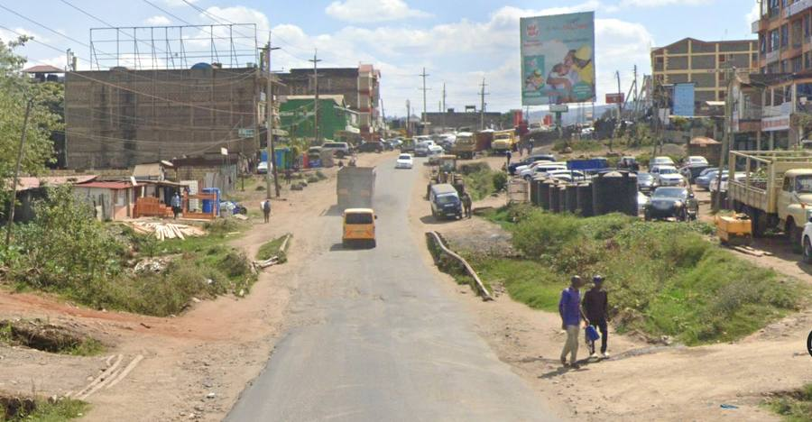  Figure 2.14: Kiserian town-centre commercial frontage (Juliet Towers area) directly abutting the road.

Road users — Bomas–Rongai–Kiserian
Users are a mix of Nairobi-bound commuters from Ongata Rongai and Kiserian; students and staff of Brookhouse School, CUEA, Laiser Hill Academy and Kiserian's primary/secondary schools; traders and market vendors moving goods to Ongata Rongai and Kiserian; matatu, minibus and shuttle operators concentrated at the Galleria roundabout, CUEA junction, Ongata Rongai and Kiserian; light-commercial and fuel-tanker traffic serving the roadside petrol stations; pedestrians and NMT users, especially at schools, markets and churches; and institutional/utility staff (teachers, health workers, county officials, KPLC/water/telecom crews).

2.2.2 Kiserian–Ngong Road
This corridor connects Kiserian Town (Kajiado North/West boundary) to Ngong Town, passing through the Matasia peri-urban belt. It crosses several seasonal drainage channels that have historically caused localised flooding and traffic delay, and is constrained by narrow, encroached road reserve at Kiserian Market, Matasia and the Ngong–Kiserian junctions.

Kiserian Junction area (Km 0+000 – Km 1+200)
High-density commercial and transport node: TotalEnergies fuel station, roadside retail, hotels/eateries, the Kiserian bus terminus and matatu stages, a police post, and dense KPLC/water/telecom infrastructure.
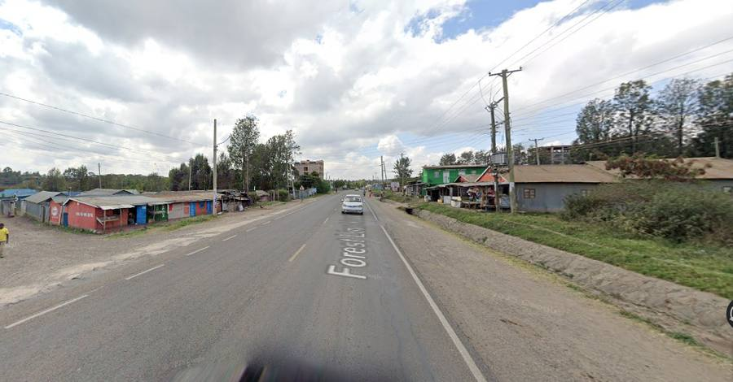  Figure 2.15: Kiserian town area — Mabatini, Shekinah Pentecostal Church HQ and the C58/Forest Line Road junction. | 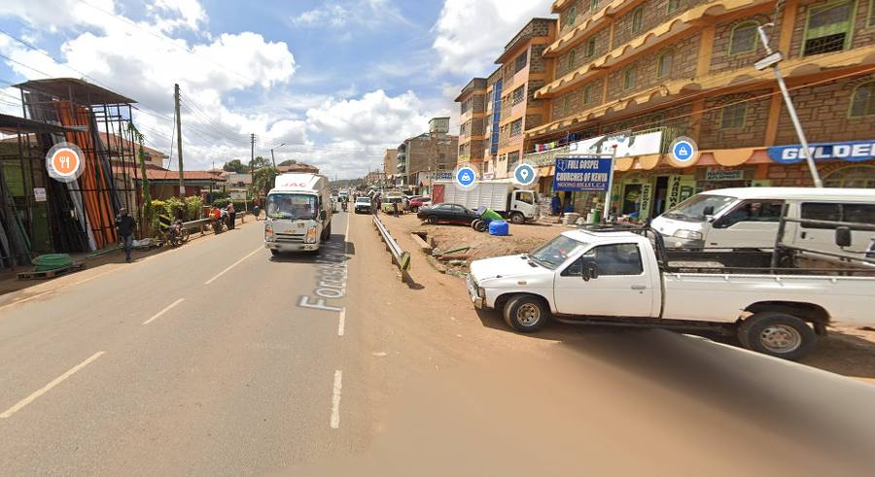  Figure 2.16: Roadside commercial frontage on Forest Line Road, Kiserian.

Matasia market area (Km 3+000 – Km 6+000)
A secondary market centre with dense, linear roadside development — kiosks, retail shops, butcheries, hardware and building-material yards, an open-air market, a chief's office, churches, private schools/clinics — and high pedestrian and boda-boda activity.
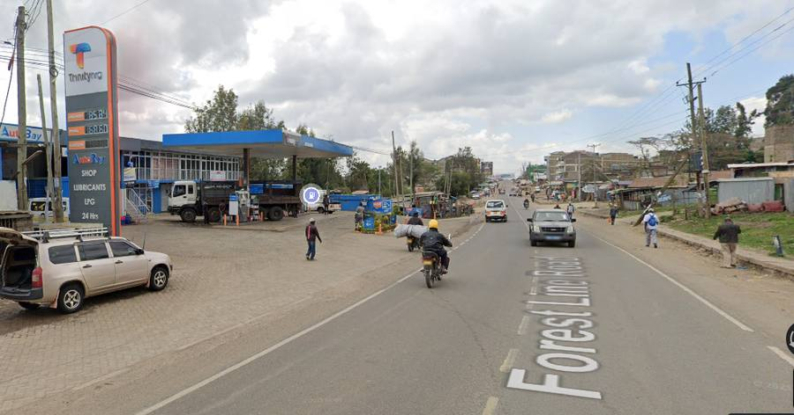  Figure 2.17: Matasia — dense linear roadside trade and residential frontage along Forest Line Road. | 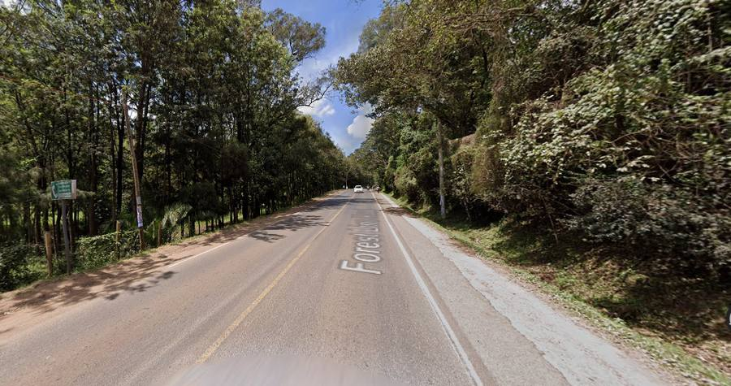  Figure 2.18: Forest Line Road through the Matasia peri-urban belt, between Kiserian and Ngong.

Peri-urban residential belt (Km 6+000 – Km 8+000)
Low- to medium-density residential development interspersed with small-scale farming and undeveloped plots; commercial activity limited to small shops, kiosks and workshops.
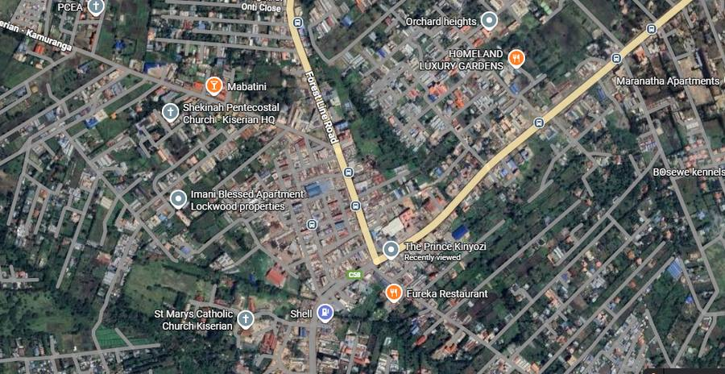  Figure 2.19: Matasia/Nyali Valley area — low-density residential and institutional plots (EagleCrest Academy) fronting the corridor. | 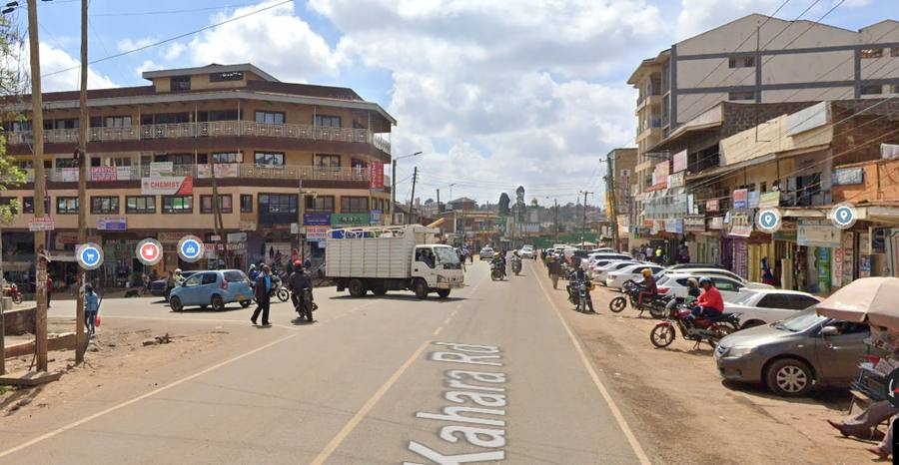  Figure 2.20: Semi-rural stretch of the Kiserian–Ngong corridor, with scattered plots and roadside vegetation.

Ngong urban approach and termination (Km 8+000 – Km 9+900)
The urban approach into Ngong Town: increasing density of shops, supermarkets and eateries, matatu stages and taxi stands, churches, private schools and clinics, and high-density rental apartments — including the area immediately adjoining Ngong Stadium.
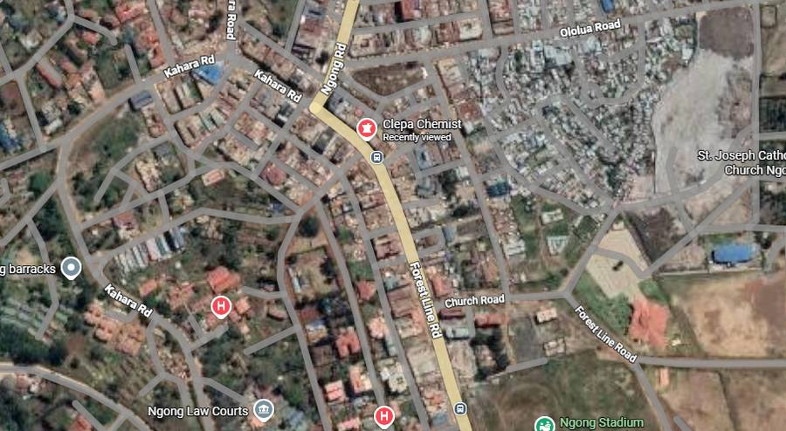  Figure 2.21: Ngong Town approach, showing Ngong Law Courts, Ngong Stadium and the dense town-centre street grid. | 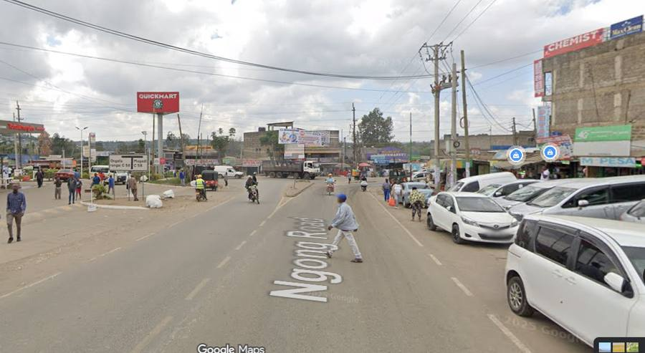  Figure 2.22: Ngong Road / Quickmart junction at the edge of Ngong Town.

Road users — Kiserian–Ngong
Local residents moving between Kiserian, Matasia and Ngong; PSV operators and passengers concentrated at Kiserian junction/town, Matasia market and the Ngong stages/termini; private motorists commuting to Ongata Rongai and Nairobi; commercial and service vehicles delivering building materials and household goods; boda-boda operators providing last-mile connectivity; pedestrians (school children, shoppers, traders) constrained by limited sidewalks; and institutional/emergency-service users.

2.2.3 Karen–Ngong Road
This corridor links Karen, in Nairobi County, to Ngong Town in Kajiado North, via Embulbul and Vet Centre. Land use transitions from planned low- to medium-density residential development at Karen to increasingly dense peri-urban and urban mixed-use development toward Ngong. As with the other two roads, the reserve is narrow and encroached, particularly at Ngong Town, Embulbul and Vet Centre, and a railway crossing (around Km 5+200–5+400) already carries the road safely over the line by bridge.

Karen Roundabout area (Km 0+000 – Km 1+500 / Km 2+000)
A major suburban node with gated communities, standalone houses and small apartment blocks; commercial anchors include Naivas and Quickmart Karen, TotalEnergies and Shell fuel stations, KCB and Equity Bank branches, Java House/Artcaffé, and Karen International School and Brookhouse School.
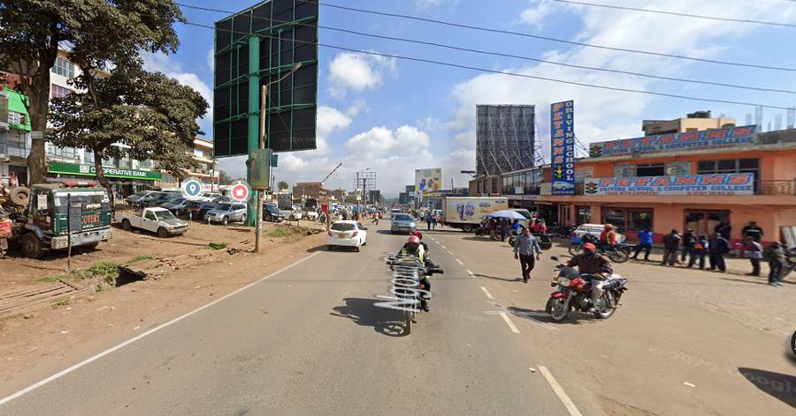  Figure 2.23: Shell fuel station at the Karen Road / Ngong Road junction, at the start of the Karen–Ngong corridor. | 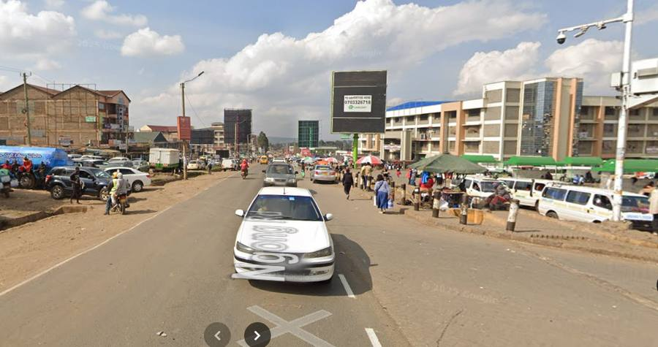  Figure 2.24: Karen / Lang'ata South Road area, bordering the Nairobi National Park and Giraffe Centre precinct.

Railway crossing (approx. Km 5+200 – Km 5+400)
The existing rail overpass carries the road safely above the line, avoiding a level crossing; roadside development around the bridge is medium-density residential with small-scale commercial activity.
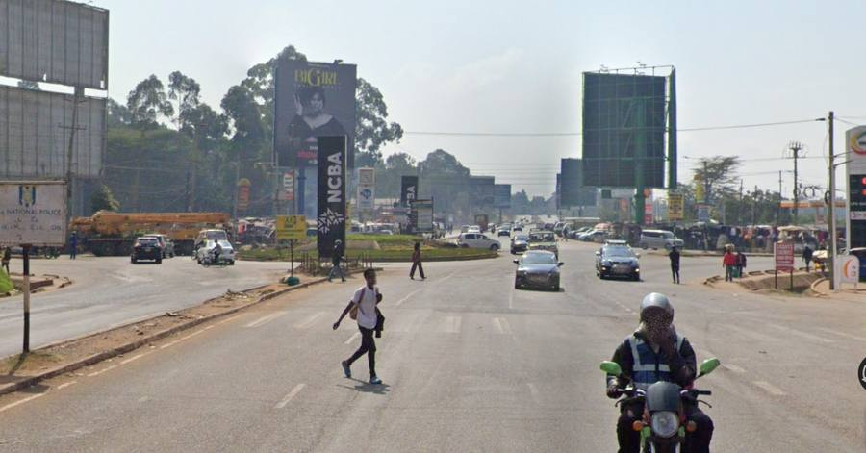  Figure 2.25: Rail overpass on Ngong Road, with the adjoining OLA fuel station. | 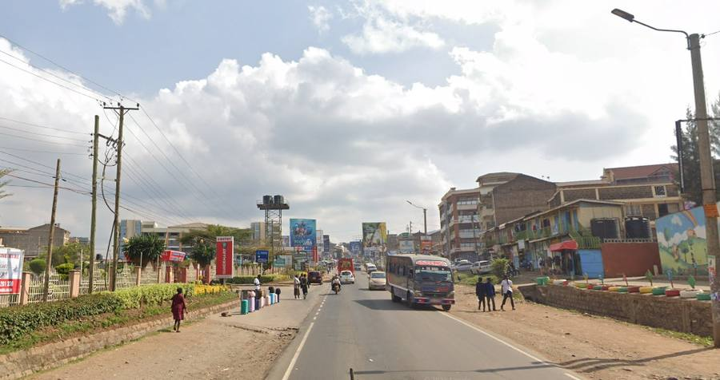  Figure 2.26: Rail bridge over Ngong Road, looking toward Ngong Town.

Embulbul and Vet Centre (Km 1+500 – Km 6+500)
Peri-urban service centres with medium-density residential plots, small commercial outlets (Embulbul Market, fuel stations, schools, churches and a health centre at Embulbul; further retail, schools and a dispensary at Vet Centre).
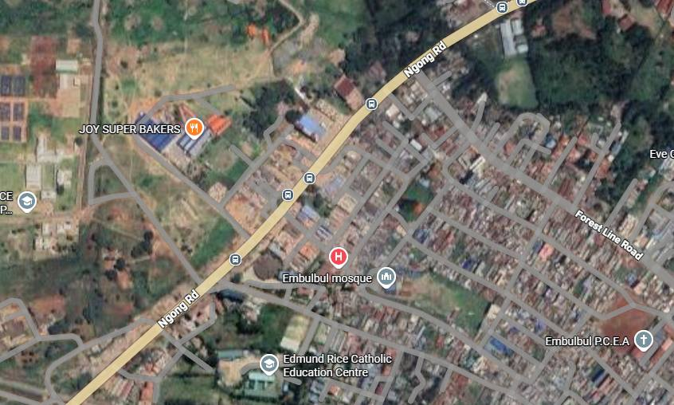  Figure 2.27: Embulbul centre — Joy Super Bakers, Embulbul Mosque and the dense roadside commercial strip. | 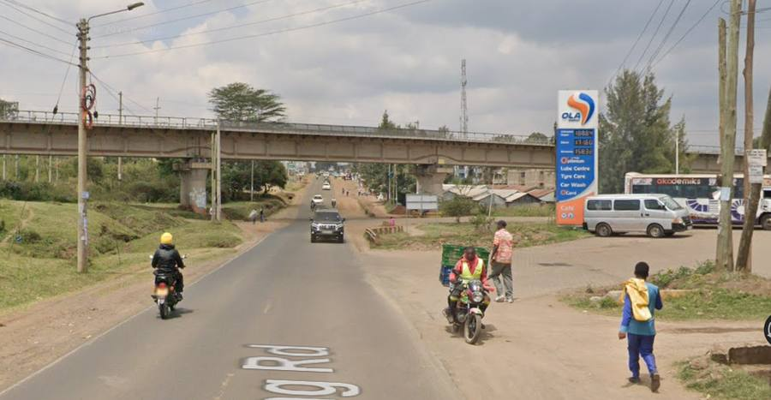  Figure 2.28: Fuel station and roadside frontage near Embulbul, on Ngong Road.

Ngong Town junction (Km 6+500 – Km 8+500 / 8+630)
The corridor's high-density urban terminus: Naivas and Quickmart Ngong, Equity/KCB/Co-operative Bank branches, Ngong Municipal offices and police station, Ngong Market, Ngong Town Primary and Ngong Girls Secondary Schools, Ngong Sub-County Hospital, and matatu/bus termini connecting Ngong to Karen, Ongata Rongai and beyond.
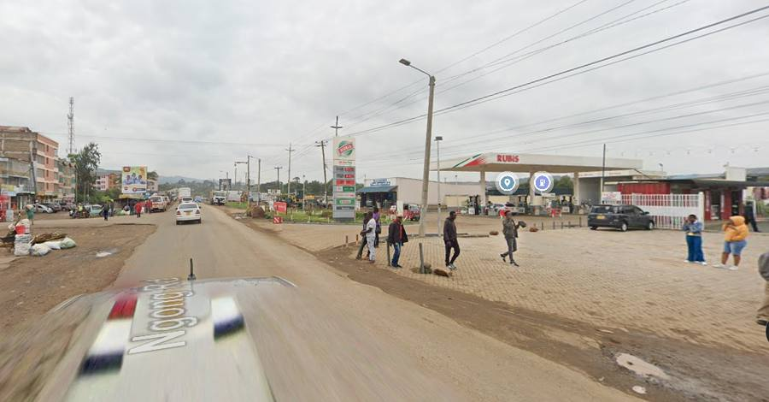  Figure 2.29: Ngong Town commercial frontage — Co-operative Bank and Petanns Driving School / Computer College. | 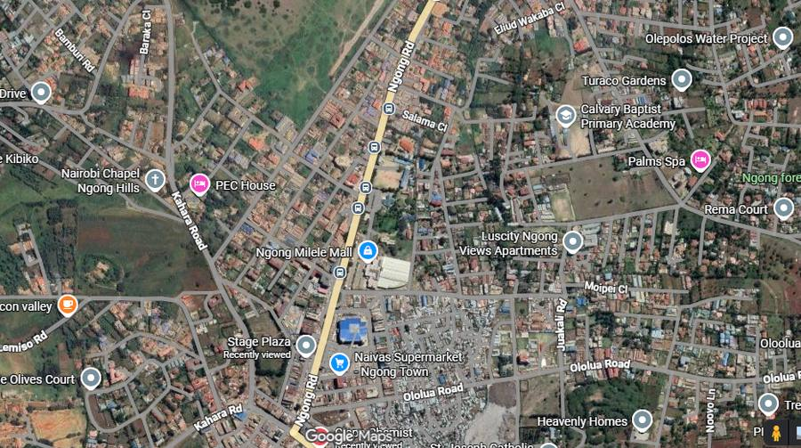  Figure 2.30: Ngong Town centre — PEC House, Ngong Milele Mall and Naivas Supermarket, near the corridor's northern terminus.

Road users — Karen–Ngong
Local residents of Karen, Embulbul, Vet Centre and Ngong; PSV operators and passengers concentrated at Karen roundabout, Embulbul, Vet and the Ngong stages; private motorists; commercial/service vehicles; boda-boda operators (particularly dominant between Karen and Embulbul); pedestrians concentrated at Karen, Embulbul market, Vet and Ngong Town; a smaller number of cyclists and hand-cart operators moving water, produce and goods in the peri-urban sections; and institutional/emergency-service users.

2.3 Proposed Improvement Concepts
The concept design (APEC Consortium Limited) proposes dualling of all three roads broadly within the existing alignment, informed by the following design philosophy: achieve minimum recommended horizontal curve parameters; improve the vertical alignment to within design standards; mitigate drainage inefficiencies; check sight distances and turning radii; provide for safety of both vehicles and NMT users in urban/town sections; avoid environmental and social impacts (particularly community/individual resettlement) where practicable; minimise construction, road-user and maintenance costs; and make maximum use of the already-acquired road reserve to limit further land acquisition and demolition.
Design standards referenced include the Road Design Manual Part 1 (Ministry of Works, Roads Department, January 1979 and February 2025 update), AASHTO's "A Policy on Geometric Design of Highways and Streets" (2018, 7th edition), the Highway Capacity Manual 2000 (4th edition), the draft Geometric Design of Urban Roads guidance, and the Global Street Design Guide.

Design standards summary
Parameter | Adopted value
Road class | B (all three roads)
Terrain | Level to rolling
Design speed — main carriageway | 70 km/h
Design speed — service roads | 50 km/h
Lane width | 3.5 m
Outer shoulder width | 2.0 m (widened from the 1.5 m manual default)
Median width | 2.0 m raised median (Bomas–Kiserian and Kiserian–Ngong dual sections)
Cross-fall | 2.5%
Minimum horizontal radius | 250 m
Minimum sight distance | 100 m
Maximum super-elevation | 6%
Maximum gradient | 6.0% (minimum 0.5%, for drainage)
Minimum vertical curve length — sag / crest | 185 m / 164 m
Maximum cut / fill | 9.0 m / 10.0 m

Cross-section and carriageway
A 2-lane dual carriageway of 7.0 m per direction (Cross-section Type I, 16.0 m overall including a 2.0 m median and 2.0 m shoulders) is proposed for the main Bomas–Rongai–Kiserian and Kiserian–Ngong sections; a single-carriageway variant (Type II) with a wider median (2.0–14 m) is proposed through constrained town sections. Service roads have been proposed on the Bomas–Rongai–Kiserian road at four locations with high localised traffic, to separate through traffic from local access — for example between Km 4+470–4+835, Km 5+660–6+135, Km 6+965–8+025 and Km 8+280–10+390.
NMT provision varies by section: 2 m footways from Bomas (Km 0+000) to Maasai Lodge (Km 5+650), widening to 3 m to Laiser Hill (Km 10+400) and narrowing back to 2 m into Kiserian (Km 18+000); 2 m throughout Kiserian–Ngong; and a notably generous 5 m from Karen (Km 0+000) to Ngong (Km 8+630) on the Karen–Ngong road.

Junctions
Both at-grade and grade-separated junctions are proposed at concept stage, based on preliminary traffic demand and turning movements:
Road | Junction | Approx. chainage | Type
Bomas–Rongai–Kiserian | Gataka Road Junction | 6+516 | Grade-separated (flyover)
Bomas–Rongai–Kiserian | Kiserian Town (junction to Ngong) | 16+670 | Grade-separated (flyover)
Bomas–Rongai–Kiserian | Bogani East Road Junction | 1+168 | At-grade roundabout
Bomas–Rongai–Kiserian | Kware Access Road (Rongai Market) | 8+151 | At-grade roundabout
Karen–Ngong | Karen–Lang'ata–Dagoretti Road Junction | n/a (Karen end) | Grade-separated (flyover)
DATA GAP — TO BE COMPLETED: The full junction schedule (including the fourth grade-separated junction referenced in the concept report as pending finalisation, and detailed lane configurations) should be carried through from the design team's current drawings once detailed design is complete.

Drainage and utilities
Open, concrete-lined trapezoidal side drains are proposed on single- and dual-carriageway sections without service roads, to collect surface run-off from the carriageway and NMT facilities. A verge is provided in the cross-section to accommodate a proposed reinforced-concrete utility duct, with crossing ducts at intervals — relevant given the density of KPLC power lines, water pipelines and telecom infrastructure already noted along all three corridors, and the proximity of the Kiserian terminus to the Kenya Pipeline Company's "Pipeline Road".

2.4 General Observations
The three corridors share a common profile: narrow, congested single-carriageway roads passing through some of the fastest-urbanising parts of the Nairobi metropolitan fringe, with dense commercial and institutional frontage concentrated at Ongata Rongai, Kiserian, Matasia, Embulbul, Vet Centre and Ngong Town, and lower-density, more conservation-influenced land use where the alignment runs alongside Nairobi National Park near Bomas/Galleria and Karen. Land acquisition, junction redesign and drainage/utility relocation will be needed at broadly similar points on all three roads — market frontages, institutional boundaries and existing at-grade junctions.

2.5 Target Materials Sites

2.5.1 Hard Stone Aggregate
DATA GAP — TO BE COMPLETED: Candidate quarry sources and haul distances have not yet been identified in the project records reviewed; to be confirmed by the contractor's materials investigation.

2.5.2 Gravel
DATA GAP — TO BE COMPLETED: Borrow-pit sources to be identified and their environmental/social clearance confirmed before construction.

2.5.3 Sand and Cement
DATA GAP — TO BE COMPLETED: Sand sources (river/quarry) and cement suppliers to be confirmed; river-sand harvesting locations, if any, will need their own NEMA clearance.

2.5.4 Water
DATA GAP — TO BE COMPLETED: Construction-water sources (piped supply, borehole, or river abstraction) and any associated water-permit requirements to be confirmed.

2.5.5 Construction Camp Sites
DATA GAP — TO BE COMPLETED: Contractor's camp and laydown-yard locations not yet identified; siting should avoid the institutional and residential frontages described in Section 2.2.

2.5.6 Others
DATA GAP — TO BE COMPLETED: Spoil-disposal sites for excavated material are yet to be identified.

2.6 Project Alternatives

No-project alternative
Rejected. Retaining the existing single-carriageway roads would leave worsening congestion, road-safety risk and drainage failure unaddressed on a corridor whose traffic demand is already exceeding capacity and continuing to grow with the peri-urban population.

Do-minimum (rehabilitate existing carriageway without dualling)
Rejected as insufficient. Resurfacing and drainage repair alone would improve ride quality but would not add the capacity, junction control or NMT/service-road provision needed to address the safety and congestion problems documented in Section 2.2, and would still require some land take at the worst junctions.

Alternative alignment / bypass of town centres
Considered and not adopted at concept stage. Bypassing Ongata Rongai, Kiserian and Ngong town centres would reduce land take and disruption to existing commercial frontage, but would require substantially new right-of-way through undeveloped or agricultural land, increasing both cost and a different category of environmental impact (land-use change, possible habitat loss). The concept design instead maximises use of the existing, already-acquired road reserve, consistent with the design philosophy in Section 2.3.

Phased implementation
Recommended for further evaluation: phasing construction by segment (e.g., completing the most congested sections — Ongata Rongai, Kiserian and Ngong Town junctions — before less critical stretches) could reduce simultaneous traffic disruption across the whole 35–40 km loop, and should be assessed alongside the construction programme once it is developed.
DATA GAP — TO BE COMPLETED: Version 8 of this report scored these alternatives using figures (a "KES 2.2 billion" foregone economic injection, "450" jobs, a "regional satellite location" alternative) that do not correspond to anything in the project's engineering or planning records and appear to be generic placeholder text from the drafting tool used; they have been removed rather than carried forward. A proper alternatives analysis with comparative cost and impact scoring should be completed once the traffic and cost-estimating work referenced in Sections 2.7–2.8 is available.

2.7 Project Implementation Schedule
DATA GAP — TO BE COMPLETED: No implementation programme (design completion, procurement, construction start/duration by segment) was found in the project records reviewed. The design team's meeting minutes record a design kick-off on 27 January 2026 and a design review stand-up on 5 February 2026; a full programme should be inserted once available from the design/contract management team.

2.8 Project Cost Estimates
DATA GAP — TO BE COMPLETED: No project cost estimate (capital cost, land-acquisition compensation budget, or funding source) was found in the project records reviewed. Version 8 carried an unsourced "KES 2.2 billion" figure in its alternatives discussion, which does not appear elsewhere in the design records and has not been carried forward. A quantity-surveyed cost estimate, and confirmation of the funding arrangement (GoK budget, county, PPP/annuity, or development-partner financing), should be inserted once available — this also determines which additional safeguard policies (e.g., a development bank's environmental and social standards) may apply alongside Kenyan law.

Chapter 3: Policy, Legal and Institutional Framework

3.1 National Policies
- Kenya Vision 2030 — identifies infrastructure, including the road network, as a foundation for the economic pillar.
- Sessional Paper No. 5 of 2012 on the National Transport Policy — sets out the framework for integrated, safe and efficient transport infrastructure.
- National Environment Policy, 2013 — the overarching policy under which EMCA and NEMA operate.
- Kajiado County Integrated Development Plan (CIDP) — identifies peri-urban service provision, market development and urban-growth management along corridors such as this one as county development objectives.

3.2 Legal Aspects
The following statutes are directly applicable to the project:
Legislation | Relevance to the project
Environmental Management and Coordination Act (EMCA), Cap 387 (No. 8 of 1999, as amended by EMCA (Amendment) Act, 2015) | Establishes NEMA and the requirement (Section 58, Second Schedule) for an EIA/ESIA for projects of this type prior to implementation.
Environmental (Impact Assessment and Audit) Regulations, 2003 (Legal Notice No. 101, as amended) | Sets out the EIA study, report content, review and licensing procedure followed in this report.
Kenya Roads Act, 2007 | Establishes KeNHA, KURA and KeRRA and allocates responsibility for national, urban and rural roads respectively; confirms KURA's mandate over these urban road corridors.
Land Act, No. 6 of 2012 | Governs compulsory acquisition of land (including the right-of-way take identified in Section 7.3) and compensation.
Way Leaves Act, Cap 292 | Governs the acquisition and use of way-leaves for the road and associated utility relocation.
Physical Planning Act (now the Physical and Land Use Planning Act, 2019) | Governs approval of the road reserve and any change of use of adjoining land.
County Governments Act, 2012 | Establishes county government roles in physical planning, public participation and local service provision relevant to Nairobi and Kajiado Counties.
Occupational Safety and Health Act (OSHA), 2007 | Governs worker health and safety during construction.
Traffic Act, Cap 403 | Governs road-traffic management, including during construction-phase diversions.
Water Act, 2016 | Governs any water abstraction (e.g., for construction) and discharge to watercourses such as the Mbagathi River.
Public Health Act, Cap 242 | Relevant to construction-camp sanitation, waste management and nuisance (dust, noise) control.
DATA GAP — TO BE COMPLETED: Confirm the current, gazetted version of the EIA/Audit Regulations (a 2023 review process was referenced by NEMA at the time of writing) directly with NEMA or the Kenya Gazette before finalising this report, as a later amendment may supersede the 2003 baseline cited above.

3.3 Institutional Arrangement

3.3.1 KURA Mandate
The Kenya Urban Roads Authority (KURA), established under the Kenya Roads Act, 2007, is responsible for the management, development, rehabilitation and maintenance of urban roads in Kenya, including the three project roads. KURA is the Proponent for this ESIA.

3.3.2 Institutional Components
- National Environment Management Authority (NEMA) — EIA review, licensing and compliance monitoring.
- Nairobi City County Government and Kajiado County Government — physical planning approvals, county public-participation processes, and local service coordination.
- Kenya Power and Lighting Company (KPLC) — relocation of power infrastructure identified along all three corridors.
- Kenya Pipeline Company — coordination near the Kiserian terminus, adjoining "Pipeline Road".
- Water service providers (Nairobi City Water and Sewerage Company; Kajiado County Water Department) and telecommunications operators (Safaricom, Airtel, Telkom) — utility relocation.
- Kenya Wildlife Service (KWS) — given the corridor's frontage onto Nairobi National Park near Bomas/Galleria and Karen.
- Kenya Railways — coordination at the railway crossings on all three roads.

3.3.3 Key Partners
APEC Consortium Limited is the design consultant of record. The construction contractor, supervising engineer and any co-financing partner are yet to be confirmed in the project records reviewed.

Chapter 4: Environmental Baseline Conditions

4.1 General Status
The corridor lies within the Nairobi metropolitan fringe, transitioning from the relatively well-vegetated, conservation-influenced setting adjoining Nairobi National Park (Bomas/Galleria and Karen) to heavily built-up commercial town centres (Ongata Rongai, Kiserian, Matasia, Ngong) and peri-urban residential/agricultural land at Nkoroi, Embulbul and Vet Centre.

4.2 Topography
The three roads traverse level-to-rolling terrain, consistent with the 70 km/h design speed adopted. Preliminary analysis of the existing roads in the concept design indicates gradients of between 0.5% and 10%, with proposed cut/fill limited to a maximum of 9.0 m / 10.0 m respectively.

4.3 Water Resources
The Mbagathi River (forming part of the Nairobi National Park boundary near Ongata Rongai) is the principal watercourse of note near the corridor. Several seasonal drainage channels cross the alignment on all three roads and have historically caused localised flooding and traffic disruption.
DATA GAP — TO BE COMPLETED: A hydrological/hydraulic assessment of watercourse crossings, and water-quality baseline sampling where the alignment approaches the Mbagathi River, has not yet been carried out.

4.4 Waste Management
DATA GAP — TO BE COMPLETED: Baseline solid-waste generation and disposal arrangements along the corridor (municipal collection coverage, informal dumping) have not been surveyed.

4.5 Drainage and Hydrology
The existing roads generally lack adequate drainage; this is cited by the design team as one of the principal deficiencies driving the upgrade. The concept design proposes concrete-lined trapezoidal side drains along sections without service roads.

4.6 Geology and Soils
DATA GAP — TO BE COMPLETED: A geotechnical/soils investigation for the corridor has not yet been completed; the concept design notes that the roads were designed at this stage using satellite-derived elevation data of accuracy below that required for detailed geometric design.

4.7 Biodiversity
The Bomas–Rongai–Kiserian and Karen–Ngong roads run directly alongside the Nairobi National Park boundary for parts of their length (near Bomas/Galleria and near Karen/Lang'ata South Road respectively), placing construction activity close to a gazetted protected area home to free-ranging wildlife.
DATA GAP — TO BE COMPLETED: A biodiversity baseline survey (vegetation, fauna use of the road verge, any wildlife-crossing or roadkill history at the National Park boundary) has not yet been carried out and should be prioritised given this proximity, in consultation with the Kenya Wildlife Service.

4.8 Air Quality
DATA GAP — TO BE COMPLETED: No baseline air-quality monitoring data was found in the project records. Given the dense roadside commercial and institutional frontage identified in Chapter 2 (schools, markets, health facilities), baseline monitoring at representative sensitive receptors is recommended before construction.

4.9 Noise and Vibrations
DATA GAP — TO BE COMPLETED: No baseline noise monitoring data was found. Representative measurement at schools, health facilities and dense residential frontage (e.g., Ongata Rongai, Kiserian, Ngong Town) is recommended.

4.10 Climatic Conditions
The project area lies at roughly 1,700–1,950 m elevation on the Nairobi/Kajiado plateau, with a generally temperate climate moderated by altitude and two rainy seasons (the "long rains" of March–May and "short rains" of October–December), typical of the greater Nairobi region.

Chapter 5: Social and Economic Baseline Conditions

5.1 Administrative Setting
The corridor lies within Nairobi County (Lang'ata Sub-County, covering Karen and the Bomas/Galleria area) and Kajiado County (principally Kajiado North Sub-County, covering Ongata Rongai, Kiserian, Matasia, Embulbul and Ngong, with the fringe of Kajiado West Sub-County near Kiserian).

5.2 Population and Demography

5.2.1 Population
Indicative population figures from the 2019 Kenya Population and Housing Census (Kenya National Bureau of Statistics) for the main urban centres on the corridor are:
Area | 2019 census population (approx.)
Kajiado County (total) | 1,117,840
Ongata Rongai (Kajiado North) | 172,570
Kiserian (Kajiado North/West) | 76,903
Ngong (township area) | 25,866 (a wider administrative-area figure of ~102,323 is also reported — to be reconciled against the primary KNBS volume)
Nairobi County (total) | 4,397,073
DATA GAP — TO BE COMPLETED: These figures are drawn from secondary (Wikipedia-sourced KNBS 2019) reporting for this draft and should be verified against the primary KNBS County/Sub-county census volumes, and a Karen/Lang'ata ward-level figure obtained, before this report is finalised.

5.2.2 Migration Patterns
All three corridors are described consistently in the design team's corridor review as experiencing rapid in-migration and urbanisation driven by proximity to Nairobi, with incremental plot subdivision and construction visible along Ongata Rongai, Matasia, Embulbul and the Ngong approach.

5.2.3 Settlement Patterns and Housing Conditions
Settlement density along the corridor ranges from low-density gated estates and institutional land near the Nairobi National Park boundary (Bomas/Galleria, Karen) to high-density mixed residential-commercial development at the four town centres — Ongata Rongai, Kiserian, Matasia/Ngong approach and Ngong Town itself — with a peri-urban gradient of medium- and low-density housing in between (see the segment-by-segment description in Section 2.2).

5.3 Land Tenure and Land Use
Land use is predominantly private freehold/leasehold residential, commercial and institutional, with the road reserve itself under public ownership. The land-acquisition schedule summarised in Section 7.3 identifies approximately 29.2 ha of additional land required across roughly 70 sections, concentrated at junctions, market frontages and institutional boundaries.

5.4 Public Utilities and Infrastructure

5.4.1 Roads Use and Traffic
See the road-user profiles in Section 2.2 for each segment. A formal traffic count/AADT survey underlies the concept design's classification of Bomas–Kiserian as >4,000 AADT and Kiserian–Ngong as 2,000–4,000 AADT; the corresponding figure for Karen–Ngong was not finalised in the concept design report reviewed.

5.4.2 Rail Lines
The Kenya Railways line crosses the Bomas–Rongai–Kiserian road in the Ongata Rongai area, the Kiserian–Ngong road near Kiserian, and is already grade-separated (by bridge) on the Karen–Ngong road near Km 5+200–5+400.

5.4.3 Airports
DATA GAP — TO BE COMPLETED: No airport or airstrip was identified directly on the corridor in the records reviewed; Wilson Airport lies within the wider Nairobi metropolitan area but its relevance (noise/obstacle-limitation surfaces) to this project has not been assessed.

5.4.4 Oil Pipeline
The Bomas–Rongai–Kiserian road terminates at Kiserian at its junction with "Pipeline Road", indicating the presence of Kenya Pipeline Company infrastructure near the corridor's southern end; coordination with KPC will be required at detailed design.

5.4.5 Power Lines
KPLC power lines, poles and transformers run along all three corridors and are visible fronting virtually every market and town-centre section described in Chapter 2; relocation will be a significant utilities task, particularly through Ongata Rongai, Kiserian, Matasia and Ngong Town.

5.4.6 Water Pipelines
DATA GAP — TO BE COMPLETED: A detailed utility survey of water-pipeline routes and depths has not yet been carried out; piped water, boreholes and water kiosks are known to serve the corridor (Nairobi City Water and Sewerage Company in Nairobi County; Kajiado County Water Department and community providers in Kajiado County).

5.4.7 Sewer Lines
DATA GAP — TO BE COMPLETED: No sewer-line survey was found in the records reviewed.

5.4.8 Communication Service Lines
Safaricom, Airtel and Telkom provide telecommunications coverage along the corridor via masts noted at multiple points in the segment descriptions; exact routing of underground cable, if any, is yet to be surveyed.

5.5 Social Welfare

5.5.1 Education
Educational institutions with frontage on, or within the immediate zone of influence of, the corridor include Brookhouse School, the Catholic University of Eastern Africa, GEMS Cambridge International School, Multimedia University of Kenya, The Banda School, Laiser Hill Academy, St Mary's School, Acacia Park School, Marengoni Community College, an Adventist University campus at Nkoroi, Arap Moi Primary School, Karen International School, and the primary/secondary schools of Kiserian, Matasia and Ngong Town. Several of these appear directly within the land-acquisition schedule in Section 7.3.

5.5.2 Health and Safety
Health facilities identified along the corridor include Ongata Rongai Health Centre, Fatima Maternity Hospital, Mount Olive/Sinai Hospital, Sagatia Medical Centre, and Ngong Sub-County Hospital, together with smaller clinics and dispensaries at Kiserian, Matasia, Embulbul and Vet Centre.

5.5.3 Religious Facilities and Practices
Numerous churches and at least one mosque were noted fronting the corridor (for example at Kiserian, Matasia, Embulbul and Ngong); specific denominations and structures should be confirmed and mapped during the socio-economic field survey.

5.6 Socio-Cultural Profile
Kajiado County is historically Maasai pastoralist territory, reflected in place names along the corridor (Maasai Lodge Road, Maasai Mall, Maasai schools) alongside the rapid in-migration of a broader, ethnically mixed Nairobi-commuter population into Ongata Rongai, Kiserian and Ngong.

5.7 Economic Activities

5.7.1 Income and Expenditure
DATA GAP — TO BE COMPLETED: No household income/expenditure survey has been carried out; this is a standard component of the socio-economic baseline survey still to be undertaken.

5.7.2 Trade and Industry
Retail and informal trade are concentrated at Galleria Mall, Kware Market, Ongata Rongai and Kiserian town centres, Matasia market, Embulbul and Vet Centre, and Ngong Town market and CBD — described in detail, segment by segment, in Section 2.2.

5.7.3 Agriculture and Livestock Keeping
Small-scale farming and livestock rearing persist on undeveloped and peri-urban plots, particularly in the Kiserian–Ngong and Karen–Ngong peri-urban belts, consistent with Kajiado County's pastoral heritage.

5.8 Cross-Cutting Issues

5.8.1 Poverty
DATA GAP — TO BE COMPLETED: No poverty-incidence data specific to the corridor has been sourced; county-level KNBS poverty statistics should be reviewed and, where feasible, a corridor-level socio-economic survey conducted.

5.8.2 Gender Issues
DATA GAP — TO BE COMPLETED: Gender-disaggregated data on road use, market trading and vulnerability to displacement is to be collected during the socio-economic survey and public consultation.

5.8.3 Child Protection Issues
The high concentration of schools directly fronting the corridor (Section 5.5.1) makes child pedestrian safety during construction a priority issue for the ESMP (Chapter 10), particularly at Brookhouse School, CUEA, Laiser Hill Academy and the Kiserian/Matasia/Ngong town-centre schools.

5.8.4 Security
DATA GAP — TO BE COMPLETED: No security-incidence baseline was sourced; the presence of a police post at Kiserian and a police station at Ngong is noted from the corridor review.

5.8.5 HIV/AIDS
DATA GAP — TO BE COMPLETED: County-level HIV prevalence data has not been compiled for this draft; a standard contractor's workforce HIV/AIDS awareness programme is nonetheless included in the impact-mitigation measures at Chapter 9.

5.8.6 Physically Challenged Persons
DATA GAP — TO BE COMPLETED: No corridor-specific data on persons with disability or their access needs has been collected; universal-access design (dropped kerbs, tactile paving at crossings) should be confirmed as a detailed-design requirement.

Chapter 7: Resettlement Issues

7.1 Overall Benefits
Dualling the corridor is expected to reduce journey times and vehicle operating costs, improve road safety for the schools, markets and health facilities documented in Chapter 2 and 5, and support continued economic growth of Ongata Rongai, Kiserian, Matasia, Embulbul and Ngong Town as the corridor's commercial centres. These benefits accrue corridor-wide, alongside the localised costs of land take described below.

7.2 Land Use Trends
As described in Section 5.2.3 and Chapter 2, land use along the corridor is densifying — subdivision and incremental construction are visible at every peri-urban section reviewed (Ongata Rongai, Nkoroi, Matasia, Embulbul, Vet Centre). This trend increases the number of structures and businesses potentially affected by future right-of-way requirements the longer land acquisition is deferred.

7.3 Summary of Affected Features
The project's land-acquisition schedule identifies land take required across the corridor, concentrated at junctions, market frontages and institutional boundaries. Based on the schedule reviewed, approximately 29.1 ha is identified across 58 parcels/sections with quantified areas — around 14.3 ha across 41 sections on the Bomas–Rongai–Kiserian / Kiserian–Ngong schedule (which does not itself separate the two roads' parcels) and around 14.9 ha across 17 sections on the Karen–Ngong road. A further, separate schedule of road-reserve encroachment widths (typically 25–50 m) is recorded for the Karen–Ngong Town section but is not expressed as an area and is not included in the hectare figure above.
Schedule | Sections | Approx. area
Bomas–Rongai–Kiserian / Kiserian–Ngong (combined in source schedule) | 41 | 14.3 ha
Karen–Ngong | 17 | 14.9 ha
Total (quantified parcels) | 58 | ≈29.1 ha
Notable locations with the largest identified land take, or where the take directly adjoins a named institution, include:
- African Nazarene Junction section and the Gataka Road junction section (Bomas–Rongai–Kiserian) — among the largest single takes on that road, associated with the proposed grade-separated junction at Gataka Road.
- Kware Market section, Marengoni Community College section and Laiser Hill Academy section — land take directly adjoining these institutions and the Kware market frontage.
- Adventist University (Nkoroi), Arap Moi Primary School and Care Community Centre sections — further institutional-boundary takes on the Bomas–Rongai–Kiserian road.
- Kiserian junction section, and (on the same schedule) the Kiserian Area, Ngong Stadium section and Ngong Junction entries.
- Karen Roundabout, Kerarapon Drive, KCB Land, Maasai Schools, Bulbul Centre, Vet Centre and Zambia Centre sections, and the Ngong Town sections — the largest single takes on the Karen–Ngong road (Vet Centre and Zambia Centre sections each exceed 2.8 ha).

7.3.1 Loss of Access to Social Facilities
Because several of the largest identified takes directly adjoin school and institutional boundaries (Marengoni Community College, Laiser Hill Academy, Adventist University, Arap Moi Primary School), temporary or permanent changes to pedestrian access, drop-off points and boundary walls at these institutions should be assessed and designed for specifically, in consultation with each institution.

7.3.2 Affected Public Assets
The land-acquisition schedule includes a section fronting Ngong Stadium; the nature of the take there (boundary strip vs. structure) should be confirmed with Ngong Town/Kajiado County authorities. No other public assets (government offices, health facilities) were identified as directly affected in the schedule reviewed.

7.4 Public Opinion on Potential Displacements
DATA GAP — TO BE COMPLETED: No verified record of public opinion on displacement was found. Version 8 of this report carried a table of dated public comments (e.g., "we will lose our business stalls", "compensation must be paid") that could not be traced to an actual consultation meeting record, attendance register or minutes in the project files supplied, and has therefore not been carried forward as if it were verified consultation data. A genuine record of PAP and community views should be gathered through the consultation process described in Chapter 8.

7.5 Grievance Redress Procedures
A Grievance Redress Procedure (GRP) is recommended, structured as follows, consistent with standard Kenyan road-sector practice:
- Grievances may be lodged verbally or in writing with the Contractor's community liaison officer, KURA's resident engineer, or the local chief/area administrator.
- Grievances are logged in a grievance register with a unique reference, and an acknowledgement is given to the complainant within an agreed number of working days.
- Straightforward grievances are resolved at site level (Contractor/KURA) within an agreed timeframe; unresolved or complex grievances (e.g., compensation disputes) are escalated to a grievance committee involving KURA, the relevant county government and community representatives.
- Complainants retain recourse to the National Land Commission (for compulsory-acquisition compensation disputes) and the courts at any stage.
- All grievances and their resolution are recorded and reported as part of the ESMP monitoring described in Chapter 10.

7.6 Resettlement Action Plan
DATA GAP — TO BE COMPLETED: Given the confirmed land take summarised in Section 7.3, a full Resettlement Action Plan (RAP) — including a Project Affected Persons (PAP) census, asset inventory and valuation, entitlement matrix, and compensation and livelihood-restoration schedule — is required before land acquisition proceeds, consistent with the Land Act, 2012 and (if the project is externally financed) the relevant development partner's involuntary-resettlement safeguard standard. No RAP or PAP census was found among the project records reviewed for this draft.

Chapter 8: Public Consultations

8.1 Overview
Two categories of engagement are relevant to this project: the design team's internal review meetings (documented and summarised below) and formal public participation with communities and Project Affected Persons along the corridor (not yet undertaken at the time of this draft).
The design team held a kick-off meeting on 27 January 2026 and a design-review stand-up meeting on 5 February 2026, both at the APEC Head Office Boardroom, chaired by Eng. Gakuhah Nyamu (Team Leader) with minutes prepared by Joyline Chepkemoi (Highway Engineer). These covered the design-review checklist and locations of interest along the corridor, and are internal design coordination meetings rather than public consultation.

8.2 Consultative Public Participation (CPP) Meetings
DATA GAP — TO BE COMPLETED: No CPP meetings with the public/PAPs along the corridor had been held or documented at the time of this draft. EMCA and the EIA Regulations require meaningful public participation as part of the ESIA process; CPP meetings should be scheduled in each of the affected administrative areas (Lang'ata/Karen in Nairobi County; Ongata Rongai, Kiserian, Matasia, Embulbul and Ngong in Kajiado County) and formally minuted, with attendance registers, before this chapter can be completed.

8.3 Public Views, Opinions, Comments and Suggestions

8.3.1 Compensation on Losses
DATA GAP — TO BE COMPLETED: To be recorded from CPP meetings and the RAP process (Section 7.6).

8.3.2 Road Safety
DATA GAP — TO BE COMPLETED: To be recorded from CPP meetings; the school-frontage and market-crossing issues identified in Chapters 2 and 5 are likely discussion points.

8.3.3 Public Utilities
DATA GAP — TO BE COMPLETED: To be recorded from CPP meetings, alongside the utility-relocation issues identified in Section 5.4.

8.3.4 Project Ownership and Timing
DATA GAP — TO BE COMPLETED: To be recorded from CPP meetings once an implementation schedule (Section 2.7) is available to share with communities.

8.3.5 Compensation, ROW Encroachment and Property/Asset Valuation
DATA GAP — TO BE COMPLETED: To be recorded from CPP meetings and the RAP valuation process.

8.3.6 Road Maintenance
DATA GAP — TO BE COMPLETED: To be recorded from CPP meetings.

8.3.7 Provision of Complementary Road Facilities
DATA GAP — TO BE COMPLETED: To be recorded from CPP meetings (e.g., requests for footbridges, bus bays, drainage at specific locations).

8.3.8 Employment
DATA GAP — TO BE COMPLETED: To be recorded from CPP meetings; local-labour preference is addressed generically in the ESMP (Chapter 10).

8.3.9 Design of the Road
DATA GAP — TO BE COMPLETED: To be recorded from CPP meetings.

8.3.10 The Marginalised and Vulnerable Members of the Public
DATA GAP — TO BE COMPLETED: To be recorded from CPP meetings, with specific outreach to persons with disability, the elderly, and low-income traders at risk of displacement.

8.4 Recommendations
DATA GAP — TO BE COMPLETED: To be completed once the CPP meetings described above have been held.

Chapter 9: Anticipated Impacts and Mitigation Measures

9.1 General Impacts
Anticipated impacts are the likely environmental and social changes that may arise from implementation of the proposed road dualling. They may be positive or negative, and may occur during the pre-construction, construction and operation phases. Identifying these impacts at this concept/preliminary ESIA stage allows appropriate mitigation measures to be built into project planning and detailed design, minimising adverse effects while enhancing the project's benefits to surrounding communities and the environment.

9.2 Positive Impacts
- Improved connectivity between Bomas, Ongata Rongai, Kiserian, Matasia, Ngong and Karen.
- Reduced travel time and vehicle operating costs across the corridor.
- Enhanced road safety through junction redesign, road markings, signage, and dedicated NMT facilities of 2–5 m width.
- Increased local employment during construction.
- Continued growth in trade and investment along the corridor's market centres.
- Improved access to the schools, health facilities and markets documented in Chapters 2 and 5.
- Improved drainage, reducing the flooding documented along all three corridors.

9.3 Specific Negative Impacts

Pre-construction phase
- Land acquisition and encroachment on the road reserve at the ~58 sections identified in Section 7.3 (≈29.1 ha).
- Temporary disruption to businesses at Kware Market, Kiserian, Matasia, Embulbul and Ngong Town during site preparation and land handover.
- Relocation of KPLC power infrastructure, water pipelines and telecom masts identified in Section 5.4.

Construction phase
- Dust generation affecting the schools, markets and residential frontage documented in Chapter 2, particularly through Ongata Rongai, Kiserian, Matasia and Ngong Town.
- Increased noise and vibration from construction machinery near schools and health facilities.
- Traffic congestion and diversions on a corridor already operating above design capacity.
- Soil erosion and sedimentation risk at drainage-channel and Mbagathi River crossings.
- Generation of construction waste and excavated spoil (disposal sites not yet identified — Section 2.5.6).
- Air pollution from construction equipment and vehicles.
- Occupational health and safety risks to the workforce.
- Increased risk of accidents involving pedestrians and motorists, given the pedestrian volumes documented at every market/town-centre section.
- Potential spread of communicable diseases associated with a construction-labour influx.
- Disturbance of roadside vegetation, including sections adjoining the Nairobi National Park boundary.

Operation phase
- Increased traffic noise and vehicle emissions as capacity (and therefore traffic volume) increases.
- Road-safety risk from higher-speed traffic if traffic-calming and NMT provision at school/market frontages is inadequate.
- Increased stormwater run-off if the new drainage system is poorly maintained.
- Pressure for further unplanned roadside development responding to improved accessibility, particularly in the peri-urban belts identified in Section 5.2.3.

Impact–Mitigation Matrix (Construction Phase)
Issue | Anticipated impact | Areas affected | Mitigation measure | Remark
Dust emissions | Reduced air quality; nuisance and health risk to roadside schools, markets and residents | Ongata Rongai, Kiserian, Matasia, Ngong Town frontages | Water exposed surfaces; cover haul trucks; enforce site speed limits; schedule earthworks away from school hours where feasible | Cost to be established by the Contractor's method statement
Noise and vibration | Disturbance to schools, health facilities and residents | All market/town-centre sections; Brookhouse, CUEA, Laiser Hill Academy and other school frontages | Restrict noisy works to daytime hours near schools; maintain equipment; provide hearing protection to workers | To be costed
Traffic disruption | Congestion and delay on an already-constrained corridor | Whole corridor, especially Kware Market, Kiserian, Matasia, Ngong Town junctions | Prepare and implement a Traffic Management Plan; install warning signage; provide trained traffic marshals; phase works (Section 2.6) | To be costed
Soil erosion / sedimentation | Siltation of drainage channels and, at sensitive crossings, the Mbagathi River | Watercourse and drainage-channel crossings | Construct drainage early in the works sequence; install silt traps; stabilise exposed slopes/cut faces | To be costed
Construction waste and spoil | Uncontrolled dumping; drainage blockage | Whole corridor | Segregate waste; dispose only at licensed sites; identify and clear spoil-disposal sites (Section 2.5.6) before works begin | To be costed
Worker occupational health and safety | Injury to the workforce | All work sites | PPE; safety training and induction; first aid provision; enforce OSHA 2007 procedures | To be costed
Public safety (pedestrians/traffic) | Accidents involving pedestrians, schoolchildren and motorists | All school and market frontages | Fence active work areas; warning signage; marshalled, safe pedestrian crossing points, especially at school entrances | To be costed
Labour-influx risks | Communicable disease spread; social friction with host communities | Construction-camp vicinity (site TBC — Section 2.5.5) | Prioritise local employment; enforce a workers' code of conduct; HIV/AIDS awareness programme | To be costed
Utility disruption | Loss of power, water or telecom service during relocation | Whole corridor (Section 5.4) | Coordinate relocation sequencing with KPLC, water utilities and telecom operators ahead of works | To be costed
Loss of roadside vegetation | Loss of amenity/shade; possible encroachment on National Park-boundary vegetation near Bomas/Galleria and Karen | National Park boundary sections; whole corridor | Minimise clearing; protect retained trees; replant indigenous species; liaise with KWS on the National Park-boundary sections | To be costed

Impact–Mitigation Matrix (Operation Phase)
Issue | Anticipated impact | Areas affected | Mitigation measure | Remark
Flooding from poor drainage | Property damage; road closure | Historic flood points identified in Chapter 2 | Maintain drainage structures; clear culverts regularly | Road-owner (KURA) responsibility
Road safety (higher-speed traffic) | Increased-severity accidents, especially at school/market frontages | Whole corridor | Install speed-calming measures, signage and pedestrian crossings at school/market frontages | Road-owner (KURA) responsibility
Roadside development pressure | Uncontrolled re-encroachment on the new road reserve | Peri-urban sections (Section 5.2.3) | Enforce land-use planning and protect the road reserve | County Government responsibility
Increased traffic noise/emissions | Nuisance to roadside schools, health facilities and residents | Whole corridor | Consider noise barriers/setbacks at the most sensitive frontages during detailed design | To be assessed at detailed design
DATA GAP — TO BE COMPLETED: Version 8 of this report carried a cost column with specific Kenya-Shilling figures (e.g., "KES 190,658") against each impact. These figures could not be traced to any costing exercise, bill of quantities, or ESMP budget in the project records reviewed, and have been replaced above with "to be costed" pending a proper quantity-surveyed ESMP budget (Chapter 10).

Chapter 10: Environmental and Social Management Plan

10.1 An Overview
While appreciating the corridor's socio-economic benefits, it is necessary to recognise the negative implications for road users, roadside communities, and — at the Nairobi National Park boundary sections — biodiversity along the route. The preceding chapters show that the project raises concerns spanning social and economic development, environmental conservation, and resettlement, and for this reason a comprehensive management plan is required for project implementation. The plan sets out key environmental and social concerns, appropriate preventive actions and responsibilities, targets to be achieved and, where possible, cost estimates, together with basic success indicators for monitoring.
Best practice in construction environmental management will be achieved through implementation of this ESMP. KURA and the supervising engineer/consultant will be responsible for environmental management and its social components. The ESMP covers the steps needed to mitigate risks of: (a) traffic congestion; (b) blockage of access to properties fronting the corridor; (c) air/dust and noise pollution; (d) water and soil contamination at work sites and camps from bitumen, oil and other hydrocarbons, litter and waste; (e) HIV/AIDS awareness for construction workers; and (f) occupational safety and health. Environmental specifications for the Contractor should be incorporated into the works contract to ensure these measures are implemented, and environmental audits/monitoring should be undertaken through the construction, operational and (where applicable) decommissioning phases.

10.2 ESMP Matrix
The matrix below summarises, for each major issue identified in Chapter 9, the management action, responsibility, monitoring parameter and phase. Detailed cost estimates require a quantity-surveyed ESMP budget (see the note at the end of Chapter 9) and are not included here.
Issue | Management action | Responsibility | Target / indicator | Phase
Dust emissions | Water exposed surfaces; cover haul trucks; enforce site speed limits | Contractor | Reduced dust complaints | Construction
Noise and vibration | Restrict noisy works to daytime near schools; maintain equipment; hearing protection | Contractor | Noise complaints minimised | Construction
Traffic disruption | Traffic Management Plan; warning signage; trained marshals | Contractor; KURA | Smooth traffic flow maintained | Construction
Soil erosion / sedimentation | Early drainage construction; silt traps; slope stabilisation | Contractor | No severe erosion observed | Construction
Construction waste | Segregate waste; dispose at licensed sites; reuse suitable material | Contractor | Waste-disposal records maintained | Construction
Worker accidents | PPE; safety training; first aid; OSHA-compliant procedures | Contractor | Reduced accident rate | Construction
Public safety | Fence work areas; signage; marshalled pedestrian crossings at schools | Contractor | No major public accidents | Construction
Labour-influx risks | Local-employment priority; workers' code of conduct; HIV/AIDS awareness | Contractor | Community grievances reduced | Construction
Utility disruption | Coordinate relocation with KPLC/utility agencies ahead of works | Contractor; utility agencies | Minimal service interruption | Pre-construction
Loss of roadside vegetation | Minimise clearing; protect/replant trees; liaise with KWS at Park-boundary sections | Contractor | Trees replanted | Construction
Flooding from poor drainage | Maintain drainage structures; clear culverts | KURA | Functional drainage | Operation
Road safety | Speed-calming measures, signage, pedestrian crossings | KURA | Reduced road accidents | Operation
Roadside development pressure | Enforce land-use planning; protect the road reserve | County Government | Reduced encroachment | Operation

10.3 Monitoring Plan
Monitoring should cover, at minimum, the parameters below, with frequency and responsibility confirmed once the ESMP budget and Contractor's environmental management plan are finalised:
Issue | Monitoring parameter | Responsibility
Air quality | Particulate matter at representative school/market receptors | Contractor / Independent monitor
Noise | Sound level at representative school/health-facility receptors | Contractor / Independent monitor
Water quality | Turbidity/sedimentation at Mbagathi River and drainage-channel crossings | Contractor / NEMA
Grievances | Number logged, resolved and outstanding, by category | KURA / Contractor
Occupational safety | Lost-time incident rate | Contractor
Land acquisition / resettlement | Compensation payments and grievances against the RAP | KURA / National Land Commission

Chapter 11: Conclusions and Recommendations

11.1 Conclusions
The proposed dualling of the Bomas–Rongai–Kiserian, Kiserian–Ngong and Karen–Ngong roads addresses a genuine and worsening congestion and road-safety problem on a corridor that is central to the daily life of Ongata Rongai, Kiserian, Matasia, Embulbul and Ngong Town, and to Nairobi's southern suburbs of Karen and Lang'ata. The engineering concept — dualling largely within the existing reserve, with service roads and generous NMT provision at the busiest sections — is a sound basis for the project. The main environmental and social risks are the land take and business/institutional disruption quantified in Chapter 7, construction-phase nuisance and safety risk to the dense school and market frontage documented in Chapter 2, and the corridor's proximity to Nairobi National Park at two points.
This report, however, remains a working draft. The baseline environmental and socio-economic data, the formal public participation record, the Resettlement Action Plan, and the detailed cost estimates that a full ESIA requires were not available in the project records reviewed, and are identified as data gaps throughout this report rather than populated with invented figures.

11.2 Recommendations
- Commission the baseline environmental studies identified in Chapter 4 (air quality, noise, water quality, biodiversity at the National Park boundary, geotechnical) before detailed design is finalised.
- Commission a corridor socio-economic survey to close the gaps identified in Chapter 5 (population verification, income/livelihoods, gender, disability access, HIV/AIDS).
- Hold and formally minute Consultative Public Participation meetings in each affected administrative area (Chapter 8), with a documented attendance register and grievance log.
- Prepare a full Resettlement Action Plan with a PAP census and asset valuation ahead of any land acquisition (Section 7.6).
- Confirm the project's cost estimate, funding source and implementation programme (Sections 2.7–2.8), and use these to complete a proper alternatives comparison (Section 2.6) and ESMP budget (Chapter 10).
- Confirm the proponent, the Kenya Roads Board classification of each road, and the NEMA-registered Lead Expert who will certify this report, and reconcile the three source-document discrepancies flagged in the Note on this Revision.
- Engage the Kenya Wildlife Service specifically on the two sections where the alignment runs immediately alongside Nairobi National Park.

References
- Environmental Management and Coordination Act, Cap 387 (No. 8 of 1999, as amended 2015).
- Environmental (Impact Assessment and Audit) Regulations, 2003 (Legal Notice No. 101, as amended).
- Kenya Roads Act, 2007.
- Land Act, No. 6 of 2012.
- Way Leaves Act, Cap 292.
- Physical and Land Use Planning Act, 2019.
- County Governments Act, 2012.
- Occupational Safety and Health Act, 2007.
- Kenya National Bureau of Statistics, 2019 Kenya Population and Housing Census (county/sub-county volumes).
- Road Design Manual Part 1, Ministry of Works, Roads Department (January 1979; February 2025 update).
- AASHTO, A Policy on Geometric Design of Highways and Streets, 7th edition, 2018.
- APEC Consortium Limited, Concept Geometric Design Report — Dualling of Bomas–Rongai–Kiserian, Kiserian–Ngong and Karen–Ngong Roads (project working document).
- APEC Consortium Limited, Land Acquisition and Major Junctions and Service Roads schedules (project working documents).

Annexes
The following project working documents underpin this report and should be appended in full to the final ESIA submission:
- Concept Geometric Design Report and Geometry Design Proposal (APEC Consortium Limited).
- Bomas–Rongai–Kiserian–Ngong Land Acquisition schedule.
- Major Junctions and Service Roads schedule.
- Road-segment appreciation reports: Bomas–Kiserian Road Project, Karen–Ngong Town Road Project, Kiserian–Ngong Road Project.
- Design-team meeting minutes: Kick-off Meeting No. 01 (27 January 2026) and Stand-up Meeting No. 02 (5 February 2026).

Declarations

Declaration by the Proponent
I, ______________________________, on behalf of the Kenya Urban Roads Authority (KURA) as project Proponent, confirm that the information provided in this report is true and accurate to the best of my knowledge, and commit to implementing the environmental and social mitigation measures set out in the ESMP (Chapter 10) once this report is finalised.
Name: ______________________________ Signature & Stamp: ______________________________ Date: ______________________________

Declaration by the Lead Expert
I, ______________________________, a NEMA-registered Lead Expert (Registration No. ______________________________), certify that this report has been prepared in accordance with EMCA, 1999 and the Environmental (Impact Assessment and Audit) Regulations, 2003, once the baseline studies and consultations identified as data gaps in this draft have been completed.
Name: ______________________________ Signature & Seal: ______________________________ Date: ______________________________
DATA GAP — TO BE COMPLETED: This report cannot be lodged with NEMA until a NEMA-registered Lead Expert is engaged and named above. Version 8 carried a fabricated-looking proponent PIN and a blank expert-registration field presented as if final; both have been replaced here with signature blocks pending the real information.

