JUnit_Basic Testing Exercises

Exercise 1: Setting Up Junit

Scenario:

You need to set up JUnit in your Java project to start writing unit tests.

Calculator.java:

package com.example.junit_test_project;

public class Calculator {

public int add(int a, int b) {

return a + b;

}

public int multiply(int a, int b) {

return a * b;

}

}

Calculatortest.java

package com.example.junit_test_project;

import static org.junit.jupiter.api.Assertions.*;

import org.junit.jupiter.api.Test;

public class Calculatortest {

Calculator calc = new Calculator();

@Test

public void testAdd() {

*assertEquals*(5, calc.add(2, 3));

}

@Test

public void testMultiply() {

*assertEquals*(6, calc.multiply(2, 3));

}

}

OUTPUT:

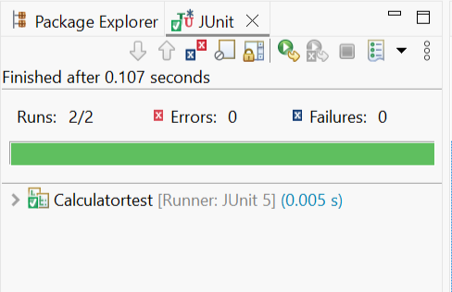

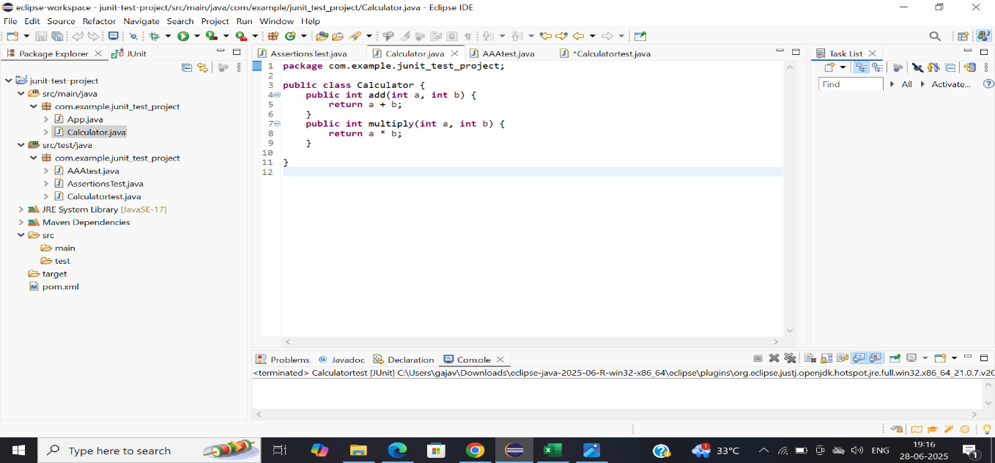

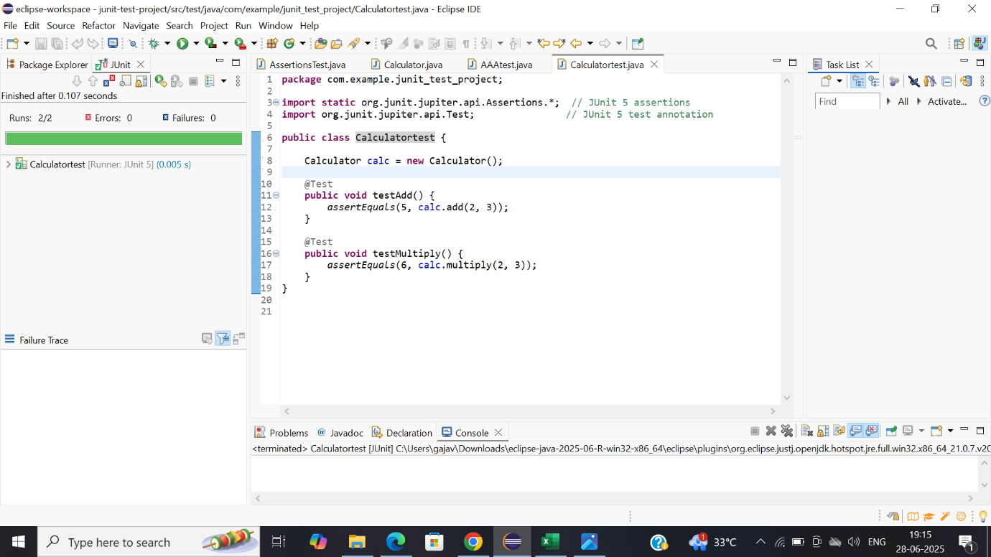

Exercise 3: Assertions in Junit

Scenario:

You need to use different assertions in JUnit to validate your test results.

AssertionTest.java:

package com.example.junit_test_project;

import static org.junit.jupiter.api.Assertions.*;

import org.junit.jupiter.api.Test;

public class AssertionsTest {

@Test

public void testAssertions() {

*assertEquals*(5, 2 + 3);

*assertTrue*(5 > 3);

*assertFalse*(5 < 3);

*assertNull*(null);

*assertNotNull*(new Object());

}

}

OUTPUT:

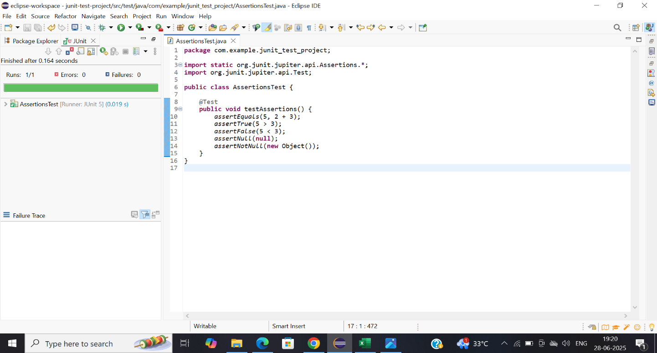

Exercise 4: Arrange-Act-Assert (AAA) Pattern, Test Fixtures, Setup and Teardown Methods in Junit

Scenario:

You need to organize your tests using the Arrange-Act-Assert (AAA) pattern and use setup and teardown methods.

Calculator.java:

package com.example.junit_test_project;

public class Calculator {

public int add(int a, int b) {

return a + b;

}

public int multiply(int a, int b) {

return a * b;

}

}

AAAtest.java:

package com.example.junit_test_project;

import static org.junit.jupiter.api.Assertions.*;

import org.junit.jupiter.api.BeforeEach;

import org.junit.jupiter.api.AfterEach;

import org.junit.jupiter.api.Test;

public class AAAtest {

private Calculator calculator;

@BeforeEach

public void setUp() {

calculator = new Calculator();

System.*out*.println("Setting up...");

}

@AfterEach

public void tearDown() {

calculator = null;

System.*out*.println("Tearing down...");

}

@Test

public void testAdd() {

int a = 4

int b = 6;

int result = calculator.add(a, b);

*assertEquals*(10, result);

}

@Test

public void testMultiply() {

int a = 9;

int b = 5;

int result = calculator.multiply(a, b);

*assertEquals*(45, result);

}

}

OUTPUT:

