PLSQL_Exercises

Exercise 1: Control Structures

**Scenario 1:** The bank wants to apply a discount to loan interest rates for customers above 60 years old.

**Question:** Write a PL/SQL block that loops through all customers, checks their age, and if they are above 60, apply a 1% discount to their current loan interest rates.

**Program Code:**

DECLARE

CURSOR cur_senior_customers IS

SELECT l.LoanID, l.InterestRate, c.CustomerID

FROM Loans l

JOIN Customers c ON l.CustomerID = c.CustomerID

WHERE MONTHS_BETWEEN(SYSDATE, c.DOB)/12 > 60;

BEGIN

FOR rec IN cur_senior_customers LOOP

UPDATE Loans

SET InterestRate = InterestRate - 1

WHERE LoanID = rec.LoanID;

DBMS_OUTPUT.PUT_LINE('Applied 1% discount to Loan ID ' || rec.LoanID ||

' for Customer ID ' || rec.CustomerID);

END LOOP;

COMMIT;

END;

/

OUTPUT:

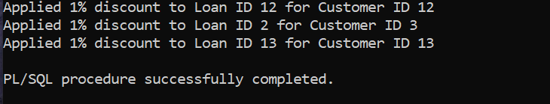

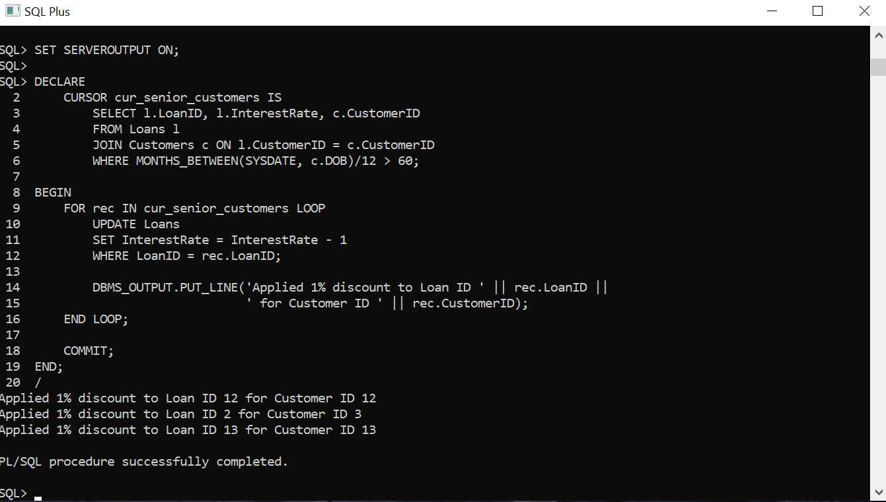

**Scenario 2:** A customer can be promoted to VIP status based on their balance.

**Question:** Write a PL/SQL block that iterates through all customers and sets a flag IsVIP to TRUE for those with a balance over $10,000.

**Program code:**

DECLARE

CURSOR vip_customers IS

SELECT CustomerID, Balance FROM Customers

WHERE Balance > 10000;

BEGIN

FOR rec IN vip_customers LOOP

UPDATE Customers

SET IsVIP = 'Y'

WHERE CustomerID = rec.CustomerID;

DBMS_OUTPUT.PUT_LINE('Customer ID ' || rec.CustomerID ||

' promoted to VIP (Balance: $' || rec.Balance || ')');

END LOOP;

COMMIT;

END;

/

OUTPUT:

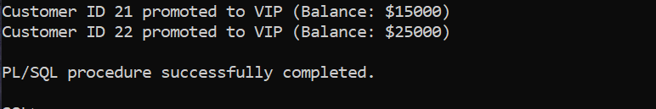

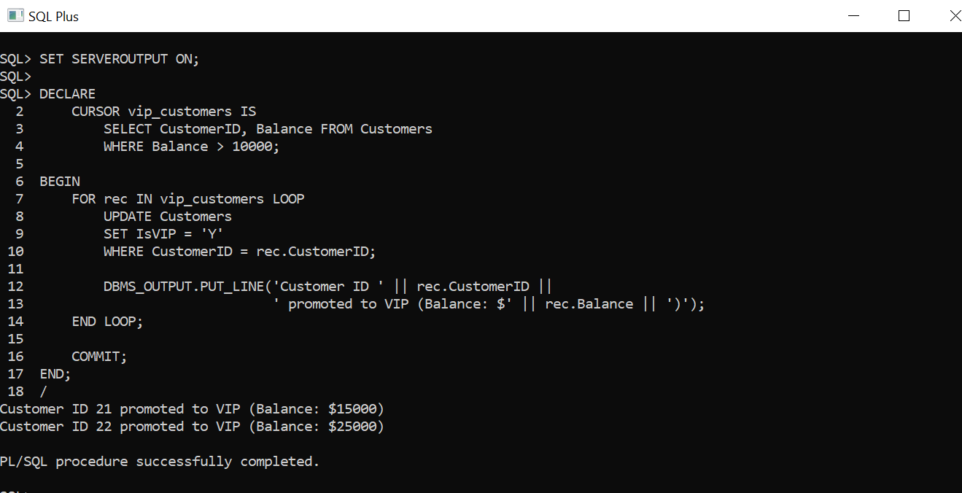

**Scenario 3:** The bank wants to send reminders to customers whose loans are due within the next 30 days.

**Question:** Write a PL/SQL block that fetches all loans due in the next 30 days and prints a reminder message for each customer.

**Program code:**

DECLARE

CURSOR due_soon_loans IS

SELECT l.LoanID, l.EndDate, c.Name, c.CustomerID

FROM Loans l

JOIN Customers c ON l.CustomerID = c.CustomerID

WHERE l.EndDate BETWEEN SYSDATE AND SYSDATE + 30;

BEGIN

FOR rec IN due_soon_loans LOOP

DBMS_OUTPUT.PUT_LINE('Reminder: Loan ID ' || rec.LoanID ||

' for Customer ' || rec.Name ||

' (Customer ID: ' || rec.CustomerID ||

') is due on ' || TO_CHAR(rec.EndDate, 'DD-MON-YYYY'));

END LOOP;

END;

/

Output:

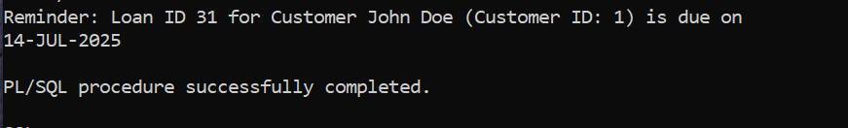

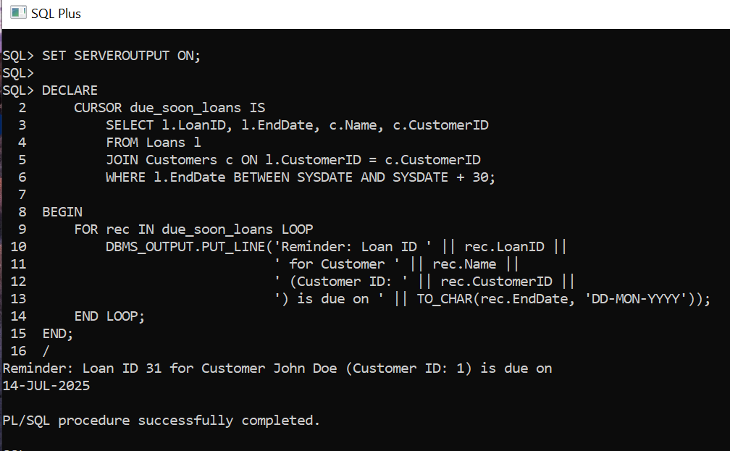

Exercise 3: Stored Procedures

**Scenario 1:** The bank needs to process monthly interest for all savings accounts.

**Question:** Write a stored procedure **ProcessMonthlyInterest** that calculates and updates the balance of all savings accounts by applying an interest rate of 1% to the current balance.

**Program Code:**

CREATE OR REPLACE PROCEDURE ProcessMonthlyInterest IS

BEGIN

-- Apply 1% interest to all savings accounts

UPDATE Accounts

SET Balance = Balance + (Balance * 0.01),

LastModified = SYSDATE

WHERE AccountType = 'Savings';

COMMIT;

DBMS_OUTPUT.PUT_LINE('Monthly interest processed for all savings accounts.');

END;

/

To Run the Procedure:

SET SERVEROUTPUT ON;

BEGIN

ProcessMonthlyInterest;

END;

/

**OUTPUT:**

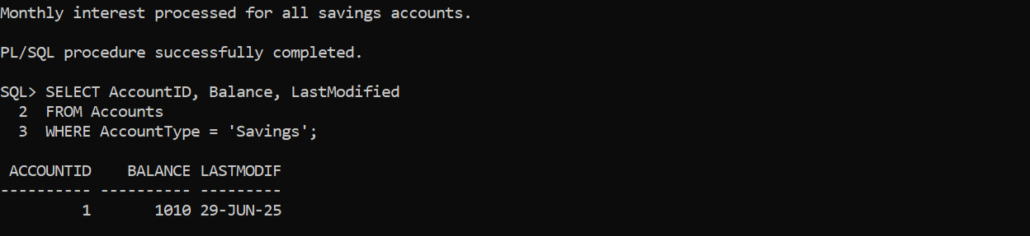

**Scenario 2:** The bank wants to implement a bonus scheme for employees based on their performance.

**Question:** Write a stored procedure **UpdateEmployeeBonus** that updates the salary of employees in a given department by adding a bonus percentage passed as a parameter.

**Program code:**

CREATE OR REPLACE PROCEDURE UpdateEmployeeBonus (

p_department IN VARCHAR2,

p_bonus_percent IN NUMBER

) IS

BEGIN

UPDATE Employees

SET Salary = Salary + (Salary * p_bonus_percent / 100)

WHERE Department = p_department;

COMMIT;

DBMS_OUTPUT.PUT_LINE('Bonus of ' || p_bonus_percent || '% applied to department: ' || p_department);

END;

/

**OUTPUT:**

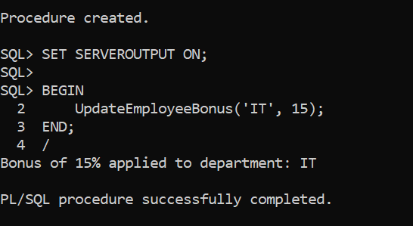

**Scenario 3:** Customers should be able to transfer funds between their accounts.

**Question:** Write a stored procedure **TransferFunds** that transfers a specified amount from one account to another, checking that the source account has sufficient balance before making the transfer.

**Program code:**

CREATE OR REPLACE PROCEDURE TransferFunds (

p_from_account_id IN NUMBER,

p_to_account_id IN NUMBER,

p_amount IN NUMBER

) IS

v_from_balance NUMBER;

BEGIN

SELECT Balance INTO v_from_balance

FROM Accounts

WHERE AccountID = p_from_account_id

FOR UPDATE;

IF v_from_balance < p_amount THEN

RAISE_APPLICATION_ERROR(-20001, 'Insufficient balance in source account.');

END IF;

UPDATE Accounts

SET Balance = Balance - p_amount,

LastModified = SYSDATE

WHERE AccountID = p_from_account_id;

UPDATE Accounts

SET Balance = Balance + p_amount,

LastModified = SYSDATE

WHERE AccountID = p_to_account_id;

INSERT INTO Transactions (TransactionID, AccountID, TransactionDate, Amount, TransactionType)

VALUES (Transactions_seq.NEXTVAL, p_from_account_id, SYSDATE, p_amount, 'Debit');

INSERT INTO Transactions (TransactionID, AccountID, TransactionDate, Amount, TransactionType)

VALUES (Transactions_seq.NEXTVAL, p_to_account_id, SYSDATE, p_amount, 'Credit');

COMMIT;

DBMS_OUTPUT.PUT_LINE('Transfer successful from Account ' || p_from_account_id || ' to Account ' || p_to_account_id);

END;

/

**OUTPUT:**

