Spring Data JPA with Spring Boot, Hibernate

**Spring Data JPA - Quick Example**

application.properties:

spring.application.name=orm-learn

# Logging

logging.level.org.springframework=info

logging.level.com.cognizant=debug

logging.level.org.hibernate.SQL=trace

logging.level.org.hibernate.type.descriptor.sql=trace

logging.pattern.console=%d{dd-MM-yy} %d{HH:mm:ss.SSS} %-20.20thread %5p %-25.25logger**{25}** %25M %4L %m%n

# \u2705 Database Config

spring.datasource.driver-class-name=com.mysql.cj.jdbc.Driver

spring.datasource.url=jdbc:mysql://localhost:3306/ormlearn

spring.datasource.username=root

spring.datasource.password=system

# \u2705 Hibernate Dialect

spring.jpa.hibernate.ddl-auto=validate

spring.jpa.properties.hibernate.dialect=org.hibernate.dialect.MySQLDialect

Country.java:

package com.cognizant.ormlearn.model;

import jakarta.persistence.Column;

import jakarta.persistence.Entity;

import jakarta.persistence.Id;

import jakarta.persistence.Table;

@Entity

@Table(name = "country")

public class Country {

@Id

@Column(name = "code")

private String code;

@Column(name = "name")

private String name;

public String getCode() {

return code;

}

public void setCode(String code) {

this.code = code;

}

public String getName() {

return name;

}

public void setName(String name) {

this.name = name;

}

@Override

public String toString() {

return "Country [code=" + code + ", name=" + name + "]";

}

}

CountryRepository.java:

package com.cognizant.ormlearn.repository;

import org.springframework.data.jpa.repository.JpaRepository;

import org.springframework.stereotype.Repository;

import com.cognizant.ormlearn.model.Country;

@Repository

public interface CountryRepository extends JpaRepository<Country, String> {

}

CountryService.java:

package com.cognizant.ormlearn.service;

import java.util.List;

import org.springframework.beans.factory.annotation.Autowired;

import org.springframework.stereotype.Service;

import org.springframework.transaction.annotation.Transactional;

import com.cognizant.ormlearn.model.Country;

import com.cognizant.ormlearn.repository.CountryRepository;

@Service

public class CountryService {

@Autowired

private CountryRepository countryRepository;

@Transactional

public List<Country> getAllCountries() {

return countryRepository.findAll();

}

}

OrmLearnApplication.java:

package com.cognizant.ormlearn;

import java.util.List;

import org.slf4j.Logger;

import org.slf4j.LoggerFactory;

import org.springframework.boot.SpringApplication;

import org.springframework.boot.autoconfigure.SpringBootApplication;

import org.springframework.context.ApplicationContext;

import com.cognizant.ormlearn.model.Country;

import com.cognizant.ormlearn.service.CountryService;

@SpringBootApplication

public class OrmLearnApplication {

private static final Logger *LOGGER* = LoggerFactory.*getLogger*(OrmLearnApplication.class);

private static CountryService *countryService*;

public static void main(String[] args) {

ApplicationContext context = SpringApplication.*run*(OrmLearnApplication.class, args);

*LOGGER*.info("Inside main");

*countryService* = context.getBean(CountryService.class);

*testGetAllCountries*();

}

private static void testGetAllCountries() {

*LOGGER*.info("Start");

List<Country> countries = *countryService*.getAllCountries();

*LOGGER*.debug("countries={}", countries);

*LOGGER*.info("End");

}

}

Pom.xml:

<dependencies>

<!-- Core Spring Boot -->

<dependency>

<groupId>org.springframework.boot</groupId>

<artifactId>spring-boot-starter</artifactId>

</dependency>

<!-- Spring Data JPA (includes javax.persistence) -->

<dependency>

<groupId>org.springframework.boot</groupId>

<artifactId>spring-boot-starter-data-jpa</artifactId>

</dependency>

<!-- MySQL Connector with version -->

<dependency>

<groupId>mysql</groupId>

<artifactId>mysql-connector-java</artifactId>

<version>8.0.33</version>

<scope>runtime</scope>

</dependency>

<!-- DevTools -->

<dependency>

<groupId>org.springframework.boot</groupId>

<artifactId>spring-boot-devtools</artifactId>

<scope>runtime</scope>

<optional>true</optional>

</dependency>

<!-- Testing -->

<dependency>

<groupId>org.springframework.boot</groupId>

<artifactId>spring-boot-starter-test</artifactId>

<scope>test</scope>

</dependency>

</dependencies>

**OUTPUT:**

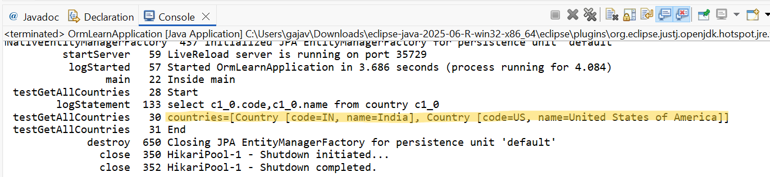

Difference between JPA, Hibernate and Spring Data JPA

application.properties:

spring.application.name=spring-data-jpa-demo

spring.datasource.url=jdbc:mysql://localhost:3306/employeedb

spring.datasource.username=root

spring.datasource.password=system

spring.jpa.hibernate.ddl-auto=update

spring.jpa.show-sql=true

spring.jpa.properties.hibernate.dialect=org.hibernate.dialect.MySQLDialect

Employee.java:

package com.example.demo.entity;

import jakarta.persistence.*;

@Entity

public class Employee {

@Id

@GeneratedValue(strategy = GenerationType.*IDENTITY*)

private Integer id;

private String name;

private String department;

// Getters and Setters

}

EmployeeRepository.java:

package com.example.demo.repository;

import com.example.demo.entity.Employee;

import org.springframework.data.jpa.repository.JpaRepository;

public interface EmployeeRepository extends JpaRepository<Employee, Integer> {

}

EmployeeService.java:

package com.example.demo.service;

import com.example.demo.entity.Employee;

import com.example.demo.repository.EmployeeRepository;

import org.springframework.beans.factory.annotation.Autowired;

import org.springframework.stereotype.Service;

import org.springframework.transaction.annotation.Transactional;

@Service

public class EmployeeService {

@Autowired

private EmployeeRepository employeeRepository;

@Transactional

public void addEmployee(Employee employee) {

employeeRepository.save(employee);

}

}

EmployeeController.java:

package com.example.demo.controller;

import com.example.demo.entity.Employee;

import com.example.demo.service.EmployeeService;

import org.springframework.beans.factory.annotation.Autowired;

import org.springframework.web.bind.annotation.*;

@RestController

@RequestMapping("/api/employees")

public class EmployeeController {

@Autowired

private EmployeeService employeeService;

@PostMapping

public String createEmployee(@RequestBody Employee employee) {

employeeService.addEmployee(employee);

return "Employee added successfully!";

}

}

SpringDataJpaDemoApplication.java:

package com.example.demo;

import org.springframework.boot.SpringApplication;

import org.springframework.boot.autoconfigure.SpringBootApplication;

@SpringBootApplication

public class SpringDataJpaDemoApplication {

public static void main(String[] args) {

SpringApplication.*run*(SpringDataJpaDemoApplication.class, args);

}

}

**OUTPUT:**

