Spring REST using Spring Boot 3

1.Create a Spring Web Project using Maven

**SpringLearnApplication.java:**

package com.cognizant.springlearn;

import org.springframework.boot.SpringApplication;

import org.springframework.boot.autoconfigure.SpringBootApplication;

@SpringBootApplication

public class SpringLearnApplication {

public static void main(String[] args) {

SpringApplication.*run*(SpringLearnApplication.class, args);

System.*out*.println("SpringLearnApplication started...");

}

}

**HelloController.java**

package com.cognizant.spring_learn;

import org.springframework.web.bind.annotation.GetMapping;

import org.springframework.web.bind.annotation.RestController;

@RestController

public class HelloController {

@GetMapping("/hello")

public String sayHello() {

return "Hello Spring!";

}

}

**application.properties**

spring.application.name=spring-learn

server.port=9090

**OUTPUT:**

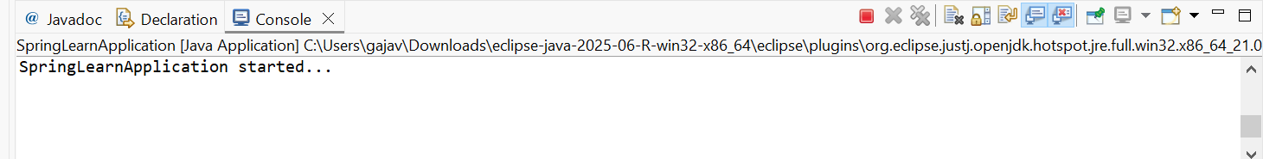

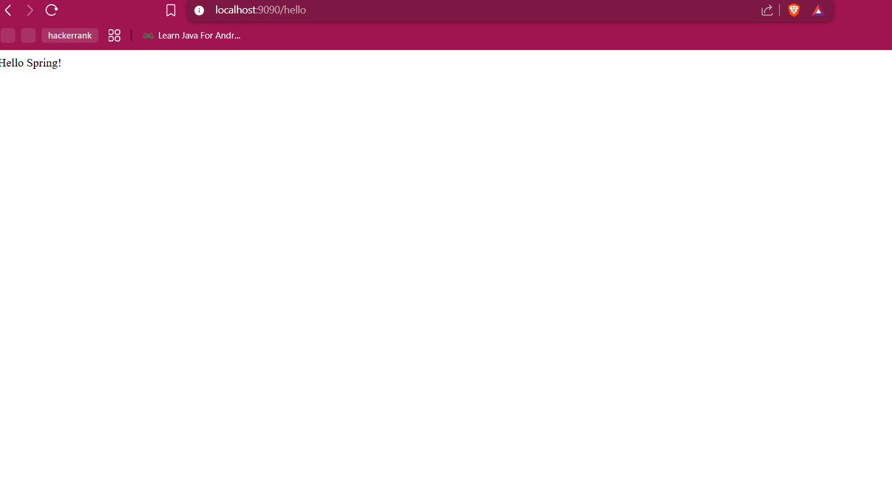

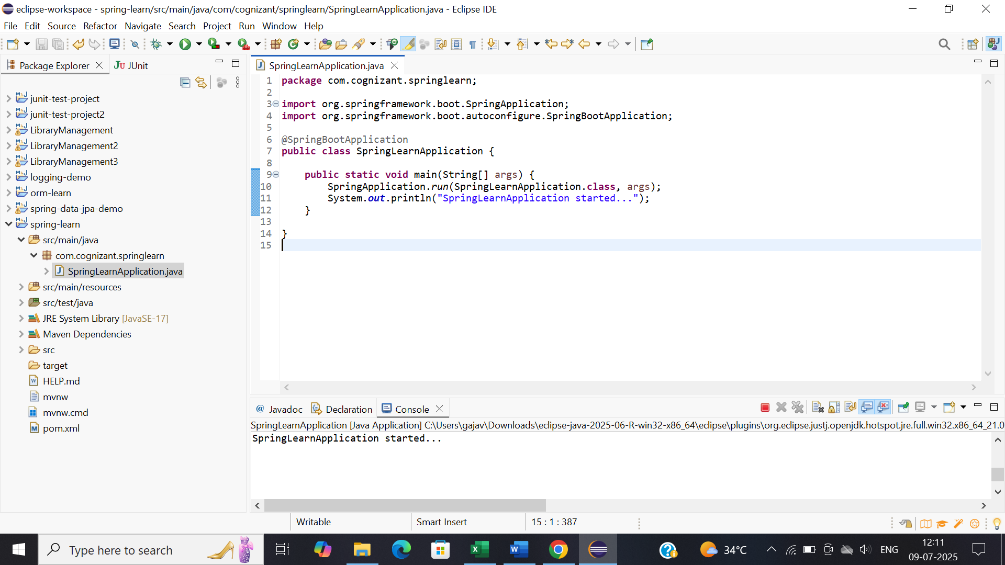

2.Spring Core – Load Country from Spring Configuration XML

**SpringLearnApplication.java:**

package com.cognizant.springlearn;

import org.slf4j.Logger;

import org.slf4j.LoggerFactory;

import org.springframework.context.support.ClassPathXmlApplicationContext;

public class SpringLearnApplication {

private static final Logger *LOGGER* = LoggerFactory.*getLogger*(SpringLearnApplication.class);

public static void displayCountry() {

try (ClassPathXmlApplicationContext context = new ClassPathXmlApplicationContext("country.xml")) {

Country country = context.getBean("country", Country.class);

*LOGGER*.info("Country : {}", country.toString());

}

}

public static void main(String[] args) {

*displayCountry*();

}

}

**Country.java:**

package com.cognizant.springlearn;

import org.slf4j.Logger;

import org.slf4j.LoggerFactory;

public class Country {

private static final Logger *LOGGER* = LoggerFactory.*getLogger*(Country.class);

private String code;

private String name;

public Country() {

*LOGGER*.debug("Inside Country Constructor.");

}

public String getCode() {

*LOGGER*.debug("Inside getCode()");

return code;

}

public void setCode(String code) {

*LOGGER*.debug("Inside setCode()");

this.code = code;

}

public String getName() {

*LOGGER*.debug("Inside getName()");

return name;

}

public void setName(String name) {

*LOGGER*.debug("Inside setName()");

this.name = name;

}

@Override

public String toString() {

return "Country [code=" + code + ", name=" + name + "]";

}

}

**Country.xml:**

<?xml version=*"1.0"* encoding=*"UTF-8"*?>

<beans xmlns=*"http://www.springframework.org/schema/beans"*

xmlns:xsi=*"http://www.w3.org/2001/XMLSchema-instance"*

xsi:schemaLocation=*"http://www.springframework.org/schema/beans*

*http://www.springframework.org/schema/beans/spring-beans.xsd"*>

<bean id=*"country"* class=*"com.cognizant.springlearn.Country"*>

<property name=*"code"* value=*"IN"* />

<property name=*"name"* value=*"India"* />

</bean>

</beans>

**Simplelogger.properties:**

org.slf4j.simpleLogger.defaultLogLevel=debug

**Output:**

