9. ReactJS-HOL

Create a React Application named “cricketapp” with the following components:

**Players.js**

export const players = [

{ name: "Virat", score: 88 },

{ name: "Rohit", score: 95 },

{ name: "Hardik", score: 65 },

{ name: "Bumrah", score: 45 },

{ name: "Dhoni", score: 55 },

{ name: "Sachin", score: 100 },

{ name: "Rahul", score: 60 },

{ name: "Surya", score: 80 }

];

**MergedPlayers.js**

import React from "react";

const MergedPlayers = () => {

const T20Players = [

{ name: "Rishabh" },

{ name: "Shreyas" },

{ name: "Gill" }

];

const RanjiTrophyPlayers = [

{ name: "Prithvi" },

{ name: "Sarfaraz" },

{ name: "Ruturaj" }

];

const merged = [...T20Players, ...RanjiTrophyPlayers];

return (

<div>

<h3>List of Indian Players Merged:</h3>

<ul>

{merged.map((player, idx) => (

<li key={idx}>{player.name}</li>

))}

</ul>

</div>

);

};

export default MergedPlayers;

**OddEvenPlayers.js**

import React from "react";

const OddEvenPlayers = ({ list }) => {

const odd = list.filter((_, i) => i % 2 !== 0);

const even = list.filter((_, i) => i % 2 === 0);

return (

<div>

<h3>Odd Players</h3>

<ul>

{odd.map((item, idx) => (

<li key={idx}>{item.name}</li>

))}

</ul>

<h3>Even Players</h3>

<ul>

{even.map((item, idx) => (

<li key={idx}>{item.name}</li>

))}

</ul>

</div>

);

};

export default OddEvenPlayers;

**App.js**

import React, { useState } from "react";

import { players } from "./data/players";

import OddEvenPlayers from "./components/OddEvenPlayers";

import MergedPlayers from "./components/MergedPlayers";

function App() {

const [flag, setFlag] = useState(true);

return (

<div>

<button onClick={() => setFlag(!flag)}>Toggle</button>

{flag ? (

<div>

<h3>List of Players:</h3>

<ul>

{players.map((item, idx) => (

<li key={idx}>

{item.name} - {item.score}

</li>

))}

</ul>

<h3>List of Players having Scores Less than 70:</h3>

<ul>

{players

.filter((player) => player.score < 70)

.map((player, idx) => (

<li key={idx}>{player.name}</li>

))}

</ul>

</div>

) : (

<div>

<h3>Indian Team:</h3>

<OddEvenPlayers list={players} />

<MergedPlayers />

</div>

)}

</div>

);

}

export default App;

**index.js**

import React from "react";

import ReactDOM from "react-dom/client";

import App from "./App";

const root = ReactDOM.createRoot(document.getElementById("root"));

root.render(

<React.StrictMode>

<App />

</React.StrictMode>

);

**Output:**

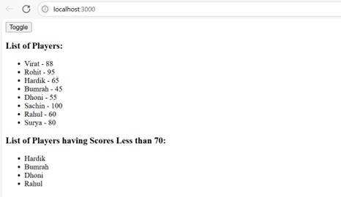

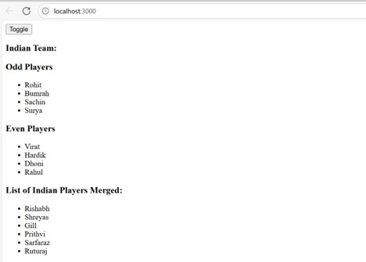

10. ReactJS-HOL

**App.js:**

import React from 'react';

import './App.css';

function App() {

  const heading = "Office Space";

  const officeSpaces = [

    {

      Name: "DBS",

      Rent: 50000,

      Address: "Chennai",

      img: "https://i.imgur.com/BhB4W6r.jpeg" // replace with your image URL

    },

    {

      Name: "WeWork",

      Rent: 75000,

      Address: "Bangalore",

      img: "https://i.imgur.com/3GvwNBf.jpeg"

    },

    {

      Name: "Innov8",

      Rent: 55000,

      Address: "Hyderabad",

      img: "https://i.imgur.com/X2vHkVa.jpeg"

    }

  ];

  return (

    <div className="App">

      <h1>{heading} , at Affordable Range</h1>

      {officeSpaces.map((office, index) => {

        const rentColor = office.Rent <= 60000 ? 'textRed' : 'textGreen';

        return (

          <div key={index} className="officeCard">

            <img src={office.img} width="25%" height="25%" alt="Office Space" />

            <h1>Name: {office.Name}</h1>

            <h3 className={rentColor}>Rent: Rs. {office.Rent}</h3>

            <h3>Address: {office.Address}</h3>

          </div>

        );

      })}

    </div>

  );

}

export default App;

**index.css:**

.App {

  text-align: center;

  font-family: Arial, sans-serif;

  padding: 20px;

}

.officeCard {

  margin-bottom: 30px;

}

.textRed {

  color: red;

}

.textGreen {

  color: green;

}

**Output:**

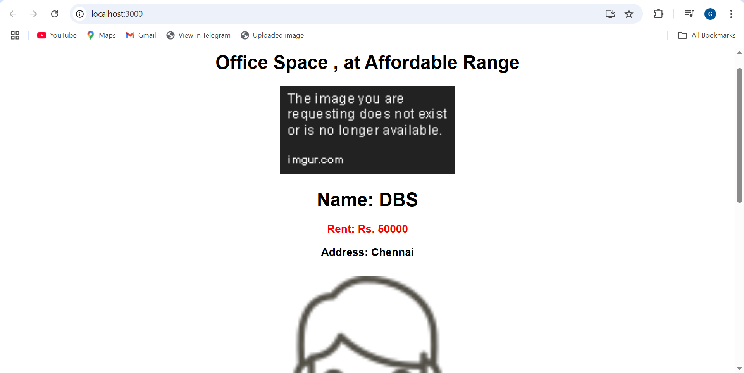

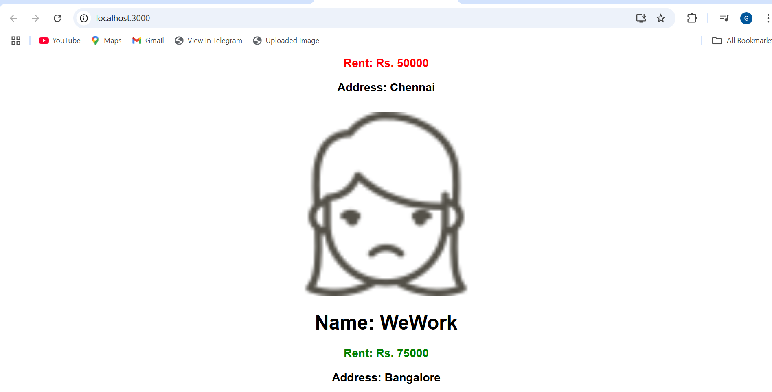

11. ReactJS-HOL

Create a React Application “eventexamplesapp” to handle various events of the form elements in HTML.

**App.js:**

import React, { useState } from 'react';

import CurrencyConvertor from './CurrencyConvertor';

import './App.css';

function App() {

  const [count, setCount] = useState(1);

  const increment = () => {

    setCount(count + 1);

    sayHello();

  };

  const decrement = () => {

    setCount(count - 1);

  };

  const sayHello = () => {

    alert("Hello! This is a static message.");

  };

  const sayWelcome = (message) => {

    alert(`Say ${message}`);

};

const handleClick = () => {

    alert("I was clicked");

  };

  return (

    <div className="App">

      <h3>{count}</h3>

      <button onClick={increment}>Increment</button>

      <br />

      <button onClick={decrement}>Decrement</button>

      <br />

      <button onClick={() => sayWelcome("welcome")}>Say welcome</button>

      <br />

      <button onClick={handleClick}>Click on me</button>

      <br /><br />

      <CurrencyConvertor />

    </div>

  );

}

export default App;

**CurrencyConvertor.js:**

import React, { useState } from 'react';

function CurrencyConvertor() {

  const [amount, setAmount] = useState('');

  const [currency, setCurrency] = useState('Euro');

  const handleSubmit = (e) => {

    e.preventDefault();

    if (currency === 'Euro') {

      const converted = parseFloat(amount) * 80;

      alert(`Converting to ${currency} Amount is ${converted}`);

    } else {

      alert("Currency not supported.");

    }

  };

  return (

    <div>

      <h2 style={{ color: 'green' }}>Currency Convertor!!!</h2>

      <form onSubmit={handleSubmit}>

        <label>Amount: </label>

        <input

          type="text"

          value={amount}

          onChange={(e) => setAmount(e.target.value)}

        />

        <br />

        <label>Currency: </label>

        <select value={currency} onChange={(e) => setCurrency(e.target.value)}>

          <option value="Euro">Euro</option>

        </select>

        <br /><br />

        <button type="submit">Submit</button>

      </form>

    </div>

  );

}

export default CurrencyConvertor;

**Output:**

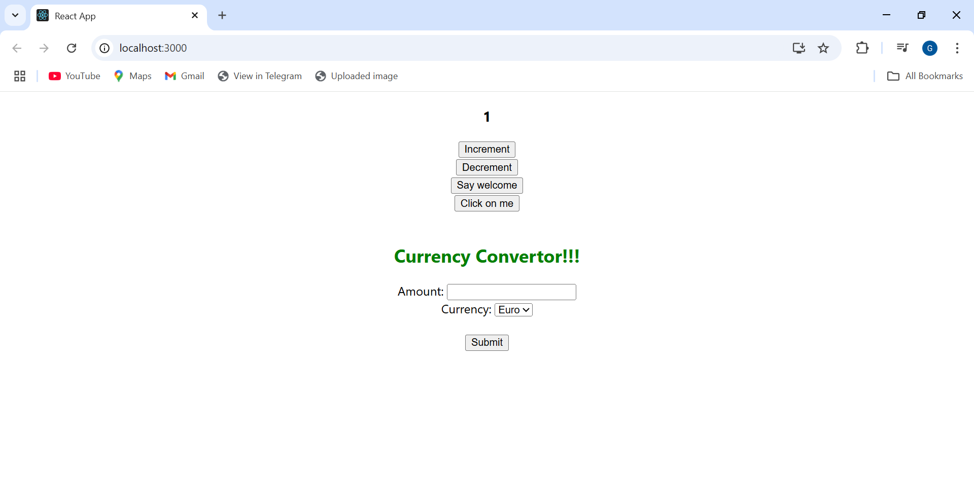

12. ReactJS-HOL

**App.js:**

import React, { useState } from 'react';

import './App.css';

function LoginButton(props) {

  return (

    <button onClick={props.onClick}>

      Login

    </button>

  );

}

function LogoutButton(props) {

  return (

    <button onClick={props.onClick}>

      Logout

    </button>

  );

}

function GuestGreeting() {

  return (

    <div>

      <h1>Please sign up.</h1>

      <p>Flight Details:</p>

      <ul>

        <li>Chennai ✈ Delhi - 9:30 AM</li>

        <li>Delhi ✈ Mumbai - 2:45 PM</li>

        <li>Mumbai ✈ Kolkata - 6:00 PM</li>

      </ul>

    </div>

  );

}

function UserGreeting() {

  return (

    <div>

      <h1>Welcome back</h1>

      <p>You can now book your tickets!</p>

      <button>Book Ticket</button>

    </div>

  );

}

function Greeting(props) {

  const isLoggedIn = props.isLoggedIn;

  if (isLoggedIn) {

    return <UserGreeting />;

  }

  return <GuestGreeting />;

}

function App() {

  const [isLoggedIn, setIsLoggedIn] = useState(false);

  const handleLoginClick = () => {

    setIsLoggedIn(true);

  };

  const handleLogoutClick = () => {

    setIsLoggedIn(false);

  };

  let button;

  if (isLoggedIn) {

    button = <LogoutButton onClick={handleLogoutClick} />;

  } else {

    button = <LoginButton onClick={handleLoginClick} />;

  }

  return (

    <div className="App">

      <Greeting isLoggedIn={isLoggedIn} />

      {button}

    </div>

  );

}

export default App;

**Output:**

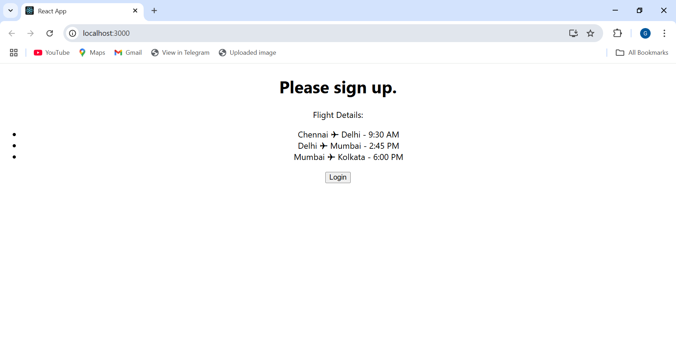

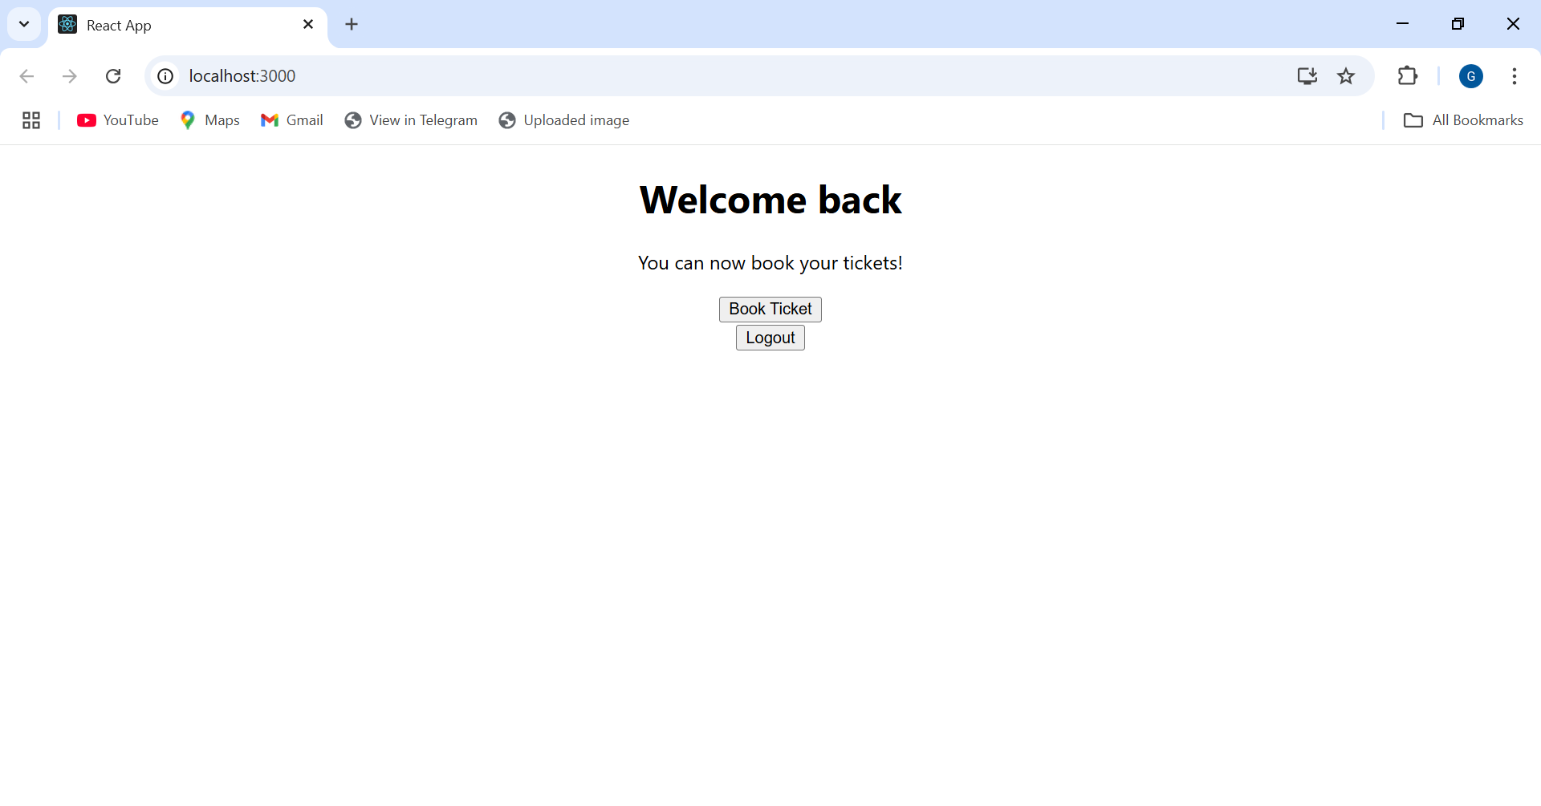

13. ReactJS-HOL

import React from "react";

const bookdet = [

{ id: 101, name: "Master React", price: 750 },

{ id: 102, name: "Deep Dive Into Angular 11", price: 800 },

{ id: 103, name: "Mongo Essentials", price: 450 },

];

function CourseBookBlog() {

const courseDet = [

{ name: "Angular", price: 4500 },

{ name: "React", price: 5500 },

];

const blogDet = [

{ title: "React Learning", description: "Beginner Kit" },

{ title: "Installation", description: "You can install React from npm" },

];

return (

<div style={{ display: "flex", justifyContent: "space-around", padding: 20 }}>

<div className="course" style={{ flex: 1 }}>

<h3>Course Details</h3>

<ul>

{courseDet.map((course) => (

<li key={course.name}>

{course.name} - Rs. {course.price}

</li>

))}

</ul>

</div>

<div className="book" style={{ flex: 1, borderLeft: "1px solid green", paddingLeft: 20 }}>

<h3>Book Details</h3>

{bookdet.map((book) => (

<div key={book.id}>

<h4>{book.name}</h4>

<p>Rs. {book.price}</p>

</div>

))}

</div>

<div className="blog" style={{ flex: 1, borderLeft: "1px solid green", paddingLeft: 20 }}>

<h3>Blog Details</h3>

{blogDet.map((blog, index) => (

<div key={index}>

<h4>{blog.title}</h4>

<p>{blog.description}</p>

</div>

))}

</div>

</div>

);

}

export default CourseBookBlog;

**Output:**

