1.GIT_HOL

**Setup your machine with Git Configuration**

**OUTPUT:**

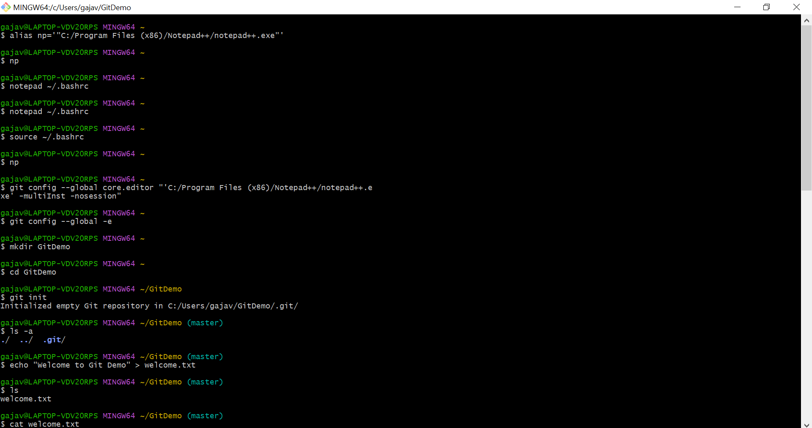

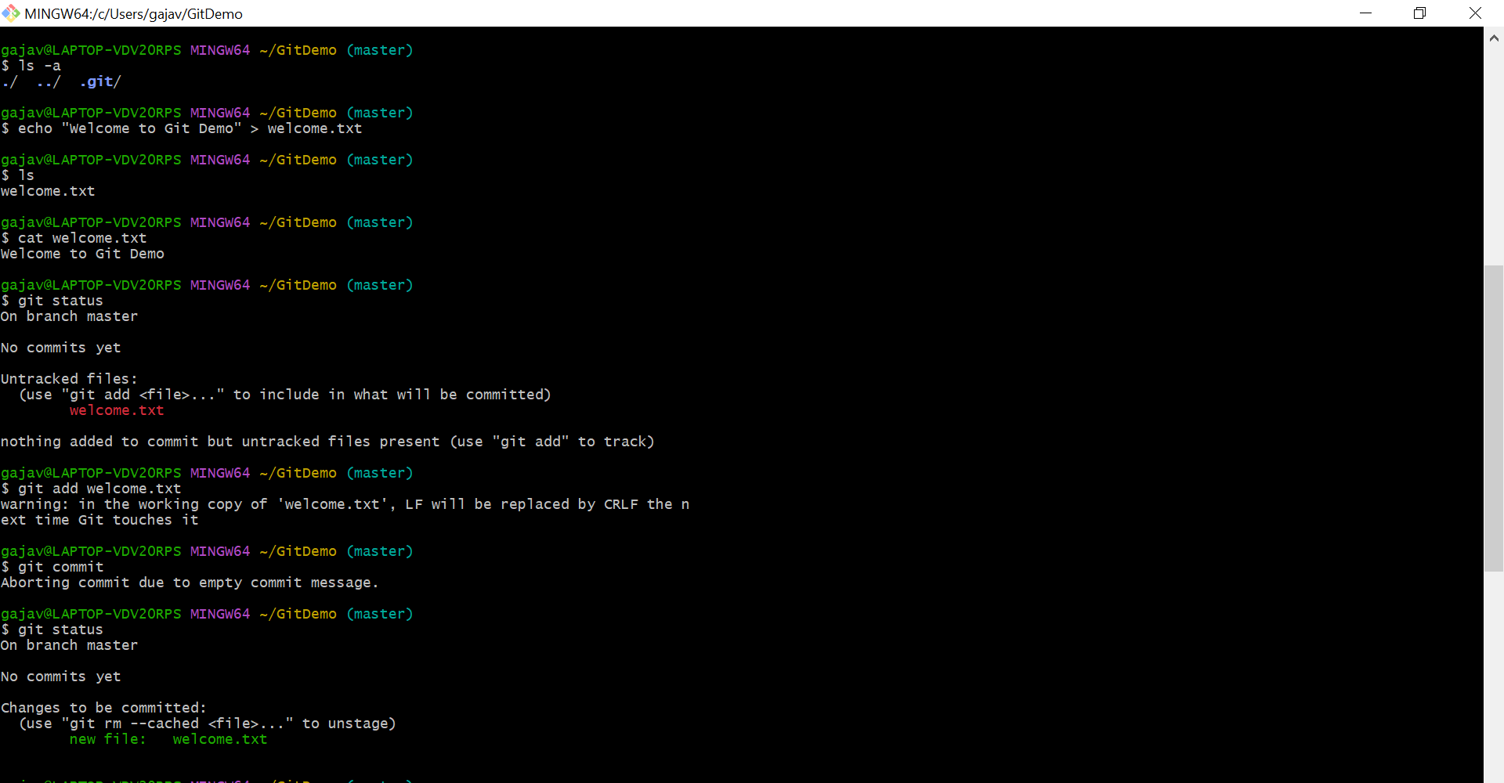

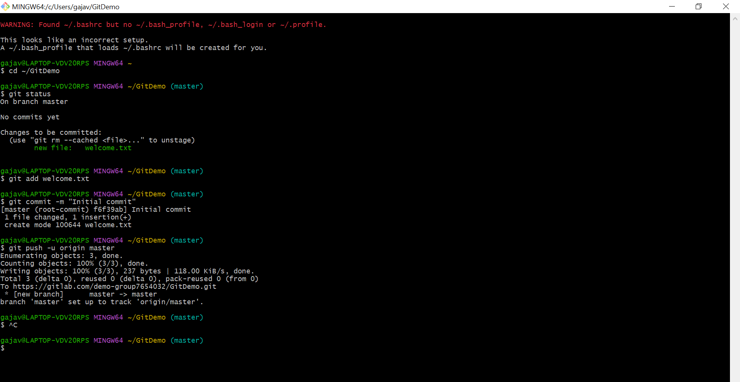

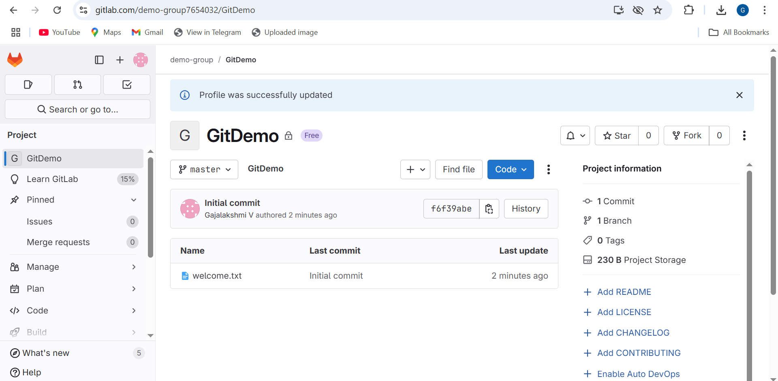

2.GIT_HOL

Create a **“.log”** file and a **log folder** in the working directory of Git. Update the **.gitignore** file in such a way that on committing, these files (.log extensions and log folders) are ignored.

OUTPUT:

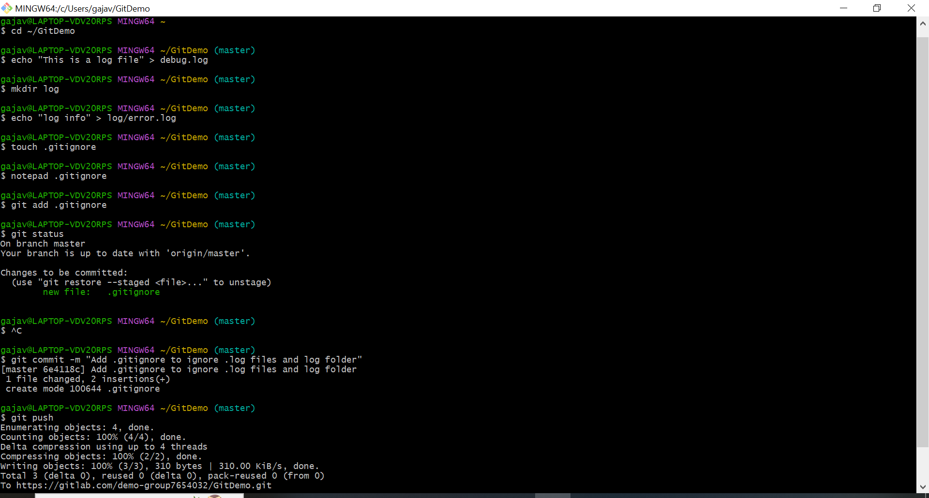

3.GIT_HOL

Branching and Merging

OUTPUT:

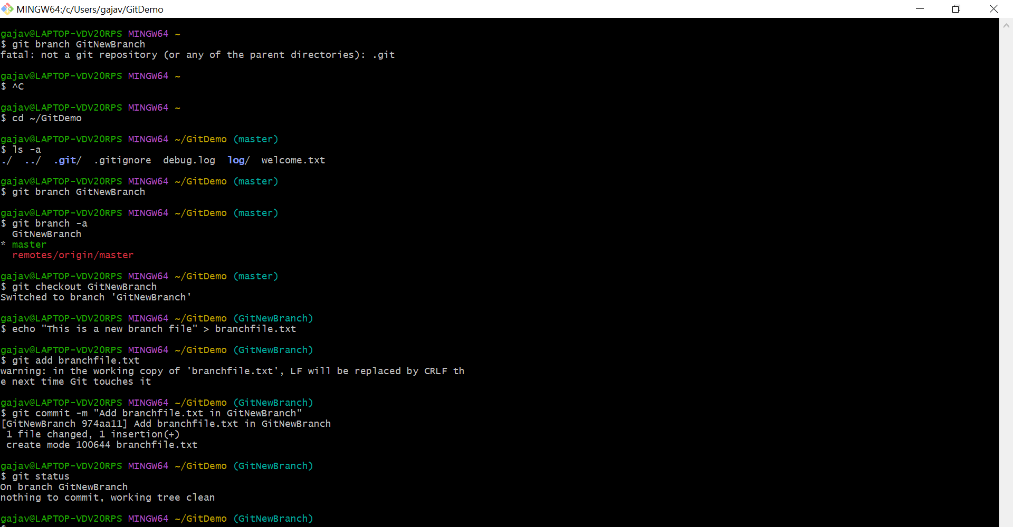

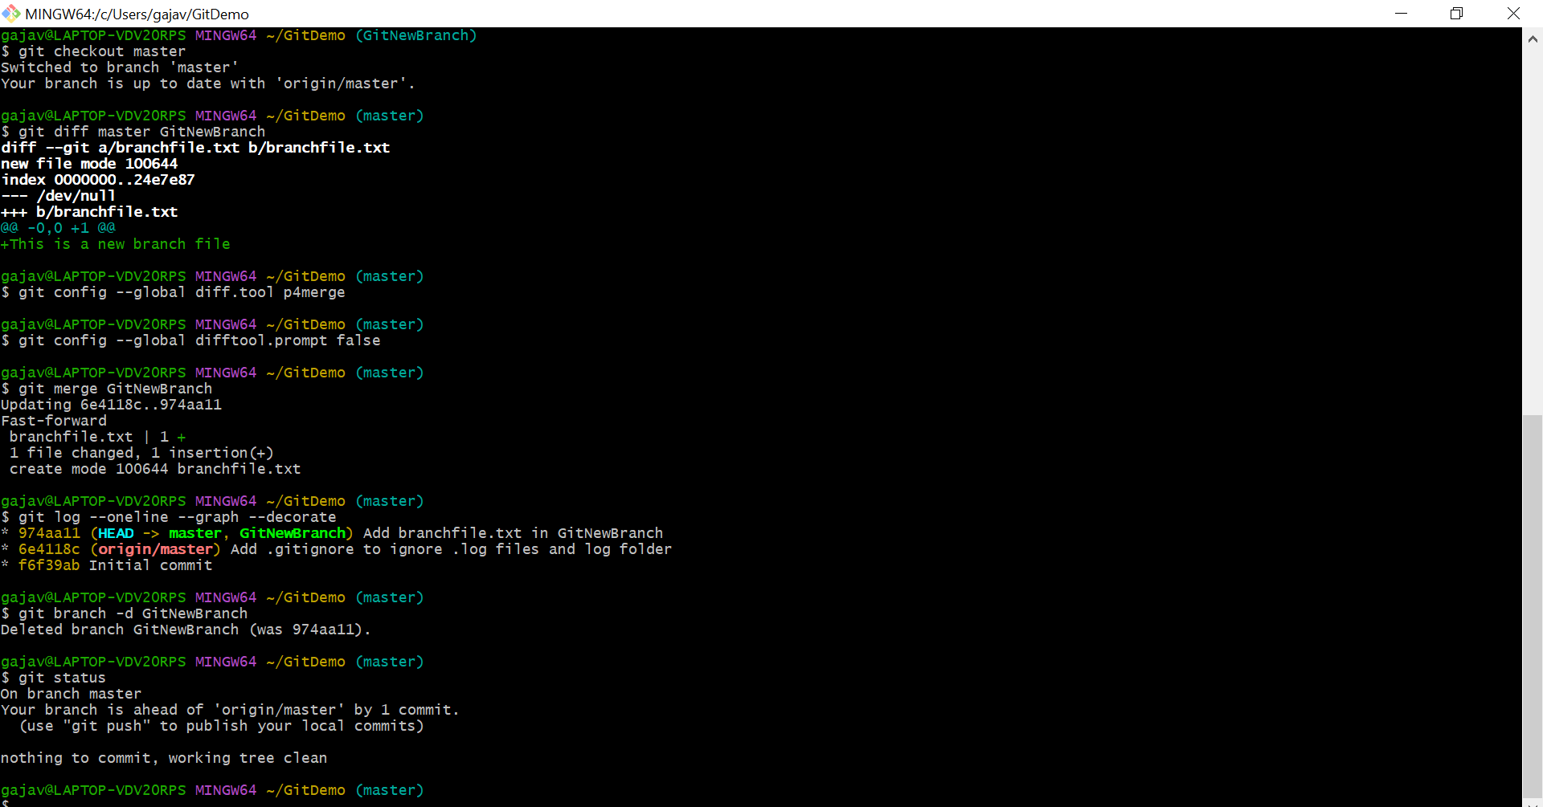

4.GIT_HOL

Please follow the instructions to complete the hands-on. Each instruction expect a command for the Git Bash.

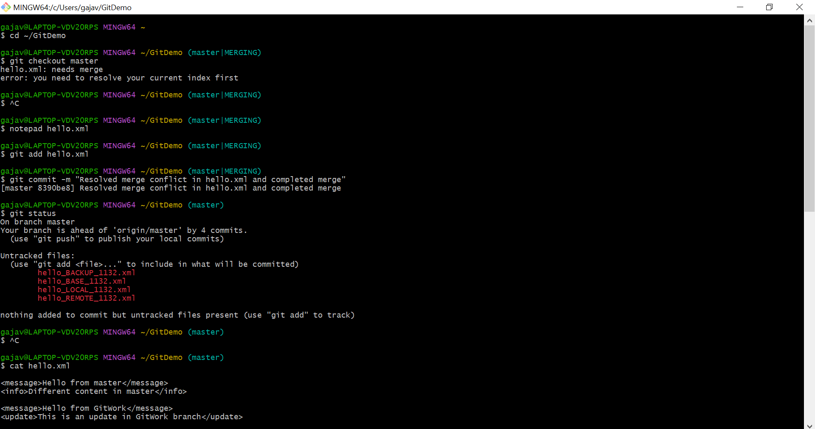

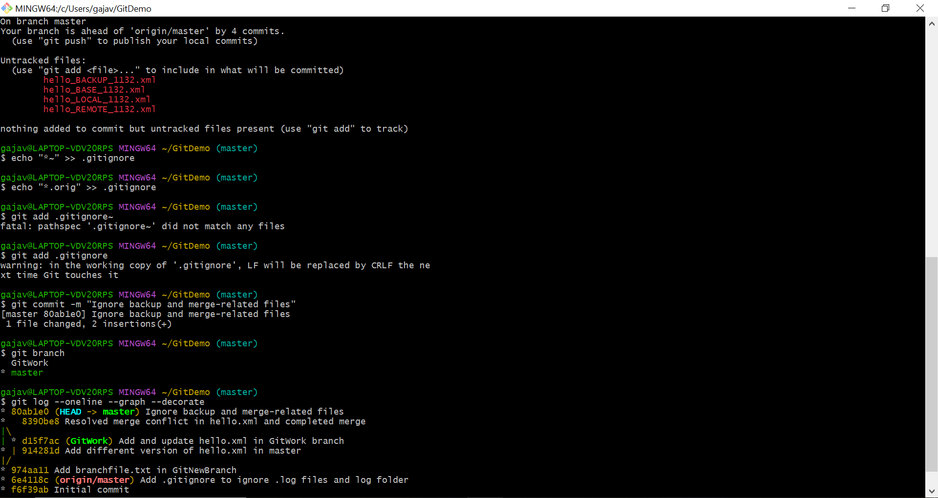

5.GIT_HOL

Push the changes, which are pending from **“Git-T03-HOL_002”** to the remote repository.

