Question 1

* **Estimate the circle using the RNASAC algorithm**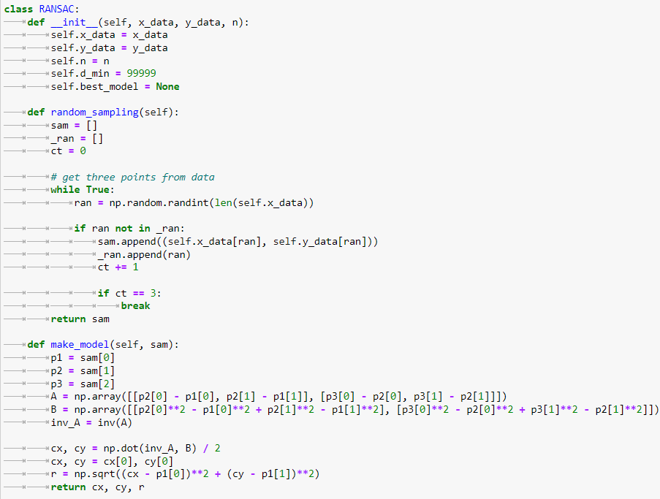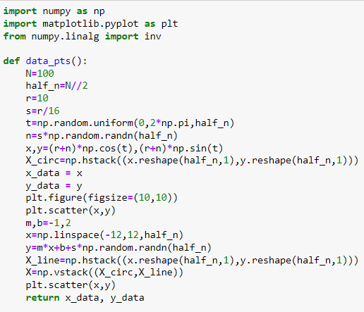

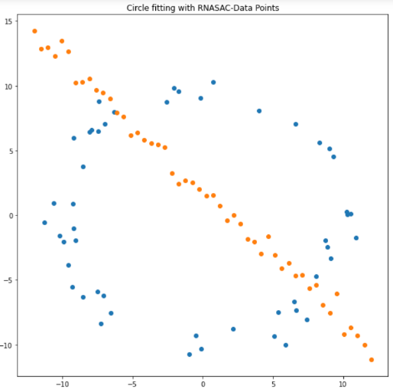

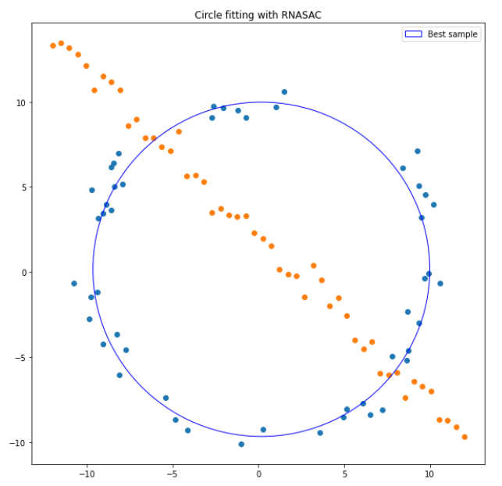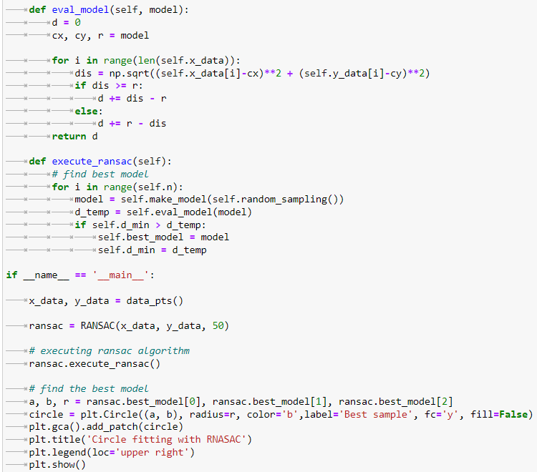

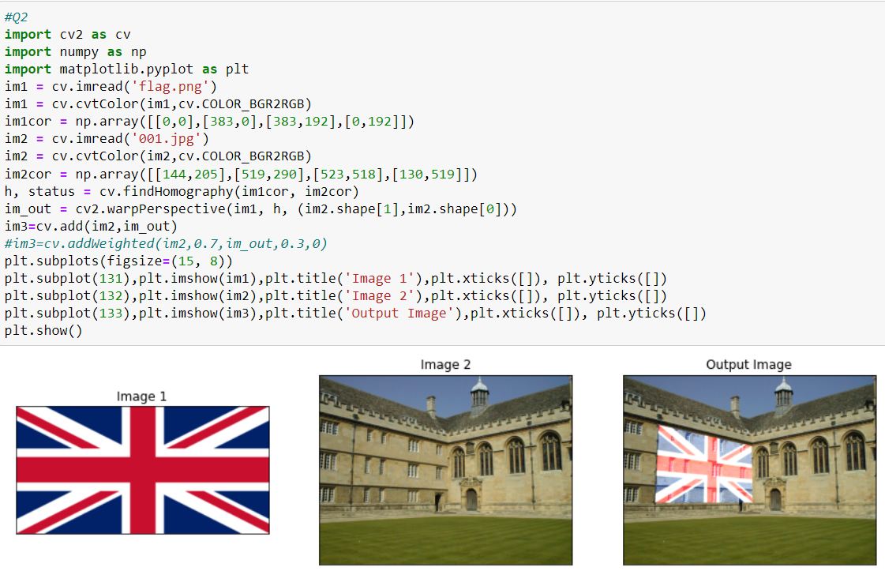Question 2

* **Wadham College image with the British flag superimposed**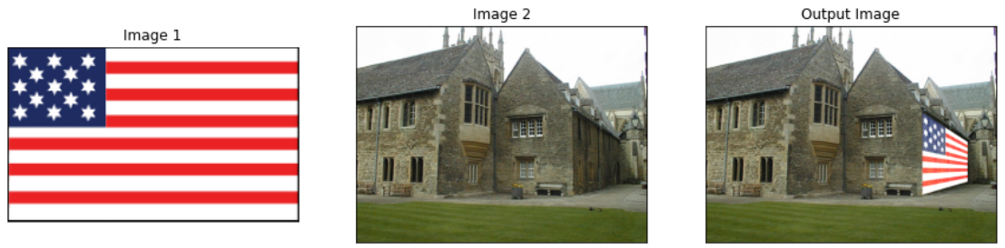.
* 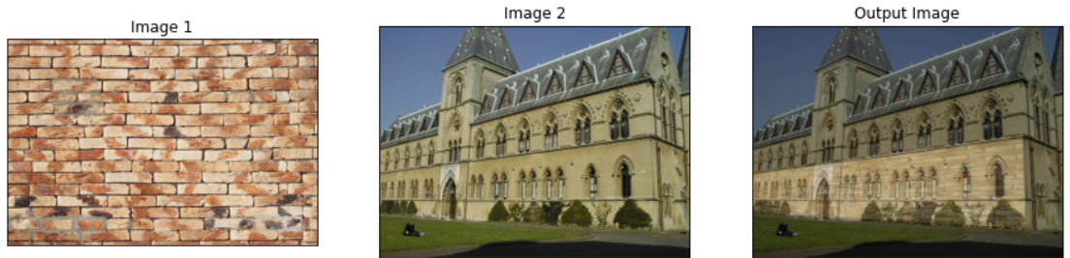**Merton College image with the United States flag superimposed.**
* **University library image with brick image superimposed.**

Question 3

* 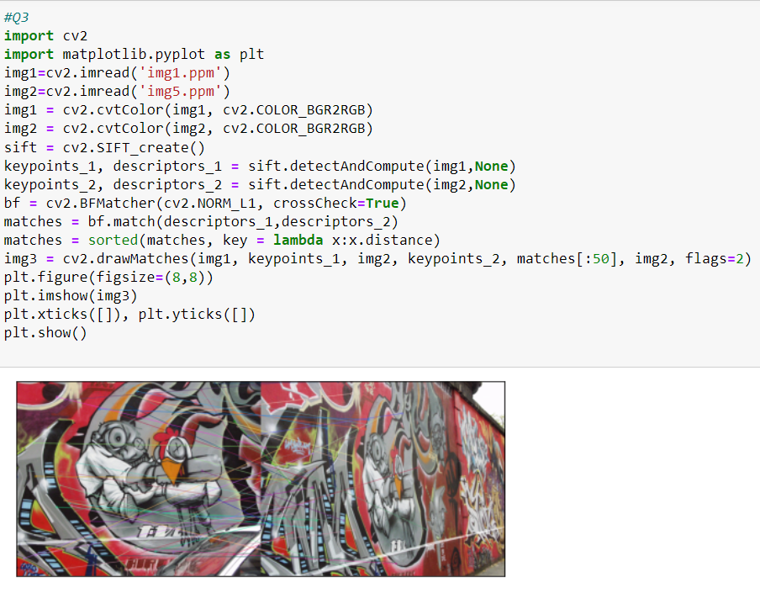**Computation and Matching of SIFT Features Between the Two Images (Img1 and Img5).**
* 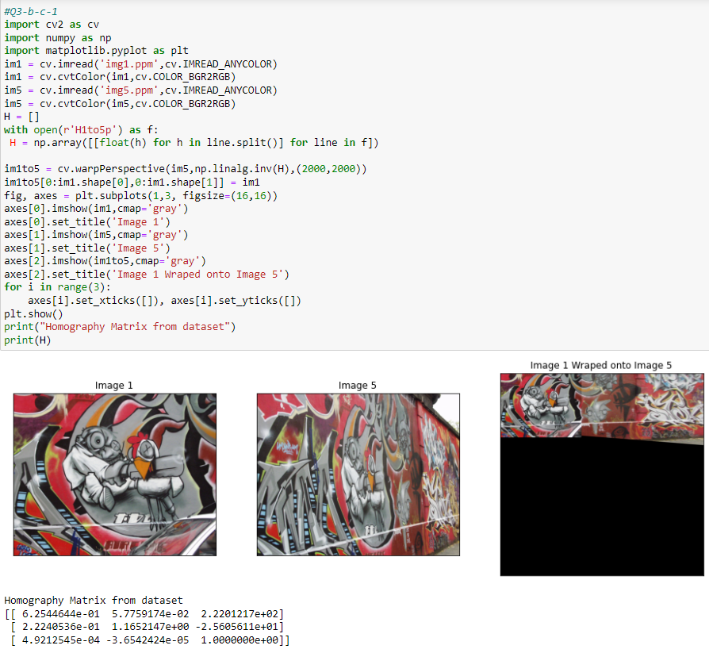**Computation of homography using relevant OpenCV function and stitching of img1 onto img5**
* **Computation of homography with RANSAC and stitching of img1 onto img5**

