1. Installed python 3.11



You can also use python3 --V here.

1. Installed python version 2.7

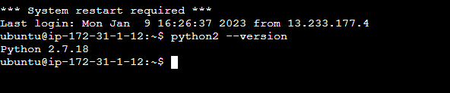

In the below snapshot, you can see both versions:

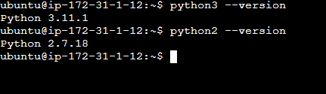

1. Install Virtual environment

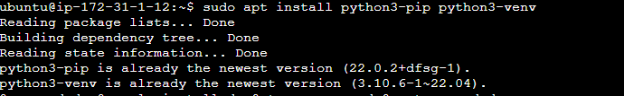

1. Install Django-> TO get the installed version name of Django

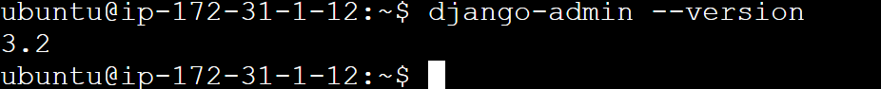

1. Installed l jdk8 and jdk11 and restarted.

Command to display all installed versions of java

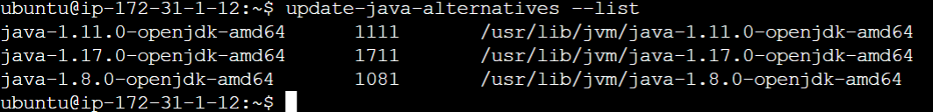

Here, I installed jdk 8 and jdk 17 by using sudo apt-get install OpenJDK-version name-JDK command.

1. Install tomcat by using sudo apt install tomcat9 tomcat9-admin command

And here is snapshot of Installed Tomcat Server

