D.Y.PATIL COLLEGE OF ENGINEERING &TECHNOLOGY, KASABA BAWADA, KOLHAPUR
DEPARTMENT OF COMPUTER SCIENCE & ENGINEERING
(Academic Year: 2025-26)



Report

of

“Smart Expense Splitter”

Submitted By:

Roll No. Name

120 Gajanan Tandale 113 Mahendra Patil

Under the Guidance of: Mrs. Ketaki Bhosale

Class: T.Y Div.: B Batch: T5

CERTIFICATE

This is to certify that following students Gajanan Tandale and Mahendra Patil have successfully completed the term work for entitled “Web-Based Hangman Game” towards the partial fulfillment of T.Y. (CSE) Sem VI during the academic year 2025-26.

Guide HOD Principal

ACKNOWLEDGEMENT
I express my sincere thanks to Mrs. Ketaki Bhosale .
Computer Science and engineering Department whose supervision, inspiration and valuable guidance helped me a lot to complete my Scripting Concepts mini Project. Her guidance proved to be the most valuable to overcome all the hurdles in the fulfillment of this Project-III Report.
I also express my sincere thanks to Dr. Prof. R.J.Dhanal, Head of computer science department and Dr. Prof. S. D. Chede, Principal of D.Y. Patil College of Engineering & Technology Kolhapur. Last but not least, this acknowledgement would be incomplete without rendering my sincere gratitude to all those who have helped me in the completion of Scripting Concepts mini Project. Finally, I express my deep sense of gratitude to my parents & family members, who are the chief source of my inspiration.

Sincerely,
Gajanan Tandale
Mahendra Patil
TY CSE
Scripting Concepts Mini Project

INDEX
Chapter-1: INRODUCTION
1.1 Introduction

Chapter-2: PROBLEM STATEMENT
2.1 Problem Statement
2.2 Objectives

Chapter-3: DESIGN DETAILS
3.1 System Architecture
Chapter-4: IMPLEMENTATION

Chapter-5: CONCLUSION
5.1 Conclusion
5.2 Future Scope
Chapter -6: REFERENCES
6.1 References

CHAPTER 1: INTRODUCTION

1.1 Introduction
In today’s lifestyle, people frequently share expenses during trips, outings, hostel living, or group activities.
Managing these shared expenses manually often leads to confusion and misunderstandings.
People tend to forget who paid for what and how much each person owes.
The Smart Expense Splitter is designed to digitally manage and simplify this process.
It ensures fairness, transparency, and accuracy in splitting expenses among multiple users.
The system automates calculations and provides clear settlement instructions.

CHAPTER 2: PROBLEM STATEMENT
2.1 Problem Statement:
- Manual expense tracking is error-prone and inefficient.
- Lack of proper records leads to conflicts among friends or group members.
- Calculating equal shares for multiple people is time-consuming.
- Settling debts requires multiple unnecessary transactions.
- No centralized system to:
  - Store expenses
  - Track balances
  - Suggest optimal settlement
- Existing solutions may be too complex or require internet/login, while users may need a simple offline solution.

🔷 Objective (Detailed Points)
- Develop a simple and user-friendly web application.
- Provide an easy way to add users and track shared expenses.
- Automatically calculate:
  - Individual contributions
  - Remaining balances
- Reduce complexity by:
  - Minimizing number of transactions
  - Showing clear “who pays whom”
- Ensure:
  - Accuracy
  - Transparency
  - Ease of use
- Make the system lightweight so it can run without backend.

3: DESIGN DETAILS
3.1 System Architecture:
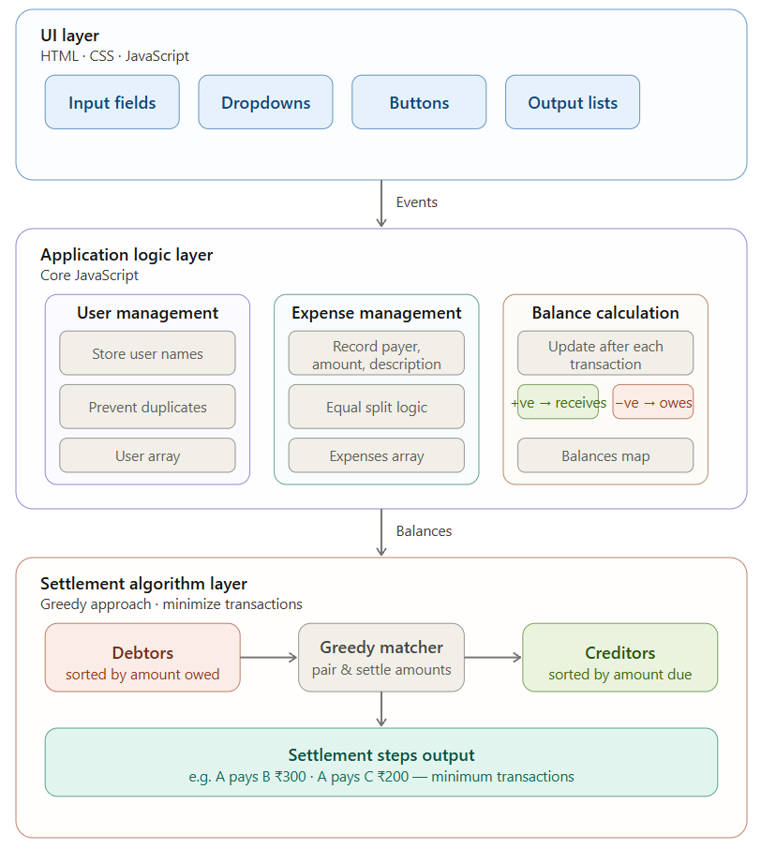
FLOW :
Add Users → Add Expense → View Balances → Settle Up

CHAPTER 4: IMPLEMENTATION

CHAPTER 5: CONCLUSION
5.1 Conclusion:
• The system successfully reduces the burden of manual calculations.
• Provides instant and accurate expense splitting.
• Eliminates confusion by clearly showing balances and settlements.
• Reduces unnecessary transactions using optimized logic.
• Easy to use and accessible for anyone without technical knowledge.
• Works as a practical solution for real-life group expense problems.

5.2 Future Scope:
• Add user authentication (login/signup system)
• Store data using cloud database (Firebase)
• Develop mobile application version
• Support:
- Unequal splits (percentage/custom amounts)
- Category-wise expenses (food, travel, etc.)
• Integrate payment systems (UPI, Google Pay, PhonePe)
• Add:
- Graphs and analytics
- Monthly reports
• Enable multi-group management
• Add export options (PDF/Excel reports)

CHAPTER 6: REFERENCES
6.1 References:
- – JavaScript concepts and DOM manipulation
- W3Schools – HTML, CSS, and JS basics
- Splitwise – Concept inspiration for expense splitting
- JavaScript Array & Object Handling Concepts
- Basic Greedy Algorithm concept for settlement optimization

