**Positive Test cases:**

Scenario: Facebook Login functionality

1.

**Expected Results**: verify user should be navigated to Login page

**Actual Result:** User is able to navigated to Login page

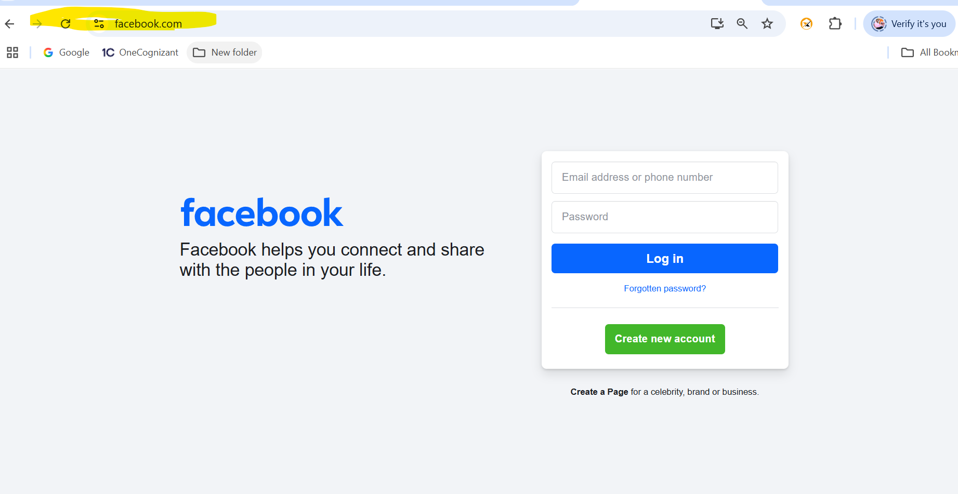

2. **Expected Results**: verify user should be enter valid username and valid password.

**Actual Result:** User is able to enter valid username and valid password.

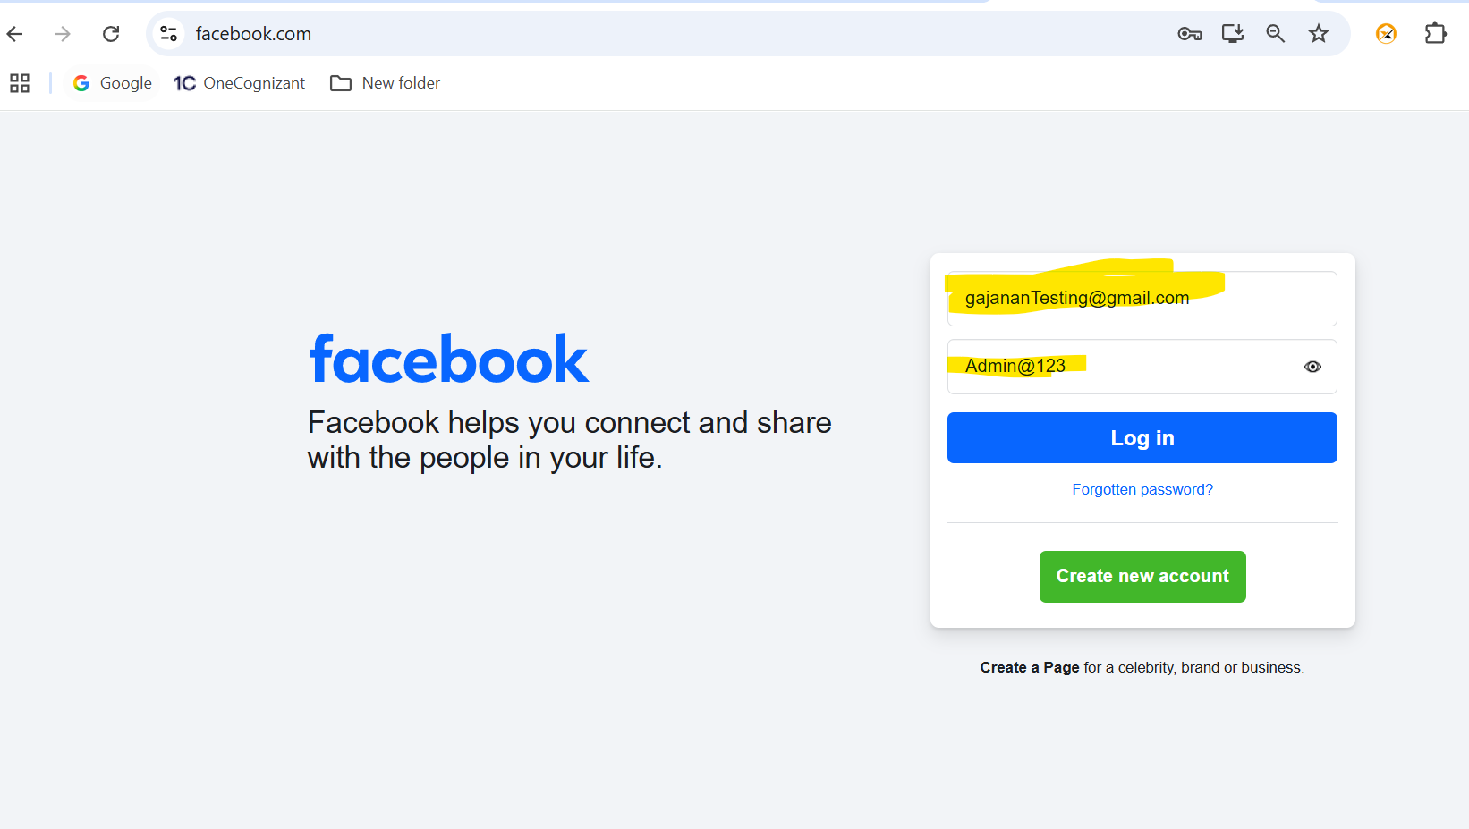

3. **Expected Results**: verify user should be able to click on 'LogIn' button and navigate to dashboard"

**Actual Result:** user is able to click on 'LogIn' button and navigate to Homepage.

**Click on Login**

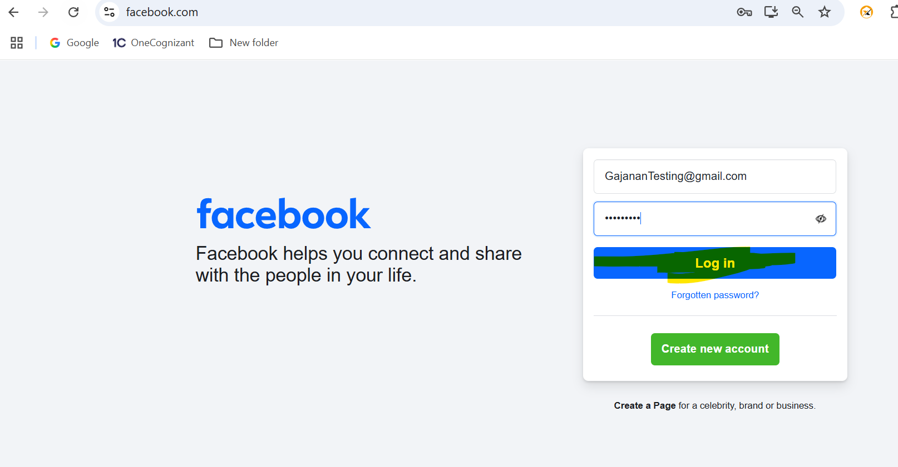

Homepage

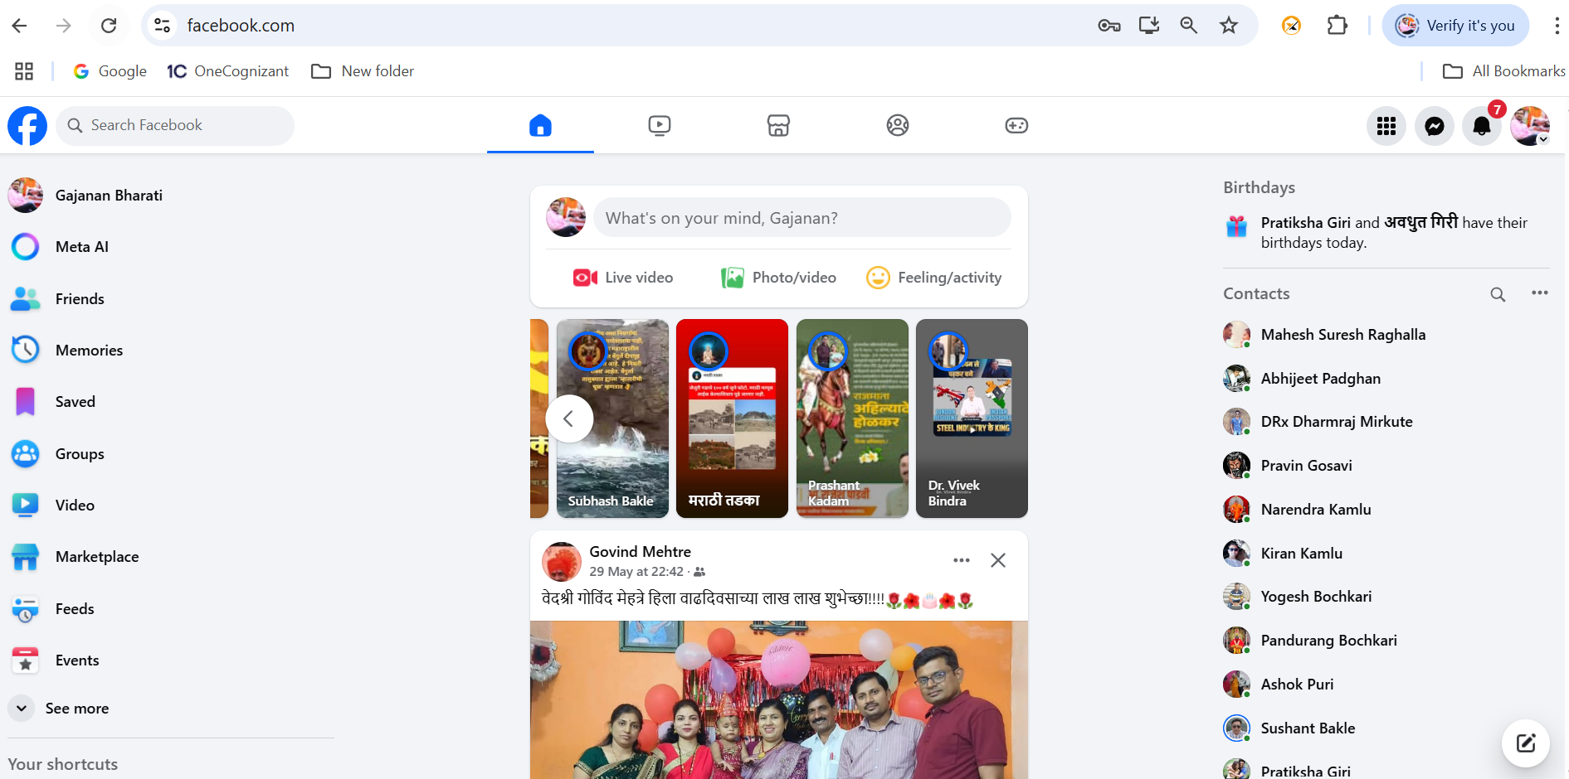

**TC_02:**

**Expected Results**: verify user should be navigated to Login page

**Actual Result:** User is able to navigated to Login page



2. **Expected Results**: verify user should be enter Invalid username and Invalid password.

**Actual Result:** User is able to enter invalid username and invalid password.

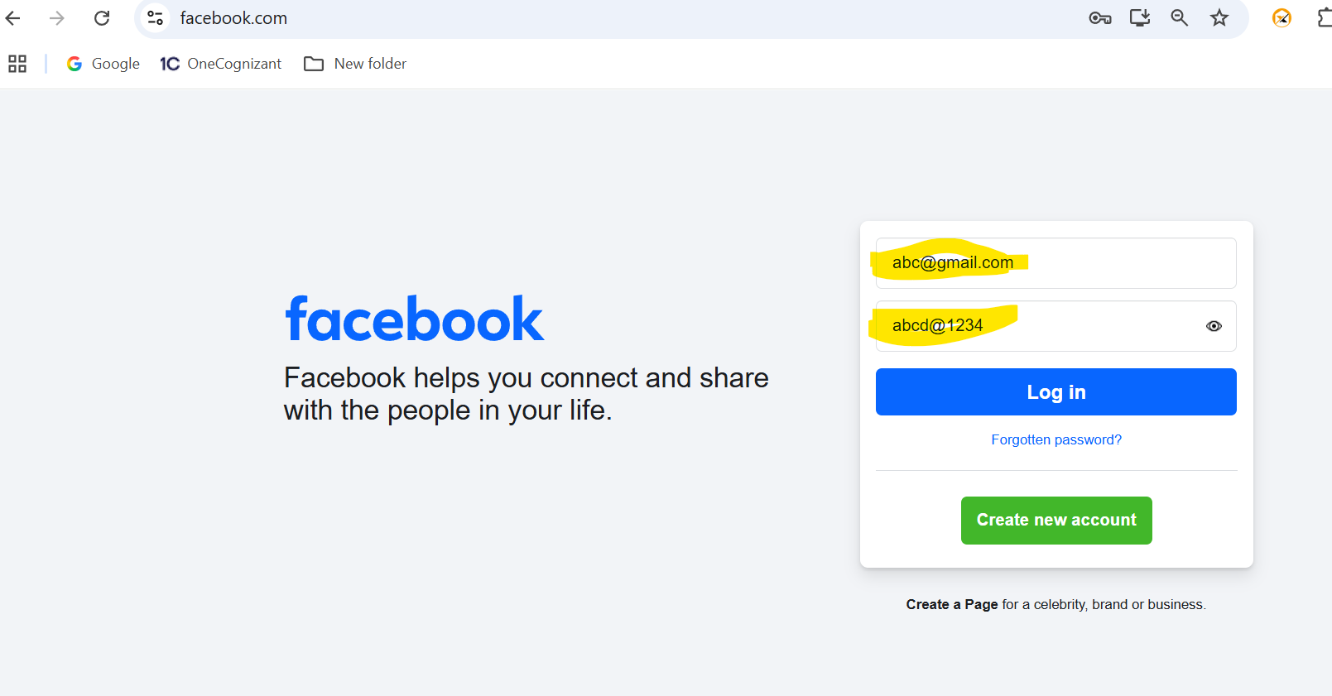

3. **Expected Results**: verify user should be able to click on 'LogIn' button and getting error message “The password that you've entered is incorrect. **Forgotten password**”

**Actual Result:** user is able to click on 'LogIn' button and getting error message “The password that you've entered is incorrect. **Forgotten password?**”

**Click on Login**

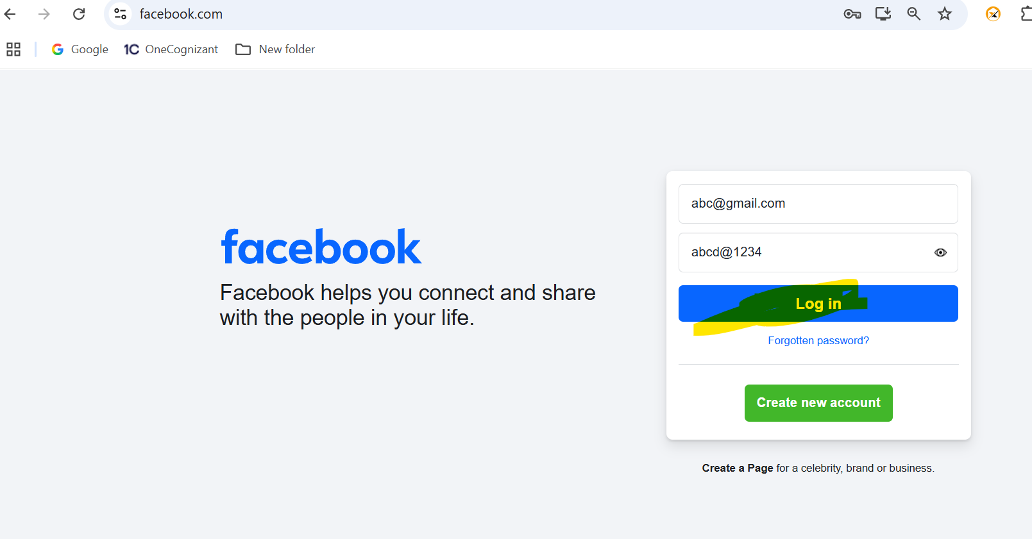Error message displayed:

The password that you've entered is incorrect. **Forgotten password?**

