Practical Questions

1. Create an array of integers with 5 elements and assign values to each element.

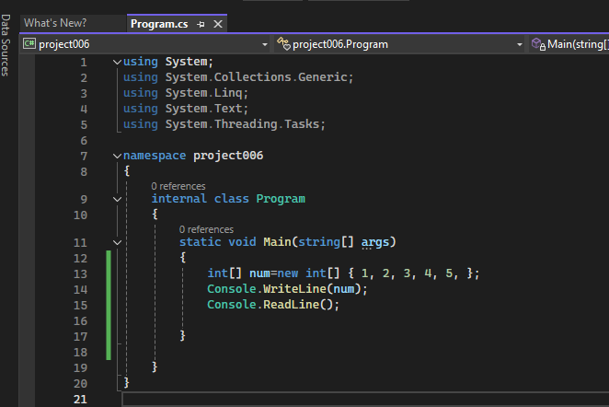

1. Write a C# program to print all elements of a 2D array.

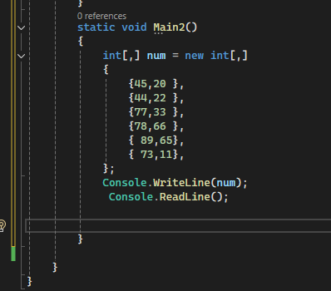

1. Create a list of strings and add five names to it.

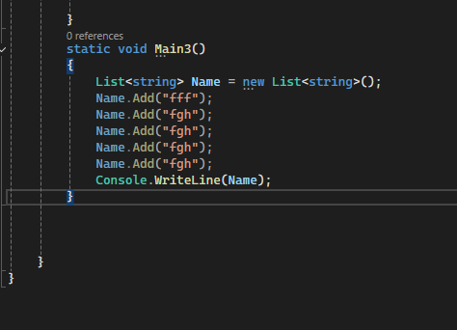

1. Write a C# program to find the length of a list containing integers.

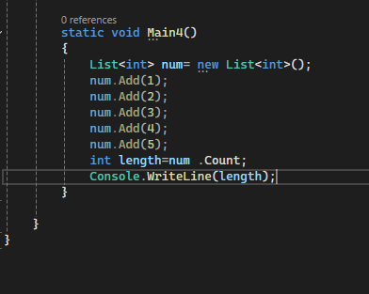

1. Create a dictionary with key-value pairs of student IDs and names. Add three entries to the dictionary.

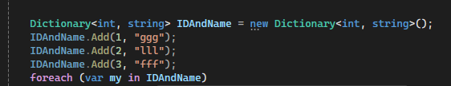

1. Write a C# program to display all keys and values in a dictionary.

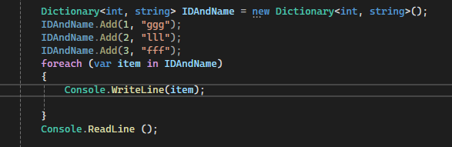

1. Create a stack and perform push and pop operations.

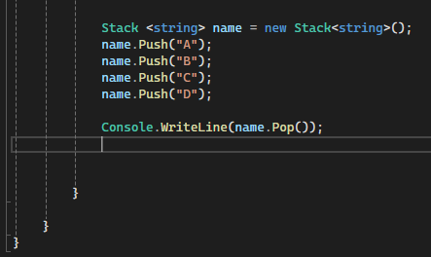

1. Create a queue and perform enqueue and dequeue operations.

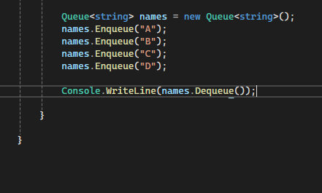

1. Write a LINQ query to find all even numbers in a list of integers.

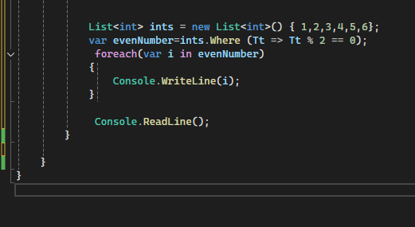

1. Write a LINQ query to sort a list of strings in ascending order.

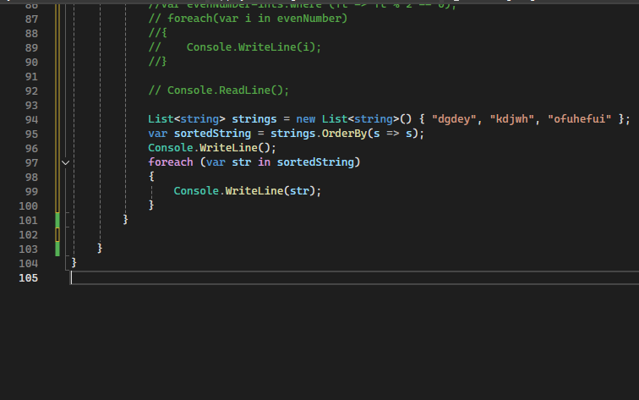

1. Write a C# program to reverse an array of integers.

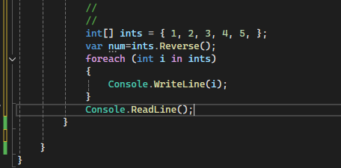

1. Create a list of integers and use a LINQ query to find the maximum value.

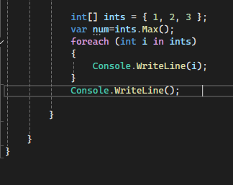

1. Write a C# program to count the number of elements in a stack.

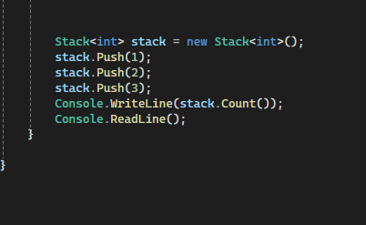

1. Create a queue of strings and check if a particular string exists in the queue.

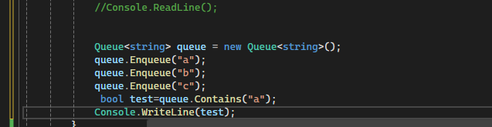

1. Write a LINQ query to group a list of strings by their first letter.

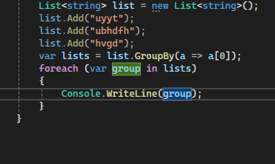

1. Write a LINQ query to find the sum of all elements in a list of integers.

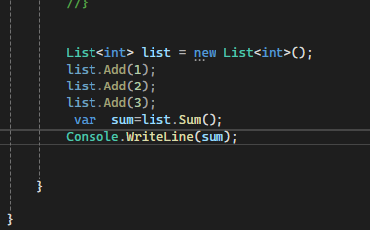

1. Create a list of strings and use a LINQ query to find all strings that contain the letter 'a'.

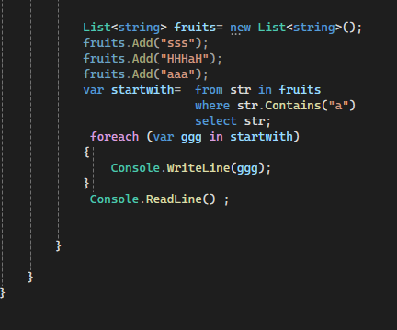

1. Write a LINQ query to find the average value of a list of integers.

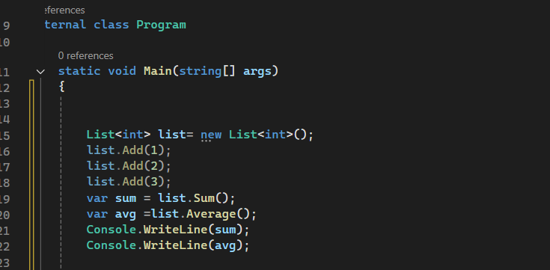

1. Create a list of integers and use a LINQ query to select only the distinct elements.

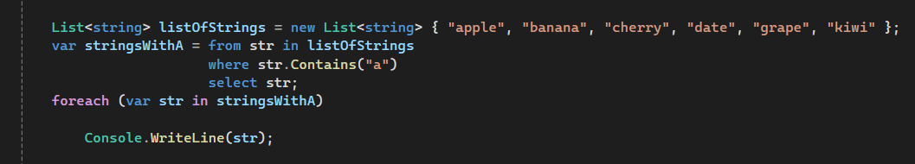

1. Write a LINQ query to find the first element in a list of strings that starts with the letter 'C'

