**How to add Eclipse Project to GitHub?**

Step 1: Login into GitHub



Step 2: Sign-in in case you have already registered

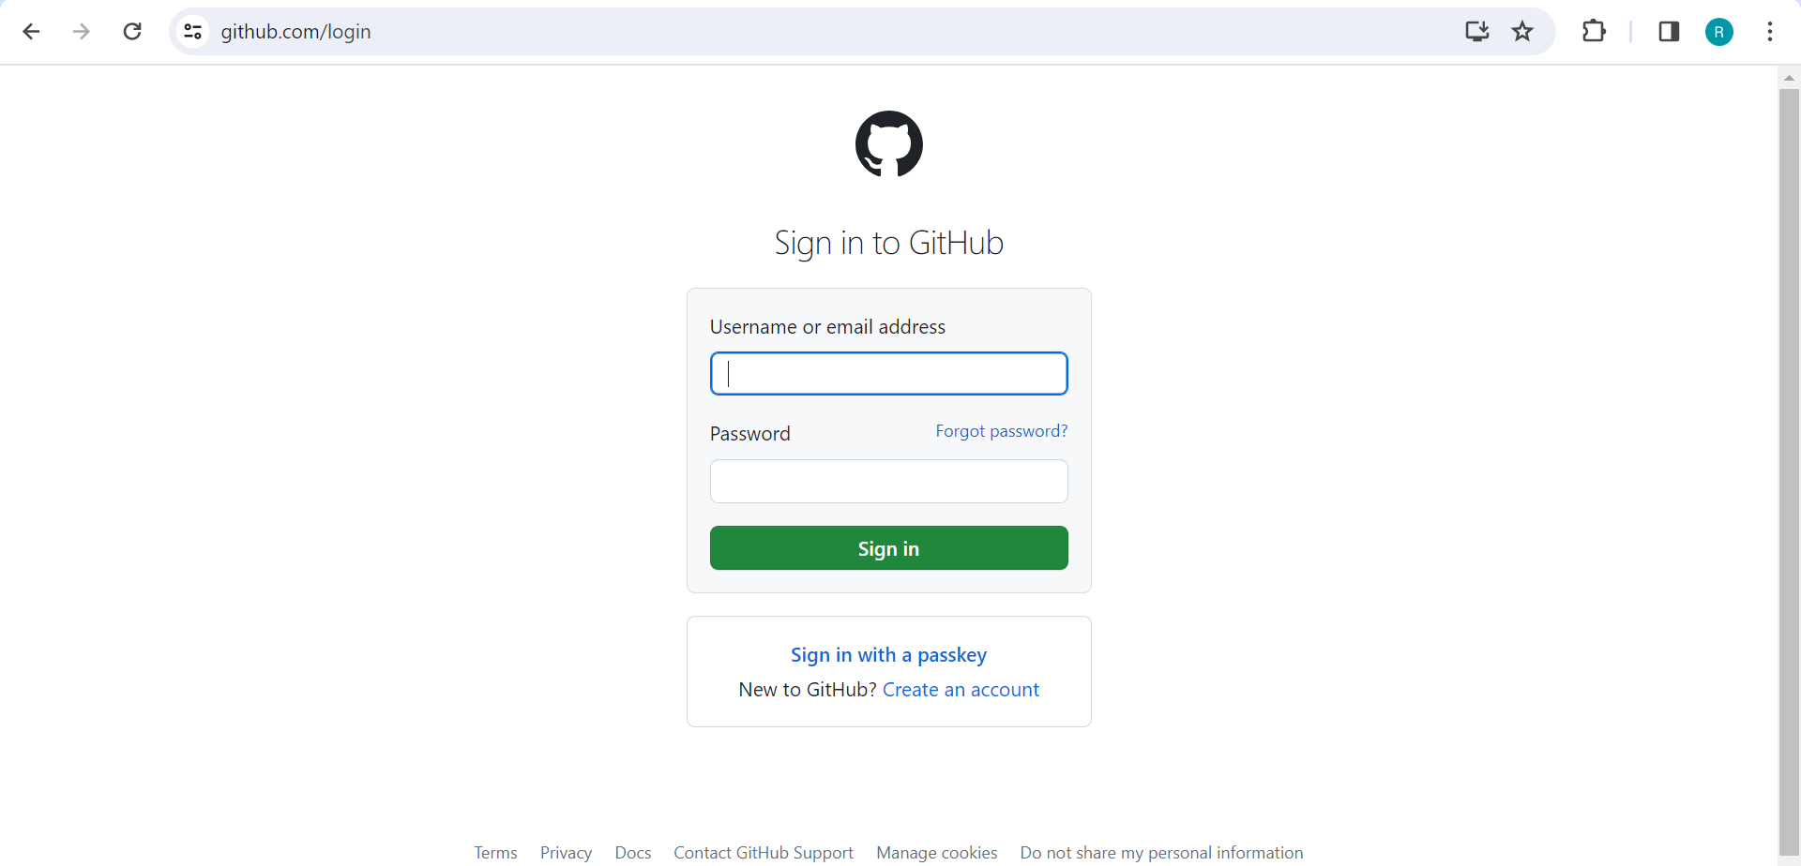

Step 3: Start a Project = Creating a Repository in GitHub

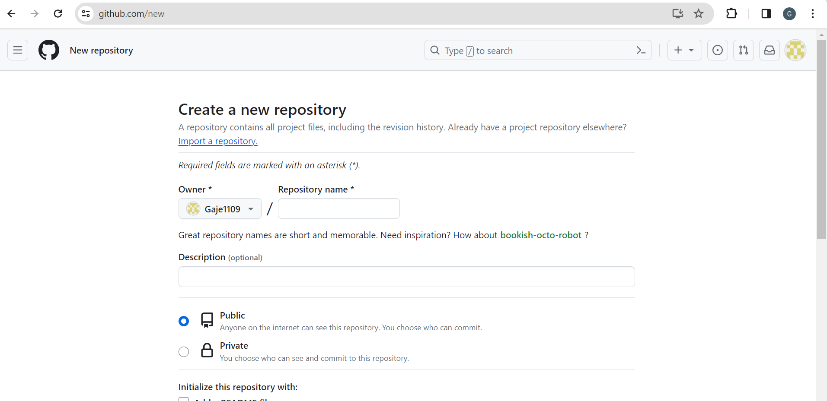

Step 4: Click on Create Repository

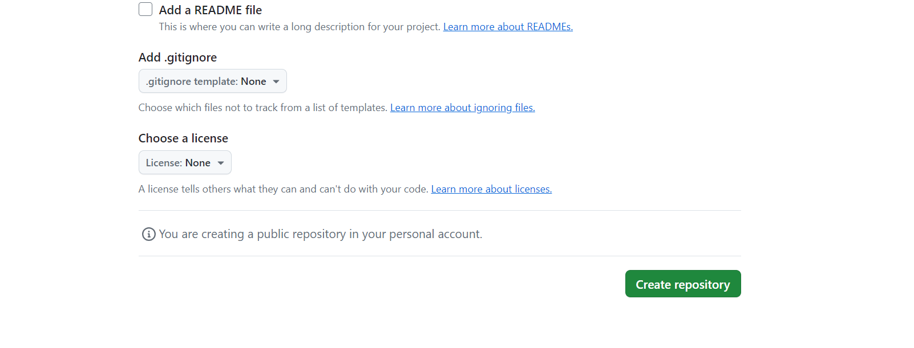

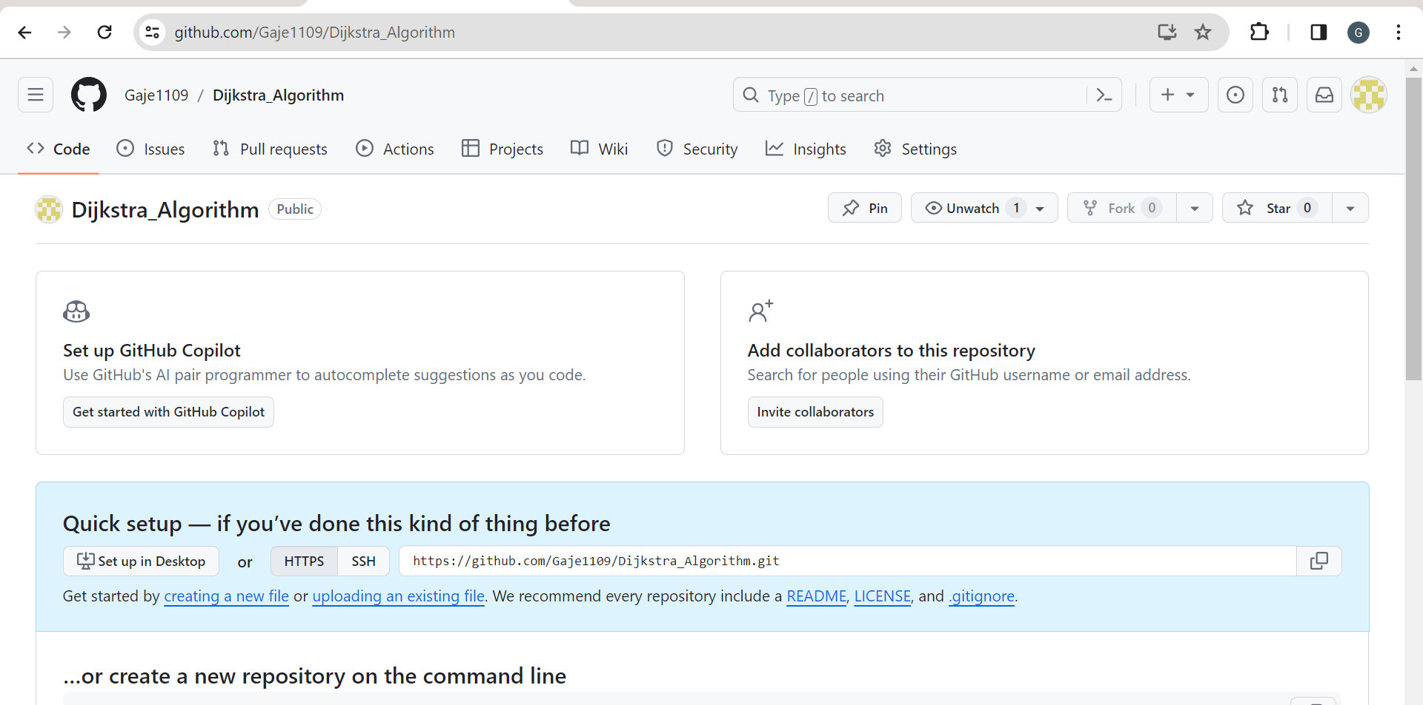

Step 5: Start Eclipse -> Go to GitHub Repository Perspective

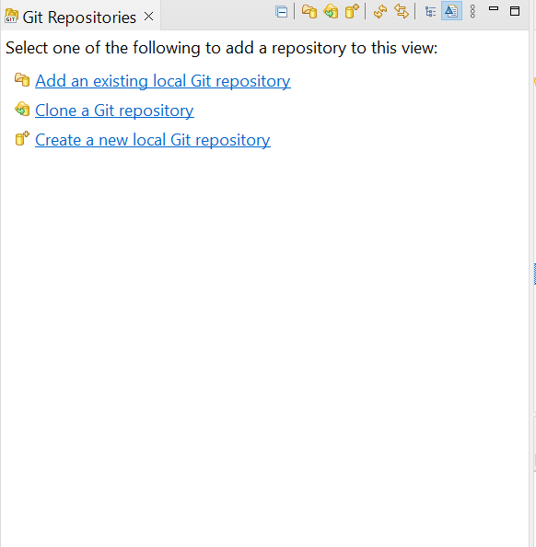

Step 7: Click on Clone a Git Repo and add the clone to this view

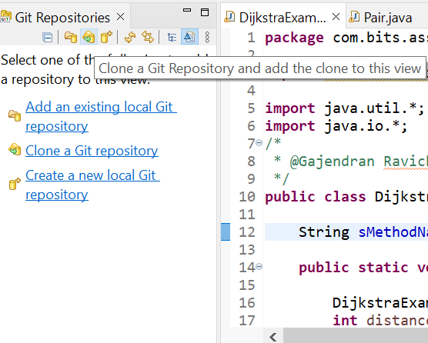

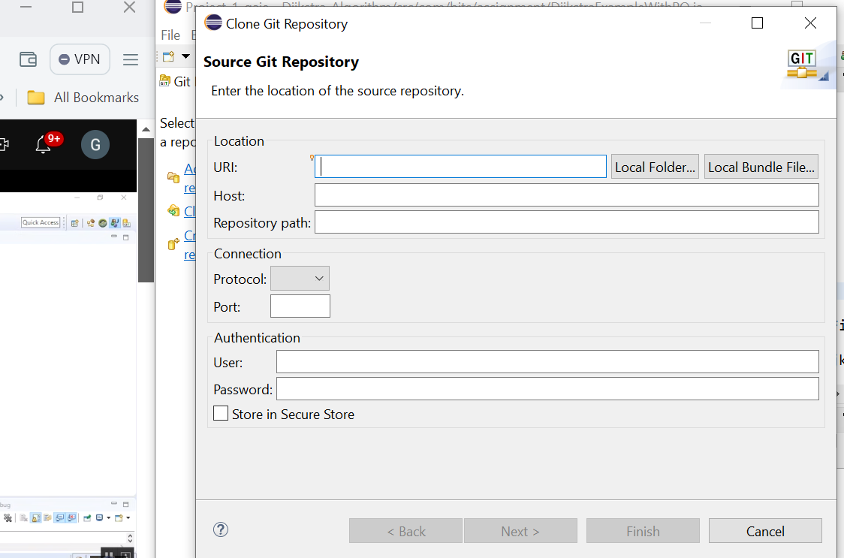

Step 8: Copy the URL from Gitub



Step 9: Add URL, username and Password in this section

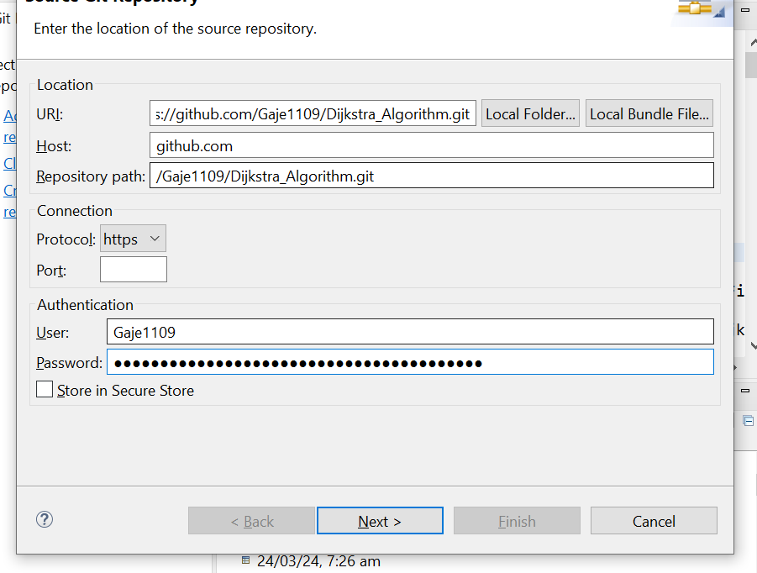

Step 10: Repository is cloned in our eclipse

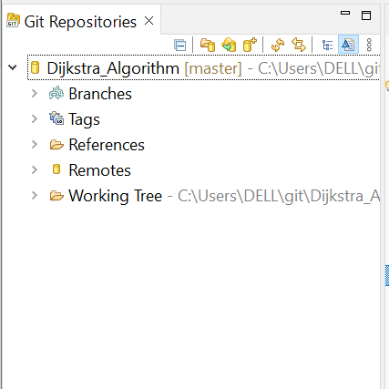

Step 11: Do a right click on project - > Team -> Share Project -> Add the git repo -> Finish

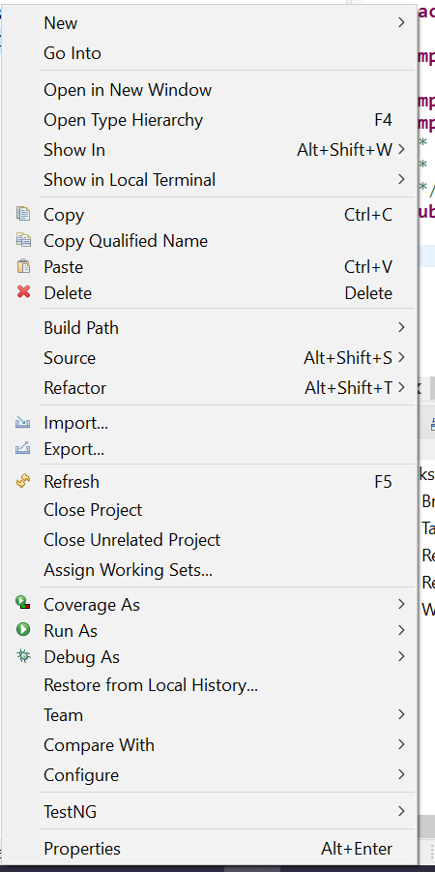

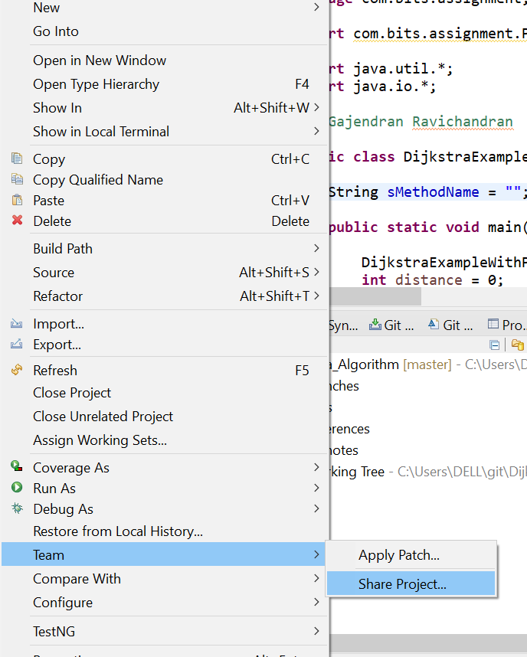

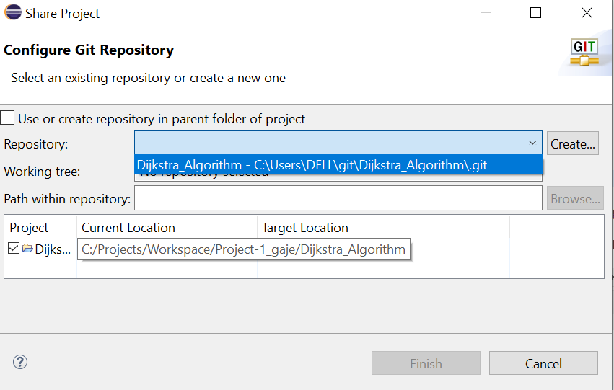

Step 12: Perform Commit by clicking on Commit

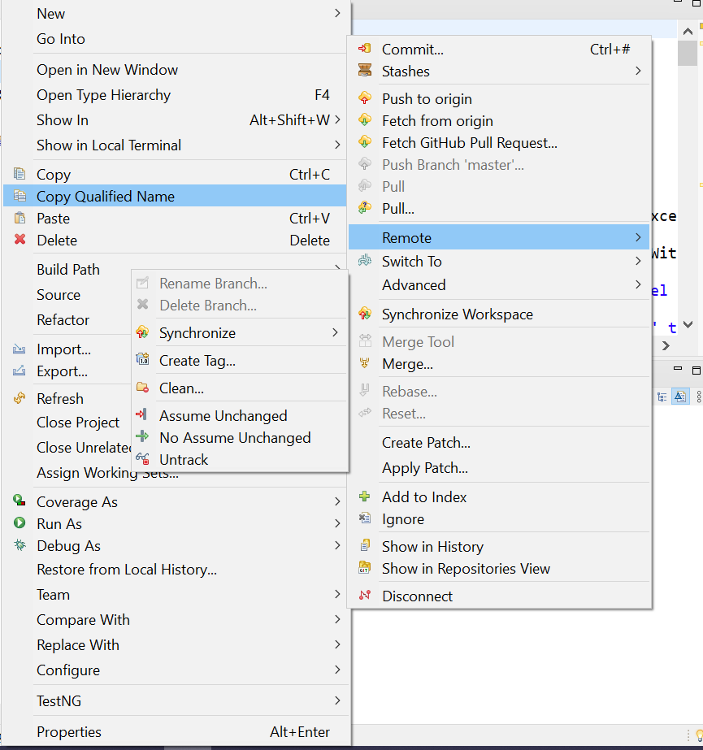

Step 13: Add the changes to be pushed and added in the GitHub repo. In addition write the commit message

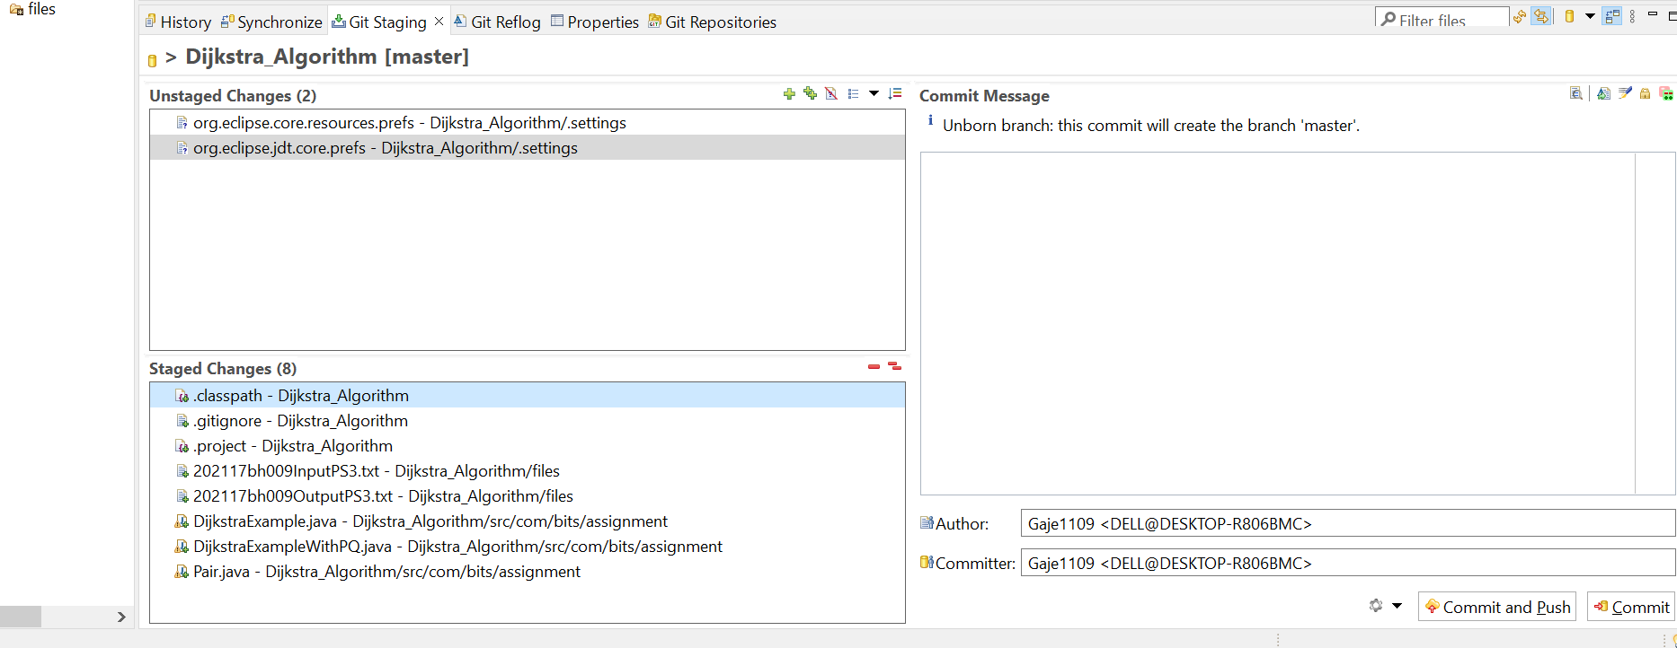

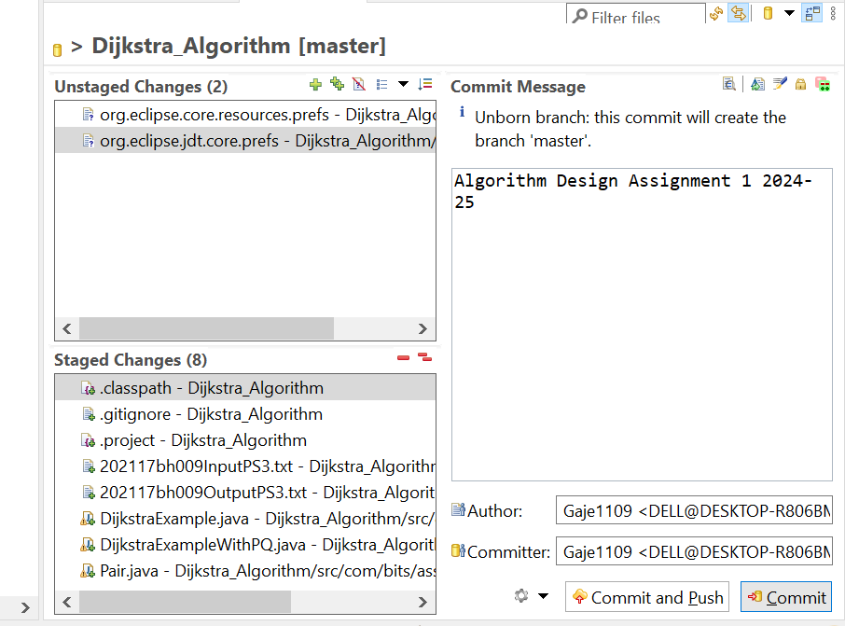

Step 14: Click on Commit and Push

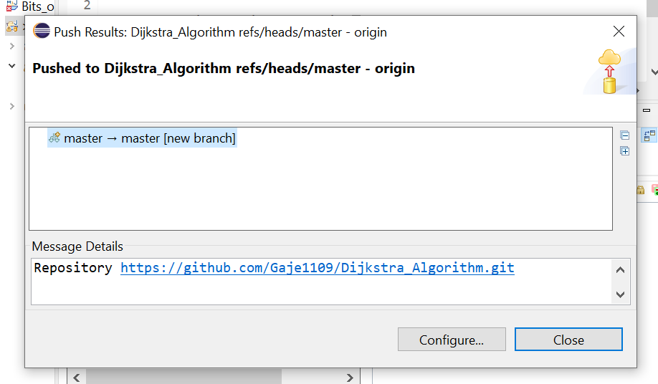

Step 15: Check the GitHub repo

