**Gajendra Singh**

**2303594 IOT-406**

* **Install Ollama & Create a ChatBot Using It**

**Step1: Install Ollama**

* Run the following command to download and install Ollama:

curl -fsSL https://ollama.com/install.sh | sh

**Step2: Pull a Model**

* Download a model you want to use, like Gemma 2B

ollama pull gemma:2b

**Step3: 4. Run the Model**

* Start an interactive chat with the model:

ollama run gemma:2b

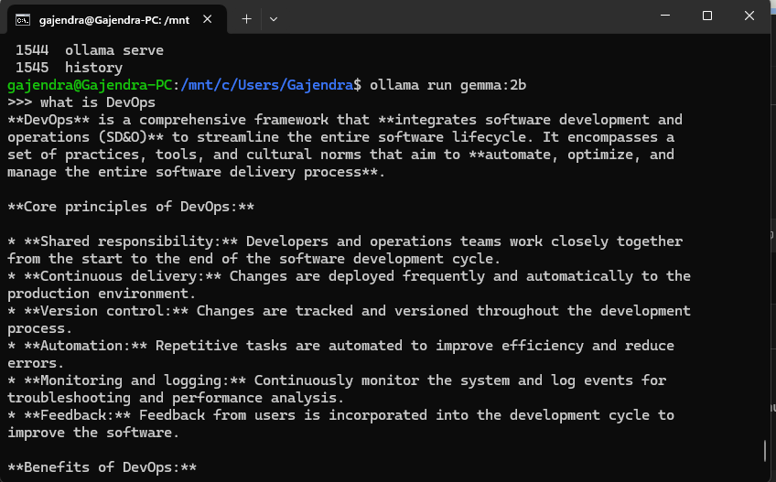

**Step4: Create a ChatBot**

* Create a Django based ChatBot web app

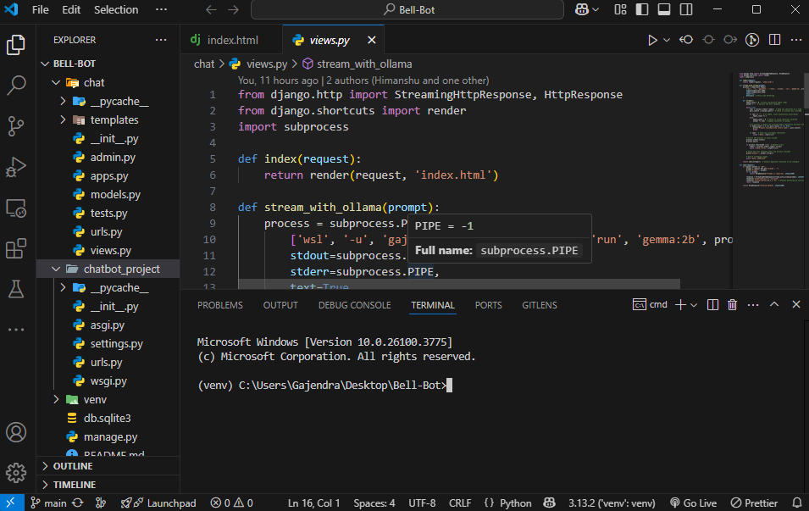

* Setup dependencies

python -m venv venv

venv/scripts/activate

pip install Django

* Run the ChatBot

Python manage.py runserver

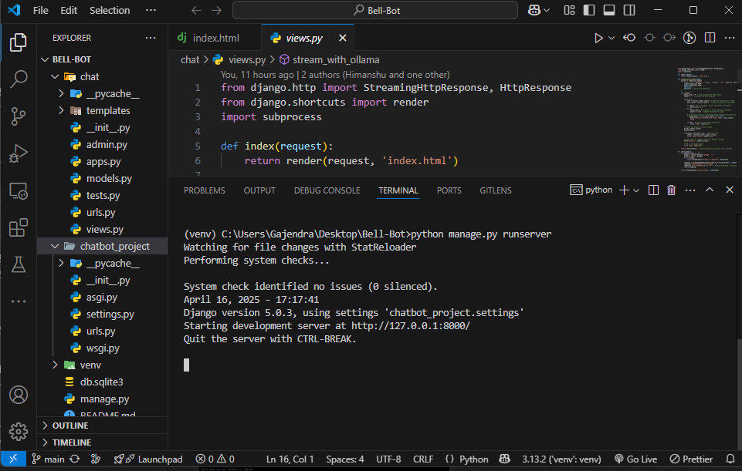

**Step5: View the ChatBot on browser**

* Open any browser and enter

[**http://127.0.0.1:8000/**](http://127.0.0.1:8000/)

