CLG Institute of Engineering & Technology, Sumerpur



Session 2019-2020

Lab Record – VLSI PHYSICAL DESIGN LAB (7CS8A)

Submitted to | Submitted by
Ms. Veena Parihar | Gajendra Kumar
Assistant Professor | 16ECLCS001
Computer Science and Engineering | B. Tech. VII Sem.

Experiment No. 1
Objective
Floor Planning
Theory
Floor planning is the most important stage in Physical Design. It is a factor that directly affects the following in a design:
- Congestion and routability.
- IR drop
- Timing etc.
In floor planning we place the I/O pins/pads, macros and blockages in the core or chip area in order to effectively find the routing space between them. This step determines the effective core/die area of the design.
Quality of your chip implementation depends on how good is the Floor plan. A well organized floor plan results in more efficient utilization of the core area thereby aiding the placement of the standard cells without causing issues related to congestion, timing, signal integrity etc.
If the floor plan is bad, it affects the area, power, reliability of the chip and requires more efforts for closure and it can increase overall IC cost also. It can create all kind of issues in the design like congestion, timing, noise, IR, routing issues.
Objectives of Floor plan:

- Minimize the area of die.
- Make the design routable and reduce the wire length.
- Reduce IR drop across the design.

Floor plan Steps
- Size and shape of the block
- Voltage area creation (Power domains)
- IO placement
- Creating Standard cell rows
- Macro-placement
- Adding routing & placement blockages (as required)
- Adding power switches (Daisy chain)
- Creating Power Mesh
- Adding boundary cells
- Adding physical cells (Well taps, End Caps etc)
- Placing & qualifying pushdown cells
- Creating bounds / plan groups / density screens
Output:

The output of the floor plan is a DEF: contains die/core area, placed macro information, blockage information (soft/hard/partial blockage), placed I/O pin/pad information, standard cell placement areas.
Sanity checks before Floor plan:
- check_design
- check_library
- check_timing

Types of Floor plan techniques in full chip design:
- Abutted floor plan: Channel less placement of blocks.
- Non-abutted: Channel based placement of blocks for block interconnections.
- Partially abutted: Partial abutment of blocks with channels in certain areas.
Types of Blockages
- Soft Blockage: It restricts placement of standard cells inside the blockage area and allows buffers to be placed at the time of optimization to meet timing.
- Hard Blockage: Both standard cells and buffers are prohibited inside hard blockage area.
- Partial Blockage: The designer can customize the amount of space to inside the blockage area. If a value of 50% is given, 50% area is blocked for any placement and the rest is available for optimization.

Experiment No. 2
Objective
Placement
Theory
To minimize the ASIC area and interconnect cost. Timing and congestion will depend more on quality of placement.
Steps in Placement stage
- Pre-placement
- Coarse placement (initial placement)
- Legalization
- High Fanout Net Synthesis (HFNS)
- Placement optimizations
- Area Recovery
- Scan chain reordering
Inputs for Placement
- Gate level netlist
- Floorplanned database (def)
- Design libraries
- Technology file
- Design constraints
Stages of Placement
Placement is performed in two stages. They are,
- Coarse Placement : During coarse placement, the PnR tool will determine an approximate location for each cell according to the timing and congestion. In fact the macros act as placement blockages for standard cells in this stage. Coarse placement is mainly performing for initial timing and congestion analysis.
- Legalization : During legalization, the tool will move the cells to legal locations for avoiding overlap between cells. These changes in the cell location will change the length of signal net leads to new timing violations. These can be fixed by incremental optimization.
Congestion
Congestion occurs if the number of routing tracks available for routing are less than the required number of routing tracks.
Congestion reduction techniques
- Placement Blockages : Inorder to avoid placement in some areas, placement blockages are used. Different types of placement blockages are soft blockage: It restricts placement of standard cells inside the blockage area but allows buffers to be placed at the time of optimization to meet timing. Hard blockage: It prevents cells from being placed in this blockage area. Both standard cells as well as buffers are prohibited inside hard blockage area. Partial blockage: The designer can customize the amount of space to inside the blockage area.
- Macro Padding : Macro padding or halos (keep-out margin) around the macros are placement blockages around the edge of the macros. This makes sure that no standard cells are placed near the pins outs of the macros, thereby giving enough space for the macro pin connections to standard cells.
- Cell Padding : Cell padding refers to placement clearance applied to standard cells in PnR tools. This is typically done to ease placement congestion to reserve some space for future use down the flow. For example typically people apply cell padding to the buffers/inverters used to build clock tree, so that space is reserved to insert decap cells near them after clock tree synthesis.
- Scan Chain Re-ordering : It is the process of reconnecting the scan chains in a design to optimize for routing by re-ordering the scan connection which improves congestion as well as timing. At the time of placement the optimization may take the scan chain difficult to route due to congestion. Hence the tool will re-order the chain to reduce congestion. Since logic synthesis arbitrarily connects the scan chain, we need to perform scan reorder after placement so that the scan chain routing will be optimal.

High Fanout Net Synthesis (HFNS)
- High Fanout Net is the net which drives more number of loads. There is a limit for maximum number of loads per net. The nets which cross more than these limit are known as High Fanout Nets.
- The process of buffering the high fanout nets is known as High Fanout Net Synthesis (HFNS).
- Clock nets, reset, scan, enable nets are generally considered as High Fanout Nets. HFNS is performed at the placement stage. Since clock nets are considered ideal at placement stage, HFNS is not performed on clock nets even though they are High Fanout Nets. Also it is not performed on don't touch attribute nets.
How to qualify placement
- Check legalization for any overlapping.
- Check PG connections for all the cells.
- Check global congestion, pin density and cell density.
- Check whether all don't touch cells and nets are preserved.
- Check for setup time violation.

Experiment No. 3
Objective
Routing
Theory
- Routing is the stage after CTS where the interconnections are made by determining the precise paths for each nets.
- This includes the interconnection of the standard cells, the macro pins, the pins of the block boundary or the pads of the chip boundary.
- After CTS, the tool will be having the information about the exact locations of the standard cells, the pins, the I/O ports and the pads.
- The logical connectivity is available in the netlist and the design rules are available in the tech file (.tf) which are the inputs that we are included while the data setup of the design.
- So in short, routing can be termed as allocating set of wires in the routing space that connects all the nets in the netlist by using certain design rules for the metals and vias used in doing so.

Goals of Routing
- Establishing the entire connectivity of the design with minimum number of vias and optimized total wire length.
- To meet the timing constraints.
- No LVS errors(Layout v/s Schematic) , i.e, the all the connections described in the netlist are completed physically.
- No DRC(Design Rules Check) violations in doing so.
- Complete routing within the area of the design.
Inputs
- Design which is done with placement, CTS and optimization.

Output
- Design with completed interconnection and geometric layout of the nets.
Prerequisites and Checks
- Timing DRC and QoR post CTS must be acceptable.
- Acceptable global routing congestion.
- HFNS should be less than the specified limit.
- Check for overlapping cells, if any.
- Check for any blocked pins, ports or PG connection.

Stages of Routing
- Global Routing.
- Track Assignment.
- Detailed Routing.
- Search and Repair.

Each stages of routing are described below.

1. Global Routing
- In global routing, the region to be routed are divided into sectors(tiles/rectangles) called global routing cells or gcells.
- Then it decides tile to tile path for the nets and simultaneously trying to optimize the length, without actually making any physical connection.
- The routing capacity of each gcell depends on the blockages, routing tracks, pin density inside it.
- This rough routing is done on the basis of available tracks in the region.
- If the required routing resources are greater than the available routing resources, then it will lead to congestion.
- So it is called coarse grain routing assignment.

Objectives of global routing
- Minimize total overflow.
- Minimize total wire length.
- Minimize total run time for carrying out routing process.

2. Track Assignment
- After the gcell estimation, tracks are assigned to each global route.
- The tracks are assigned in vertical and horizontal direction for each partition.
- The direction of routing is dependent on the metal used, which has preferred routing direction. For e.g. If Metal 1 has routing direction Horizontal, then Metal 2 has direction Vertical.
- In this stage, the global routes are replaced with metal layers, which have many DRC violations, Signal Integrity (SI) and timing violations.

3. Detailed Routing
- In detailed routing, the router uses the scheme made in the global routing and track assignment phases to lay metals to connect the nets to the pins.
- The violations that were created in the previous stage, will be fixed by multiple iterations of routing, so that no connections will be left short , open or spacing violations.
- First, the block is divided into specific areas called the Sboxes (switch boxes) which comprises of multiple gcells.
- These boxes are in alignment with the gcell boundary.
4. Search and Repair
- It is done along with detailed routing, specifically after the primary iteration.
- The shorts and spacing violations are sorted and is fixed.
Experiment No. 4
Objective

Synopsys
Theory
Synopsys’ Digital Toolset is used for silicon chip design, verification, IP integration, and application security testing. Unlike previous generations of EDA, its Fusion Technology eliminates the former hard boundaries between synthesis, place-and-route and signoff, sharing integrated engines across the platform.
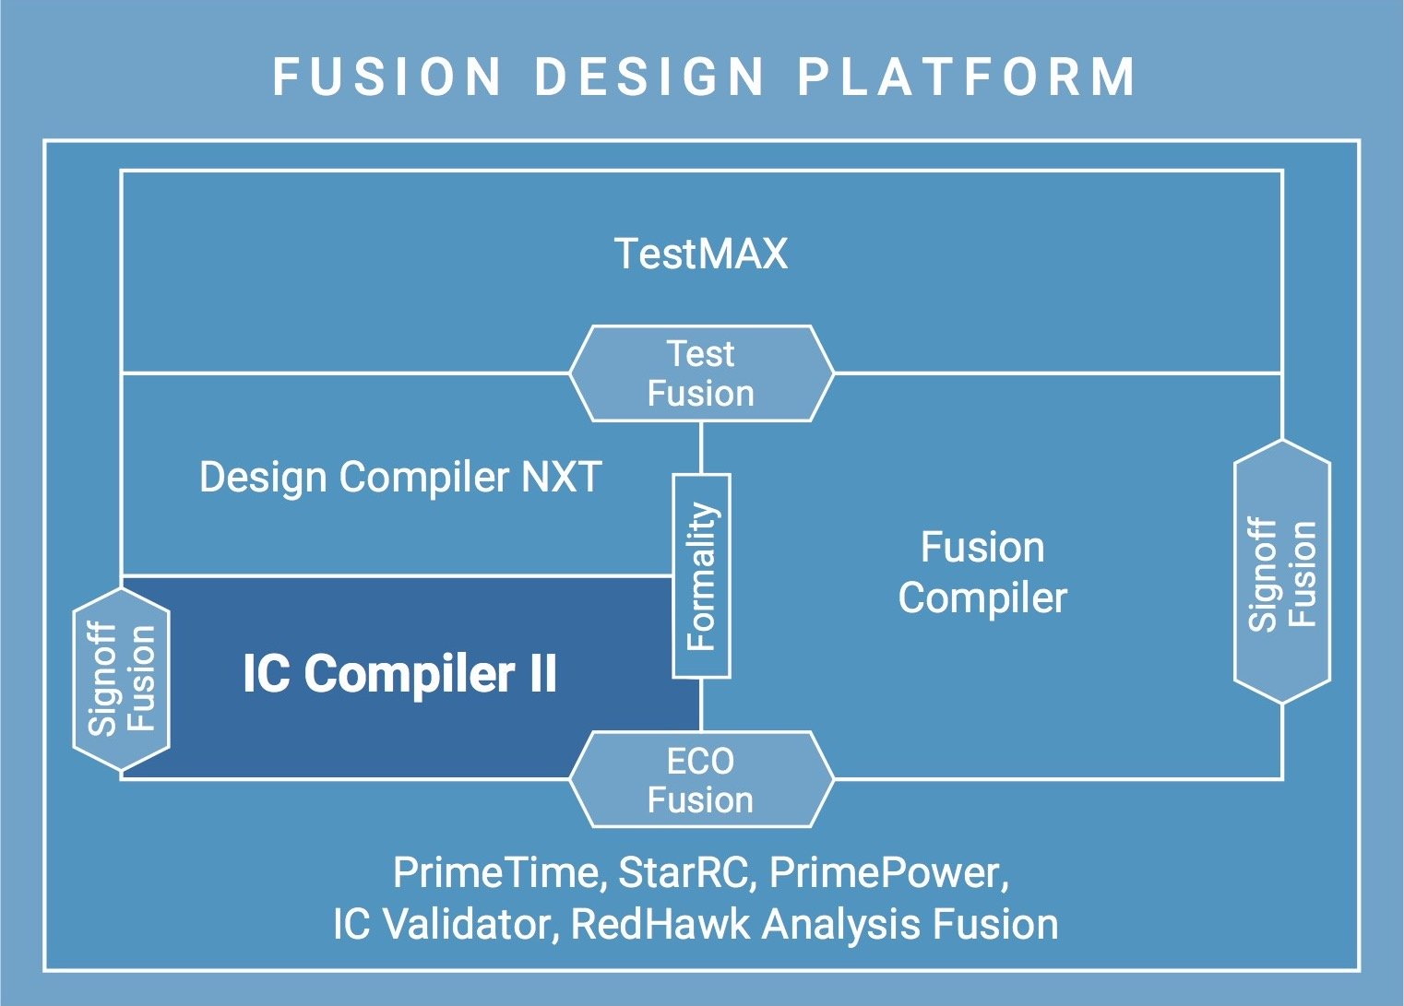
Figure : IC Compiler II Anchor in Synopsys Design Platform
The Fusion design platform employs machine learning to enable better and faster results by speeding up computation-intensive analyses, predicting outcomes to improve decision-making, and leveraging past learning.
The cloud-based solution is available on Microsoft Azure, Amazon Web Services, and the Synopsys Cloud Solution.

The key to the fusion design platform is the solid back-and-forth coordination between:
- RTL Synthesis
- Physical Implementation (RTL-to-GDSII)
- Signoff (design verification)
- Physical Verification (design rules and manufacturability)
- Test Automation
IC Compiler II enables designers to perform fast exploration and floor planning with complex layout requirements. IC Compiler II can create bus structures, handle designs with n-levels of physical hierarchy, and can support multiply instantiated blocks (MIBs).
A design data mismatch inferencing engine analyzes the quality of inputs to deliver design insights even with “incomplete” data early in the design cycle.
Of great importance to designers, Synopsys collaborates closely with all the leading foundries to ensure that IC Compiler II can deliver support for both early prototype design rules and for the final production design rules.

