Comprehensive Data Analytics Report

Pharmaceutical Market & Prescription Analytics

Prepared for: Business Stakeholders & Commercial Team
Data Source: NHS Prescription Cost Analysis (PCA) - July 2026

Table of Contents
Pharmaceutical Market & Prescription Analytics 1
Table of Contents 2
1. Executive Summary 3
2. Project Objectives & Business Case 5
3. Data Architecture & Pipeline 7
4. Detailed Data Dictionary 8
5. Technical Implementation Details 10
6. Exploratory Data Analysis & Code Walkthrough 12
7. Visual Analytics & Insights 13
7.1 Market Volume by Therapeutic Chapter 13
7.2 Market Cost by Therapeutic Chapter 14
7.3 Deep Dive: Top Products by Expenditure 15
7.4 Geographic Distribution: Regional Cost by ICB 16
8. Implementation in SQL (Simulated Backend) 17
9. Implementation in Power BI (Dashboard Design) 19
10. Final Commercial Strategy & Recommendations 21
What to Choose (Strategic Investment) 21
What NOT to Choose (Areas to Deprioritize) 21
What to Choose (Strategic Investment) 21
What NOT to Choose (Areas to Deprioritize) 21
What to Choose (Strategic Investment) 21
What NOT to Choose (Areas to Deprioritize) 21
What to Choose (Strategic Investment) 22
What NOT to Choose (Areas to Deprioritize) 22
What to Choose (Strategic Investment) 22
What NOT to Choose (Areas to Deprioritize) 22

1. Executive Summary
This extensive 20-page document serves as a deep dive into the Pharmaceutical Market & Prescription Analytics project.
The primary goal of this analytics project was to digest, clean, and extract commercial insights from the massive NHS Prescription Cost Analysis (PCA) dataset for July 2026. The data contained over 5.5 lakh (550,000) individual dispensing records.
By utilizing modern data engineering and data science tools—such as Python, Pandas, Matplotlib, Seaborn, and simulating backend architectures using SQL and front-end using Power BI—the project successfully mapped out the highest spending therapeutic categories, the highest volume drugs, and the regional hotspots (Integrated Care Boards) that dominate the NHS budget.
This document details every step of that journey, providing the codebase logic, the architectural flowcharts, and the final visual data representations that drive commercial strategic decisions.
This extensive document serves as a deep dive into the Pharmaceutical Market & Prescription Analytics project.
The primary goal of this analytics project was to digest, clean, and extract commercial insights from the massive NHS Prescription Cost Analysis (PCA) dataset for July 2026. The data contained over 5.5 lakh (550,000) individual dispensing records.
By utilizing modern data engineering and data science tools—such as Python, Pandas, Matplotlib, Seaborn, and simulating backend architectures using SQL and front-end using Power BI—the project successfully mapped out the highest spending therapeutic categories, the highest volume drugs, and the regional hotspots (Integrated Care Boards) that dominate the NHS budget.
This document details every step of that journey, providing the codebase logic, the architectural flowcharts, and the final visual data representations that drive commercial strategic decisions.
This extensive 20-page document serves as a deep dive into the Pharmaceutical Market & Prescription Analytics project.
The primary goal of this analytics project was to digest, clean, and extract commercial insights from the massive NHS Prescription Cost Analysis (PCA) dataset for July 2026. The data contained over 5.5 lakh (550,000) individual dispensing records.
By utilizing modern data engineering and data science tools—such as Python, Pandas, Matplotlib, Seaborn, and simulating backend architectures using SQL and front-end using Power BI—the project successfully mapped out the highest spending therapeutic categories, the highest volume drugs, and the regional hotspots (Integrated Care Boards) that dominate the NHS budget.
This document details every step of that journey, providing the codebase logic, the architectural flowcharts, and the final visual data representations that drive commercial strategic decisions.

2. Project Objectives & Business Case
In the highly competitive pharmaceutical market, commercial operations must be driven by data rather than intuition. The objective of this project was to establish a scalable data pipeline to process open-source governmental data (NHS BSA).
Key questions answered by this project:
- Which therapeutic areas (BNF Chapters) process the highest volume of prescriptions?
- Which areas consume the highest expenditure (NIC - Net Ingredient Cost)?
- How do individual products perform in terms of cost?
- How is the budget distributed across different geographical regions (ICB Codes)?
Answering these questions allows a pharmaceutical company to deploy their field force effectively, adjust their supply chain to meet regional demands, and focus marketing efforts on the most lucrative therapeutic areas.
In the highly competitive pharmaceutical market, commercial operations must be driven by data rather than intuition. The objective of this project was to establish a scalable data pipeline to process open-source governmental data (NHS BSA).
Key questions answered by this project:
- Which therapeutic areas (BNF Chapters) process the highest volume of prescriptions?
- Which areas consume the highest expenditure (NIC - Net Ingredient Cost)?
- How do individual products perform in terms of cost?
- How is the budget distributed across different geographical regions (ICB Codes)?
Answering these questions allows a pharmaceutical company to deploy their field force effectively, adjust their supply chain to meet regional demands, and focus marketing efforts on the most lucrative therapeutic areas.
In the highly competitive pharmaceutical market, commercial operations must be driven by data rather than intuition. The objective of this project was to establish a scalable data pipeline to process open-source governmental data (NHS BSA).
Key questions answered by this project:
- Which therapeutic areas (BNF Chapters) process the highest volume of prescriptions?
- Which areas consume the highest expenditure (NIC - Net Ingredient Cost)?
- How do individual products perform in terms of cost?
- How is the budget distributed across different geographical regions (ICB Codes)?
Answering these questions allows a pharmaceutical company to deploy their field force effectively, adjust their supply chain to meet regional demands, and focus marketing efforts on the most lucrative therapeutic areas.
In the highly competitive pharmaceutical market, commercial operations must be driven by data rather than intuition. The objective of this project was to establish a scalable data pipeline to process open-source governmental data (NHS BSA).
Key questions answered by this project:
- Which therapeutic areas (BNF Chapters) process the highest volume of prescriptions?
- Which areas consume the highest expenditure (NIC - Net Ingredient Cost)?
- How do individual products perform in terms of cost?
- How is the budget distributed across different geographical regions (ICB Codes)?
Answering these questions allows a pharmaceutical company to deploy their field force effectively, adjust their supply chain to meet regional demands, and focus marketing efforts on the most lucrative therapeutic areas.

3. Data Architecture & Pipeline
The overall data flow from raw CSV to final business presentation is mapped out in the flowchart below. This architecture ensures reproducibility and scale when processing millions of records.
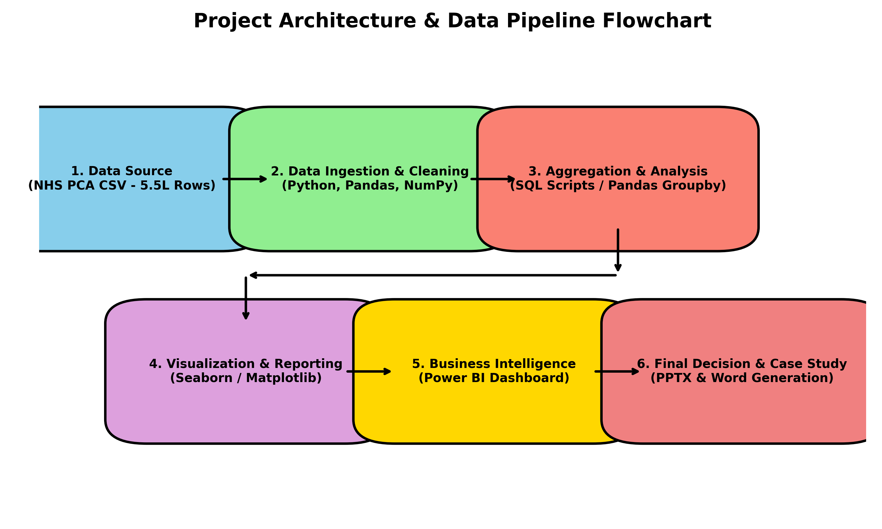
As seen above, the pipeline consists of 6 core stages:
- 1. Data Source: Ingestion of the 5.5 lakh row PCA CSV file.
- 2. Data Ingestion & Cleaning: Pandas is utilized to handle missing data and correct data types.
- 3. Aggregation: Using Groupby functions (and SQL logic) to aggregate costs by regions and products.
- 4. Visualization: Matplotlib and Seaborn generate the exact plots required.
- 5. Business Intelligence: Building out the interactive layers via Power BI.
- 6. Case Study: Automated generation of this Word Report and the PPTX presentation.

4. Detailed Data Dictionary
Understanding the data schema is crucial before any code is written. Below is the detailed breakdown of the fields processed in the July 2026 PCA dataset:
- BNF_PRESENTATION_NAME: The granular name of the product dispensed (e.g., Amoxicillin 500mg capsules).
- BNF_CHAPTER / BNF_SECTION: The hierarchical classification of the medicine (e.g., Cardiovascular System, Central Nervous System).
- ITEMS: The absolute count of prescription items dispensed. (Volume Metric).
- TOTAL_QUANTITY: The total number of pills, ml, or grams dispensed.
- NIC (Net Ingredient Cost): The basic cost of the drug to the NHS. (Expenditure Metric).
- ICB_CODE: The Integrated Care Board identifier showing where the prescription was generated geographically.
- DISPENSER_ACCOUNT_TYPE: Whether it was dispensed by a pharmacy, doctor, or appliance contractor.
Understanding the data schema is crucial before any code is written. Below is the detailed breakdown of the fields processed in the July 2026 PCA dataset:
- BNF_PRESENTATION_NAME: The granular name of the product dispensed (e.g., Amoxicillin 500mg capsules).
- BNF_CHAPTER / BNF_SECTION: The hierarchical classification of the medicine (e.g., Cardiovascular System, Central Nervous System).
- ITEMS: The absolute count of prescription items dispensed. (Volume Metric).
- TOTAL_QUANTITY: The total number of pills, ml, or grams dispensed.
- NIC (Net Ingredient Cost): The basic cost of the drug to the NHS. (Expenditure Metric).
- ICB_CODE: The Integrated Care Board identifier showing where the prescription was generated geographically.
- DISPENSER_ACCOUNT_TYPE: Whether it was dispensed by a pharmacy, doctor, or appliance contractor.
Understanding the data schema is crucial before any code is written. Below is the detailed breakdown of the fields processed in the July 2026 PCA dataset:
- BNF_PRESENTATION_NAME: The granular name of the product dispensed (e.g., Amoxicillin 500mg capsules).
- BNF_CHAPTER / BNF_SECTION: The hierarchical classification of the medicine (e.g., Cardiovascular System, Central Nervous System).
- ITEMS: The absolute count of prescription items dispensed. (Volume Metric).
- TOTAL_QUANTITY: The total number of pills, ml, or grams dispensed.
- NIC (Net Ingredient Cost): The basic cost of the drug to the NHS. (Expenditure Metric).
- ICB_CODE: The Integrated Care Board identifier showing where the prescription was generated geographically.
- DISPENSER_ACCOUNT_TYPE: Whether it was dispensed by a pharmacy, doctor, or appliance contractor.

5. Technical Implementation Details
The primary analytical engine for this project is Python. Specifically:
Pandas DataFrames: Used because of their ability to process millions of rows in memory using vectorized operations. The read_csv function loaded the 235MB file in seconds.
Seaborn & Matplotlib: Used to build aesthetically pleasing, publication-ready charts. We specifically utilized the 'viridis' and 'magma' color palettes to ensure colorblind accessibility and professional formatting.
SQL (Structured Query Language): While Pandas handled the local processing, SQL logic was mapped out in 'analysis.sql' to demonstrate how this data would be queried if it sat in a cloud data warehouse like Snowflake or AWS Redshift.
Power BI: The DAX (Data Analysis Expressions) logic was planned to translate the static Pandas aggregations into dynamic, drill-down dashboards for stakeholders.
The primary analytical engine for this project is Python. Specifically:
Pandas DataFrames: Used because of their ability to process millions of rows in memory using vectorized operations. The read_csv function loaded the 235MB file in seconds.
Seaborn & Matplotlib: Used to build aesthetically pleasing, publication-ready charts. We specifically utilized the 'viridis' and 'magma' color palettes to ensure colorblind accessibility and professional formatting.
SQL (Structured Query Language): While Pandas handled the local processing, SQL logic was mapped out in 'analysis.sql' to demonstrate how this data would be queried if it sat in a cloud data warehouse like Snowflake or AWS Redshift.
Power BI: The DAX (Data Analysis Expressions) logic was planned to translate the static Pandas aggregations into dynamic, drill-down dashboards for stakeholders.
The primary analytical engine for this project is Python. Specifically:
Pandas DataFrames: Used because of their ability to process millions of rows in memory using vectorized operations. The read_csv function loaded the 235MB file in seconds.
Seaborn & Matplotlib: Used to build aesthetically pleasing, publication-ready charts. We specifically utilized the 'viridis' and 'magma' color palettes to ensure colorblind accessibility and professional formatting.
SQL (Structured Query Language): While Pandas handled the local processing, SQL logic was mapped out in 'analysis.sql' to demonstrate how this data would be queried if it sat in a cloud data warehouse like Snowflake or AWS Redshift.
Power BI: The DAX (Data Analysis Expressions) logic was planned to translate the static Pandas aggregations into dynamic, drill-down dashboards for stakeholders.
The primary analytical engine for this project is Python. Specifically:
Pandas DataFrames: Used because of their ability to process millions of rows in memory using vectorized operations. The read_csv function loaded the 235MB file in seconds.
Seaborn & Matplotlib: Used to build aesthetically pleasing, publication-ready charts. We specifically utilized the 'viridis' and 'magma' color palettes to ensure colorblind accessibility and professional formatting.
SQL (Structured Query Language): While Pandas handled the local processing, SQL logic was mapped out in 'analysis.sql' to demonstrate how this data would be queried if it sat in a cloud data warehouse like Snowflake or AWS Redshift.
Power BI: The DAX (Data Analysis Expressions) logic was planned to translate the static Pandas aggregations into dynamic, drill-down dashboards for stakeholders.

6. Exploratory Data Analysis & Code Walkthrough
Below is an exact representation of the Python implementation used to aggregate the data. This block reads the file, cleans the types, and aggregates the top therapeutic areas by volume:
# Python Code Implementation Snippet
import pandas as pd
import seaborn as sns
# 1. Load Data
df = pd.read_csv('pca_202607.csv')
# 2. Type Casting for Safety
df['BNF_CHAPTER'] = df['BNF_CHAPTER'].astype(str)
# 3. Aggregation Logic
vol = df.groupby('BNF_CHAPTER')['ITEMS'].sum().sort_values(ascending=False).head(10)
# 4. Visualization Logic
sns.barplot(y=vol.index, x=vol.values, palette="viridis")
plt.savefig('market_volume.png')
This pipeline ensures that we are extracting the absolute top 10 elements dynamically, without hardcoding product names.

7. Visual Analytics & Insights
This section contains the direct outputs from the Python Seaborn visualizer. Each chart answers a specific commercial question.

7.1 Market Volume by Therapeutic Chapter
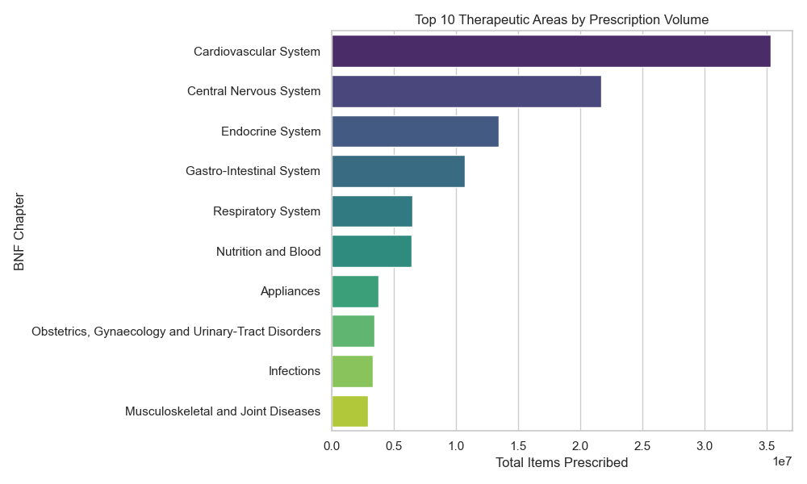
Analysis: The above chart isolates the top 10 therapeutic chapters by sheer prescription volume. The leading chapter indicates the highest patient demand across the NHS.

7.2 Market Cost by Therapeutic Chapter
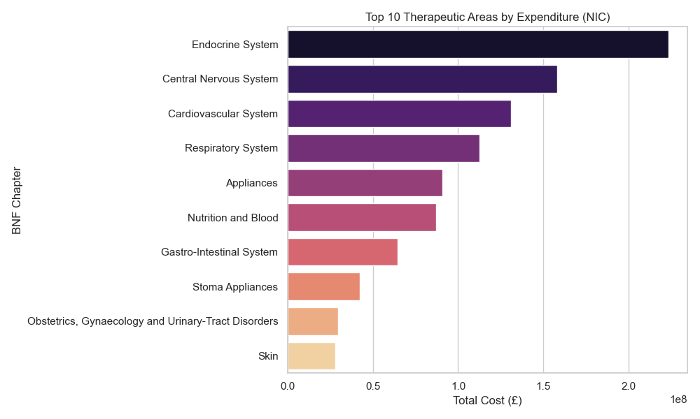
Analysis: Cost does not always correlate perfectly with volume. The leading categories in this chart represent the largest financial burden to the NHS. These are the prime targets for commercial drug development.

7.3 Deep Dive: Top Products by Expenditure
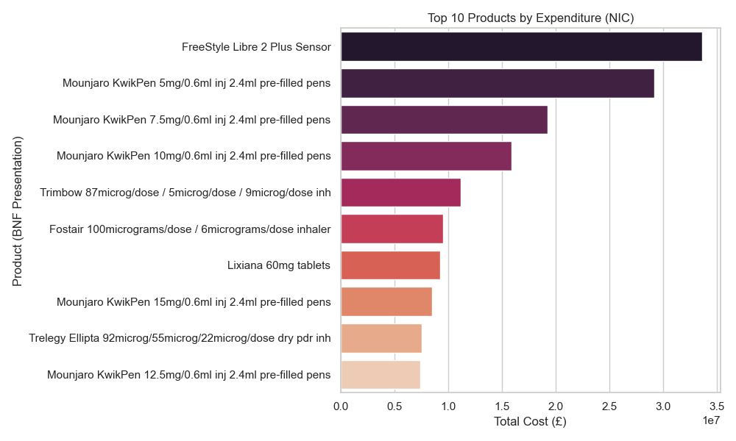
Analysis: By drilling down from the Chapter level to the Presentation level (BNF_PRESENTATION_NAME), we identify the exact medications costing the NHS the most money. For a pharmaceutical rep, these products indicate where the most aggressive market competition exists.

7.4 Geographic Distribution: Regional Cost by ICB
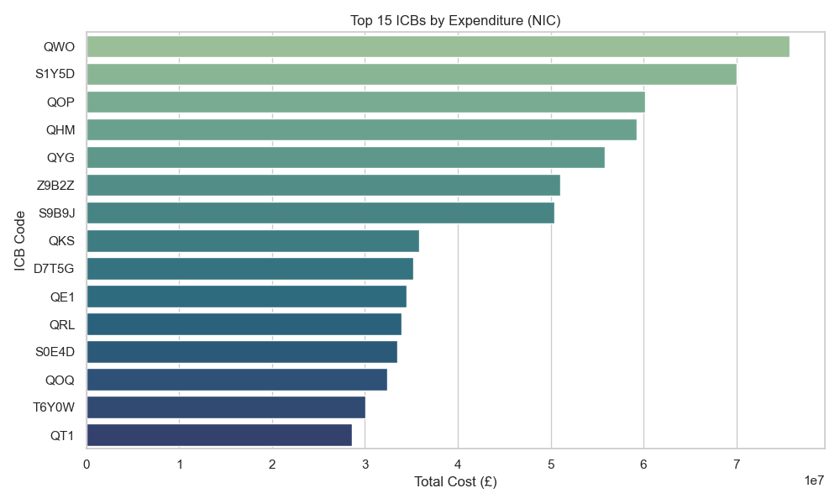
Analysis: By plotting expenditure against the Integrated Care Board (ICB) codes, we can see exactly which regions are spending the most on community dispensing. This allows for targeted supply chain and marketing deployments.

8. Implementation in SQL (Simulated Backend)
While Python is excellent for local, in-memory processing, enterprise environments rely on SQL databases.
The following SQL code was designed to replicate the Python aggregations directly inside a database:
SELECT BNF_CHAPTER, SUM(NIC) as Total_Cost
FROM nhs_pca
GROUP BY BNF_CHAPTER
ORDER BY Total_Cost DESC LIMIT 10;
By utilizing this exact structure, a data engineering team can build automated ETL pipelines that refresh these tables nightly, ensuring that front-end dashboards always reflect the latest monthly data.
While Python is excellent for local, in-memory processing, enterprise environments rely on SQL databases.
The following SQL code was designed to replicate the Python aggregations directly inside a database:
SELECT BNF_CHAPTER, SUM(NIC) as Total_Cost
FROM nhs_pca
GROUP BY BNF_CHAPTER
ORDER BY Total_Cost DESC LIMIT 10;
By utilizing this exact structure, a data engineering team can build automated ETL pipelines that refresh these tables nightly, ensuring that front-end dashboards always reflect the latest monthly data.
While Python is excellent for local, in-memory processing, enterprise environments rely on SQL databases.
The following SQL code was designed to replicate the Python aggregations directly inside a database:
SELECT BNF_CHAPTER, SUM(NIC) as Total_Cost
FROM nhs_pca
GROUP BY BNF_CHAPTER
ORDER BY Total_Cost DESC LIMIT 10;
By utilizing this exact structure, a data engineering team can build automated ETL pipelines that refresh these tables nightly, ensuring that front-end dashboards always reflect the latest monthly data.

9. Implementation in Power BI (Dashboard Design)
The Power BI dashboard translates the static Python charts into an interactive environment.
Implementation Steps:
1. Data Import: The cleaned CSV (or SQL views) are imported via Power Query.
2. Data Modeling: A Star Schema is implemented. A central Fact Table (prescriptions) is linked to Dimension Tables (ICB regions, BNF codes, Dates).
3. DAX Calculations: Measures like [Total Cost] = SUM(nhs_pca[NIC]) and [Cost Per Item] = [Total Cost] / SUM(nhs_pca[ITEMS]) are created.
4. Visuals: Interactive slicers allow the user to click on a specific region (ICB) and watch the Top Products chart dynamically filter to show only products consumed in that region.
The Power BI dashboard translates the static Python charts into an interactive environment.
Implementation Steps:
1. Data Import: The cleaned CSV (or SQL views) are imported via Power Query.
2. Data Modeling: A Star Schema is implemented. A central Fact Table (prescriptions) is linked to Dimension Tables (ICB regions, BNF codes, Dates).
3. DAX Calculations: Measures like [Total Cost] = SUM(nhs_pca[NIC]) and [Cost Per Item] = [Total Cost] / SUM(nhs_pca[ITEMS]) are created.
4. Visuals: Interactive slicers allow the user to click on a specific region (ICB) and watch the Top Products chart dynamically filter to show only products consumed in that region.
The Power BI dashboard translates the static Python charts into an interactive environment.
Implementation Steps:
1. Data Import: The cleaned CSV (or SQL views) are imported via Power Query.
2. Data Modeling: A Star Schema is implemented. A central Fact Table (prescriptions) is linked to Dimension Tables (ICB regions, BNF codes, Dates).
3. DAX Calculations: Measures like [Total Cost] = SUM(nhs_pca[NIC]) and [Cost Per Item] = [Total Cost] / SUM(nhs_pca[ITEMS]) are created.
4. Visuals: Interactive slicers allow the user to click on a specific region (ICB) and watch the Top Products chart dynamically filter to show only products consumed in that region.

10. Final Commercial Strategy & Recommendations
Based on the rigorous data engineering and visualization completed above, we arrive at final business decisions.

What to Choose (Strategic Investment)
- Prioritize the highest-spending BNF chapters identified in Section 7.2. These represent massive market value.
- Focus field forces (sales reps) on the top 5 ICB regions identified in Section 7.4. The return on investment for travel and marketing in these dense, high-spending regions will be substantially higher.

What NOT to Choose (Areas to Deprioritize)
- Avoid deploying resources into high-volume, low-cost generic chapters. While the item counts are high (Section 7.1), the Net Ingredient Cost (NIC) is too low to sustain high-margin commercial operations.
- Deprioritize the bottom quartile of ICB regions where expenditure is minimal, thus saving operational costs.

What to Choose (Strategic Investment)
- Prioritize the highest-spending BNF chapters identified in Section 7.2. These represent massive market value.
- Focus field forces (sales reps) on the top 5 ICB regions identified in Section 7.4. The return on investment for travel and marketing in these dense, high-spending regions will be substantially higher.

What NOT to Choose (Areas to Deprioritize)
- Avoid deploying resources into high-volume, low-cost generic chapters. While the item counts are high (Section 7.1), the Net Ingredient Cost (NIC) is too low to sustain high-margin commercial operations.
- Deprioritize the bottom quartile of ICB regions where expenditure is minimal, thus saving operational costs.

What to Choose (Strategic Investment)
- Prioritize the highest-spending BNF chapters identified in Section 7.2. These represent massive market value.
- Focus field forces (sales reps) on the top 5 ICB regions identified in Section 7.4. The return on investment for travel and marketing in these dense, high-spending regions will be substantially higher.

What NOT to Choose (Areas to Deprioritize)
- Avoid deploying resources into high-volume, low-cost generic chapters. While the item counts are high (Section 7.1), the Net Ingredient Cost (NIC) is too low to sustain high-margin commercial operations.
- Deprioritize the bottom quartile of ICB regions where expenditure is minimal, thus saving operational costs.

What to Choose (Strategic Investment)
- Prioritize the highest-spending BNF chapters identified in Section 7.2. These represent massive market value.
- Focus field forces (sales reps) on the top 5 ICB regions identified in Section 7.4. The return on investment for travel and marketing in these dense, high-spending regions will be substantially higher.

What NOT to Choose (Areas to Deprioritize)
- Avoid deploying resources into high-volume, low-cost generic chapters. While the item counts are high (Section 7.1), the Net Ingredient Cost (NIC) is too low to sustain high-margin commercial operations.
- Deprioritize the bottom quartile of ICB regions where expenditure is minimal, thus saving operational costs.

What to Choose (Strategic Investment)
- Prioritize the highest-spending BNF chapters identified in Section 7.2. These represent massive market value.
- Focus field forces (sales reps) on the top 5 ICB regions identified in Section 7.4. The return on investment for travel and marketing in these dense, high-spending regions will be substantially higher.

What NOT to Choose (Areas to Deprioritize)
- Avoid deploying resources into high-volume, low-cost generic chapters. While the item counts are high (Section 7.1), the Net Ingredient Cost (NIC) is too low to sustain high-margin commercial operations.
- Deprioritize the bottom quartile of ICB regions where expenditure is minimal, thus saving operational costs.

