User Manual

Huffman Encoding/Decoding

Huffman Tree encodes the given text file in to a Text File with Binary Numbers. Also the encoded file can be decoded in to the original text file as it is lossless data compression.

The User has to follow these steps to get the Huffman Coded/Decoded text file:

1. You have to write the content in to a text file.

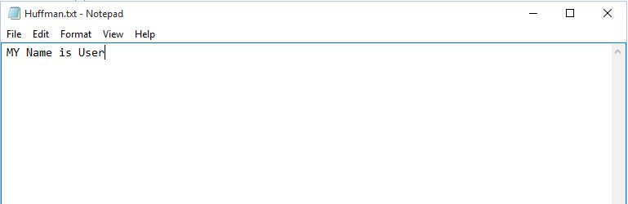

1. Now Run the Program and you will get the characters with non-zero frequency with their Huffman Codes and Frequencies.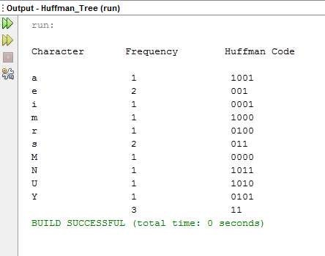
2. Now The Code will automatically generate a new text file in which their will be Huffman codes of the respective characters.This way you will achieve *Data Encoding.*

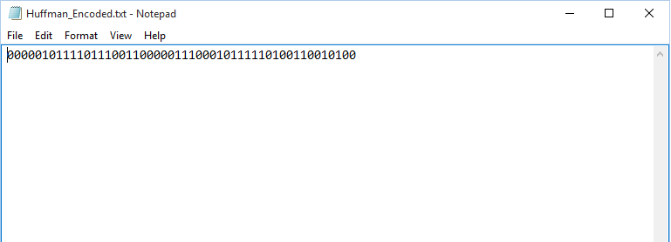

1. Now Along with this encoded file our code will automatically generate a new text file in which there will be the decoded data i.e. the original data. This way you will achieve *Data Decoding.*

