Quadrature Amplitude Modulation

(QAM)

Group Number: 25

Group Members:

Mihir Gajjar – 1401076

Ravi Limbad – 1401077

Kedar Acharya – 1401081

Shloak Agarwal – 1401105

Name of the Instructor Name of the Mentor

Prof. Ashok Ranade Smit Tripathi

Quadrature Amplitude Modulation:

* Quadrature Amplitude Modulation is a modulation scheme which conveys two analog message signals, or two digital bit streams, by changing (modulating) the amplitudes of two carrier waves, using the amplitude-shift keying(ASK) digital modulation scheme or amplitude modulation (AM) analog modulation scheme. The two carrier waves of the same frequency, usually sinusoids, are out of phase with each other by 90° and are thus called quadrature carriers or quadrature components — hence the name of the scheme. The modulated waves are summed, and the final waveform is a combination of both phase-shift keying (PSK) and amplitude-shift keying (ASK), or, in the analog case, of phase modulation (PM) and amplitude modulation.
* QAM modulation is a combination of ASK and PSK. Both carrier waves are modulated by changing both their amplitude and phase.

QAM Modulation:

* Quadrature amplitude modulation (QAM) requires changing the phase and amplitude of a carrier sine wave. One of the easiest ways to implement QAM with hardware is to generate and mix two sine waves that are 90 degrees out of phase with one another. Adjusting only the amplitude of either signal can affect the phase and amplitude of the resulting mixed signal.

QAM Demodulation:

* At the receiver, the two modulating signals can be demodulated using a demodulator. Such a receiver multiplies the received signal separately with both a cosine and sine signal to produce the received estimates of I(t) and Q(t) respectively. Because of the orthogonality property of the carrier signals, it is possible to detect the modulating signals independently.

Types of Modulation and Demodulation:

1. Analog QAM:

* The analogue versions of QAM are typically used to allow multiple analogue signals to be carried on a single carrier. For example, it is used in PAL and NTSC television systems, where the different channels provided by QAM enable it to carry the components of Chroma or color information. In radio applications a system known as C-QUAM is used for AM stereo radio. Here the different channels enable the two channels required for stereo to be carried on the single carrier.

2. Digital QAM:

* Quadrature amplitude modulation, QAM, when used for digital transmission for radio communications applications is able to carry higher data rates than ordinary amplitude modulated schemes and phase modulated schemes. When using QAM, the constellation points are normally arranged in a square grid with equal vertical and horizontal spacing and as a result the most common forms of QAM use a constellation with the number of points equal to a power of 2 i.e. 4, 16, 64 . . .
* By using higher order modulation formats, i.e. more points on the constellation, it is possible to transmit more bits per symbol. However, the points are closer together and they are therefore more susceptible to noise and data errors.

Block Diagram for transmitter (Modulation):



* The data signal is split in to two waves using the flow splitter.
* Then the two digital signals are converted in to analog signals using Digital to Analog Convertor.
* Then using oscillator, the carrier waves are generated which are 90° in phase with each other.
* The two carrier waves represent the in-phase (I) and quadrature-phase (Q) components of our signal. Individually each of these signals can be represented as:  
    
  I = A cos(φ) and Q = A sin(φ).
* Note that the I and Q components are represented as cosine and sine because the two signals are 90 degrees out of phase with one another. Using the two identities above and the following trigonometric identity  
    
  cos (α + β) = cos(α)cos(β) – sin(α)sin(β),  
    
  rewrite a carrier wave A cos (2πfct + φ) as  
    
  s(t) = A cos (2πfct + φ) = I cos(2πfct) – Q sin(2πfct).
* As the equation above illustrates, the resulting identity is a periodic signal whose phase can be adjusted by changing the amplitude of I and Q. Thus, it is possible to perform digital modulation on a carrier signal by adjusting the amplitude of the two mixed signals.
* The “Quadrature Modulator” block shows how the I and Q signals are mixed with the local oscillator (LO) signal before being mixed together. The two waves are exactly 90 degrees out of phase with one another.

Block Diagram for receiver (Demodulation):

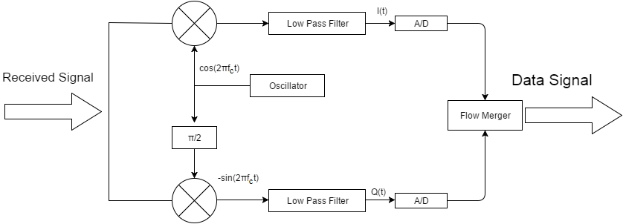

* In the ideal case I(t) is demodulated by multiplying the transmitted signal with a cosine signal:

r(t) = s(t)cos (2 $π$ fct)

r(t) = I(t)cos (2 $π$ fct) cos (2 $π$ fct) – Q sin (2 $π$ fct) cos (2 $π$ fct)

* Using standard trigonometric identities, we can write it as:

r(t) = $\frac{1}{2}$ I(t) [1 + cos (4 $π$ fct)] - $\frac{1}{2}$ Q(t) sin (4 $π$ fct)

r(t) = $\frac{1}{2}$ I(t) + $\frac{1}{2}$ [I(t)cos (4 $π$ fct) - Q(t) sin (4 $π$ fct)]

* Low-pass filtering r(t) removes the high frequency terms (containing 4 $π$ fct), leaving only the I(t) term. This filtered signal is unaffected by Q(t), showing that the in-phase component can be received independently of the quadrature component.
* Similarly, we may multiply s(t) by a sine wave and then low-pass filter to extract Q(t).

Specification table for Transmitter:

|  |  |
| --- | --- |
| Parameter | Value |
| device names | 10.20.2.200 |
| IQ rate | 400K |
| gain | 20 |
| carrier frequency | 434M |
| active antenna | TX1 |
| pulse shaping filter | none/raised cosine/root raised cosine |

Specification table for receiver:

|  |  |
| --- | --- |
| Parameter | Value |
| device names | 10.20.16.201 |
| Rx IQ rate | 400K |
| rx gain | 20 |
| carrier frequency | 434M |
| active antenna | RX2 |
| pulse shaping filter | none/raised cosine/root raised cosine |
| number of samples | 16536 |
| millisecond timer value | 1000 |

Modulation Tool kit approach and simulation results:

Transmitter Section:

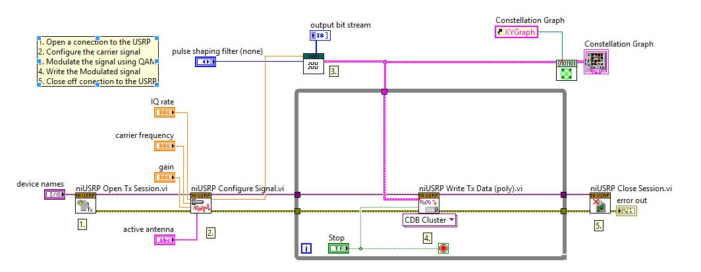

1. Open a connection to USRP for transmission.
2. Configure the carrier signal.
3. Modulate the signal using QAM Modulation.
4. Plot the Constellation Graph.
5. Write the modulated signal to the channel.
6. Close off the connection to USRP for transmission.

QAM Modulation:

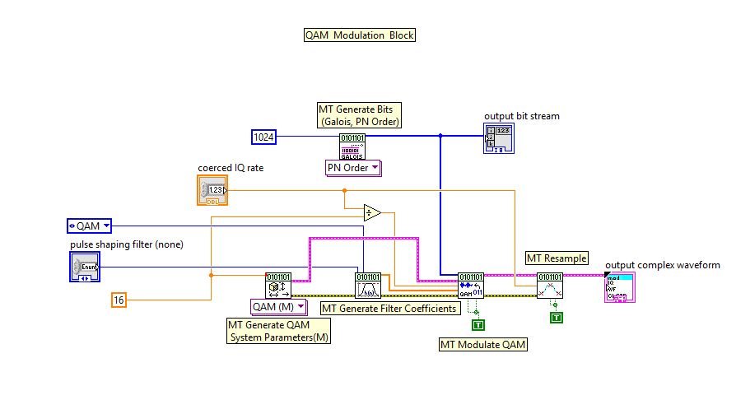

1. Generate System Parameters.
2. Generate Pulse shaping Filter Coefficients
3. Generate bits using Galois Algorithm.
4. Modulate the signal using QAM.
5. Resample the signal and giving it as an output.

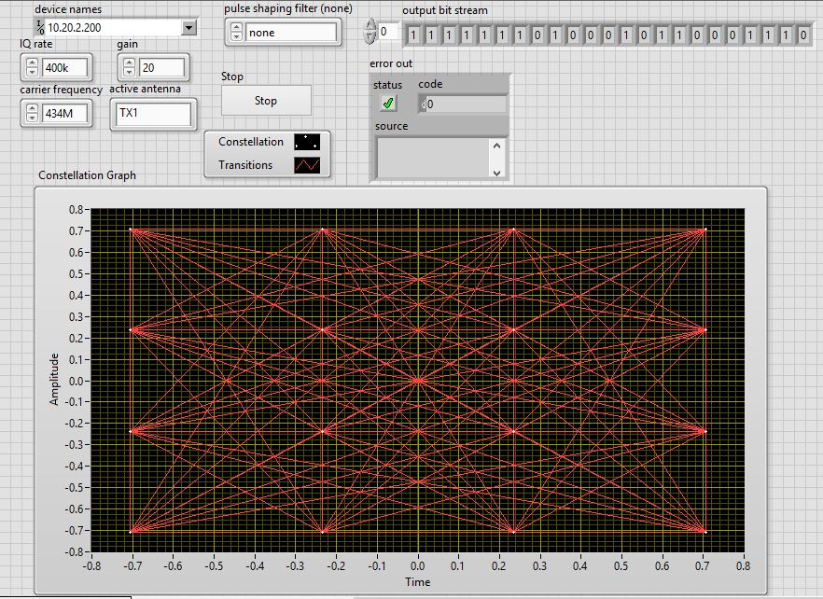Front Panel and Simulation Results for transmitter:

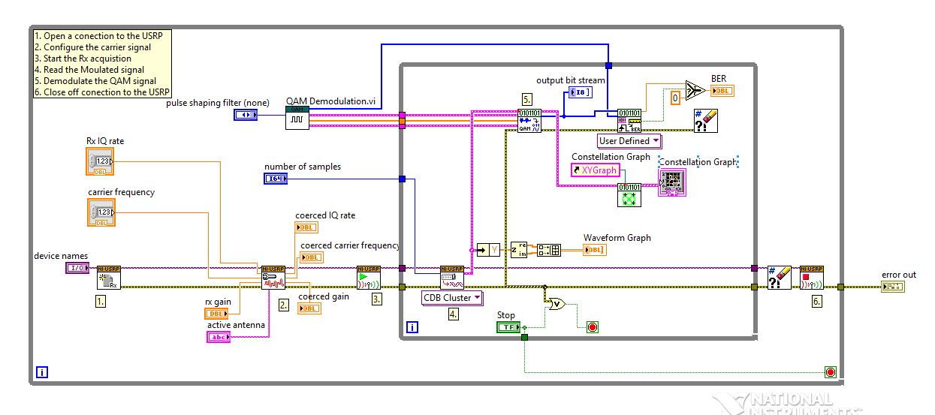Receiver Section:

1. Open a receive session with the USRP.
2. Configure the Carrier Signal.
3. Start the Rx acquisition.
4. Read the modulated signal from the channel.
5. Generate the waveform graph of the received signal
6. Generate the parameters for QAM Demodulation.
7. Demodulate the QAM signal.
8. Calculate the Bit Error rate.
9. Plot the Constellation Graph of the received signal.
10. Close off the receive session to the USRP.

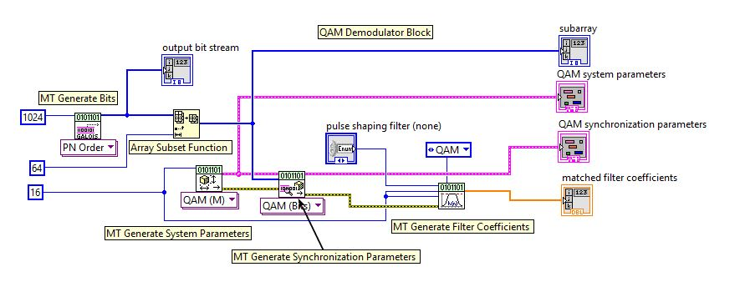QAM Demodulation:

1. Generate the QAM System Parameters.
2. Plot the QAM System Parameters.
3. Generate bits using Galois Algorithm.
4. Generate the Synchronization Parameters.
5. Plot QAM Synchronization Parameters.
6. Generate Matched Filter Coefficients.

Front Panel and Simulation Results for receiver:

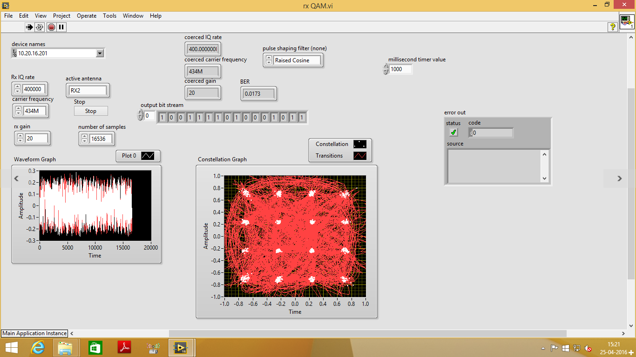

Conclusion:

* We successfully implemented 16 QAM Modulation and Demodulation.
* It is very important to understand the transmitter block diagram first. If it is understood properly then the receiver can be made easily. Hence after understanding the transmitter we successfully implemented 16 QAM transmitter.
* At the receiver side along with the QAM modulated signal certain other signals which are present in the environment were also received. Hence we were able to plot the received signal with a certain amount of noise present.

References:

<https://github.com/ay0034/LabVIEW/tree/master/USRP%20QAM%20TxRx>

<http://www.ni.com/white-paper/3876/en/>

<https://www.youtube.com/watch?v=d7l5NbFfBiU>

<https://www.youtube.com/watch?v=eYyKRaKjLD0>

<https://en.wikipedia.org/wiki/Quadrature_amplitude_modulation>

<http://www.radio-electronics.com/info/rf-technology-design/quadrature-amplitude-modulation-qam/8qam-16qam-32qam-64qam-128qam-256qam.php>